AMAZON
PRAYER CHAMBER
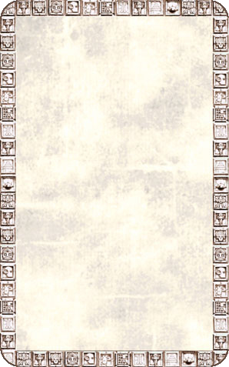
DUNGEON ROOM
A large golden statue stands on a pedestal in the middle of this room.

The Amazon Prayer Chamber will always trigger an Event Card. Monsters whose bases take up more than 1 square are considered to be on the level containing the front of their base for purposes of the multi-levelled room rules.
