ARMOURY
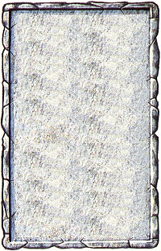
DUNGEON ROOM
Weapons and armour of all varieties lay strewn around this room, almost begging the Warriors to pick them up.

What a find! This room is the armoury, and each Warrior may roll once on either the Magic Weapon or Magic Armour Table in the Roleplay Book to see what they discover.
