MASTER BEDROOM
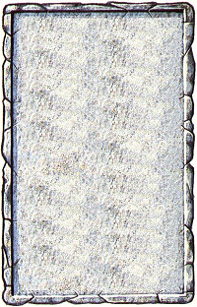
DUNGEON ROOM
Whose bedroom this is is a mystery but it sure looks inviting.

For each turn the Warriors remain in this room doing nothing else but sleeping they may each gain 1D6 Wounds. At the end of every turn they sleep roll 1D6. On a roll of 1-2 an Unexpected Event occurs. Any Monsters appearing will have the Ambush special ability if they do not have it already.
