BRIDGE OF DESPAIR
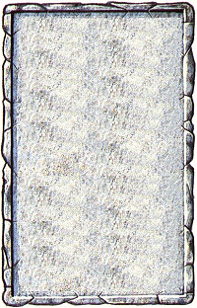
DUNGEON ROOM

The Warriors are wary of the rickety looking bridge that greets them as they enter this room.

Refer to the Warhammer Quest: Pits and Traps rules supplement for information about the Bridge of Despair.
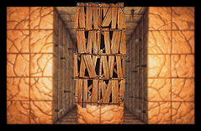
Entry
Exit

