CHAMBER OF SACRED PLAQUES
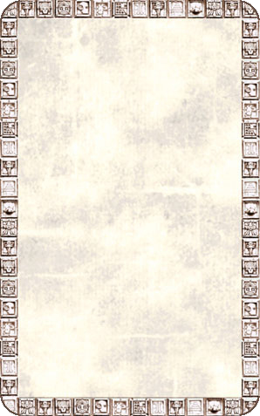
DUNGEON ROOM
Lined along the walls of this room are many stone plaques, each with what appears to be glyph writing on them.

The Chamber of Sacred Plaques will always trigger an Event Card.
