CHAMBER OF
THE SUN
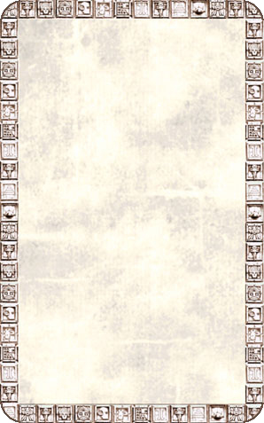
DUNGEON ROOM
In the centre of this rather large room is a huge sun painted onto the floor.

The Chamber of The Sun will always trigger an Event Card. If any Warrior ends his Movement on a square containing the sun symbol roll 1D6. On a roll of 1-2 he will be blinded for 1 turn, during which he suffers a -2 To Hit penalty. Monsters receive +2 To Hit the blinded Warrior.
