CORNER
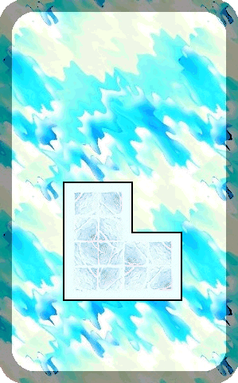
CORRIDOR
The passageway takes a turn here, heading off deeper into the caverns.

The Corner will always be empty unless an Unexpected Event occurs.

