CROCODILE PIT
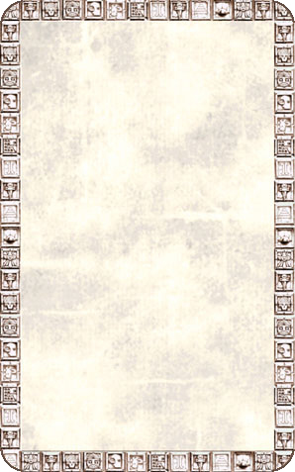
DUNGEON ROOM
This room contains a huge pit containing fierce crocodiles!

The Crocodile Pit will always be empty unless an Unexpected Event occurs. If any Warrior rolls a 1 To Hit while standing in a square adjacent to the pit roll on the Lair of the Orc Lord pit table. If he falls into the pit he immediately suffers 3D6 Wounds. At the start of each Warriors’ Phase the Warrior may try to escape by rolling 1D6. On a roll of 4-6 he climbs up the rope to safety which takes his entire turn. Otherwise he takes a further 2D6 Wounds damage from the crocodile attacks and may try again next turn.
