CROSSROADS
OF DOOM
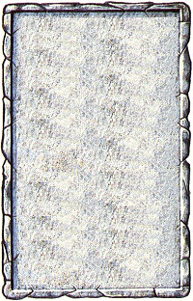
CORIDOOR
This passageway appears to be a dead-end, but the Warriors notice 2 levers on the floor…

Refer to the Warhammer Quest: Pits and Traps rules supplement for information about the Crossroads of Doom.
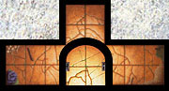
Entry
Exit

