FOOD HALL
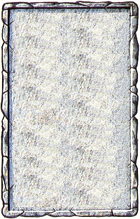
OBJECTIVE ROOM
This large room seems to be an eating area. Long tables and chairs are scattered randomly around and food is strewn everywhere.

The Food Hall is treated as a normal Objective Room unless the adventure the Warriors are playing states otherwise. After the room is cleared of Monsters, each Warrior may scrounge up 1D6 provisions.
