INNER SANCTUM
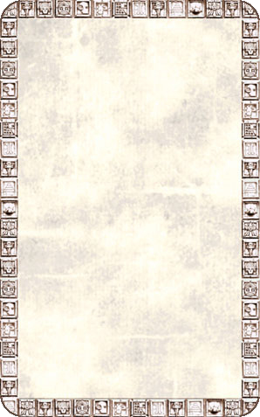
OBJECTIVE ROOM
This enormous chamber consists of multiple levels. Four giant Pygmy statues sit at the base of four towering columns.

The Inner Sanctum is treated as a normal Objective Room unless the adventure states otherwise. Monsters whose bases take up more than 1 square are considered to be on the level containing the front of their base for purposes of the multi-levelled room rules.
