INTERSECTION
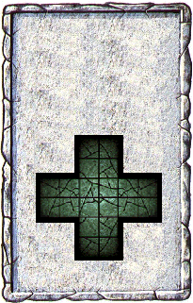
CORRIDOR
The light from the lantern shines off three other passageways. The Warriors will have to make a choice - which way do they go?

The Intersection will always generate an Event.

