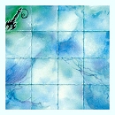
MYSTICAL
ICE ROOM

DUNGEON ROOM
The Warriors feel a strange aura emanating from somewhere in this room.

The Mystical Ice Room will always generate an Event. This room has a curse upon it. No magic of any kind will work in this room, including spells. Magical effects currently affecting any Warriors, eg. Disease etc. will instantly be nullified.

