NARROW SANDSTONE PASSAGEWAY
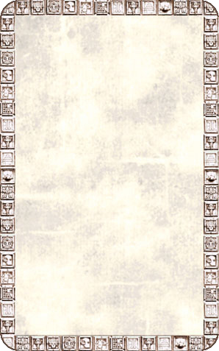
CORRIDOR
The passageway narrows drastically here. There seems to only be room for the Warriors to pass through in single file.

The Narrow Sandstone Passageway will always be empty unless an Unexpected Event occurs.


