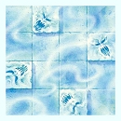
ROOM OF THE NORTH WIND

DUNGEON ROOM
The temperature drops dramatically as the Warriors enter this room.

The Room of the North Wind is home to small Air Elementals, blowing their frosty breath and chilling the Warriors’ bones. The Air Elementals will not harm the Warriors directly, but the temperature of the room will continue to lower. At the end of each turn the Warriors remain in this room, they will each lose 1 unmodified Wound due to the extreme cold. The Warriors cannot move onto any square containing an Air Elemental.

