SACRIFICIAL PIT
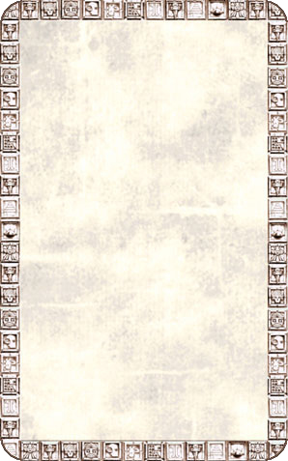
DUNGEON ROOM
A vast pit greets the Warriors as they enter this room. They will have to make their way carefully around it to continue.

The Sacrificial Pit will always trigger an Event Card. If the card reveals Monsters place the Monsters in the pit. Any Monsters that don’t fit in the pit are assumed to be ‘lined up’ waiting to enter by means of the iron gate. If a Warrior rolls a 1 To Hit while standing in a square adjacent to the pit he falls in. Move the models in the pit around to accommodate him. Warriors cannot attack Monsters in the pit (and vice versa) if they are not in the pit themselves unless they use a missile weapon. Warriors can climb in or out of the pit but doing so takes an entire turn during which time they may do nothing else. Other Event Cards which reveal Monsters can be placed anywhere on the board – they do not have to be placed in the pit.
