SANDSTONE
T-JUNCTION
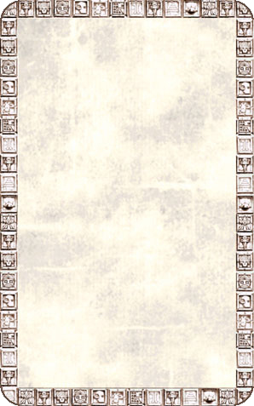
CORRIDOR
The passageway splits into two sections, causing a dilemma for the Warriors - which way do they go?

The Sandstone T-Junction will always be empty unless an Unexpected Event occurs.
