SAURUS BARRACKS
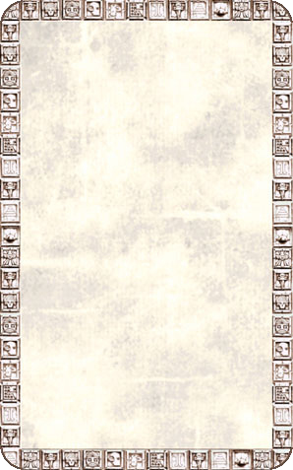
DUNGEON ROOM
Crude straw bedding lines the floor of this room and gnawed bones litter the area.

There will always be Monsters in this room. There is no need to draw an Event Card. Unexpected Events will happen as usual.
