SAURUS SPAWNING CAVERNS
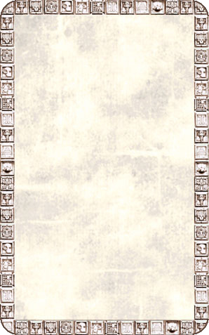
DUNGEON ROOM
These eerie gigantic caverns seem to never end. The Warriors think they can hear scratching and grunting sounds in the darkness.

The Saurus Spawning Caverns will always trigger an Event. When this card is drawn roll 1D6 and arrange that many of the Saurus Spawning Cavern board sections in any way on the table. Now roll 1D3 for the amount of exits from the caverns; the remainder of the exits will be blocked by fallen rubble. Because of the caverns’ immense size, after the conclusion of each Event roll 1D6. This is the amount of turns the Warriors have before they must draw another Event Card.
