SECRET CHAMBER
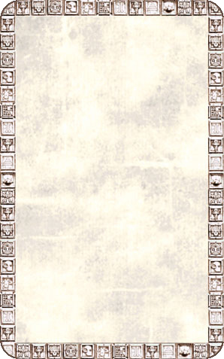
DUNGEON ROOM
Treasure belonging to the Slann Mage-Priests is stored in the Secret Chamber.

The Secret Chamber will always be empty unless an Unexpected Event occurs. When this card is drawn place it to one side and immediately draw another Pyramid Temple Card to determine the next room as usual. The Secret Chamber card represents the Warriors learning of the location of a secret room somewhere in the Pyramid Temple. Randomly choose a board section currently in play and place the Secret Chamber board section off it, along with a Dungeon Doorway to represent the entrance. The Warriors can now explore this new section of the Pyramid Temple. There will be a total of 1D6 Dungeon Room Treasure Cards and 1D3 Objective Room Treasure Cards here. Warriors may take as many Treasure Cards as they like but must roll 1D6 for each card taken. On a roll of 1-2 for Dungeon Room Treasure or 1-4 for Objective Room Treasure the Warriors must make 1 roll on the Monster Table as the inhabitants of the Pyramid arrive to reclaim their treasure!
