SKINK BARRIO
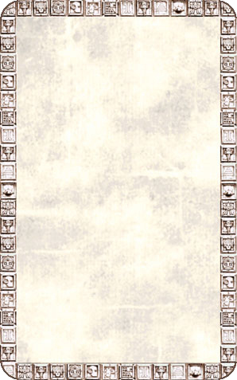
DUNGEON ROOM
Broken javelins are scattered over the floor of this room, along with crude straw bedding.

There will always be Monsters in this room. There is no need to draw an Event Card. Unexpected Events will happen as usual.
