SMALL PASSAGEWAY
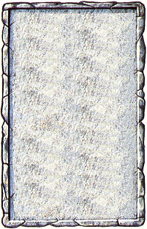
CORRIDOR
This passageway is rather tiny, and it is a squeeze to walk down it.

The Small Passageway will always be empty, unless an Unexpected Event occurs.
