SMALL
SANDSTONE ROOM
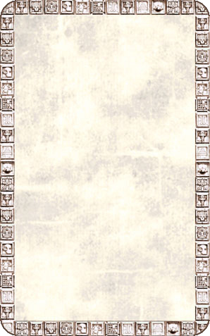
DUNGEON ROOM
This room is much smaller than usual.

The Small Sandstone Room will always trigger an Event Card.


