TERRADON PERCHERY
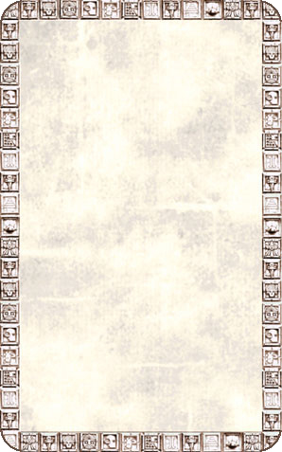
OBJECTIVE ROOM
The Terradon Perchery is located at the upper most point of the Pyramid Temple. Terradons are hatched here and once they are old enough can take flight and soar high above the jungles of Lustria.

Terradons are constantly hatching from their eggs in the perchery. At the beginning of each turn a Warrior is in this room he must roll 1D6. On a roll of 1 he has been knocked prone for the rest of the turn by a baby Terradon slamming into his chest while learning to fly.
