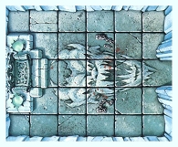
THE FROST DEMON’S THRONE ROOM

OBJECTIVE ROOM
This is the Throne Room of a mighty Frost Demon, who delights in terrorising all who invade his dungeon.

Fortunately the Frost Demon is not here at the moment... However, he has left some magical traps for those stupid enough to trespass in his throne room. If a Warrior moves during his turn roll 1D6. On a roll of 1 a trap is activated - roll on the Ice Magic table to determine what spell is set off. Spells requiring a point of origin should use the Throne square. The traps are activated the turn after the Warriors move into the room.

