THRONE ROOM OF DEATH
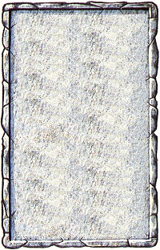
OBJECTIVE ROOM
The most noticeable feature about this throne room is the huge skull carved and painted on the ground.

The skull is a magical tribute to Nagash,. No magic spells can be cast by the Warriors while standing on any square containing the skull. In addition, the magical effects of any items the Warriors use is nullified, as are any special abilities the Warriors have gained which are magical.
