WIZARD’S STUDY
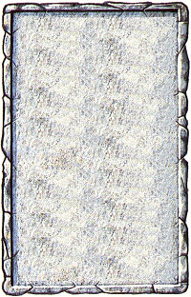
OBJECTIVE ROOM
This large room has a magical glow about it. A large circle inscribed in the centre of the room depicts a sun and moon, and the four elements; earth, air, fire and water.

At the end of each adventure roll 1D6. On a roll of 4-6 a random spellcaster in the party finds a magic spell inscribed on a scroll. He may immediately learn a new spell as per the normal rules.
