
• NEHEKHARA HAZARDS •

1 UNEVENTFUL WEEK

2 SHIFTING SANDS
The Warriors believe they are making good progress when they find a set of tracks. After a careful examination they realise they are their own footprints! The Warriors are clearly lost. Add 1D3 weeks to the journey.

3 DEAD HEROES
The Warriors come across a group of dead adventurers, their bodies ripped and torn by hungry vultures. When they investigate further they find 1D3 Nehekharan Treasures that they divide amongst themselves.

4 DARKNESS
A strange dark cloud is seen moving on the horizon. Before long, although they try and avoid it, the Warriors are enveloped within it. Roll 1D6:

1 The warriors find themselves inside a tomb of some sort. Place them on a random board section. Then place 1D6 board sections leading off each way. At the end of both of these path lies the exit to the tomb.

2 The Warriors find themselves back at the Pyramid entrance.

3-4 Nothing happens and the cloud passes.

6 The Warriors find they are at their targeted Settlement.

5 WOLVES
During the week the Warriors notice a group of desert wolves following the party. Roll 1D6:

1-2 The wolves attack without warning. Roll 5D6 for the amount of wolves attacking, then roll 1D6 for each Warrior and add them together. Subtract the Warrior’s amount from the wolves number. The difference is the amount of Wounds each Warrior receives from the battle before the wolves retreat.

3-4 The wolves sneak into camp while the Warriors are asleep and the Warrior on guard is also asleep. They make off with 1D3 provisions from each Warrior.

5-6 The wolves lose interest in the Warriors and leave without incident.

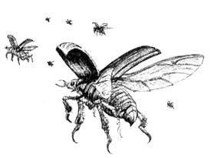

6 OASIS
The Warriors come across an isolated oasis. Here they may rest and heal back to full Wounds.

7 SINKHOLE
The Warriors decide to rest a moment on a low dune. Suddenly it gives way below them. They fall into a corridor, but can get out if they possess a rope. If no one has a rope they must play an adventure using 1D6 + 2 Dungeon Cards, with the last card being a way to the surface. If and when the Warriors leave the dungeon they are 1D2 weeks off course.
8 PILLARS
The Warriors encounter a circle of pillars with an altar in the middle, obviously to please a god of some sort. Each may if they wish try and pray to the God, by rolling 1D6:

1 The God is displeased with the Warrior’s ramblings and loses 1 Starting Wound, permanently.

2 Only a deep laughter can be heard from the sky.

3-5 Nothing happens.

6 The God is pleased with what the Warrior says and bestows him 1 Starting Wound, permanently.

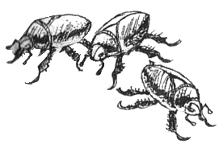

9 BLISTERS
A random Warrior’s old boots start to give him painful blisters. He must take 1D2 unmodified damage for this week and for every week of travel that is left.

10 BEGGAR
The Warriors happen across a beggar drawing something in the sand with his walking stick. The Warriors realise it is the layout of a large room. One of the Warriors scribbles it down on a bit of parchment. When that Warrior enters an Objective Room roll 1D6. On a 6 it is the same room that he has on the parchment. Once the Monsters have been killed, the Warrior may follow the map and find an Objective Room Treasure Card for himself.

11 UNEVENTFUL WEEK

12 ANUBIS STATUES
The Warriors come to two towering Anubis statues that they presume mark the existence of an Anubis Settlement nearby. The Warriors can either skirt this area adding 2 weeks to travel time or continue through. If they continue roll 1D6. On a 1 the Warriors encounter a group of Anubis Warriors patrolling the area. Fight a battle with 1D6 + 2 Anubis Warriors, 1 Anubis Champion and 1 Anubis Priest.

13 GIVING UP
A random Warrior is completely exhausted and falls to his knees in the sand. The other Warriors turn to see him fall face first in to the sand as if giving up to die! They come over and pull him to his feet. With a mouthful of sand the warrior states that he just can’t go on anymore! Another random Warrior is sick of this and slaps him hard across the face trying to shake him out of it. Roll 1D6. On a 5-6 it works and the Warrior finds the strength to go onwards. If that fails they can give him 2 water skins and he feels well enough to continue. If they have no water skins then the warriors are forced to leave him behind in the sands for the carrion. He is dead and the sands of Nehekhara have claimed yet another victim.

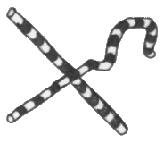

14 DESERT RAIDERS
The Warriors make out what looks to be a band of desert raiders up ahead on horse back. If the Warriors are on horses they can outrun this band. If not, the band of 16 or so raiders ride up to the Warriors. They demand a random Treasure Card, including Objective Room, from each Warrior. If they refuse or can’t give the raiders what they want, roll 1D6:

1-5 The raiders battle the Warriors. Roll 16D6 for the raiders then the normal Damage Dice for each Warrior. Add the Warriors’ total together and take that from the raiders total. Then divide this result between the amount of Warriors. This is how much damage each Warrior takes before the Raiders turn tail and ride off.

6 The raiders seem poised to attack but are obviously worried about a fight with such battle hardened Warriors. They attempt to act superior and say ‘Well, we’ll let you off with a warning this time,’ before turning around and riding off as fast as their horses can carry them!

15-21 SANDSTORM
The Warriors are suddenly caught in a merciless sandstorm. Roll 1D6:

1-2 The storm whips sand into the Warriors, cutting into their flesh. They sustain 3D6 Wounds damage and must add 1D6 weeks to travel.

3-4 The Warriors are turned around in the storm resulting in them moving in the wrong direction. Finally it clears, but they are 1D3 weeks off track.

5-6 The Warriors manage to battle through the storm, and continue their journey.

22 UNEVENTFUL WEEK

23 MIRAGE
The heat is almost unbearable, when a random Warrior looks up and sees a large lake only about 100 metres from him. He starts running, shouting out “We’re saved!” When he finally gets there he dives in, but it is only a mirage and he lands face first in a pile of sand. He stands up and comes to his senses. Not long after this humiliating act, he realises he has lost 1D6 x 50 Gold in the sands after his frantic run.

24 BLOOD OATH
The Warriors come across a dying boy next to his dead parents and their upturned cart. A random Warrior kneels and holds the boy in his arms while the others look on.

“Who did this to you?” the Warrior asks.

“A.... beast....” the boy gurgles, as his blood turns the sand crimson.

“Avenge..... our ..... death!” he says as the last of his life runs from him.

Right then the Warrior swears an oath to kill the “beast” that did this. At the next Objective Room, a random Monster will be the killer of the family. The Warrior will try anyway possible to attack him and will not stop until he is dead. He gets +1 Attacks against him and will not run from the battle unless the beast is dead.

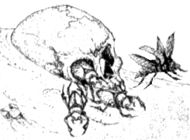

25 SNAKE
A slithering noise alerts the Warriors to a gigantic snake moving up behind them. They must face this fearful opponent. Keep rolling on this table until it is killed. The snake has 25 Wounds. Roll 1D6 for each Warrior:

1 The Snake strikes the Warrior, impaling him with one of his massive fangs (the Warrior loses half of his remaining Wounds), then lifts him high into the air and drops him hard into the sand (take a further 1D6 damage).

2 The Snake’s large tail smashes into the Warrior knocking him fifteen metres through the air! Take 2D6 + 4 Wounds damage.

3 The Warrior hacks at the creature’s scaly hide but fails to do any substantial damage.

4 The Warrior stabs skilfully at the creature’s underbelly. The Snake receives (1D6 + the Warrior’s Strength) damage.

5 The Warrior slices at the monster’s mighty head. The Snake takes (2D6 + Warrior’s Strength) damage.

6 The Warrior waits for it to strike then leaps to the side, stabbing it in the eye. If the Snake is on less than 12 Wounds it is killed outright. Otherwise, the Snake receives (3D6 + Warrior’s Strength) damage.

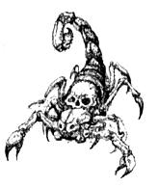
26 LAND OF THE DEAD
The Warriors pass through an old battlefield. The skeletons are more than half covered with sand, their twisted bodies a chilling reminder of the slaughter of war. Roll 1D6:

1 The Warriors are passing through this area with they see a hunched figure over the bones of the dead. Calling out to him, the figure rises slowly and turns showing that is a Liche Priest! He then chants an incantation from his dry throat, raising 2D6 Skeletons. Fight a battle with these opponents.

2 The Warriors spot a group of 2D6 undead Carrion not too far from the battle. If all the Warriors pass an Initiative roll of 7 then they pass by the Carrion unnoticed, otherwise one of the Warriors trips over a shield laying on the ground and calls out in surprise! The Carrion hear this and attack the Warriors.

3 The Warriors pass though this mass grave of Pharaoh’s soldiers and continue on.

4 The Warriors find an undamaged shield in the remains. If the any of them want the shield it gives +1 Toughness.

5-6 As they are leaving the area, a random Warrior spots something shiny. Take one Treasure Card.

27 BETRAYAL
From now on, for every friendly person encountered in an event, roll 1D6. On a 1-2 it is really an assassin sent by the one of the Warriors enemies, whose plans would be hindered if the Warriors complete their quest. If the person is an assassin, a random Warrior takes 2D6 + 4 Wounds (no modifiers for armour) before the assassin is slain. The event’s rules are void. The effects of this event end when the next adventure starts, or when the Warriors leave Nehekhara.
28 ORGUT’S LAIR
The Warriors approach some rocky cliffs where they find a cave. From the objects, bones, bloody rocks and large footprints, they realise that this is an Orgut’s Lair. If the Warriors decide to investigate the lair roll 1D6:

1-2 The Warriors burst into the cave to find 1D6+2 Orguts walking around doing various things. When the Warriors enter they are seen instantly and a battle ensues. Once the battle is won the Warriors each find a Treasure Card.

3-4 The Warriors find the cave to be inhabited by 1D6 Orguts. They are currently asleep, making disgusting snorting sounds. The Warriors can try to sneak around them if they wish, or charge in yelling battle cries (in which case fight a battle, only the Warriors get a free Ambush Attack due to the fact the Orguts were sleeping). If the Warriors decide to sneak around and take whatever treasure they can find, use a large board section to symbolise the cave, then place the sleeping Orguts in random squares. Now place the Warriors at one end of the cave (cave entrance) and something to symbolise treasure at the other end. The Warriors can now attempt to sneak past the Orguts to the treasure and out again. For every square moved onto or through by a Warrior roll 2D6. If any of the rolls come up doubles he has been too noisy and has alerted the Orguts, who bellow in anger and battle their intruders. Now receive the treasure after the battle as usual. Once a Warrior has reached the treasure at the end without alerting the Orguts, roll on the following table. Each Warrior can do this.

1-2 1D6 x 100 Gold.

3-5 1 Treasure Card.

6 1 Objective room Treasure.

5-6 The cave is unoccupied, but the Warriors find 1D6 water skins each, hanging around the walls.
29 PASSING CARAVAN
The Warriors come across a caravan travelling in the opposite direction. The Warriors can avoid them or meet with them. If they decide to meet them roll 1D6:

1 As the caravan draws near, the Warriors see that all that are in it are hooded and have heavy cloaks. They see this as being very strange, considering the heat of the land. When the cloaked figures come within about 12 feet from the Warriors they look up and throw their cloaks off showing that they are Nehekharan Assassins! There are 5D6 assassins. Roll Damage Dice + Strength for each Warrior, add these together and subtract this total from the total amount of assassins. The remainder is how much unmodified damage each Warrior takes from the battle before it is won.

2-3 As the caravan approaches, the Warriors see that the occupants’ faces look blotchy and blue. Suddenly the Warriors realise that the caravan must have the Blochcan Plague. They quickly run from the area, adding one week to travel. Each Warrior must also roll 1D6. On a 1-2 he has come too close to the caravan and has contracted the plague also. Any Warrior with the plague is at -1 To Hit and -10 Starting Wounds. The plague is only temporary though and can be healed at a Pharaoh’s City for 500 Gold.

4-6 As the Warriors approach, they see that it is a caravan of traders. Any of the Warriors may trade, or buy the following items. To trade, the Warrior must swap a treasure of equal or greater value than the item wanted.

1D6 Water Skins 100 Gold each
1D6 Provisions 70 Gold each
1D6 Bandages 50 Gold each
Shield 300 Gold
1D3 Healing Potions 100 Gold each
30 CIRCLING DRAGONS
The heat beats down on the Warriors like a pounding drum. A deafening shriek is heard and they look up to see 1D6 Dragons flying high above them. There is no cover around so they have no choice but to keep going. The hours pass on and the Warriors start to think that they may have just been seeing things, when another shriek is heard and the Dragons swoop. They breathe streams of fire at the Warriors. Roll 2D6 for each Dragon. Add this score together and subtract the total of all the Warriors’ Battle Levels. The remainder is how many Wounds are inflicted on each Warrior. If any Warrior falls unconscious roll 1D6. On a 1, before he can be healed, a Dragon swoops down and snatches him from the sand. Miles in the air the Warrior is played with by the Dragons. His body is ripped and torn at and eventually shredded. Bits of him fall down around his companions, littering the ground with body parts. After the next Hazard roll in this adventure roll 1D6. On a 1-2 the Dragons have followed the Warriors and this event must be replayed. After the next event do the same and so on until a 3-6 is rolled, in which case the Dragons lose interest.

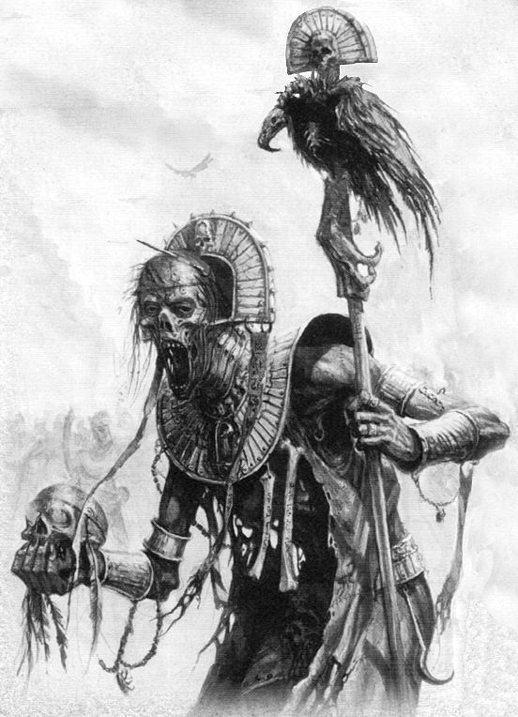
31 SAND STONES OF FORTUNE
Giant sandstone sculptures are seen far on the horizon and strike an interest in the Warriors even before they are reached. When they are reached they find that these are sculptures of great Pharaohs of the past. They have no idea what they are doing out in the middle of nowhere but sense a strange feeling about them. It is about time to set up camp. If the Warriors decide to set up camp here roll 1D6:

1-2 The Warriors dreams are filled with horrid nightmares of a time long since past in the realm of Nehekhara, of demons and torture, pestilence and slavery.

3-5 The magical essence of the statues heals the Warriors 2D6 Wounds each.

6 The magical essence of the statues heal the Warriors back to their Starting Wounds. They also receive 1 Starting Wound, permanently.

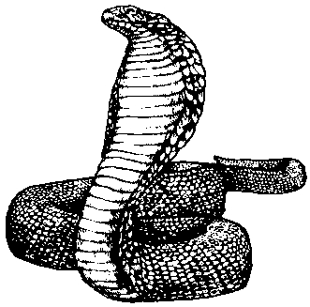

32 HEAT WAVE
The Warriors are unlucky enough to be caught in a heat wave. These are unpleasant anywhere, but in Nehekhara they can be fatal. Roll 1D3 for each Warrior. This is how many Starting Wounds each Warrior endures. For every water skin used, a Warrior may cancel the effects of the loss of one Starting Wound.
33 UNEVENTFUL WEEK

34 VULTURES
The Warriors see that there are heaps of vultures milling around on the ground where they are headed. The Warriors find this interesting and investigate. Upon approaching the squabbling vultures, they see a blanket of dead bodies covering the sand. Half of them seem to be human soldiers and half are Orguts. The vultures are fighting each other over every piece of meat, but move as the Warriors walk among them. Then they hear a murmur from one of the bodies, it seems it is still alive. Roll 1D6. On a 1-3 the survivor is an Orgut - go to the Orgut section. On a 4-6 the survivor is a human solider - go to the Human section.

ORGUT
The Warriors see a lance stuck out of the Orgut’s stomach and various slashes over its body. Its one eye opens slowly as they get nearer to him. Then in a crude form of English, it speaks. “YOU.. SMALL ONES ..... YOU ARE WEAK... WE ARE STRONG..... WE WILL... CRUSH YOU ALL, ... I WILL” and with that he amazingly lifts his huge bulk to his feet. The Warriors are a bit taken aback by this, considering the huge amount of damage done to his body. He manages a slow, useless swing at the Warriors before falling to the ground dead with a very loud thud. The Warriors search the battlefield and find 1D3 water skins each.

HUMAN
The Warriors see that there is a wounded solider heaped on a pile of bodies. They try to comfort him but his wounds are fatal. He manages to speak, only for a moment, “There is ....no crueler foe than.. the Orgut.... remember.. this.......” Before he dies he thrusts one Treasure Card into a random Warrior’s hand “Kill them… with this!!” he splutters with his dying breath. The Warriors search the battlefield and find 1D3 water skins each.
35 ABANDONED CITY
The Warriors approach the gates of a great city. After a quick look it is obvious that the city has been abandoned for many years. If they investigate further roll 1D6:

1-2 The Warriors burst in on a group of Monsters that have been using the city as shelter from the sun. A battle ensues. Roll on the appropriate Monster Table. After the battle the Warriors may rest in the city, regaining 2D6 Wounds.

3-4 The Warriors find nothing of interest, but may rest in the city, regaining 2D6 Wounds.

5-6 After a thorough search the Warriors find 1 Treasure Card.

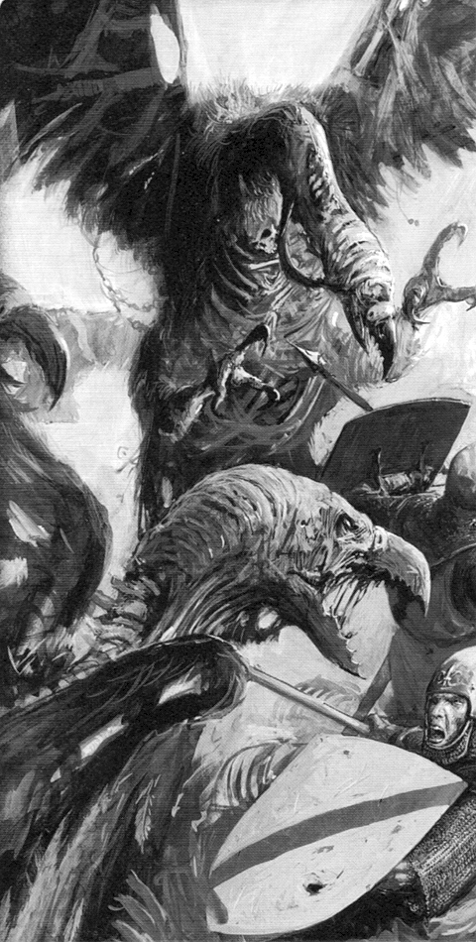
36 STATUE IN THE SAND
The Warriors see a great statue in the sand. It rises many feet in the air and is shaped as a huge fat man. It is made of marble and is embedded in sand up to its waist. There is a large cracked hole in the statue’s stomach, making it obvious that it is not solid. A Warrior may put his hand into the darkness to investigate. If one of the Warriors does this roll 1D6. Only one Warrior can do this per time this event is rolled.

1 The Warrior cautiously reaches his hand into the hole and begins to feel around. He puts his arm in up the shoulder, when his whole arm is engulfed in a creature’s mouth of some kind. The Warrior yells, half in pain and half in shock as the mouth’s sharp teeth tear through the top part of his arm. He must roll 1D6 and add his Strength. Then roll 1D6 and add the creature’s Strength, which is 8. If the Warriors score is higher then he manages to pull his arm out of the mouth, but receives 2D6 Wounds in the process. If the creature’s score is equal to or greater than the Warriors score, then his arm has been ripped clean off! He reels back in pain with blood spraying from his stump. The other Warriors eventually stop the bleeding, but he takes 2D6 unmodified Wounds, and only has one arm. While the Warrior only has one arm he is at -1 To Hit, cannot use a shield, or two handed weapon, and cannot hold the lantern. Perhaps go to a Nehekharan Limb Replacement Workshop, to see if they have any spares!

2-3 The Warrior reaches his hand in but finds nothing.

4-5 The Warrior reaches his hand in to find 1D3 water skins. They must have been left behind by travellers, thinking it would be a cool place to keep their water, while they camped.

6 The Warrior reaches his hand in cautiously and feels something in there. Grabbing hold of it he pulls it out a Treasure Card.

37 SMALL PYRAMID
The Warriors come to a small Pyramid. The Warriors may enter the Pyramid if they wish. If they decide to, play a normal adventure, only with half the normal amount of Pyramid Cards.

38 PALACE OF PLAGUE
The Warriors see a mighty city on the horizon, and think that their journey might finally be over. As they draw near they see a curious black cloud above the city. Soon they are close enough to be spotted by the city’s look out and before long a group of four guards on horseback come to greet them. The guards explain to the Warriors that the city’s palace has a powerful curse on it causing all that live in the city to have a deadly plague. This is the doing of a powerful wizard who lies in a small Pyramid to the east. They beg the Warriors to help them as they are all too weak from the plague. They believe that by killing the wizard the curse will be undone.

If the Warriors accept, they hurry off to the Pyramid, only a days travel away. Play a normal adventure only with half the normal amount of Pyramid Cards. Once the Warriors get to the Objective Room they come across the wizard responsible for the plague. Fight a battle with the usual amount of creatures in the Objective Room as well as the wizard who is a Necromancer Champion.

Once the task is complete the Warriors make their way back to the city, which is now cured. The Pharaoh rewards them each with 3D6 x 100 Gold and a Treasure card each. Although the populace is now healthy, most of the water and food is still contaminated, so the Warriors decide to continue on their way to their original destination, after sleeping in the palace for one night and regaining 2D6 Wounds.

39 FED UP WITH SAND
A random Warrior starts to go slightly crazy from the constant sand everywhere he looks; sand in his boots, in his eyes, in his pants, and just about everywhere else! The other Warriors believe he is going slightly delirious from the heat, as he starts muttering to himself, about how he is going to destroy every bit of sand one day and starts laughing madly to himself. If this crazed Warrior doesn’t get to a Settlement in the next 2 weeks he stays delirious for the whole next adventure, muttering to himself and cursing the sand. While in this state he if he rolls a 1 to hit he will immediately attack an adjacent Warrior, believing him to be evil sand sneaking up on him!

40 NIGHT WATCH
A random Warrior is watching over the other Warriors as they sleep. Roll 1D6:

1 The Warrior falls asleep at his post and the party is attacked by wandering Monsters! All of the Monsters have Ambush, Magic A as the Warriors are surprised. Roll once on the appropriate Monster Table.

2 The Warrior falls asleep at his post and a sand storm starts up over night. The Warriors are so tired they sleep right through it, but when they awaken, they find one of their items is lost, buried deep in the sand forever. Each Warrior must lose 1 random item.

3 A strong wind fills the night air making a howling noise. Although the wind is loud he still notices the Nehekharan Assassin just before he whips a thin metal cord over the Warriors head and pulls it tight around his neck. Half choking, the Warrior tries to throw off the assassin. He must roll 1D6 and add his Strength. On a 9 or more he has thrown the assailant off and he runs off into the night, otherwise read on. Remember, a 6 is an automatic success.
For every turn the Warrior doesn’t throw off the assassin, he loses 1 Toughness. (This is only to show how long he can go without air. He doesn’t actually lose any Toughness.) If the Warrior’s Toughness reaches 0 he is choked to death and dies.

If there is no way the Warrior can make the test or wants too, he can, instead of throwing off the assailant, try and wake up another Warrior by rolling 1D6:

1-4 The Warrior is unsuccessful, the wind drowning out his muffled calls.

5-6 The Warrior manages to kick sand in a random Warrior’s face, who wakes up and in the next turn can throw off the assailant who then runs off into the night.

4-5 Nothing happens.

6 The Warrior is visited by a ghostly figure in the form of a long dead friend. She tells him that he is doing the right thing and to go on righting wrongs and sending evil back where it came from. The Warrior rushes to her but she dissipates at his touch. “Good bye <Warriors name>, don’t give up the fight,” echoes in his ears. From this visit he is reassured of what he is doing. Add 1 non permanent Luck.

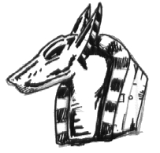

41 BODYGUARD
The Warriors come across a man travelling alone. He is dark of skin, and the thick scimitar by his side tells them he is a fighter. He talks with a heavy accent, of what origin the Warriors are unsure. He explains to them that he is an out of work bodyguard who is in desperate need of employment. He says that he will stand by any one Warrior who pays him (400 x Warrior’s Battle Level) Gold an adventure. He goes on to say that any money or Gold that he gets from the adventure would go his employer, and that he would be happy with his payment. If no one wants him he heads off into the dunes alone.

If any Warrior accepts his offer the bodyguard will always (if he can) stand by the Warrior. His statistics are as follows.

Name | <Name Table>
Wounds | 30
Move | 4
Weapon Skill | 6
Ballistic Skill | 3+
Strength | 4
Toughness | 5 (9)
Armour | 4
Initiative | 5
Attacks | 2
Damage | 2D6
Willpower | 5
Luck | 1
Pinning | 3+

Equipment 1D6 Provisions
1D6 Water Skins
1D6 Bandages
Weapon Scimitar , causing 1D6+3 Wounds. Monsters are at -1 to hit the bodyguard while he is wielding the Scimitar.
Armour Heavy Armour (+3 T, -1 M)
Open Helmet (+1 T)

The bodyguard’s employer controls him. He is, in all other respects, classed as a Warrior (eg. add counter for him, subject to missile fire, represented by miniature on the board, etc.) The bodyguard counts as being an extra Warrior when calculating the amount of Monsters in a battle. When placing Monsters place them as you normally would with Monsters being assigned to the bodyguard as well.

If the bodyguard cannot be paid one adventure, he will give the Warrior another adventure to make it up to him, although now the Warrior will owe him double. If he is still not paid he leaves the group.

In the Settlement the bodyguard will go and buy Provisions, Water Skins and Bandages. Then he will wait around in the Settlement, and leave with his employer. Roll for Settlement Events for him just like the other Warriors.

42 LIGHT IN THE DARK
The Warriors are travelling through the night when they see a light from a fire in the distance. As they draw near they see that there are humanoid figures dancing around the fire and that they are cooking some sort of meat on a spit. The Warriors are hungry from their trek and hope that the strangers won’t mind parting with some food. Roll 1D6:

1-3 When the Warriors get close enough they see that the figures dancing around the fire are Anubis Warriors, and the meat they are cooking is human! As the Warriors start to think about what they are going to do, it is already too late as they are downwind of the Anubis and they have smelt them. Fight a battle with 2D6 Anubis Warriors. Work out the treasure as normal.

4-6 The strangers are indeed friendly and welcome the Warriors into the camp. They all eat well and each Warrior regains 1D6 Wounds. The Warriors also enjoy a full nights sleep, with one of the others on watch.

43 OASIS
The Warriors are glad to see the markings of an oasis in the distance, but when they draw closer to it they see shines from what looks like metal armour. When they draw closer still they see a group of 2D6 Skeletons, the sun shining off their shields and helmets. They remain motionless, perhaps left to guard the oasis from the living who require water. The Warriors have not been seen and could skirt the oasis, but perhaps using the oasis would outweigh the battle to claim it. If they decide to claim the oasis for themselves fight a battle with the Skeletons and one Skeleton Champion. Once they have been slain the Warriors can rest and each regain 4D6 Wounds.

44 UNEVENTFUL WEEK

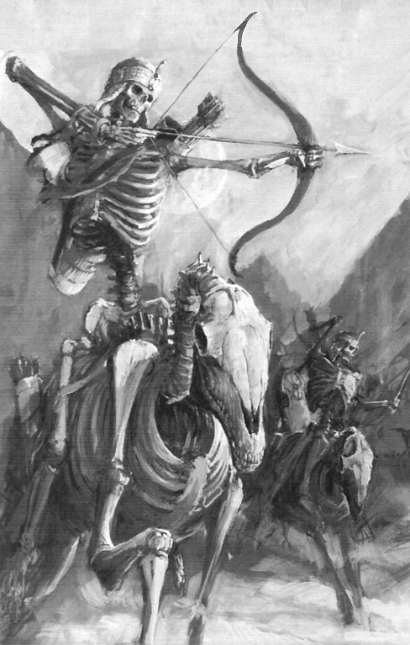
45 SAND WORMS
The Warriors are trudging through the wasteland when the ground gives way under a random Warrior. That Warrior must roll 2D6. If the total is under his Initiative then he has leaped clear of the sinking ground, and this is where the event ends. Otherwise the beak of a great worm bursts forth from the sinking sand and engulfs the Warrior’s legs in its mouth. He is lifted high in the air by the worm, where the other Warriors get a chance to hack at it. The remaining Warriors can use all their normal attacks or magic (make a power roll), on the worm, who has Weapon Skill 3, Toughness 4. The Warriors must take the beast down by 12 Wounds in one turn other wise the worm pulls the Warrior it is holding deep into the ground where he is never seen again.

If they manage to damage the worm enough it releases the Warrior in pain and returns into the ground. The Warrior, though still alive, has had his legs badly damaged. Take 3D6 Wounds.

After the next Hazard roll (in this adventure) roll 1D6. On a 1-2 the worm has followed the adventurers. Repeat this event and continue this process. If it is impossible for the worm to follow them then it gives up.

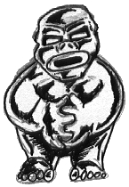
46 THE BLACK ROSE
The Warriors notice a single black rose sticking out of the sand. They are very surprised at this, considering this is a barren wasteland. One of the Warriors thinks he has heard that the petals of the rose have magical properties when eaten. There are just enough petals for each of the Warriors, and for every Warrior that eats one roll 1D6:

1 The petal does not effect the Warrior unless he is a Vampire. If he is a Vampire then he finds that the petal has instantly cured his vampirism! He is now reduced to a fighter of the same battle level. He loses all his vampire attributes. If the Warrior ever becomes a Vampire again, (through an event) then his powers as a Vampire are completely restored, including gained abilities.

2 The petal is tasteless until swallowed, when it begins to burn the Warriors insides. He takes 1D6 unmodified damage.

3 The petal heals the Warrior 1D6 Wounds.

4 The petal heals the Warrior 2D6 Wounds.

5 The petal fizzes in the mouth of the Warrior. It gives him +1 Strength for the remainder of the adventure.

6 After swallowing the petal the Warrior feels stronger than ever. He gains +1 Starting Wound, permanently.

47 DARK RIDERS
The Warriors are travelling at dusk when they see dark shadows circling above them. Soon they fly low enough to be seen. They look like Undead travelling on Undead steeds! They ride just above them, just out of reach, galloping through the air and they chant a mournful song. By the end of the week they fly off in a different direction. The whole experience is very disheartening, resulting in all of the Warriors losing 1 Luck for the remainder of the adventure.
48 CARRIER PIGEON
While the Warriors are pondering their next move a very worn out bird flies into view. It flies directly into the arms of one random Warrior, who pulls a note from its leg. The note reads (Roll 1D6):

1 The note is damaged and unreadable.

2-6 The note is a challenge to that Warrior to a duel to the death from an old foe. At the next Settlement he can take him up on his offer (when it suits him) and battle him. Continue this event at the Settlement. Roll 1D6 to see where the battle is held. Then refer to the appropriate section.

1 Slave Mud Pits
2-3 Deserted Alleyway
4 Home of a Friend
5-6 Arena

Slave Mud Pits
The Warrior unhappily trudges into the mud to face his foe. A crowd of slaves part so the battle can take place. Roll 1D6:

1 In the mud the Warrior is sluggish and he takes many hits from his foe. Take 3D6 Wounds. Roll again with a -1 modifier.

2 The foe seems quicker in the mud than the Warrior and he is smashed for 2D6 Wounds. Roll again.

3 The sound of metal against metal sounds out around the mud pit as the two seasoned Warriors block and attack. Roll again.

4 For a moment the Warrior seems to have the upper hand and manages to hit his foe in the face with the hilt of his weapon. This stuns him momentarily. Roll again with a +1 modifier.
5 The Warrior slashes his foe across the gut causing him a serious wound. He doubles over clutching at the gaping slash. There is now only to finish him. Roll again on this table with a +2 modifier, this remains as a permanent modifier.

6 The Warrior sees that he is wide open for a strong attack and cleaves off his foe’s head, which falls and sinks into the mud. The Warrior sees it as a fitting grave and leaves the mud pit.

Deserted Alleyway
The Warrior enters the sandy alleyway to see his foe at the other side. Both know the penalties for fighting in the City but both are willing to risk the consequences. Roll 1D6:

1 The Warrior trips over a scurrying rat and is dealt a hefty blow to his side causing him 3D6 Wounds. Roll again on this table with a -1 modifier.

2 The loud commotion of the battle arouses the Pharaoh’s Guards, who promptly arrive and throw them in the Palace Dungeon for fighting in the city (5 days).

3 The battle rages with neither side giving in to the other. Roll again.

4 The Warrior’s foe slips on a piece of rubble causing him to bend over. The Warrior seizes his chance and kicks him in the face, littering the ground with teeth. Roll again on this table with a +1 modifier.

5 The Warrior leaps onto a nearby crate when his foe swipes at his legs. He manages to somersault over the slash landing behind his foe where he stabs him between the ribs. The punctured opponent slowly turns around somewhat in a daze, ready for the death blow. Roll again on this table with a +2 modifier, this remains as a permanent modifier.

6 Seeing his chance the Warrior slashes at his opponent’s throat making a deep cut. He drops to his knees gurgling blood and falls flat on his face, dead. The Warrior finds 2D6 x 50 Gold on the body and then runs off before the authorities can arrive.

Home of a Friend
The Warrior bursts into his friend’s house to see it ransacked, with his friend tied up in the corner. In the centre of the room stands his old foe who launches his attack immediately. Roll 1D6:

1 The Warrior slips on a piece of furniture and leaves himself open to attack, which his foe does not pass up. Take 3D6 Wounds. Roll again on this table with a -2 modifier.

2 The Warrior loses his grip on his weapon and it is knocked from his hand. His foe quickly strikes him while he is trying to retrieve it. Take 2D6 Wounds. Roll again on this table with a -1 modifier.

3 The two combatants fight with all manner of weapons showing a dazzling display of skill. Roll again on this table.

4 The Warrior manages a lucky strike stabbing his foe in the arm. Roll again on this table with a +1 modifier.

5 The Warrior elbows his foe sharply in the face, making him stumble back, dazed. Roll again on this table with a +2 modifier.

6 The Warrior’s foe slips backward on a statue and the Warrior manages to stab him in the chest, piercing his heart. He then unties his friend who offers a house and food for the Warrior to stay while in the city, at no cost of course.

Arena
The Warrior enters the sandy arena and instantly spots his foe standing at the centre. The arena is deserted bar a few onlookers. Roll 1D6:

1 The Warriors foe stabs forcefully but misses. Just when the foe is about to be finished the Warrior is struck in the back of the head by a large rock by a bored onlooker. Dazed, his foe stabs again, this time hitting his mark inflicting 3D6 Wounds. Roll again on this table with a -2 modifier.

2 A strong wind comes up, whipping sand into the Warrior’s face, momentarily blinding him. His foe strikes him on the forehead with the hilt of his weapon, inflicting 2D6 Wounds. Roll again on this table with a -1 modifier.

3 The two combatants stand their ground as they think of the next move to make. Roll again on this table.

4 The Warrior kicks sand in his foe’s face and slashes at him causing a sizeable wound. Roll again on this table with a +1 modifier.

5 One of the bystanders takes a liking to the Warrior and throws a rock at his foe, hitting him in the head and knocking him to the ground. Roll again on this table with a +2 modifier.

6 The Warrior hacks into his foe’s neck, severing a major artery. The last thing the dying man sees is his own blood spraying over the warrior. The bystanders cheer the Warrior’s victory and throw 3D6 x 50 Gold to him.

49 WANDERING MONSTERS
Trudging through the sand, one of the Warriors trips at the top of a dune and falls down the other side, tumbling and rolling. Finally he stops rolling at the base of the dune. Only then he looks up to see he is surrounded by ‘Objective Room Monsters!’ Roll for Objective Room Monsters and place the Warrior in the centre. The other Warriors who wish to join the battle charge down the dune and can be placed at one side of the board section after the Monsters are placed. After the battle is won, take an Objective Room Treasure, and 1D6 Nehekharan Treasures.

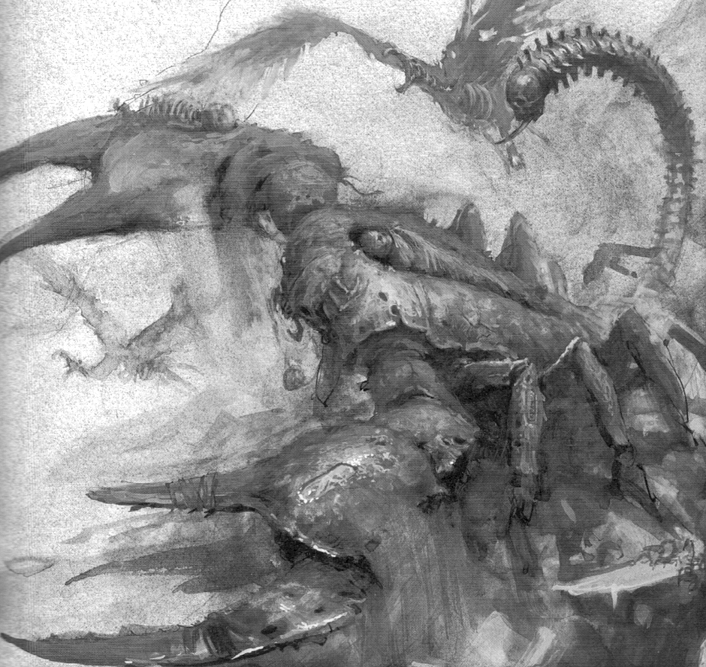
50 NEHEKHARA TRAINERS
The Warriors approach a large marble fortress. They are welcomed in to see a great hall filled with training combatants. They are led to the head trainer that is a well muscled man who explains that this fortress belongs to him and its primary function is to train people so that they can survive the hard conditions of Nehekhara.

There are many different trainers here, including magical, and the Warriors can train to their next level if they wish, for the same cost. Training takes one week so an extra week must be added to travel to represent this. The Warriors also have the opportunity to train for an extra skill or spell from their own character skill or spell lists. Only one skill can be learnt and only if the Warrior is not also training in that stay. Learning an extra skill/spell costs 1000 Gold, and gives them a roll on the appropriate table.

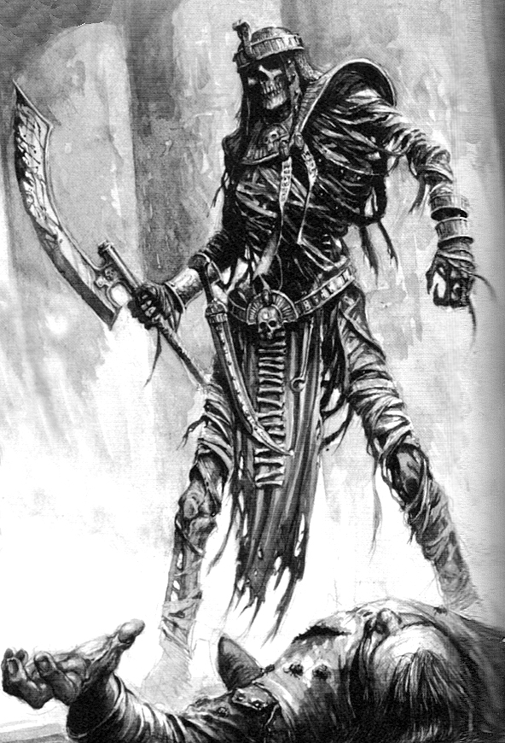

51 HAUNTED HEAD
During the dead of night a loud howling is heard and the Warriors awaken to see the ghost-like apparition of a severed head screaming around the camp site about two metres above the ground. The Warriors are quickly on their feet and are swinging their weapons at the head. They soon discover that their weapons just pass through the head, even magical ones. The head continues to fly around the campsite, occasionally stopping for a look at the Warriors before continuing. They decide it best to pack up camp and move on, but they soon discover that the head is following them. It doesn’t attack them at all, just flies around them screaming. From now on before an event is rolled roll 1D6. On a 1-4 the head remains with the Warriors. On a 5-6 the head screams off into the night never to be seen again. While the head is with the Warriors all events with friendly people cannot be used as they run in terror at the sight of the head, while it laughs at the Warriors’ misfortune.

If the head is still with the Warriors when they enter a Settlement the head will follow a random Warrior around who is thrown out of the Settlement straight away to await his fellow Warriors, his only company being the flying head that howls and taunts him. Roll as normal to see if the head goes away for each week in the Settlement.

If the head follows the Warriors into a Pyramid then it acts as always, scaring off any friendly people or things in the events and therefore making them unable to be used. At the end of every turn the Warriors aren’t involved in combat (the head enjoys a good fight) roll 1D6 - on a 6 the ghostly head flies off down the corridor never to be seen again.

52 FRIENDLY TRAVELLERS
A group of travellers are seen making their way towards the Warriors. Eventually they meet and they are friendly. They claim to have found treasure on some slain men a while back and have no use for it. Draw 1D3 Treasure Cards to see what they are. They tell the Warriors that they will trade each one for 1D6 water skins. Once the trade is completed they continue on their way.

53 BATTLE
The Warriors stop at the edge of a craggy cliff below which is a great sandy valley. It seems they are just in time to see the start of a mighty conflict. On one side, heavily armoured knights on horses are charging, leading groups of soldiers into the battle. On the other side are huge amounts of charging Orguts, moving at an alarming speed considering their size and shape. Soon the two hit each other and the bloodshed begins. It is now that the Warriors must decide whether they wish to enter the fight, or skirt around it adding 2 weeks to travel. If they decide to join the battle they quickly descend the cliff and join it, bringing new hope to the human combatants. Roll 1D6 for each Warrior:

1 The Warrior leaps between a wounded man and an Orgut, not seeing the second Orgut behind him who slams his spiked club into his back. Impaled by the spike he is lifted high into the air, his blood flowing from the deadly wound. The other Orgut chuckles and swings his spiked club directly at the Warrior’s head impaling it with the spike and tearing it from his body with the sheer force of the hit. The Warrior is well and truly dead.

2 Taking on four Orguts at once, the Warrior puts up a brave fight. Unfortunately he slips in the blood stained sand and is clubbed repeatedly by the Orguts who eventually believe that he is dead (Which he well may be) and continue the fight elsewhere. Take 6D6 Wounds.

3 The Warrior dodges, weaves and thrusts, felling many foes, but not without sustaining some damage. Take 3D6 wounds.

4 The Warrior’s weapon is covered in his enemies’ blood, as he hacks, crushes and slashes his way through the enemy ranks.

5 The Warrior leaps headlong into the fray, felling many opponents, greatly increasing the chance of victory. The soldiers see him as a great hero!

6 The Warrior leaps from half way down the cliff onto the back of a huge Orgut and quickly cuts its throat wide open. Leaping off his dead foe he seemingly becomes a whirlwind of death tearing through any defence given. Finally, drenched in the enemies’ blood, he sees one of the leaders of the Orguts army, an Orgut chieftain who is commanding his troops. Seizing his chance he hurls a nearby dagger at him which hits its target directly in the eye, piercing it and his brain. He falls, taking his valuable commands with him. All other Warriors yet to roll on this table receive a +1 modifier.

Once everyone has rolled
The battle is eventually over - roll 1D6. On a 1-3 the Orguts have won, forcing any remaining troops to flee, including the Warriors who must run out of their way, resulting in them adding 2 weeks to travel. On a 4-6 the human armies have won and the Warriors are hailed as heroes. They are offered gifts for their service - roll 1D6. Each Warrior receives what is rolled.

1 200 Gold
2 400 Gold
3 600 Gold and 1 Treasure Card
4 800 Gold and 1 Treasure Card
5 800 Gold and 2 Treasure Cards
6 1 Objective Room Treasure and 1D6x100 gold.

54 CLIFF
The Warriors approach the edge of a very high cliff. There seems to be no quick way around. Add 3 weeks to travel time.

55 UNEVENTFUL WEEK

56 BLACK POOL
The weary Warriors come to a wide pool of a thick black substance. One of the Warriors has heard of pools like this and knows that they hold magical properties. If any Warrior wishes to wade into the pool roll 1D6:

1 The Warrior cautiously wades into the black muck, which smells more like effluent than anything else. The pool seems to drain the Warrior’s stamina. For the next adventure he is at -1 Toughness.

2 The sticky black goo is oddly warm and the Warrior really doesn’t enjoy his stay in it. When he gets out he just stands there like a black dripping mudman.

3-4 The black substance glows with a yellow aura when the Warrior enters. He feels rejuvenated and adds 2D6 Wounds.

5 The black substance swirls around the Warrior, as if analysing him. Then he feels oddly stronger. The Warriors lowest attribute (not including Damage Dice) is boosted by 1 for the next adventure.

6 The dark liquid engulfs the Warrior as he enters the pool. He feels strengthened, and gains +1 Strength for the next adventure.

57 SARCOPHAGUS
The sun shows the Warriors little mercy as they trudge through the wasteland. Soon they reach a half buried Sarcophagus made from thick Gold. Littered around the casing are four skeletons. Were they killed from lack of water, or was it from whatever was, or is, in the sarcophagus? If the Warriors wish to, they can lift the lid off. It prises off with little effort to reveal a mummified man laden with jewels and a traditional Nehekharan headpiece. They wait for a moment, unsure of whether it is one of the Undead or not. Roll 1D6:

1 The Mummy is indeed one of the Undead and gets to its feet. Unfortunately for the Warriors it is a Tomb King and he is unimpressed with being disturbed. Fight a battle with one Tomb King.

2 The Mummy is indeed one of the Undead and gets to its feet. It is a Liche Priest and attacks the Warriors. Fight a battle with the Liche Priest.

3 The Mummy is indeed one of the Undead and gets to its feet. It is a Mummy Hero. Fight a battle with one Tomb Prince.

4 The Mummy is just a corpse. The sarcophagus holds 1D6 x 100 Gold.

5 The Mummy is just a corpse. The sarcophagus holds 1 Treasure Card.

6 The Mummy is just a corpse. The sarcophagus holds 1D3 Treasure Cards.

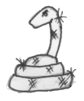
58 WELL
The Warriors see a well in the distance. First they think that it is a mirage but it does not disappear as they grow near and it is a well. After dropping a rock down it they discover that it (roll 1D6):

1-2 is dry, so they move on.

3-6 has water in it. The Warriors gain 1D6 water skins before all they pull up is sand.

59 CITY
The city that the Warriors are headed for is closer than they first thought. It looms above them from the sand, and is one of the most welcome sights they have ever seen. The Warriors are at the Pharaoh’s City they were travelling to.

60 MYSTERIOUS TOWER
In the distance the Warriors can see a tall black tower. It has a dark appearance, but any sign of life in the Nehekharan desert is a welcome sight. As they approach roll 1D6:

1 A bolt of lightning shoots from a window of the tower, straight at a random Warrior who takes 2D6 Wounds modified only for armour. Obviously the owner doesn’t wish to be disturbed. The Warriors decide it best to skirt the tower and continue on.

2-3 A random Warrior suddenly feels strange and transforms into a Battle Level 1 Monster (Roll on the Monster Table) for 1D3 weeks, or until a Settlement is reached.

4-6 A group of reptilian creatures that are not recognised as usual Lizardmen come out and greet the Warriors. They claim that the owner of the tower wishes to meet them. If the Warriors accept the offer they are escorted into the castle where they are refreshed and given a chance to relax, allowing them to regain 2D6 Wounds. That night they are welcomed to a banquet by the owner of the tower who seems to be one of the few humans in the whole place. While they are all dining on fresh meats and drinking foreign wines, they are entertained by a strange game where there are three boulders varying in size, which are moved certain distances to determine the winner. A burly lizard creature moves the middle sized boulder a fair distance, but then a large muscled human barbarian picks up the largest boulder with seemingly little difficulty and moves it even further and remarks “Now you move my rock back.” While the Warriors are enjoying the entertainment, the owner of the tower states that he is a wizard and has been living in Nehekhara for many years. He also claims that he has been experimenting with a new type of magic on willing subjects. He points out his recent subjects around the room who all appear to be mighty Warriors and willing participants, all apart from the burly barbarian moving rocks around who seems to want no part of it. The experiments with this new magic can gift the subject with strange new powers, heightening their senses and making them stronger, but in some cases it has lead to a painful death. He offers this honour to the Warriors as he is always looking for strong subjects, because only the strongest survive. Any Warrior can take the mage up on his offer, if they trust him, and remain for the treatment. It takes 4 weeks for the treatment and to symbolise this 4 weeks must be added to travel time. Any Warrior is welcomed to stay at the tower free of charge until their companions have finished treatment.

Leaving
Whether the Warriors decide not to accept the offer or have gone through it and are leaving they are each given 1D6 water skins and 1D3 provisions.

Undergoing Treatment
Any Warrior undergoing treatment is taken to the lower dungeon under the tower and shackled to the wall, being convinced it is for his own safety. Then for a gruelling 4 weeks he is cut, injected, subjected to strange magic and driven to such pain that he is almost driven mad. Finally he is released - roll 1D6 to see how he has been changed: All results are permanent.

1 The Warrior stumbles and falls to the ground, the treatment being too much for him. Soon after he dies frothing at the mouth and bleeding from his ears. He is dead.

2 The treatment has no effect and it seems that all that pain was for nothing.

3 After the treatment the Warrior finds that he is now very resistant to magic and now has Magic Resistance 6+. If the Warrior ever has this treatment again and rolls this, add +1 to the Magic Resistance number. ie 5+, 4+ etc.)

4 After the treatment the Warrior finds that the colour of his blood has turned black and has become a potent acid. From now on any creature that inflicts 4 or more Wounds on the Warrior must roll 1D6. On a 6 the monster has been splashed with the Warriors acidic blood causing 1D6 unmodified wounds. If a Vampire ever “bites” the Warrior it immediately takes 2D6 unmodified Wounds.

5 The Warrior has been affected by the treatment in a very strange way. He sees that he now has very impressive leathery wings, protruding from each shoulder blade. The Warrior now has the fly ability. In addition the Warrior need not, but can if he wishes, take a sailing ship when travelling across the ocean for he can fly, occasionally resting on small islands. In the Settlement the Warrior wears a cloak which covers his wings, and onlookers think of him as just a hunchback. If he ever is found out in the Settlement then he is immediately thrown out.

6 When the Warrior comes out of treatment he finds he is seriously changed. It seems the Warrior is now affected by a rage and anger. Whenever a battle starts roll 1D6. On a 5-6 he undergoes an amazing change which lasts until all Monsters on the board are killed. The Warrior yells out in rage as his body grows and grows become huge and muscled. Soon any straps holding armour are snapped and fall off as he continues to grow. Finally he stops growing as a huge muscled giant that has become a strange colour of (roll 1D6):

1 Yellow
2 Orange
3 Red
4 Blue
5 Purple
6 Green

While in this state the Warrior takes up four squares (move models accordingly to fit him in). His usual weapons are now so small to his great hands that they are useless, so he just uses his bare hands to tear the enemy apart. Unfortunately while in this state the Warrior is blinded by rage and has little intelligence, finding it hard to remember even who his fellow Warriors are, and on occasions will even attack them. As this hulking creature the Warrior has a Toughness of 10 and a Strength of 8. The giant beast that the Warrior has become does not attack as usual - instead of attacking roll twice on the following table.

Giant Warrior Attack Table

1 Befuddlement
The giant looks around the battle and seems confused for a moment, unsure of who to attack. He loses this attack in his befuddlement and gets a -1 modifier to the next roll on this table (as long as it’s in the same battle).

2 Head Slam
The huge giant grabs a random model that is adjacent to him, which may well be a Warrior. He then slams the grabbed victim into the roof. Roll 4D6 - any dice that come up with 4-6 inflict that much damage. He then drops the victim down, in search of another.

3 Throw
The giant Warrior picks up a random enemy up to 2 squares away with one mighty hand and hurls him 2D6 squares in a random direction. If the victim hits a wall he is inflicted with 2D6+5 unmodified Wounds. The Monster then falls in that square or nearest adjacent square.
4 Mighty Clap
The Warrior slams his mighty hands together and makes a deafening clap that affects all models of 5 Strength or less up to 4 squares away in front of him and blows them 1D3 squares back. All those affected must also roll 1D6. If a 1-2 is rolled then that Monster/Warrior also loses an attack this turn.

5 Earthquake Stamp
The giant Warrior lifts his muscled leg up and smashes it back down again onto the floor of the dungeon causing the whole place to shake. Roll 1D6 for how many slabs of rock or stone fall from the roof. Randomly determine which squares they fall in, within the same board section as the Warrior. Each slab takes up 1 square. If any model is under one of these falling slabs they take 3D6 Wounds. If this attack is executed outside roll again.

6 Deadly Attack
The giant Warrior lifts his hands up together making fists and slams them down directly on whoever he wishes to attack (adjacent Monsters only). The victim of this attack takes 5D6 Wounds.

After the Battle
After the battle, or in fact whenever the Warrior calms down and returns to his original state, the metamorphosis takes a terrible toll on his body - roll 1D6:
1 Lose 1 Starting Wound, permanently
2 Lose 10 unmod Wounds
3 Lose 8 unmod Wounds
4 Lose 6 unmod Wounds
5 Lose 4 unmod Wounds
6 Lose 2 unmod Wounds

In the Settlement
In the Settlement if the Warrior is ever attacked or angered he must roll 1D6. On a 5-6 he turns into the beast and destroys half the city before leaving the city where he must wait for the others.

At Sea
If the Warrior is attacked or angered at sea he must roll 1D6. On a 5-6 he turns into the beast, deals with the problem (fights the enemy) then does a mighty leap that sends him flying off the ship in the way of their destination. He eventually makes it to the shore where he returns to normal and meets the other Warriors at the Settlement when they arrive.

Restoring the Warrior to normal
The best place the treatment can be reversed is at the mysterious tower and it must be found again in Nehekhara (with a rolling result of 4-6). It is harder to reverse the procedure and costs 2500 Gold (for the cost of the rare herbs and so on). The affliction can also be healed at a Settlement, but only in a City and only by the finest wizards, for 6000 Gold. The treatment cannot be reversed in the same event. Only after the time of one adventure can this be achieved.

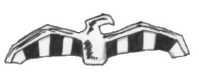

61 CURIOUS STONES
The Warriors come to a circle of curious stones. They are about 2 metres in height and have a hole hollowed out in the centre of them large enough for a person to fit in. Another stone stands about waist height in the centre of the stones with a number of odd shaped rocks stuck on it. If the Warriors try to figure out this madness roll 1D6. On a 1-3 they have no idea what it is about and continue on their journey. On a 4-6 they push and pull the stones causing an interesting phenomenon to occur. Across the entrance of each hole in the stones appears to be a sheet of rippling water that seems very strange to the Warriors. If they decide to step into the vertical water roll 1D6:

1-2 The Warriors step out into another circle of rocks, only they recognise the place as The Old World. They now can either step through the portal they came through to return to Nehekhara or head towards the nearest Settlement as normal in the Old World.

3-4 The Warriors step out into another circle of rocks, only they recognise the place as Norsca. They now can either step through the portal they came through to return to Nehekhara or head towards the nearest Settlement as normal in Norsca.

5-6 The Warriors step out into another circle of rocks, only they recognise the place as the Lost Kingdoms. They now can either step through the portal they came through to return to Nehekhara or head towards the nearest Settlement as normal in the Lost Kingdoms.

62 VAMPIRE HUNTER
A crude stone hut comes into view. The Warriors draw closer to see crosses painted liberally on its walls in what looks like blood. Upon entering, they see a man in his late 50’s clutching a stake in one hand and a small metal cross in the other. When he sees who it is he breathes a sigh of relief. He soon explains to the Warriors that until a few years ago he hunted vampires across the Old World, but now he is retired and decided to move to Nehekhara, knowing how much vampires hate intense sunlight. Because they are so rare here he says he feels almost safe. After a short discussion he gives the Warriors a special vial of liquid each that, when smeared on an edged weapon inflicts an extra damage dice on Vampires. It can only be used once and lasts for an entire combat.

63 UNLIKELY HERO
An amateur gas trap in the sand sends the Warriors to the ground unconscious. They awake to find themselves in a dungeon of some sort, strapped to a huge spiked sphere that is hanging from a chain in the roof which is connected to a hook. The chain then goes down on an angle to a huge contraption. Under the sphere is a large round well from which pours gaseous odours.

Standing on the ground near the edge of the well, laughing at the Warriors predicament is a Necromancer. He starts boasting about how good he is and how easily he managed to capture such well known Warriors, as he flicks a switch on the contraption holding the chain. Slowly the chain moves and the sphere with the Warriors on it slowly descends into the well.

There seems to be no other sign of life in the large room when suddenly a Snotling runs from the shadows directly behind the wizard, and leaps at him slamming into his back. This attack, out of nowhere, surprises the Necromancer and he loses his balance, falling over the edge of the well, screaming to his doom into the well’s liquid. The Warriors can now clearly see the liquid as being acid as the Necromancer’s face melts back to his skull and sinks beneath the surface.

With the chain still moving down, the Warriors only have 2D6 + 2 turns before they are engulfed by the acid and are melted to death. And all they have to help them is a small Snotling who looks up at the Warriors with a puzzled look as if awaiting instruction.

The Warriors now have 2 choices - they can either motion to the Snotling to try and get to them and cut them free, or try to get him to work the machine in such a way to make them stop their decent.

Get the Snotling to work the Machine
The Warriors frantically motion to the Snotling to try and stop the machine. He looks at them for a moment and then runs off toward the machine and starts messing around with the controls. After 1D6 turns he manages to achieve something. Roll 1D6:

1 The Snotling has made a critical error, sending the sphere plummeting downwards into the acid where the Warriors thrash around only for a moment before they are melted to the bone.

2 The Snotling does something wrong, causing spikes behind two random Warriors to shoot out, inflicting 2D6 Wounds. Slapping his head, the Snotling tries desperately to make the machine work, which takes another 1D3 turns. Roll again on this table with a +1 modifier.

3-4 Just when he thinks something is going to happen it doesn’t, so instead the Snotling pulls out a small club and starts smashing at the machine, sending cogs and bolts flying out everywhere. Roll again on this table with a -1 modifier (this modifier is not cumulative).

5-6 The Snotling manages to work out the controls and the great sphere stops. Within seconds the Snotling leaps up the chain and down to the Warriors where he nimbly undoes the shackles holding them in place. They then all manage to climb up the chain and slide down it again to the other side. Now looked under the “saved” heading to see what happens next.

Get the Snotling to cut them free
The Snotling nimbly scales the chain to the roof and slides down it to the sphere where the Warriors are shackled which takes 1D3 turns. He then begins to try and get the Warriors out of the shackles. It takes him 1D2 turns to break out each Warrior so they can leap to safety (they cannot help the Snotling with the other Warriors because the sphere is impossible for them to climb on, but the nimble Snotling can navigate it easily. If any of the freed Warriors can fly then they can help the other Warriors in the same way as the Snotling is). The Warriors are released in a random order.

Saved
Once all of the Warriors are saved, the Snotling explains to the Warriors, in crude Common, that he was kidnapped from the Old World to be the Necromancer’s servant where he was going to be made into a Snotling Mummy! He begs the Warriors to take him with them to the next Settlement where he can sneak into a cart and get to a dock and stow away to the Old World. The Warriors can hardly refuse considering he saved their lives and so they accept (If they really don’t want to they can slay him and move on). He has the stats of a normal Snotling and will stay out of events where he can, but will fight in a battle. He then leads the Warriors to a secret treasure room in the Pyramid, where there are 3 Treasure Cards and 1D6 x 100 Gold before leading them out of the Pyramid.

64 PATHWAY
The Warriors come to a stone pathway heading in the same direction as they are travelling. They welcome something hard beneath their feet. Subtract -1 week from travel.

65 DISPUTE
A petty dispute breaks out between 2 random Warriors, about who is the best fighter and the most important team member. Finally one of them (randomly choose who) gets so fed up with it he walks off in his own direction, saying that he will meet them at the City. From now on roll separately for his Hazards after the other Warriors. The first group to reach the Settlement waits for the other to meet them there before they go in.

66 UNEVENTFUL WEEK

67 FALLEN EMPIRE
The sight of a Pharaoh’s City in the distance fills the Warriors with hope, only when they draw near they see it is in ruins and seemingly deserted. If they wish to investigate the ruins roll 1D6:

1 While they are searching, one of the Warriors moves away from the group to explore on his own. He comes to the stairs leading to a once great palace. While he is scaling them he is attacked by Monsters. (Roll on the appropriate Monster Table), who had been using the ruins for shelter from the elements. The Warrior must battle the full amount of Monsters (do not alter for the amount of Warriors) for 1D2 turns before the rest of the Warriors reach him to help. Once they get there they run in from a random side of the battle. The Warrior is unable to flee from the battle until the others arrive, unless he is the only Warrior in this event.
2 The Warriors are soon to discover that the ruins are not completely deserted for there are huddled peasants in the streets. One of the Warriors goes to a group of these peasants to ask what has happened. He looks down to see that their skin is covered in blotchy black marks. They have Ram-Tuts black plague the Warrior realises. (Ram-Tut, an evil dictator, hated grave robbers and filled his tomb with a deadly plague. The plague, released by grave robbers spread across Nehekhara with the dealings of Ram-tut’s stolen treasures.) No wonder the City has been deserted he thinks as he recoils back, covering his mouth. The Warriors leave quickly and hope they have not contracted the plague. Roll 1D6 for all of the Warriors:

1-3 They have contracted Ram-Tut's plague. Only the strong survive the plague and the following roll must be made for each Warrior. For every 5 Wounds that make up his Starting Wounds roll 1D6. If the resulting number is more than the Warriors Starting Wounds the Warrior has died a miserable death. If the number rolled is equal to or less than the Warriors Starting Wounds, then they were strong enough to survive the plague and continue on.

4-6 The Warriors have managed to escape the death filled city without contracting its deadly black plague.

3 The Warriors search the ruins thoroughly but only find a tired old Dwarf Prospector. If they have met the Dwarf Prospector in the past he runs off screaming and cursing at the Warriors, firstly into a brick wall, then secondly out into the sand dunes. If they haven’t met the Dwarf Prospector before he explains to the Warriors that he’s just passing through and is searching for rare jewels, without much luck he adds. He also gives the Warriors a key to the portcullis. The Warriors leave him to his work.

4 Wind howls through holes in the walls throughout the ruins as the Warriors undergo their search. Before long they find that the place is completely deserted and completely devoid of any valuables.

5 The ruins look like they haven’t been lived in for years but after a hard search the Warriors find 1D6 x 20 Gold each.

6 When the Warriors enter the City, it is obvious that a battle raged there not many days past. Corpses litter the ground of both human and Orgut. After searching through the rotting corpses they find 1 Treasure Card each.

68 ORGUT ATTACK
The weary Warriors are walking through a shallow valley between two small cliffs when they are ambushed by a group of Orguts. There are 1D3 Orguts who have Ambush A. Fight a battle.

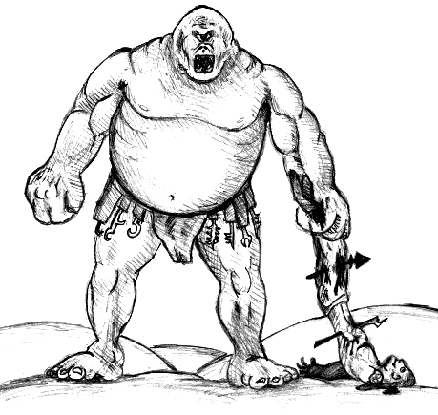
69 UNWELCOME GUESTS
A random Warrior is casually looking through his belongings when he discovers that 1D3 of his provisions have big fat maggots in them. He tosses the provisions aside cursing his luck.

70 TRADER
A trader crosses the Warriors path. He claims that he only trades water, and yet there seems to be no water in his possession. Discarding him as a misguided fool the Warriors push past him. This is when he stops them and shows them a single water skin. He then tips it and the water flows out but the water never stops coming out until the man tips it back the right way. Grinning at the Warriors he tells them that it is a magical water skin, and he will fill up one water skin per 500 Gold for the Warriors. They may buy as many water skins as they wish from the trader. At such a ridiculous price they consider taking the magic water skin by force but decide against it unsure of what other magical items he may have hidden away.

71 GIANT SCARAB BEETLE
The Warriors are honoured to see a strange procession. A giant scarab beetle wanders by in front of them. Then 10 seconds later a group of Nehekharan worshipers hurry quickly behind it, chanting loudly. Shaking their heads at this the Warriors continue on.

72 SAND CYCLONE
The familiar funnel of a cyclone is seen on the horizon. Roll 1D6:

1-3 The cyclone heads straight for the Warriors, engulfing them with sand moving so fast that it cuts into their flesh. The force of the cyclone also flings them into the air like rag dolls. Finally it moves on but not before inflicting 2D6 Wounds on each Warrior modified only for armour.

4-6 The cyclone heads off in a different direction and the Warriors are spared its wrath.

73 KNOCK TO THE HEAD
The Warriors are passing a small peasant group when a random Warrior is hit in the back of the head with a large rock and falls unconscious. It was thrown by a mischievous young lad in the peasant group. Roll 1D6:

1 When the Warrior comes to, he doesn’t remember how to perform 3 of his skills/spells for the remainder of this adventure and the next one. Determine these skills/spells randomly.

2 When the Warrior comes to he doesn’t remember how to perform 2 of his skills/spells for the remainder of this adventure and the next one. Determine these skills/spells randomly.

3 When the Warrior comes to he doesn’t remember how to perform 1 of his skills/spells for the remainder of this adventure and the next one. Determine these skills/spells randomly.

4 When the Warrior comes to he doesn’t remember his own name for the remainder of the adventure and the next adventure.

5-6 When the Warrior comes to he has a sore head but has no serious injury.

74 TIRED WARRIOR
A random Warrior who is on watch duty while the others get some sleep is very tired after the day’s travel and falls into a deep slumber. Roll 1D6 to see what happens:

1 Nehekharan thieves sneak into the camp and make off with 1 random treasure item from each Warrior and 1D3 Nehekharan Treasures.

2 A group of Monsters attack the Warriors, gaining Ambush, A because the Warriors are asleep. Roll on the appropriate Monster Table.

3 A weary adventurer happens across the slumbering party. Seeing there are some leftovers of food from the Warriors dinner, he helps himself and decides to take some with him as well. Each Warrior loses 1D3 provisions and 1D3 water skins.

4 A howling wind awakens the Warrior and he returns to duty, at least until he falls asleep again. Roll again on this table with a +1 modifier.

5-6 The sleeping Warrior on duty is awakened by a slap on his back. Startled he turns to see a fellow Warrior who says he will take over the watch duty.

75 THE FIVE DOCTORS
The Warriors come across a group of mumbling old men riding camels. They dismount and tell them that they are all doctors of fine medicine, between squabbling over who is the best. If any of the Warriors are wounded, they can attempt to be healed by the doctors, by rolling 1D6 on the next table and by paying them 250 Gold, in advance.

1 The five doctors are so busy arguing and fussing over who knows more about what, that they completely forget about what they are doing. Unfortunately for the Warrior they smear the wrong medicine on his wounds, using poisonous frogs eggs instead of healing paste. He feels slightly better but next week he loses 1 Starting Wound permanently due to the poison.

2 The five doctors chuckle loudly at the Warrior’s wounds saying that they are but nicks and scratches! They add some medicine to his wounds, unfortunately it’s the wrong type and he loses 1D6 unmodified Wounds. When the Warrior accuses them of trying to kill him they all point to each other insisting that it was another doctors fault. Shaking his head at their stupidity he decides to forget it.

3 The five doctors stand around the Warrior looking at his wounds, frowning and saying that nothing can be done. All five of them shrug saying they don’t know what to do and give the Warrior back his Gold.

4 The bumbling doctors poke around at the Warriors wounds making him wince in pain. They administer some medicine, although most of them disagree on its choice. It heals the Warrior for 2D6 Wounds.

5 The group of doctors start to stich up the Warrior’s Wounds, all the while mumbling and grumbling at each others methods. By the end of it they actually do a good job. The Warrior gains 3D6 Wounds.

6 The five doctors decide to give the Warrior a full examination, making him stick out his tongue and hitting his knee repeatedly with a small hammer, which abruptly stops when the Warrior takes the hammer and smashes the doctor on head with it. One of the doctors then asks the Warrior to bend over while putting on a glove on his right hand. He is about to proceed when the Warrior points out that the doctor actually has a spiked gauntlet on. Blushing from embarrassment he says “Oh silly me,” as he pulls it off. Once the five buffoons have finished fussing over him he has been healed 4D6 Wounds. Crazy as they may be, those doctors sure know their stuff!
76 PYRAMID’S CURSE
A random Warrior was the first to enter a room that was cursed in the last Pyramid, and a curse was put on him. Roll 1D6 to see what it does to him:

1 The Warrior has a deadly curse placed on him causing him to age rapidly. He must reach a Settlement in 2D6 weeks to have the spell lifted for 2D6 x 100 Gold, or he dies of old age.

2 The curse is bound with powerful magic making the Warrior feel very heavy. He is at -1 Move, until the spell can be lifted for 700 Gold at a Settlement.

3 The curse has made the Warrior hallucinate, seeing demons and undead everywhere. When in battle roll 1D6 at the start of the turn. If a 1 is rolled the Warrior madly swings his weapon through imaginary enemies that only he can see and can do nothing else that turn. This curse can be lifted at a Settlement for 600 Gold.

4 The curse of weakness has been placed on the Warrior. Roll 1D6:

1 Lose 1 permanent Strength.

2 Lose 1 permanent Toughness.

3 Lose 1 Strength for the next adventure and the remainder of this adventure.

4 Lose 1 Toughness for the next adventure and the remainder of this adventure.

5-6 The Warrior manages to remain unharmed from the curse.

5 The curse makes the Warrior ill. He spends the week coughing and clutching his twisting stomach. The Warrior loses 1D6 unmodified Wounds per week until the curse can be healed at a Settlement for 600 Gold.

6 The curse seems to do nothing at all. The Warrior’s strength must have overcome the curses power.

77 UNEVENTFUL WEEK

78 ROTTEN BANDAGES
A random Warrior checks his bandaged wounds. If the Warrior has used no bandages this adventure then treat this as an uneventful week. Otherwise roll 1D6:

1-3 The Warrior sees he has placed rotten bandages on his wounds and they have become infected. The Warrior loses 1 Starting Wound, permanently.

4-6 His bandages are all in place and nothing is wrong.

79 RUNES
The Warriors enter a sacred building. It is of obvious Dwarf design, although it seems to be deserted. Things are strewn about as is if it was left in a hurry. After a thorough search the Warriors find that left behind is a magic rune rock. The Warriors know well of their purpose (press to a weapon to burn on rune and enhance weapon capabilities). Any Warrior may use the rune rock by burning it permanently on a weapon. To determine the effect of the rune rock, roll on the Dwarf Runesmith Table.

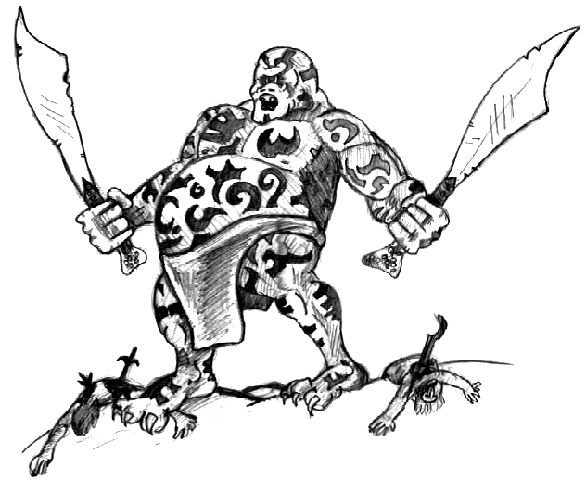

79 PILLARS OF TAHO-TEPRA
In the distance is the ominous sight of the giant pillars of Taho-Teptra. Each one is crafted into a giant arm with a fist at the top which almost touches the clouds. The pillars go on and on marking Taho-Teptra’s territory. All know of his warning, saying that all who enter his land will be attacked and made to join his legion of the dead as one of the undead. The Warriors can either pass through his land, taking 1D6 + 2 weeks, or make a huge detour of an extra 8 weeks.

For every week spent in Taho-Teptras territory roll on the table below after rolling for a normal event. Any event concerning friendly travellers must be rolled again; only mad people pass through this land.

1 The Warriors are set upon by what seems like Taho-Teptra’s entire army of Undead. They have no choice but to flee. Roll 1D6 for each Warrior. If any Warrior rolls a 1 he is unable to escape and dies bravely, drawing the majority of the army away from the other escaping Warriors. On any other number the Warrior manages to escape the army, either by hiding throughout cliffs or managing to get far enough away to outrun them.

2-3 The Warriors are set upon by a group of Taho-Teptra’s Mummies. Roll 4D6 for the amount of Mummies. Then roll 1D6 for each Warrior and add the scores together. Subtract the Warriors’ total from the Mummies total. The remainder is the amount of 1D3 Wounds that each Warrior receives in the battle, unmodified, before vanquishing the Mummies.

4 The Warriors’ minds are affected by the dark magic of the land, making them become lost. Add 2 weeks to travel time.

5-6 The Warriors pass through the land without incident.

81 YOGA MASTER
The Warriors see a spec on the horizon. As they draw near they see a strange sight. Hovering cross legged 1 metre off the ground is a skinny, sinuous man with dark skin. He is bald with two red lines painted on his head and thick golden arm bracelets. He mumbles a strange chant almost as in some sort of meditation. As the Warriors approach, the man, he extends his legs and stands on the ground greeting them openly. He claims that he is a master of Yoga, the technique of focusing the mind and the body into one. He then goes on to say that the art form is dying out and he has been unsuccessful in acquiring new pupils. He asks the Warriors if they will accompany him back to his village to train with him. Of course, a man must feed his family so he also humbly asks for 1000 Gold from each Warrior. If the Warriors accept his offer they follow him to a very small village. They are welcomed by its inhabitants and no sooner do they arrived than the training begins. They train for two weeks (they are fed by the Yoga Master’s family). By the end of this time each Warrior has acquired the skill of Yoga. After this they must leave, for adventure awaits! If this event is rolled again, more skills can be learnt. Reroll any of the same skill. Once all of the skills are learnt then the Warrior has truly become a “Yoga Master” and can perform the skills with additional benefits. Roll 1D6 to see what skill is learnt:

1 Body Focus
Once per turn the Warrior may go into a meditative state, channelling inner energy through his body. This heals 1D3 Wounds and takes up his entire turn. This can only be done if there are no other Monsters on the same board section.

Yoga Master Bonus
A Yoga Master can perform this skill with other Monsters on the same board section, even if he is pinned.

2 Mind Focus
Once per turn, unless Pinned, the Warrior can enter a deep state of meditation. This takes his entire Warriors’ Phase and involves the Warrior channelling his thoughts through an enemy. This can only work on a Monster worth 100 Gold x Warrior’s Battle Level or less on the same board section as the Warrior. Roll 1D6. On a 5-6 he can control that Monster in the Monsters’ Phase. Any Gold gained is kept by the Warrior. This skill does not work on Undead.

Yoga Master Bonus
The Warrior can perform this while Pinned and on a Monster worth 1100 Gold or less.

3 Yoga Teleport
The Yoga Teleport skill does not actually teleport the Warrior but to his enemies it seems that way. He channels his mind into those around him, focusing on the respiratory sense of sight. By doing this, he actually slows down the input of what the Monster sees to its brain for a few moments. While the Monster is seeing the same image through his slowed down sense, the Warrior can walk around him. When the Monster comes to his full senses again it simply seems that the Warrior has disappeared and has reappeared in another place, hence making a teleport effect. This skill does not work on Undead. The Warrior can use this once per turn and is effectively another Pinning roll of 3+.

Yoga Master Bonus
The Warrior can automatically escape from Pinning.

4 Yoga Flame
The art of Yoga is that of complete body control, over all of its different elements. Yoga Fire is achieved in this way. The Warrior first puts 2 metal balls in his mouth and a special fire fluid. He takes up a huge breath of wind and then blows it out in one big burst. Just as he does this he bites the metal balls together making a spark and igniting the fire fluid breath mixture into a stream of fire. The fire can reach a distance of two squares. He can use this skill once per battle. If the fire hits an opponent it inflicts 2D6 Wounds modified only for Toughness.

Yoga Master Bonus
The Warrior can use this skill twice per battle.

5 Yoga Levitate
By using his mental energies, the Warrior, once assuming the Yoga position (cross legged, palms outstretched), can levitate off the ground. It takes him a lot of concentration and cannot be instantly done, eg if the Warrior falls into a pit. He can however, levitate out of the pit. In his heightened position he can move at half his normal movement. While levitating, the Warrior cannot do anything else and it takes him the whole turn.

Yoga Master Bonus
Now the Warrior can concentrate very quickly and on a roll of 5+ can levitate before falling in pits etc.

6 Yoga Contortion
This skill shows true mastery over the physical body. The Warrior can now bend his body (popping joints, stretching) into amazing shapes and lengths. On occasions after a battle it is not uncommon to see Gold in places impossible to reach. Now after every battle roll 1D6 - on a roll of 6 the Warrior has spotted some Gold in a crevice or through bars where it was otherwise unattainable. But through the use of his Yoga ability he can move and stretch his body in such a way he is able to get 1D6 x 20 Gold.

Yoga Master Bonus
The Warrior can now stretch even further and is therefore able to grab more Gold. He can now get 1D6 x 50 Gold.
82 PRISONERS
Tied on 3 posts in the sand are three men. They are dressed in rags and are so skinny that their bones seem only to be covered with a thin layer of skin. It looks like an obvious Orgut torture routine, but whether they are still around is another matter. If the Warriors try to help the prisoners roll 1D6:

1 The Warriors rush to untie the prisoners, only the find that they disappear at their touch. They are just mirages! The Warriors move on.

2 It doesn’t take long to see that the prisoners are dead. The Warriors are angered at the Orgut’s blatant disregard for life, but there is nothing more that can be done.

3-5 The Warriors untie the prisoners, who can hardly stand on their own two feet. They must be given a water skin each straight away or they will die. They each have 10 Wounds and the normal rules for travel in the wilderness apply to them (needing a water skin every week). Put three counters with the Warriors’ counters as they are all affected by the events on this chart, but they cannot fight or be involved in battles. Once they get to a Settlement the Warriors can either sell them to the City as slaves (15 Gold a head) or they can give them 100 Gold each, so they can start a new life, or they can just let them go off on their own.

6 As the Warriors go to untie the prisoners, they dissipate into a fine Gold dust that spins around under its own power until it forms a beautiful woman with skin and eyes the colour of Gold. The Warriors draw their weapons, but the strange female entity does not seem worried. Instead, she speaks to the Warriors in a voice that is caring but also all powerful. “I have watched you for many moons, my friends, and this last act has shown me of your true nature. For this you shall be rewarded.” The Warriors are healed back to full Wounds, and 3D6 water skins magically appear before them. The strange woman then dissipates back into Gold dust and swirls away in a mini whirlwind.

83 BOUNTY
Walking through some craggy cliffs, the Warriors approach a man leaning against a large boulder. He is dressed in a long black cloak and wears a thick brimmed hat that covers half of his face in shadow. They approach him cautiously, but he makes no attempt to move until they are about a foot from him. He flings out a piece of paper which falls directly in the Warriors’ path. It reads:

REWARD - (4D6 x 100 Gold)

DEAD OR ALIVE

WANTED FOR (1D6) COUNTS OF (1D6)

1 MURDER
2 PILLAGING
3 TREASON
4 ARMED ROBBERY
5 TRESPASSING
6 FRAUD

BY THE LAND OF (1D6)

1-2 THE OLD WORLD
3-4 NORSCA
5 THE LOST KINGDOMS
6 NEHEKHARA

Drawn on the wanted poster is a random Warrior’s face. “This you?” the bounty hunter says in a deep dry voice. At this point he stands and pulls back one side of his coat to reveal a large holstered pistol which has obviously been modified to be more powerful.

Whether the Warrior actually did commit the crimes or not is irrelevant. The only way to deter the bounty hunter is to pay him the price on his head, and he demands 1D6 x 100 Gold extra as well for the bribe. If the Warrior can not or will not pay the price, then he motions to the other Warriors to try and jump the bounty hunter before he can pull out his pistol. Roll 1D6:

1-2 The bounty hunter has drawn two guns before the Warriors have even gotten one step. BLAM, BLAM, BLAM, BLAM. His guns go off, powerful and with amazing accuracy. He manages to shoot all of the Warriors before they even come near him. They all take 4D6 damage each, and if any triples are rolled the Warrior has been killed. The Warriors finally reach the bounty hunter, but the bullets in them weaken them. He then dispatches them quickly into unconsciousness, by either hitting them over the head with the butt of his pistol, or kneeing them in the face. When they finally come to they find that all of their Gold has been taken. In addition a note is left. “You’re lucky I am impressed by bravery, otherwise you’d all be dead. I left your flashy treasure, because there’s nothing better that a good pistol at your side. You had better pray we don’t meet again, in future I won’t be as lenient.”

3-4 The Warriors manage to jump the bounty hunter, but not before he shoots two random Warriors for 3D6 damage each. They decide not to kill him; instead they knock him unconscious and take his 500 Gold.

5-6 The Warriors are on him before he can even draw his pistol. They have him unconscious in seconds. They leave him and carry on, but not before ripping up the wanted poster.
84 OGRE SLAVE
The Warriors approach a strange sight - an Ogre pulling a huge block of rock behind him with a thick chain. They approach him and he sees them, but he makes no motion to attack. Instead he begins to plead with the Warriors in crude Common. “Please, no... hurt, no...Kill, Please... help me.” The Warriors can either hear him out or continue the journey.

If they hear him out he continues to tell the Warriors about an evil wizard who has kept him as a slave for many years. He knows he could not kill him on his own but if the Warriors were to help him then there may be a chance. He says he has asked many a traveller, but all have laughed at him, and say that he deserves to die. If the Warriors decide to help the Ogre, they follow him to a small Pyramid. Here they will play a normal adventure with 2D6 Pyramid Cards and an Objective Room at the bottom of them. The Objective Room has a Liche Priest as well as the normal Monsters. The Ogre joins the Warriors - he has normal Ogre stats at the Warriors’ current Battle Level, and insists that they have all the treasure for helping him, although they may give him a Magic Weapon for the duration of the Pyramid. Once the Warriors have finished the Pyramid, the Ogre thanks them and leaves. The Warriors then continue on their way.

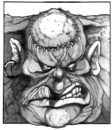
85 THE CHRONICLES OF DEATH
The Warriors meet a man in their travels. He stumbles towards them, gasping and moaning. As he passes he literally throws a leather bag at them, and stumbles off. Looking in the bag the Warriors see three books, written in blood and bound in human flesh. They quickly realise that they are books from a series of books called the “Chronicles of Death.” They don’t know how many are in the set, but they do know that they are worth a lot of Gold. Unfortunately they also realise that Undead everywhere can sense the books’ presence and will try to re-acquire them, obviously the cause of the other man’s distress. The books can be sold at a Settlement for 1D6 x 500 Gold each, but only if a 6 is rolled, otherwise the Warriors can’t find a buyer. They may only try once per Settlement. For every week of travel, roll 1D6 on the next table to see what attacks them:

1-3 The Warriors are attacked from all sides, resulting in a long tiring battle. They are victorious, but have each lost 2D6 unmodified Wounds in the process.

4-6 The Warriors are not attacked.

For every day in the Settlement roll 1D6. On a 1 the entire city is overrun with Undead and must be evacuated, forcing everyone out of the city including the Warriors.

The books may be discarded at any time.

86 PASSING FRIEND
The Warriors meet a friend of theirs during the week who used to adventure with them. He greets them and says he has an extra (roll 1D6):

1-2 1D6 Provisions

3-4 1D6 Bandages

5-6 1D6 Water Skins

for each of the Warriors. They then part ways.
87 THE STRONG MAN
The Warriors come to a small outpost near an oasis. It consists of a few tents and a handful of people. As they approach, they see a huge man throwing people around and yelling “I am the strongest.” He then points to a necklace made from emerald gemstones he is wearing “These rocks make me the strongest man in the world!” A random Warrior decides to put him in his place. Roll 1D6:

1 The Warrior stands a few metres from the man and states “You are as stupid as you are arrogant.” The huge man turns his attention to him suddenly and charges. The Warrior is not worried, considering his huge experience at combat. Unfortunately as the man draws near, the Warrior loses his footing and is unable to dodge the charging ball of muscle. The next thing the other Warriors see is their friend flying though the air, landing about ten metres away. 1 random item of treasure (not metal armour or metal weapons) breaks. The Warriors shake their heads and then dispatch the muscleman quickly. Unfortunately the Warriors find that the necklace has no effect for them. The remaining inhabitants invite the Warriors to drink at their water hole (+1D6 Wounds each) before they continue on.

2 Strutting up to the huge man, the Warrior confidently says “Fat is the only thing I see on that weak body!” The man’s attention is soon turned to the Warrior and a fight breaks out. The Warrior can’t seem to put a foot right and takes quite a pounding. Only when the other Warriors step in and dispatch the muscled brute does he manage to get to his feet, minus a few teeth and 2D6 Wounds. Unfortunately the Warriors find that the necklace has no effect for them. The remaining inhabitants invite the Warriors to drink at their water hole (+1D6 Wounds each) before they continue on.
3-4 Walking casually up to the muscleman, the Warrior taps him on the shoulder. His big head turns around only to be greeted with the Warrior’s fist that sends him sprawling backwards, unconscious. Unfortunately the Warriors find that the necklace has no effect for them. The remaining inhabitants invite the Warriors to drink at their water hole (+1D6 Wounds each) before they continue on.

5 The Warrior picks up large stone and lets out a loud whistle. The muscleman turns at the sound and the Warrior hurls the stone with deadly precision, hitting him directly between the eyes, knocking him out. Unfortunately the Warriors find that the necklace has no effect for them. The remaining inhabitants invite the Warriors to drink at their water hole (+1D6 Wounds each) before they continue on.

6 Walking directly up to the strongman, the Warrior says “Muscle is only part of real strength - true strength lies in how strongly we believe in our own actions.” The muscleman turns and seems to ponder his statement for a moment, but soon his confusion turns to aggression and he charges at the Warrior who remains standing casually. The man is almost upon him when the Warrior leaps forward and punches him square in the face, making him fly backwards into, and through, a nearby hut. The man is dead. The necklace gifts the wearer with +1 Strength until the end of the next adventure. The remaining inhabitants invite the Warriors to drink at their water hole (+1D6 Wounds each) before they continue on.

88 UNEVENTFUL WEEK

89 LAMP
The team comes to a skeleton in the sand, its bony hand gripping a leather sack. When the Warriors look in the sack they find (Roll 1D6):

1-2 Nothing.

3 5 Gold.

4-6 A Lamp.
The lamp is old and dusty, causing a random Warrior to try and rub it clean with the side of his hand. Roll 1D6:

1 When the lamp is rubbed, a great swirling is heard and a mighty red Genie appears from its nozzle. The Warrior is already reciting a wish when the Genie points at the Warrior causing (roll 1D6):

1 The loss of 1 Strength.

2 The loss of 1 Toughness.

3 The loss of 1 Initiative.

4 The loss of 1 Weapon Skill.

5 The loss of 2 Starting Wounds, permanently

6 The loss of 1 Starting Wound, permanently.

The Genie then lets out a great laugh and re-enters the lamp which the Warriors leave in the sand.

2-5 The Lamp looks very shiny now and can be sold for 10 Gold at a Settlement.

6 A Genie rises from the Lamp and explains to the Warrior that he is now entitled to a wish for freeing him, which he can pick from the following:

- +1 Strength
- +1 Toughness
- +1 Movement
- +1 Initiative
- +1 Willpower
- +1 Weapon Skill
- Restore Full Wounds

The Genie then flies off, thanking the Warrior. The lamp can only be used by one Warrior.

90 BLOOD RAGE
The recent carnage seen by a random Warrior has given him an urge to fight. If there is any chance of attacking an enemy until he reaches the Settlement, he will always attack, and if there is a combat he will never run.

91 HEROES HAILED
When the Warriors reach the next Settlement, they are hailed as mighty heroes because word has spread of their great deeds. They are showered with gifts and receive one Treasure Card each.

92 MIST OF CHANGE
The Warriors see a strange green mist on the horizon. They try to avoid it but they are engulfed by it. At first they enjoy the cool vapour, but then they feel changed. The Warriors all much receive 1 Chaos Attribute which lasts for 1D3 adventures. Rules for Chaos Attributes are found in the Chaos Warrior expansion.

93 RUMOUR
The Warriors encounter a group of soldiers. They talk for a while and throughout the discussion they mention that a lot of Settlements in the area have been completely destroyed by Tomb King armies. When the Warriors reach the next Settlement roll 1D6. On a 1-2 the Settlement has indeed been destroyed by Undead and the Warriors must journey to the next Settlement (same travelling time) or head off to the next adventure.
94 CITY
Far off in the distance the Warriors see the towers of a great city, but not in the direction they are travelling in. If the Warriors wish to go to the city roll 1D6:

1-4 As the Warriors draw near, the city simmers into nothingness! A mirage! Add 2 weeks to travel time for deviating off course.

5-6 The Warriors reach the city.

95 OMNIPOTENT POWER
The Warriors are moving slowly through the sand when a great shadow covers them. Turning, they see a huge red Genie in the sky. All of the Warriors must roll 1D6 on the following table:

1 The Genie is feeling angry and turns the Warrior into an animal. Roll 2D6 on the following Animal Table. His adventuring days are over........Unless the Warrior has helped a Genie in the past by releasing him from the bonds of his lamp, in which case that Genie senses he is in danger and protects him from harm.

Animal Chart
2 Cat
3 Frog
4 Bat
5 Rat
6 Goldfish
7 Snake
8 Scorpion
9 Lizard
10 Donkey
11 Camel
12 Sea slug

2 The Genie opens his mouth, bringing forth a swarm of locusts that engulf the Warriors. The magical bugs bite and gnaw at the Warrior’s flesh and each Warrior must take 1 unmodified Wound until they can roll a 5-6 on 1D6.

3-6 The Genie is disinterested with the Warrior.

96 BAD WEATHER
The Warriors are dealt a heavy punishment from the sun and must drink 2 water skins or lose 1D6 unmodified Wounds each.

97 SIGN
The Warriors enter a cliffy area and come to a dungeon entrance. A sign adjacent to the entrance states that there is a City on the other side of the dungeon. If the Warriors wish to enter it then play a dungeon with 1D6 Pyramid Cards and no Objective Room. The last room will have an exit. Just beyond the exit lies a great Pharaoh’s City that the Warriors can visit instead of travelling to one.

98 STARVATION
The travel is long and hard and the Warriors cannot survive on water alone. All Warriors must eat 1 Provision immediately or lose 1 Starting Wound, permanently.

99 UNEVENTFUL WEEK

100 THE TREASURE OF SETTRA
The Warriors stumble upon a Pyramid entrance, which seems to have been just uncovered by the recent winds. If the Warriors investigate read on, otherwise the Warriors continue with their journey. Upon entering the Pyramid they soon notice that all of the engravings on the walls are in tribute to Settra, but only they are not to the Mummy he is now, but to the man he once was. As the Warriors journey on they realise that this must be one of the legendary treasure pyramids of the Pharaoh Settra who hid his wealth across Nehekhara in a hope to hang on to his riches from thieves. The Warriors encounter 1D6 traps. Roll for how many and for which ones on the next chart.

1 Decapitation Blade Trap
All Warriors must roll 1D6. On a 1 they are decapitated, and are of course dead.

2 Boulder Trap
All Warriors must roll 1D6. On a 1-3 the Warrior is squashed by a boulder for 3D6 unmodified Wounds.

3 Guillotine Trap
A random Warrior is hit by a guillotine for 3D6 + 4 Wounds.

4 Poison Gas Trap
All Warriors take 1D6 unmodified Poison damage.

5 Crushing Ceiling Trap
2 random Warriors are injured for 1D6 unmodified damage in the escape from the ceiling.

6 Spear Trap
A spear hits a random Warrior for 2D6 Wounds.

The surviving Warriors make it to the inner chamber where lies a multitude of riches, unless a 1 is rolled on a 1D6. If a 1 is rolled then the chamber has already been plundered by thieves and the Warriors leave through a secret exit. Each Warrior rolls 1D6 on the following table to see what they find:

1 1D6 x 100 Gold
1Treasure Card

2 1D6 x 200 Gold
2 Treasure Cards

3 1D6 x 300 Gold
3 Treasure Cards

4 1D6 x 400 Gold
2 Nehekharan Treasures
3 Treasure Cards

5 1D6 x 500 Gold
2 Nehekharan Treasures
3 Treasure Cards
1 Objective Room Treasure Card

6 1D6 x 500 Gold
2 Healing Potions (+1D6 Wnds each)
6 Nehekharan Treasures
4 Treasure Cards
1 Objective Room Treasure Card

The Warriors then leave through a secret exit.

Nehekhara Hazards © Ben Head

