
• NEHEKHARA SETTLEMENT EVENTS •

1 UNEVENTFUL DAY

2 TAXES
The Pharaoh’s Guards approach the Warrior and demand 1D6 x 50 Gold tax for walking on the Pharaoh’s blessed ground. If the Warrior refuses to pay or cannot pay he will be thrown out immediately.

3 SLAVES
Seeing the slaves working on the Pharaoh’s latest building saddens the Warrior, who gives them 1D6 x 50 Gold without the Pharaoh’s Guards noticing. The slaves thank the Warrior, saying that that amount of Gold should get them out of slavery forever! The Warrior leaves with a sense of pride.

4 BRICK
The Warrior foolishly walks underneath a building site just as a large stone brick unbalances and falls directly towards him. Roll 1D6. If a 6 is rolled he jumps out of the way in time. If any other number is rolled the brick falls directly on his head, causing 3D6 Wounds damage.

5 PICKPOCKET
The Warrior, when opening his money bag, sees that he has been robbed! The pickpocket is 1D6 x 50 Gold richer.

6 WORTHLESS
If the Warrior has bought a weapon or item today, he takes second look at it and finds it is useless. He knew he shouldn’t have bought anything in that dodgy market place!
7 STENCH
The Warrior is unlucky that he is walking under a window when a pail of human waste is thrown out. It falls on him; needless to say he reeks. The next day no one will let the Warrior in their establishment.

8 LUCKY FIND
The Warrior trips over an old sack in back alley. Giving in to curiosity he looks in the sack to find (roll 1D6):

1 A severed hand
2 An ox tongue
3 1Gold
4 1D6 x 10 Gold
5 Nehekharan Treasure
6 1 Treasure Card

9 FOUNTAIN
The Warrior sees a fountain. It is off limits, but the guards have left to chase down some helpless slave. He can if he wishes to, fill 1D6 water skins before they return.

10 PHARAOH’S GUARDS

11 UNEVENTFUL DAY

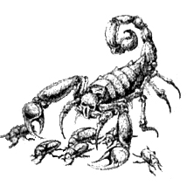

12 FIGHT
The Warrior watches on when a rowdy fight breaks out. It’s all fairly harmless, but then a huge man enters, and starts doing some real damage! Quickly looking around for guards, the Warrior decides to intervene. If he does, roll 1D6:

1 Just as the Warrior enters the fray, a group of Pharaoh’s Guards comes around the corner. They soon break up the fight and send the participants to the Palace Dungeon for 1D6 days.

2 The Warrior is just knocking the great man out when he is hit on the back of the head with a hard object. Before he regains his senses, 1D6 x 50 Gold is stolen from him.

3-4 The Warrior is up to his usual form, toying with the big man until his annoying attacks becomes too irritating and he knocks him out.

5 The Warrior knocks the brute out and hears a mighty roar of appreciation rise up from the surrounding crowd. 2D6 x 50 Gold is thrown down at him, of which he manages to only collect half of due to the squabbling of the fighting rabble.

6 One well placed punch to the jaw and the mighty man falls down, knocked out cold. Unfortunately, guards have come up behind the Warrior. Fortunately they explain that the man at the Warrior’s feet has a bounty on his head and pay him the reward of 400 Gold!

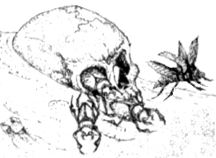
13 STRANGE WOMAN
The Warrior is approached by a strange woman, just after dusk. She seduces the Warrior and gets him to go up to her room. Just when he places his weapon down she lunges at him, two sharp fangs glinting in the moonlight! She is a Vampire! Roll 1D6 to see how the Warrior handles the situation.

1 The Warrior is caught by surprise and the Vampire sinks her teeth into him, inflicting 1D6 + 4 unmodified damage. The Warrior then manages to slay her.

2-4 The Warrior, although surprised, pulls away from the woman, her fangs only grazing his neck. This inflicts 1D6 unmodified Wounds. The Warrior then manages to slay her.

5 The Warrior manages to kill the woman before she can bite him.

6 Thinking quickly he moves to the side, grabs the Vampire’s head, twists it, and breaks her neck. While the vampire is writhing on the bed he grabs his sword and decapitates the foul temptress! He then picks up his belongings and walks casually from the room.

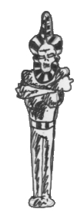
14 WIZARD
A wizard is being pestered by a group of children, pulling at his robes and throwing dirt at him. The Warrior walks by him and can’t help but chuckle at his misfortune. The wizard sees this and takes it personally, placing a curse on the Warrior. Roll 1D6 to see what effect the curse has:

1 The Warrior is at -1 Toughness for the next adventure.

2 The Warrior is at -1 Strength for the next adventure.

3 The Warrior is turned into a pig for the rest of the day.

4 The Warrior is turned into a huge fat man and must spend 1 week training in the Settlement (no event rolls needed) to get back into fighting shape. If the Warrior will not or cannot spend this week training, he is at 2 Strength, 3 Toughness, 2 Weapon Skill, 1 Attack and must go last in the Warriors’ Phase. He will remain this way until he trains for 1 week as above.

5 The Warrior is turned into a goat for the remainder of the day.

6 The Warrior falls flat on his face in the mud, suddenly becoming the new object of ridicule for the group of children who harass him for the rest of the day.

15 LIVESTOCK
The Warrior is perusing the market place when a bull charges into him from the side, smashing him into a nearby pig pen and covering him in mud. The embarrassed Warrior pulls himself up and leaves the area quickly to find a place to clean his clothes. When he does he finds that he has lost 1D6 x 50 Gold in the mud.

16 LEGEND
A large crowd gathers around the Warrior, praising him. Apparently his name and deeds have been told in tales and stories, and he has become somewhat of a legend. From now on he is classed as a legend.

17 ILLEGAL GAMBLING
The Warrior stumbles upon a group of old men illegally gambling in an alleyway. They ask him if he would like to join them. If he does, he can play in the same way as in the Gambling House, but must roll a D6 before playing. If a 1 is rolled the Pharaoh’s Guards turn up an throw everyone in the Palace Dungeon. If the Warrior wins at anytime roll 1D6. On a 6, the winnings are doubled!

18 BIRTHDAY
Tomorrow is the Pharaoh’s birthday. No locations can be visited by anyone on this day.

19 GOLD PURSE
The Warrior notices that a woman, obviously one of the Pharaoh’s wives, has dropped her purse behind her. He can take this and give it back to her, or take the 1D6 x 200 Gold within it for himself. If he takes it roll 1D6. On a 1 one of the lady’s bodyguards sees him and throws him in the Palace Dungeon for Theft.

20 PHARAOH’S GUARDS

21 BARGAIN
The Warrior is pulled into an alleyway, where an old man tries to sell him something. Randomly find which item it is from the Settlement shops. He then offers it for one third of its original price.
22 UNEVENTFUL DAY

23 UNCOMMON VALOUR
It is not hard to see that the slaves in this Settlement are treated too harshly, leaving many run into the ground and dead. The Warrior cannot stand it any longer and gets together with the other Warriors to plan a rescue of epic proportions. They decide to strike after each Warrior has had one more day in the Settlement. Roll events for these days then come back to this event to see what happens.

The Warriors have, by this time, split the slaves into a number of different groups equal to the number of Warriors in the Settlement, and therefore participating in the breakout. For each Warrior’s group roll 1D6:

1-2 The breakout goes terribly wrong and all of the Warrior’s slaves are slain. He is then thrown into the Palace Dungeon, but not before he is beaten for 5D6 Wounds with metal bars. Finally the Warrior manages to bribe a guard for 1D3 x 500 Gold (or as much as he has left) and escapes into the desert to join up with the others. Obviously they must go on to the next adventure.

3 The breakout goes well but many of the slaves are slain and the Warrior takes 4D6 Wounds. Once they escape the City they reach an oasis and wait for the rest of the Warriors. Obviously they must go on to the next adventure.

4-5 The breakout goes exactly as planned with the Warrior and his slaves overpowering the guards and escaping the City to a nearby oasis. Here the Warrior waits for the others. Obviously they must go on to the next adventure.
6 The breakout goes so well that the guards are completely defeated and the entire Settlement is taken over by the Warriors and their slaves. This Settlement has been liberated! The rest of the Warriors meet up at the Palace, even if they were waiting outside the city, or in the dungeon. No more rolls on this table are required. The City can be used as normal now, but don’t roll for Settlement Events. All items are half price because of the Warriors’ assistance in the slave break.

24 POISON
The Warrior has eaten something that has given him food poisoning. For 2 days he is sick in bed and can do nothing, including rolling on this chart.

25 DRUNK
The Warrior has drowned his sorrows this night and staggers between the guard’s quarters. Before long he is shouting abuse at them in a drunken slur, and is quickly thrown in the Palace Dungeon for 1D6 days for .

26 ERASED
The Warrior is pulled aside by a shadowy looking man dressed completely in black. Just as the Warrior begins to demand an explanation, the man cuts him off, saying “You look like someone with a past,...perhaps a dark past? Perhaps even a past that you don’t wish to be burdened with? I can help you with that; you could say it is my business. But erasing someone’s past is no easy task, it requires me to chase around to where you have been, and wipe your name from whatever records are held with your name.” For each record of the Warrior’s past (eg. warrant, title, etc), that the Warrior wants ‘erased’ the man charges 200 Gold. Once the business is done the man hurries off into the darkness, but turns before disappearing and says “You’ll be erased.”
27 ILLEGAL ACT
While the Warrior is looking through some items at a stall selling various foods, a large roasted chicken falls to the ground and rolls a few metres away. Deciding to do his good Samaritan deed for the day, the Warrior moves over and picks up the chicken to give back to the stall owner. But, as he picks up the food the stall owner calls out to some Pharaoh’s Guards nearby, yelling “Thief!, Thief!,” as he points at the Warrior. The Warrior now has two choices; either tell his story to the guards or run.

Tell Story
Roll 1D6

1-4 The Guards don’t believe the story and throw the Warrior in the Palace Dungeon for Theft.

5-6 The Guards believe the story and go on their way.

Run for it
Roll 1D6:

1-3 The Warrior is caught before he gets more than 5 metres. He is thrown in the Palace Dungeon for Theft and Running from the Pharaoh’s Guards.

4-6 The Warrior manages to flee the area, but a warrant is out for his arrest for the crime of Theft and Running from the Pharaoh’s Guards. Record this warrant and the crimes listed and keep them while in this Settlement.

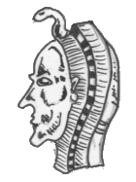
28 SHIFTY SLAVE
As the Warrior is walking around the Settlement he comes across a young slave. He staggers over and says in a somewhat over acted voice, “A few coins for a poor slave?” If the Warrior gives the slave 5 Gold, roll on the following chart with a +1 modifier. If the Warrior does not give the slave any money roll on the following chart with a -1 modifier.

1 The slave is actually a thief and with his nimble fingers manages to steal a random item or Treasure Card from the Warrior (not any armour that is being used, obviously!).

2-3 The slave is actually a thief and with his nimble fingers manages to steal a sum of 1D6 x 100 Gold.

4-6 The slave thanks the Warrior for his time and moves on.

29 BLOOD MONEY
The Warrior is just about to call it a day and return to his sleeping quarters when he hears a scream! Rushing to investigate, he finds a corpse that was obviously stabbed to death. He is just about to leave before the Pharaoh’s Guards arrive, when he notices the huge sack of Gold on the ground next to the body. Looking at the coins closely he sees that the coins are counterfeit, but it is only half noticeable. He sees that there is 2D6 x 100 Gold in the sack. If the Warrior wishes to take this Gold record the counterfeit Gold on his character sheet in a separate area to his normal Gold. Whenever he wishes to try and use any of the counterfeit Gold roll 1D6. On a 1-2 the receiver of the Gold sees that it is counterfeit and the Guards quickly take him to the Palace Dungeon and charge him with Counterfeiting. This Gold can only be used in a Pharaoh’s City.

30 PHARAOH’S GUARDS

31 STRANGE SMELL
A strange pungent odour invades the Warriors nostrils, causing him to cough and sneeze. Curious of what could cause such a strong smell the Warrior tries to track it to the source. He finally tracks it to a grate in the ground. Upon closer inspection he finds it is a makeshift sewer system that looks like is has not been maintained. He is about to leave when a giant purple tentacle pushes the grate off, grabs him around the waist and begins to pull him back down into the sewer! He now has 3 turns to try and hack the tentacle off, before he is pulled into the sewer and chewed on by the tentacle beast’s huge mouth. Within these turns the Warrior must deplete the tentacles by 15 Wounds. Just roll for damage with any items or weapons that the Warrior wishes to use. Once the three turns are up the Warrior is pulled into the tentacle beast mouth and is gnawed on. For every turn the Warrior is gnawed on he loses 2D6 Wounds. Now he must kill the beast itself who has 25 Wounds in the same way as above only now he is being gnawed on every turn as well for the above damage. Once the Warrior has either cut the tentacle or slays the beast he leaves the area, making a mental note not to be so curious in future.

32 STRAY DOG
At the beginning of the day, a stray dog comes across the Warrior, obviously brought from overseas. The dog follows the Warrior around the whole day and the Warrior becomes quite attached to him. He nicknames the dog “Lucky” and he stays with the Warrior while in the settlement. Having an extra set of eyes around is quite an advantage and for the rest of the Warrior’s stay in the Settlement the Warrior may re-roll any one event.

33 UNEVENTFUL DAY

34 FALLING BLOCK
The Warrior is walking along minding his own business when suddenly he is covered in a dark shadow in the shape of a square. The Warrior must roll 1D6 and add his initiative. If the result is 9 or over he has leapt out of the way of the block of stone. If the result is below 9 then the large stone block falls directly on him. It fell from a huge building that is under construction. Roll 1D6 for how many stories the block has fallen from. For each story, the block inflicts 6 Wounds, which are all added together before subtracting Toughness and armour. When and if the Warrior pulls himself from under the stone block he looks up to see a group of slaves looking innocent, next to a broken pulley system.

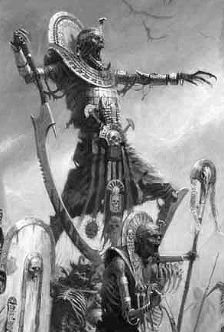

35 ENTERTAINMENT
The Warrior is walking past the Pharaoh’s Palace when he sees that there is a sign saying that the Pharaoh is holding a banquet that night and he is seeking entertainers. If the Warrior wishes to try and entertain the Pharaoh at his banquet roll on the following table to see what happens. If the Warrior has a warrant out for his arrest he can still enter the Palace with a disguise, but he must roll 1D6. On a 1-2 he is discovered and is sentenced for his crimes in the Palace Dungeon.

1 The Warrior enters the banquet hall deciding to treat the Pharaoh with his dazzling ability to make up poetry on the spot about his hosts. This is what he manages to say (said to the tune of “you’d love to have a beer with Duncan”)

Oh you’d love to have an ale with the Pharaoh,
you’d love to have some wine as well,
but if you stay too long,
the Pharaoh will pong,
And he really has quite a pungent smell!

The Warrior is just about to start another one when the Pharaoh’s Guards grab him and throw him in the Palace Dungeon for the crime of Insulting the Pharaoh.

2 The Warrior enters the main eating hall and decides to impress everyone with his infamous juggling act. He quickly grabs two legs of meat and throws them into the air. At this point he remembers he never learnt how to catch them again! The legs of meat come down hard on the Pharaoh’s Guards. They then chase the Warrior around the room for 5 minutes before grabbing him and throwing him in the Palace Dungeon for Assaulting the Pharaoh’s Guards.

3 The Warrior begins to entertain the Pharaoh with rendition of “the dream” but only manages to come up with a loud burp, a result from his drinking binge earlier. He is quickly thrown out.

4 The Warrior enters the entertainment arena and begins a powerful opera song telling a tale of the tragic romance between a Nehekharan vizier and a powerful female Vampire. His performance is rewarded with cheers and 1D3 x 50 Gold.

5 The Warrior manages to dazzle the Pharaoh with an amazing dance routine and pulls the head of the guards into the show. The performance is loved by all and money is thrown to him. He receives a total of 1D3 x 100 Gold for his efforts.

6 The Warrior enters the entertainment area calmly. He than begins a great theatrical performance telling the tale of a great Pharaoh and his rise to power. So taken by the moving performance of the Warrior that the Pharaoh takes him aside. he then takes him to a vast treasure room. He gives the Warrior a gift from his treasure room as a reward for the best entertainment he has ever had. Take one Objective Room Treasure Card.

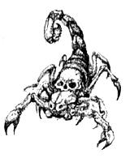

36 SETTING UP SHOP
The Warrior decides to try his hand at setting up a stall to sell (Roll 1D6):

1 Camels
2 Rare Fruits
3 Exotic Clothing
4 Slaves tools
5 Books on the art of war
6 Furniture

The Warrior spends 1D6 x 100 Gold on the stock of his product and decides to try selling it for 1D6 days. For these days don’t roll on any other events and roll on the table below for each day.

1 The Warrior has stock stolen from his store resulting in a loss of 1D3 x 50 Gold

2 Some of the Warrior’s stock either dies, breaks, rots or burns, resulting in a loss of stock, equalling 100 Gold.

3 The business goes well this day, profiting 1D3 x 50 Gold.

4-5 Business goes well this day resulting in a profit of 1D6 x 50 Gold.

6 The stall thrives with new customers resulting in a huge profit of 1D6 x 100 Gold.

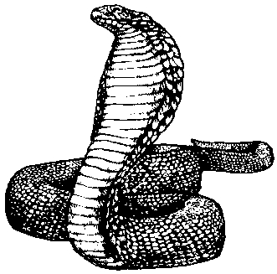

37 LUCKY FIND
The Warrior is lucky to come across an item he lost a long time ago. Randomly pick out a Treasure Card from the discard pile.
38 KILLER
The Warrior finds out that someone has been murdering people around the city. The Pharaoh’s Guards haven’t been able to catch him, so if the Warrior wishes, he can help out. If the Warrior does help out roll 1D6 on the following table:

1 Tracking the killer to a dark alleyway, the Warrior spots him stabbing a woman repeatedly with a curved dagger. The killer sees the Warrior approach and flees the area, leaving the Warrior to rush to the woman’s side to see if see is dead. Unfortunately, a group of Pharaoh’s Guards spot him in the alley holding the dead woman and arrest him. They throw him in the Palace Dungeon, charging him with Murder. The killer is not heard from again.

2 Tracking the killer, the Warrior manages to corner him in a disused alleyway. The killer behaves like a wounded animal, hacking and slashing at the air as the Warrior approaches. Finally he manages to catch the killer but only after withstanding 2D6 Wounds. After delivering him to the authorities he receives the 100 Gold reward.

3-4 After some careful tracking, the Warrior chases the killer into a peasants house, where the two fight. Finally the Warrior is victorious after suffering 2D6 Wounds. The reward for the killer’s capture is 250 Gold, which he collects.

5 After tracking the killer into a shop that sells water skins, the Warrior spots him about to stab the shop owner. Roll 1D6 and add the Warrior’s Initiative. If the result is 8 or higher he manages to get to the killer before he stabs the shop keeper and defeats him. If the result is below 8 then the Warrior defeats the killer but not before he manages to kill the shopkeeper. The Warrior collects the 400 Gold reward. If the shop keeper survived he rewards his saviour with 1D6 water skins.
6 The Warrior tracks the killer into the Pharaoh’s Palace. The next few hours are spent following the killer until he reaches the Pharaoh’s chambers, where he sees the Pharaoh wrestling with the killer. Charging in, the Warrior pulls off the attacker and knocks him out with one punch. The Warrior collects the 500 Gold, and the Pharaoh gives him a piece of treasure from him vault for saving him. Take one Treasure Card.

39 TRIP OVER
The Warrior is strolling along when suddenly he trips over a rock and falls flat on his face. When he comes to, he looks up to see a huge battalion of Pharaoh’s Guards marching down the street towards him. Roll 1D6:

1-2 The Warrior cannot get out of the way in time and the guards march straight over the top of him! The Warrior takes 3D6 Wounds damage and one treasure item is broken!

3-4 The Guards march straight over the top of the Warrior, causing 2D6 Wounds damage and squashing 1D6 provisions.

5-6 The Warrior quickly gets up and leaps out of the way, just as the Pharaoh’s Guards march down the street.

40 PHARAOH’S GUARDS

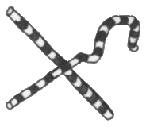

41 SECOND HAND WATER
Walking around the various streets of the City, the Warrior is stopped by a short man. He holds up 1D6 water skins and says he will sell them to the Warrior for 10 Gold each. He goes onto say that they were bought by other Warriors but they never ended up using them so they were given to him. If the Warrior does buy the water skins they act as normal, but for each one used roll 1D6. On a roll of 1 a large beetle was in the water skin and it goes down the Warriors throat, choking him. Roll another 1D6. On a 1, the Warrior dies from choking to death. On any other number he manages to cough it up and is unharmed.

42 BEING SHIFTY
If the Warrior has a warrant out for his arrest then read on, otherwise treat this as an uneventful day. As the Warrior passes the Guard house he sees the warrant out for his arrest sticking on the wall with a big drawing of his face. Thinking that this is his chance he runs up to the poster and redraws the face so it looks completely different with a moustache and glasses! Cross out any warrant that the Warrior may have had out for his arrest.

43 UNLUCKY
Walking around the City, the Warrior becomes irritated about all of the talk about the Pharaoh until finally he has had enough and yells out, “SHUT UP ABOUT THE DAMN PHARAOH, TO HELL WITH HIM. I’M SICK OF HEARING ABOUT HIM!!” Unfortunately he is overheard by a Pharaoh’s Guard who takes his words as an offence against the Pharaoh. The Warrior soon outruns the Guard, but earns a warrant with the crime of Insulting the Pharaoh. Record this.

44 UNEVENTFUL DAY
45 THE CURSE OF RAM-TUT
An outbreak of Ram-Tut’s black plague effects the Settlement, leaving mass death in its wake. All Warriors leave the Settlement immediately from fear of being infected.

46 ONE MAN AND A BABY
The Warrior is walking through the streets of the City when an irate woman screams at him for help. Looking up, he sees a baby falling out of a building window! Realising that catching the baby from that height will require something soft, he quickly grabs a huge mushroom from an adjacent garden. Holding it up, the baby falls directly on it and bounces up almost to the same height that it fell! (that’s one rubbery mushroom!). Now the Warrior is running everywhere bouncing the baby on the mushroom, knowing that each time it bounces less high than the last. Roll 2D6 for how many bounces the baby will take before it bounces only a small distance and is able to be caught. For each bounce roll 2D6. On a double, the Warrior has missed the baby and it lands on the ground with a rather fatal splat! He immediately vacates the area. If the Warrior saves the baby he is rewarded with 20 Gold from its mother.

47 MUMMY TOMB
The Warrior comes to a large excavation site that is right in the centre of the City! Apparently they have found an old tomb under the City! Just as he goes in for a closer look, slaves come flying out of the main hole in the ground leading to the tomb. Within moments, a Mummy pulls itself out of the hole. Being the only one around with any fighting skills at that moment the Warrior assumes a combat stance. He must fight a battle with one Mummy! Fight the battle on a Dungeon Room board section. If the Warrior leaves the board section and tries to flee, he must roll 1D6. On a 1-3 he fails to flee the combat and is placed on the square he left by.
48 EYES OF FATE
The Warrior approaches a large statue of the current Pharaoh. It stands tall and towers above him. Little does that poor Warrior know that the statue was enchanted by a powerful wizard to suck the power from any one worthy that passes by. Suddenly bolts of lighting shoot from the statue’s eyes and entangle the Warrior in crackling coils of energy. Roll 1D6 to see wether he can withstand the statues power:

1 The Warrior is at the statue’s mercy as it sucks raw energy from him. He is at -1 Strength for the next adventure.

2 Unfortunately, the Warrior cannot withstand the power of the statue. He is at -1 Toughness for the next adventure.

3 The power is too great for the Warrior to withstand. He is at -1D6 Starting Wounds for the next adventure only.

4-6 Fighting against the arcane magic of the statue, the Warrior throws off the coils that bind him and vacates the area immediately. He tells of the statue to others, but they think he is crazy and don’t believe him.

49 UNDERGROUND RIVER
An underground river has been discovered. For the rest of the stay in the Settlement all water skins are half price.

50 PHARAOH’S GUARDS

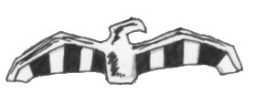
51 HOLY PASTE
The Warrior comes across a strange little shop. It has all manner of odds and ends but there seems nothing of interest. Just when he is about to leave he spots a large pot labelled “Holy Paste.” The shop keeper explains that the holy paste is holy water mixed with a substance like flour, creating a paste. He goes on to say that it is used to smear on doors to ward off evil spirits. The Warrior knows of a better use and can purchase up to 1D6 amounts of paste, at a cost of 80 Gold each. The Warrior can use the paste by smearing it on any weapon. From then onwards the weapon causes an extra Damage Dice against Undead. This lasts until the end of the combat the Warrior is currently in.

52 PHARAOH’S DEATH
The mighty Pharaoh has died, from natural causes so they say. Tomorrow is his funeral where he is mummified and placed in his own tomb. All shops and locations are closed tomorrow in honour of this event. A new Pharaoh is quickly appointed.

53 WRONG PLACE, WRONG TIME

Walking past the guard house, the Warrior spots an old man sketching up a criminals profile on a new warrant sheet. Unknown to the Warrior is the fact that the old man has forgotten how the criminal looked. Knowing that the sentence for incompetence would be slavery, he quickly just draws whoever walks by, which in this case is the Warrior. From now on, the Warrior has a warrant out for his arrest for the crime of (Roll 1D6):

1 Murder
2 Assaulting the Pharaoh’s Guards
3 Insulting the Pharaoh
4 Counterfeiting
5 Running from the Pharaoh’s Guards
6 Theft

Record this warrant on the Warriors adventure sheet.
54 HEAVY METAL
Patrolling proudly down the street is what looks like a knight on a horse. The man is short and covered head to toe in heavy plate mail. His horse looks completely exhausted and has obviously gone without water for sometime. The Warrior calls his attention and advises the knight to give his horse a drink. Roll 1D6.

1-4 The knight seems very annoyed that the Warrior thinks that he knows better than him and shouts horrendous abuse at him, before he begins to trot past. As he does pass, the Warrior slaps the horse on its rump, making it rear up and throw off the short knight, who falls to the ground hard and can’t get up. Looking down at him and laughing, the Warrior pulls over the horse and gives it a drink from one of the water bottles hanging at its side. Then both the horse and the Warrior walk off in different directions and leave the pompous knight squabbling around on the ground unable to get up.

5-6 The Warrior’s advice seems to get through to the knight and he immediately gives his horse a drink.

55 UNEVENTFUL DAY

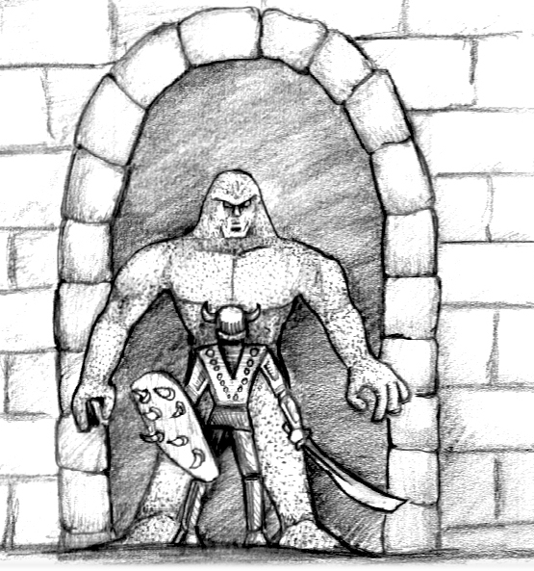
56 ANUBIS WARRIOR ATTACK
The sound of a great horn sounds out across the City. It warns of an attack! Quickly finding the other Warriors (the ones in the settlement, or waiting outside) they stand their ground, ready for battle. Before long, hordes of Anubis Warriors enter the City. The Warriors must fight a battle along side the other city guards (although they are not actually in the battle on the board) against (roll 1D6)

1 3D6 Anubis Warriors
1 Anubis Champion
1 Anubis Hero

2 3D6 Anubis Warriors
1 Anubis Champion
1 Anubis Priest

3 2D6 Anubis Warriors
1 Anubis Champion
1 Anubis Priest

4 2D6 Anubis Warriors
1 Anubis Champion

5 2D6 Anubis Warriors
1 Anubis Priest.

6 2D6 Anubis Warriors

Fight the battle on a large board section. Once the enemy is defeated, the Warriors help the rest of the Pharaoh’s Guards drive back the Anubis Warrior attack, and life returns to normal.

57 WEAPONS DISPLAY
The Warrior approaches a large group of people. They are all watching a grand weapons display put on by some travelling warriors. Soon they call out for a volunteer to try and unarm their swordsman. If the Warrior wishes he can step forward and volunteer. If he does, roll 1D6 and add his Weapon Skill. Then roll 1D6 for the swordsman and add his Weapon Skill of 6. The one with the highest total unarms the other. The winner is showered with 1D6 x 20 Gold from the onlookers.
58 TALES
Passing a dark alleyway, the Warrior’s keen hearing picks up a conversation about a vast treasure-laden tomb not far from the City. Drawing a quick map from what he hears, his thoughts soon turn to the riches within his grasp! Gathering the other Warriors he explains the situation. If the Warriors wish to go and explore the tomb, play a normal dungeon with 1D6 + 2 Pyramid Cards and an Objective Room at the end. Once any battle is finished roll 1D6 for each Monster slain. On a 6 the Warriors receive double Gold. Unexpected event occur on a 1-2 while exploring this tomb, and once the Objective Room is completed an extra Objective Room Treasure Card is awarded. The Warrior can then continue on in the Settlement.

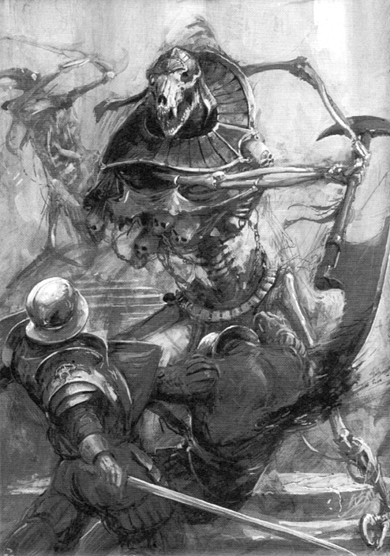

59 TAXES
The Pharaoh introduces a new goods tax, making every item for sale in the Settlement 50 Gold more expensive.

60 PHARAOH’S GUARDS
61 GIANT INSECT
A loud buzzing alerts the Warrior to a giant insect flying above him. It zooms in and out of the buildings until it swoops and picks up a small child and begins to fly off. Thinking quickly, the Warrior acts. Roll 1D6:

1 Quickly reaching around for an object to throw, the Warrior grabs one and throws it at the insect. Only after it is flying towards its target does the Warrior realise he has thrown another small child! Just as the child reaches the insect it twists and grabs that child too and fly’s off. The Warrior feels ashamed of himself and is at -1 Luck for the next adventure.

2 Without hesitation the Warrior grabs the closest object to him and throws it at the insect. Unfortunately it is a mouldy cabbage, which bounces harmlessly off the insect. With that, the insect fly’s off with the child. The Warrior is ashamed of himself and is at -1 Luck for the rest of his stay in the Settlement.

3 Grabbing a large rock, the Warrior throws it at the insect, but it misses. The insect then fly’s off with the child. The Warrior is ashamed of his performance.

4-5 Grabbing a sharp pointed rock the Warrior throws it at the insect. The rock hits and tears through the insect’s abdomen killing it. It plummets to the ground, the baby falling from its grasp. The Warrior just manages to catch it, and is rewarded with 35 Gold from its mother.

6 Picking up a nearby dagger, the Warrior throws it at the insect. The weapon imbeds itself in the bugs head killing it. It falls to the ground and the child falls into the Warriors arms. He soon finds out it was the Pharaoh’s son! He is rewarded with 1D6 x 200 Gold.

62 BLIND BEGGAR
The Warrior comes across a blind beggar being teased and harassed by a Pharaoh’s Guard. He is throwing a coin into his beggars collection can. The coin has a string attached and the guard pulls it out as soon as he puts it in. The Warrior decides to intervene on this cruelty. Roll 1D6:

1-3 Strutting over to the guard, the Warrior takes a punch at him. The guard though, is extremely fast and dodges, bringing up his sword and hitting the Warrior on the head with the hilt. The Warrior awakes in the Palace Dungeon for the crime of Assaulting the Pharaoh’s Guards.

4-6 Charging quickly towards the guard, the Warrior shoulder-charges him and knocks him straight into a nearby wall. The guard is knocked unconscious and gold coins fall from his pockets. The Warrior picks these up and fills the beggars cup up, before walking from the scene.

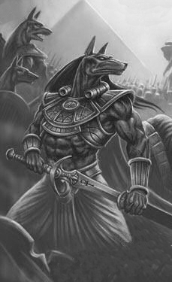

63 DARK FOLLOWER
The Warrior discovers a makeshift barn in the slave area of the City. Inside he sees an amazing sight. A necromancer is performing some sort of magic ritual. A swirling black cloud moans and screams over an unholy green flame, as he moves his hands in front of it in a way only one akin to the ways of magic can. The Necromancer is obviously plotting to do something evil to the City or the people within it. If the Warrior wishes to intervene, fight a battle with 1 Necromancer. If the Warrior defeats the Necromancer, the Necromancer’s incantations affect him. The cloud has now formed into a dark shadowy ghost-like form about the size of a monkey. Ready for anything, the Warrior prepares for another battle. But it doesn’t come, instead the little form playfully circles the Warrior. Eventually he puts his weapon away and moves from the barn. The dark form follows him like a stray dog. This keeps up for a while and the Warrior realises this must be a familiar that the wizard conjured up for himself. Obviously the wizard was slain before it was fully formed, but when it did form the first person it saw was the Warrior, therefore believing that he is its master. From now on the dark familiar follows the Warrior everywhere and also bestows upon him its magical properties which are (roll 1D6):

1 +1 Luck
2 +1 Toughness
3 +1 Move
4 +1 Weapon Skill
5 +1 Strength
6 +1 Damage Dice

At the end of every adventure roll 1D6 for the dark familiar. If a 1-3 is rolled the familiar’s magic essence has finally expired and it dissipates into nothingness, along with any magical properties it bestowed on the Warrior while with him.

64 PROVISIONS
A Pharaoh’s Guard barges past the Warrior on his horse, dislodging one of the horses saddle bags. The guard continues on completely unaware. In the bag the Warrior finds 1D6 provisions which he may take.
65 PHARAOH’S DAUGHTER
Throughout the day the Warrior becomes attracted to a beautiful lady who is obviously the Pharaoh’s daughter as she is laden heavily with gold and is escorted by guards. Roll on the following table, now and for every day after, unless that day’s events prevent him from doing so.

1 Deciding that now is as good a time as any the Warrior walks forth and introduces himself to the Pharaoh’s daughter. Unfortunately as he does this he trips on a rock and falls forward grabbing onto anything to support him. What he grabs, to the Warriors later dismay, is the daughter’s dress which is pulled off by his clutching hands, leaving her standing there naked. Needless to say he is promptly thrown in the Palace Dungeon for 4 days. Do not roll on this table again.

2-4 The Warrior watches her for most of the day but can’t muster up the courage to try and speak to her.

5 The Warrior musters up enough courage to go and talk to her. He introduces himself and she seems to enjoy his company. Finally she has to go into the Palace. Roll 1D6. On a 1-3 the Warrior decides royalty isn’t for him and goes his separate way. Do not roll on this table again. On a 4-6 the princess says to meet her again. The next day go straight to the 6 on this table.

6 The Warrior and the princess get together and find they have a lot in common, becoming quite close. If the Warrior remains in the Settlement for another day read this event after resolving any Settlement Events. The two love birds fall in love and the princess wishes to be married. If the Warrior decides to get married roll 1D6 on the following table. If he decides he doesn’t want to be married he must leave the Settlement immediately leaving his lady friend behind.

1 Once the two get married the Warrior makes the decision to give up his hazardous life of questing and live out his days in luxury. For of course, he will be Pharaoh one day. His adventuring days are over.

2 When the two tell the Pharaoh of their plans he is out raged. The thought of a foreigner with his daughter sends him into a mad rage and has his guards chase him out of the city inflicting 4D6 Wounds before closing the main gate in his face.

3-4 The two get married, but almost instantly the Warrior’s wife becomes a completely different person telling him do everything and ordering him around everywhere. He realises he has made a mistake and flees the City.

5-6 The two are married and the Warrior soon finds out he was a pawn in a twisted game of deceit. Apparently she only married him in spite of her father who hates foreigners. The Warrior is deeply hurt and decides to raid the Palace treasure hold before leaving the settlement. He makes off with (roll 1D6):

1 1D3 Nehekharan Treasures

2 3 Treasure Cards

3-4 3 Treasure Cards
1 Nehekharan Treasure

5 4 Treasure Cards
2 Nehekharan Treasures

6 2 Treasure Cards
1 Objective Room Treasure Card
2 Nehekharan Treasures
66 UNEVENTFUL DAY

67 KRIBBLES
It seems almost instantly the Settlement is over run by a plague of small furry animals in the shape of a ball, that the local inhabitants have named Kribbles. When visiting any location roll 1D6. On a 1-2 the location is overrun with Kribbles and has been closed. This effect lasts for the entire stay in the Settlement.

68 RUNAWAY PIG
The Warrior is walking along minding his own business when suddenly a loud snort is heard. A huge runaway pig runs directly at the Warrior. Roll 1D6 and add the Warrior’s Initiative. If the total is over 8 he manages to leap out of the way of the angry snorter. If the total is 8 or below then the pig has careered into the Warrior causing him to fall to the ground, twisting his leg. The Warrior takes 1D6 unmodified damage.

69 THE WARLOCK
The Warrior finds a large tent with the symbol of magic painted on the front. Becoming interested, he enters to find an old man stirring what looks like his dinner in a large pot. Just as the Warrior is about to excuse himself for his rude interruption, the man speaks. “You are looking for… magic young one? Then you have come to the right place, for I am a great warlock, a master of magic.” The old man then goes on to say that he used to be a teacher and can teach the Warrior a new spell (If he is a Wizard or magically inclined.) He can teach the Warrior 1 random spell for the small price of 800 Gold.

70 PHARAOH’S GUARDS

71 WILL OF THE PHARAOH
The Pharaoh of the City decides that the Palace treasure hold is severely lacking. Seeing that there is a lot of foreigners in the city, he states that all foreigners must give one piece of treasure to the palace or be thrown out. The Warriors must comply or be thrown out of the City.

72 WHOOPS!
The Warrior comes across a curious sight. A dwarf is working a strange contraption on a large stone rock. He seems to be carving a statue of the Pharaoh. The contraption has a huge cutting blade that carves the stone like butter. Getting a closer look, the Warrior moves in. His sudden movement surprises the dwarf who hits a wrong switch on his contraption sending it hurtling towards the Warrior. Roll 1D6 for the Warrior and add his Initiative. If the total is over 8 then he has dodged the machine. If the total is 8 or less then the Warrior has been hit by the cutting blades, resulting in the loss of 2D6 unmodified Wounds.

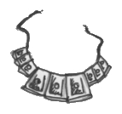

73 ELEMENTAL FORCES
A great sandstorm whips up over the Settlement causing all people to stay indoors and lock up their windows. For the next day no locations can be visited, for the people are too busy sheltering from the storm to open their businesses.

74 AN UNEARTHLY CHILD
The Warrior has often heard of a great legend regarding a child that was supposedly not born of this world, but never had he ever thought he might meet that child! There before him stands a grand tent, with the “unearthly child” written on it. A long line comes from the tent waiting to get a chance to meet him. The Warrior can wait too if he wishes, and of course there is a measly cost of 1000 Gold. If he does this roll 1D6:

1 The child seems to look like any other and the Warrior feels he has been had! He quickly tries to reclaim his money but remembers the legal contract he signed when he gave the money away.

2 Upon entering the tent the Warrior sees the child. It looks no different but its eyes are a blood red. It is then he sees the pile of dead bodies lying on the floor of the tent. “Come to see the child have you?” the child says, as he springs forth and attacks the Warrior. Drawing his weapon the Warrior prepares for battle. Roll 1D6 and add the Warrior’s Strength. Now roll 1D6 and add the child’s Strength of 6. The combatant with the highest total wins. If the child wins he has overpowered the Warrior and draws his life force from him and brings it into himself. The Warrior is now dead. If the Warrior wins the combat he slays the evil child and takes back his Gold.

3 The child has an extra head and is very interesting. The Warrior then leaves.

4 The child is indeed a marvel of great power and bestows the Warrior 1 permanent Initiative.

5 The child has great power can takes a liking to the Warrior. He bestows him 1 permanent Weapon Skill.

6 The child is indeed an unearthly child as his eyes glow with blue crackling energies. He somehow knows of the good deed of the Warrior and bestows him 1 permanent Strength.
75 HAMMER OF DEVASTATION

The Warrior hears a commotion in a dark alleyway. Going to investigate, he finds a group of peasant men throwing dice around a glowing hammer. After a brief discussion he finds out that they are gambling for the glowing hammer that they all found, and all want. If the Warrior also wishes to gamble for the hammer he must pay 500 Gold to enter the game, (after all he didn’t find it!). To play the game roll 2D6 for each of the 4 men, and the Warrior. The person with the highest total wins the hammer, re-roll any doubles.

Hammer of Devastation
This magical hammer has the power to cause cave-ins. Once per adventure the sword can be smashed onto the ground causing a controlled earth quake. The Warrior can place 1D6 squares worth of cave-in counters anywhere in the board section (one per square). Any model on the square takes 4D6 damage. The square is then blocked by rubble. Any surviving model on the square is pushed to an adjacent square.

76 PHARAOH’S PREJUDICE
The Pharaoh passes a new law, declaring that the City is to be rid of outsiders! He is giving them 1D6 days to get out, before he starts killing them. After this time all Warriors must leave the Settlement, for to stay would be certain death. Any Warrior still within the settlement is hunted down and killed.

77 UNEVENTFUL DAY

78 TORMENTED BEAST
In the middle of one of the City’s main squares, the Warrior sees a group of children poking and prodding something through a steel grate in the ground. Getting closer, the Warrior sees there is some kind of beast in a hold trapped under the grate that the children are tormenting. The beast looks somehow sad and sorrowful, but the Warrior isn’t sure of its true nature. The Warrior decides to try and help the beast, and attempts to pull the grate from the ground. Roll 1D6 and add the Warrior’s Strength. If the total is greater than 10 roll 1D6:

1-3 That beast was locked up for a reason! It bounds out of the hole, frothing at the mouth, and before the Warrior can react it grabs up a child and bites his head off! Drawing his sword and attacking, the Warrior manages to defeat the beast, but not before being inflicted with 3D6 Wounds. Perhaps he will mind his own business in future.

4-6 After helping the beast out of the hole, the Warrior sees he has made the right decision. The beast remains calm, thanks the Warrior with a motion of his head and bounds off down an alleyway.

79 WEAPONS SHOP
The Warrior enters a shop supposed to be a water skin shop. The shop keeper calls him over and it is soon discovered that the shop is actually a weapons shop, of course outlawed in a Pharaoh’s City. Use this shop as a normal weapons shop from the Old World, but due to high import costs everything is 100 Gold more expensive.

80 PHARAOH’S GUARDS

81 ASSASSINATION
Late at night, the Warrior is heading back to his sleeping quarters when he is jumped in the street by a deadly Nehekharan Assassin. The Assassin is truly a master and is adorned with all manner of magical weapons. The two seasoned warriors battle for what seems an eternity until the Warrior ends up with the Assassin’s knife at his throat. Roll 1D6 and add the Warrior’s Strength. Now roll 1D6 and add the Assassin’s Strength of 4. If the Warrior’s total is higher he pushes the Assassin off and he runs off never to be seen again. If the Assassin’s total is the same or higher, then the knife is pushed into the Warriors throat slaying him! The Warrior is dead! If the Warrior saved the beast in event 78 then the beast leaps in and throws the Assassin off before he can make the killing blow and they both disappear into the night.

82 CAUGHT!
Temptation comes over the Warrior as he is walking past a food stall; hunger can be a driving force! Slipping a roasted chicken under his tunic he begins to quickly walk from the scene. Unfortunately the Warrior was seen by a patrol of Pharaoh’s Guards. Luckily they are a fair distance away and are easily outrun. The Warrior can now add 1 provision, but he also has a warrant out for his arrest for Theft. Record this.

83 ROTTEN FOOD
If the Warrior has bought any provisions while in the Settlement he soon finds that 1D3 of them are rotten and wasted.

84 BONUS
If the Warrior has bought any provisions while in the Settlement he soon finds he has been given an extra 1D3 of them by mistake!

85 CITY FESTIVAL
Today the City is holding a festival in honour of the Pharaoh. If the Warrior wishes to join in the festivities roll 1D6:

1 The day starts of well, with the Warrior participating in a knife throwing game. He hits down the first two metal ducks, and as he is just about to hit the third he is bumped by a large man. Turning to see who it was he is momentarily distracted and when he turns around again he just throws the knife where he remembers the duck was. Unfortunately by then the owner of the game stall had walked in front of him! The knife hits him squarely in the chest, killing him. A Pharaoh’s Guard spots the Warrior and he has no choice but to run from the scene, knowing that the guard wouldn’t see it as an accident. The Warrior manages to escape but he has a warrant out for his arrest for the charge of Murder and Running from the Pharaoh’s Guard.

2-5 The Warrior has an enjoyable day, winning a few wooden dolls from the various games.

6 The Warrior wins every prize there is at the festival, knocking down metal ducks with throwing knives, and showing he is the strongest man there is in the strongman competition. He is soon heralded as a champion, and awarded 1D6 x 100 Gold.

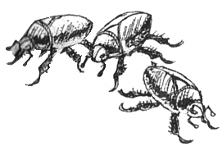

86 SECRET TUNNEL
Pushing away some suspiciously placed debris, the Warrior finds a trapdoor in the ground. Lifting it up reveals a tunnel. If he wishes to follow the mysterious tunnel roll 1D6:

1 Following the tunnel for hours, the Warrior ends up at a trap door above him. Pushing it up and climbing through, he find himself in the Palace guardhouse, surrounded by Pharaoh’s Guards. If the Warrior has a warrant, he is thrown in the Palace Dungeon for his crimes. Otherwise he is thrown out of the guardhouse.

2 Following the tunnel for a while, the Warrior finally comes to a trapdoor above him. Opening it and climbing through, he finds himself in the slave pits. This must be a way for them to escape! This is good for them but does not help the Warrior in any way.

3-4 The tunnel leads nowhere, just to a dead end.

5 The tunnel leads to the Palace Armoury. Lying around are various weapons and armour. Hearing guards approaching he has time to only grab one thing if he wishes too. Roll 1D6:

1 Long Sword
2 Broad Sword
3 Great Sword
4 Leather Armour
5 Heavy Armour
6 Plate Armour

6 The tunnel leads directly to the Palace Treasury. Hearing the guards approaching he has time only to grab what he can quickly. Roll 1D6.

1 A sack of 1D3 x 100 Gold
2 A sack of 1D3 x 200 Gold
3 A Treasure Card
4 A Treasure Card
1D2 Nehekharan Treasures
5 2 Treasure Cards
1D3 Nehekharan Treasures
6 1 Objective Room Treasure Card

87 FREE PASS
Blowing across the ground is a small piece of paper. It looks familiar to the Warrior and he picks it up to find that it is a boat ticket. The ticket can be used instead of paying the usual fee to travel to or from Nehekhara .

88 UNEVENTFUL DAY

89 OLD WARRIOR
The Warrior approaches another warrior. He seems to be a fighter but is adorned in strange armour. The two have a friendly chat in which he tells about his armour. It is made from the carapace of a giant scarab beetle. The fighter says it’s not plate mail but it’s tough and for free! The fighter then goes on to tell the Warrior that is getting old and wishes to give up on adventuring, he offers his scarab armour to the Warrior. If he wants it, it will give him 3 armour.

90 PHARAOH’S GUARDS

91 TROPHIES
The Warrior enters an interesting shop dedicated to monster trophy heads. There are many animal and monster heads on the wall, but one of the skulls appeals to the Warrior most of all. It is the skull of an Orgut, and from the dimensions of it he thinks he can make a helmet out of it. It will cost him 150 Gold and when worn will give the wearer +1 Toughness, for Orgut’s bone is very tough. If anyone roll a 6 To Hit the Warrior while he is wearing the helmet he must roll 1D6. On a 1, the helmet is hit hard and splinters into bone shards.

92 FEAST
The Warrior’s nostrils bring him to a large roasted animal on a spit, surrounded by a few other adventurers. He is greeted by them and he sits down and swaps stories. They welcome him to take part in the feast, and he does. He is rejuvenated by 3D6 Wounds.

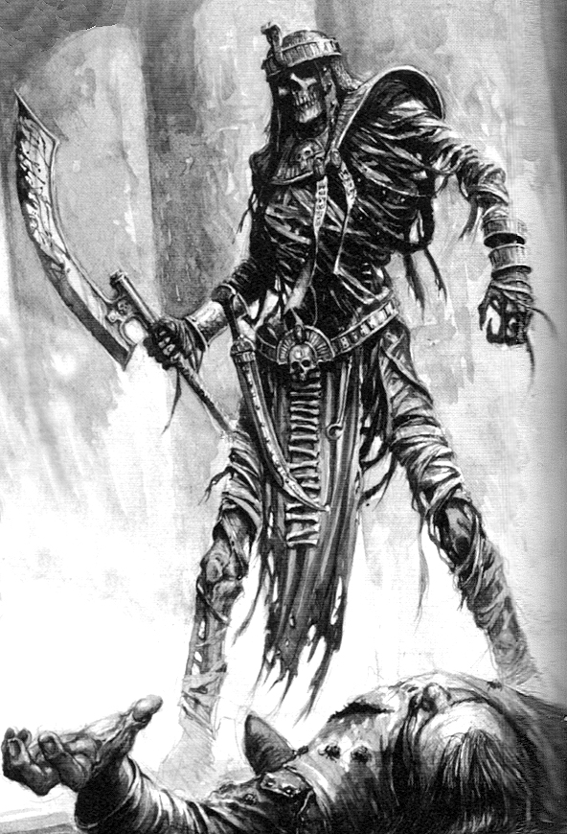

93 SHIFTY CHAP
Late at night the Warrior is pulled into an alleyway by a shifty looking chap. He tells the Warrior he has a cunning skill that he will teach the Warrior for 1D6 x 100 Gold. If he takes the shifty man up on his offer the shifty skill he offers is being able to hide in the shadows. To use this skill the Warrior must be in the corner of a board section. For 1D3 turns he may hide in the shadows. While in the shadows, Monsters cannot see him and therefore he is counted as not being there and is not the target of spell effects that are directed to specific Warriors. He can use this skill once per adventure. He can also break out of the shadows at any time.
94 CHANCE MEETING
The Warrior manages to catch up with an old friend who is in the city. They discuss recent adventures, and who chopped off what monsters head and so forth. Eventually he tells the Warrior of a great Pyramid he has once heard of. The Pyramid is rumoured to be laden with many riches, but was designed as a network of tunnels, creating a maze, to deter adventurers from entering. He then pulls from his pocket a torn old map saying he is too old to go questing anymore. He gives the map to the Warrior, which clearly shows the way to the legendary Pyramid. From now on instead of going on a normal quest, the Warrior, and any Warriors accompanying him may venture to this Pyramid and try to plunder its riches, only once though of course! Treat this as a normal adventure, with the following differences. Use twice the amount of Pyramid Cards with two Objective Rooms shuffled into the last twelve. When the Warriors complete the first Objective Room they receive the usual treasure, and a secret door opens at the far side of the room, so they can continue to the second Objective Room. When the Warriors complete the second Objective Room they receive 1 Objective Room Treasure Card each.

95 HEROIC DEED
Travelling past the slave pits, the Warrior notices a group of slaves being beaten by a group of Pharaoh’s Guards. The display is appalling to the Warrior and he decides to do something about it. Leaping into the fray, he pulls off the first two guards and then smashes the last two guards heads together. The other two are cowards and run. The slaves thank the Warrior and steal all worthy items off the two unconscious guards. They then run off into the others slaves never to be seen again. With the knowledge of a job well done, the Warrior continues on his way. The Warrior now has a warrant for Assaulting the Pharaoh’s Guards.
96 CAMEL RACE
The Warrior notices that there is a camel race going on in the middle of the City. If he wishes to enter, continue reading. Set up three passageway board sections, parallel to each other. Place five models, and the Warrior’s model at one end of the three board sections. This represents the competitors on camels at the starting line. Each camel moves 1D6 squares each turn; roll for each in turn. Before the race starts, roll 1D6 to see when the Warrior is rolled for in the turn; the others just go in order. The first person to pass the finish line (end of the board sections) is the winner! The winner receives a 1D3 x 200 Gold prize for such an amazing performance.

97 AUCTION
The Warrior discovers an auction taking place. He takes a look at what is being sold and it all looks pretty useless, all apart from one piece; a large golden statue, encrusted with jewels. He decides to wait around for the bidding to start. When the statue is brought out he is surprised that it was described as being a fake, when the Warrior is sure its real. The Warrior can, if he wishes to, enter the bidding for this piece, knowing that he could sell it for a fortune. If he does, roll 1D6 for the amount of people bidding for it (represent these with miniatures if you wish). The bidding starts at 100 Gold. This turn and the following turns roll 1D6 for the bidders. On a 4-6 they up the bidding by 50 Gold. On a 1-3 they decide it’s not worth it and quit bidding. For the Warrior to eventually win the bidding he must raise the bid by 50 Gold at the end of each turn also (he is bidding too!). When all other bidders have given up, the Warrior can buy the statue for the gold he has bid. When the Warrior has the statue roll 1D6. On a 1 it was a fake and no one will buy it from him. On any other number he can sell it for 1D6 x 300 Gold.

98 GOLD FEVER!
Madness seems to be over the City today with everybody running around with spades and buckets. The Warrior manages to stop one person and ask him what’s going on. “There’s Gold in them there cliffs!” he shouts pointing at the cliffs near the City. “People are finding Gold all around the cliff, and I ain’t missing out!. With that, he runs off. If the Warrior wishes to try and dig for some Gold at the cliff roll 1D6:

1-2 He is attacked by 2D6 Skeletons in the cliffs!!!! Fight a battle.

3 He finds 1D3 x 100 Gold

4-5 He finds 1D6 x 100 Gold

6 He finds 2D6 x 100 Gold

99 UNEVENTFUL DAY

100 THE LEGEND OF SETTRA
The Warrior notices an old man babbling about something. He is being pushed out of the way of everyone and told to shut up. The Warrior approaches the man and tries to ask him what he’s talking about. He is babbling on seemingly about nothing until one word strikes out from the rest ; ‘Settra.' The old man then presses an old map into the Warriors hand, and to his disgust it’s tattooed on a shaved scalp. The old man seems very happy to get rid of it and runs into the crowd. Looking at the map the Warrior deduces that it is a map to Settra’s Pyramid, or at least one he has lived in some time ago. He knows this because the symbol of Settra is above the destination inscribed on the scalp.

From now on instead of going on a normal quest the Warrior, and any Warriors accompanying him may venture to this pyramid and try to plunder its riches, only once though of course!

Treat Settra’s Pyramid as a normal adventure, except with the following changes.
Use all Pyramid Cards available, including Objective Rooms (Settra only uses the biggest Pyramids!) Shuffle them all together.

Every time an Objective Room is used place a door on the other side of the room, so the Warriors can continue on to the next one. Treat the Objective Rooms as normal, but after rolling for all other Monsters roll 1D6. On a 5-6 Settra is in the room. Place him at the back, out of close combat range. When in play, Settra will Move to and Attack the closest Warrior.

Obviously Settra can only be found once, but the rest of the Pyramid can be explored. If Settra is defeated, the Warriors receive 1 Objective Room Treasure Card each (not an extra one for the room though!) Enjoy.

Settra
Settra, best known for his victorious battle against Nagash in the Imperial year of -40, is without doubt the most powerful Mummy in the entire history of the undead. The very first Tomb King, Settra has grown in strength to an unbelievable level. An Undead army at his command, he reaps Nehekhara of life and scourges the seas with his undead fleet. Although Khemri is his main area of operations, he spends a great deal of time in Nehekhara, preferring to be surrounded by his own kind.

 | Settra
Wounds | 90
Move | 4
Weapon Skill | 7
Ballistic Skill | -
Strength | 6
Toughness | 6 (12)
Armour | 6
Initiative | 5
Attacks | 5
Damage | 6D6
Gold | 7000

ENEMY’S WS 1 2 3 4 5 6 7 8 9 10
Settra 3 4 4 4 5 5 6 6 6 6

Settra
Armed with Flail of Skulls; Armed with Staff of Osiris; Armed with The Crown of Settra; Regenerate 4D6; Terror 15; Tomb Rot 3D6.

Staff of Osiris
The Staff of Osiris is used once every Monsters’ Phase, after any spells have been cast. It shoots out a blinding white light at a random Warrior in Settra’s line of sight. The Warrior can try to dodge into an adjacent square if there is one available. To dodge, roll 1D6 and add the Warrior’s Initiative. If the result is 12 or more the Warrior has dodged the blast and is placed into an adjacent square of his choice. If the dodge is failed the blast inflicts 1D3 x 10 Wounds.

Flail of Skulls
The Flail of Skulls is an ancient magical weapon crafted from the skulls of fallen enemies. In addition to acting as a normal weapon, the jaws of the skull bite into the victim. If the To Hit roll is a 5-6 the flail rips out chunks of flesh, causing an extra 2 Damage Dice, (6 + 2 = 8 dam dice).

The Crown of Settra
The Crown of Settra has supreme control over all Undead Monsters in the Pyramid. If Settra’s Wounds ever get down to 30 or below, any Undead in the battle will turn and fight the Warriors attacking Settra, if possible, and will continue to do so until Settra’s Wounds reach 30 or above. In addition, the Crown of Settra (crafted by his own hand), is really his way to immortality, or at least an Undead immortality. The Crown cannot be removed from Settra’s head, and if Settra is ever killed, the Crown instantly begins drawing undead essences from the surrounding area, building life force within Settra. When the absorption is complete, Settra again rises, and is at full Wounds. Once the battle is over he rises after 2D6 turns.

Nehekhara Settlement Events © Ben Head

