
• DUNGEON EVENTS •

1 NOTHING HAPPENS

2 CAVE IN
As the Warrior’s enter this area of the dungeon, the ceiling starts to shudder and the roof caves in. Place the cave-in marker in the board section at the end of the Warriors’ Phase. All exits apart from the one where the Warriors entered are now blocked. Any Warrior's still on this board section at then end of next turn are crushed by falling rubble and are killed. Warriors attempting to escape are not subject to the rules of pinning whilst in this room. This room is now impassable and may not be re-entered as normal. Instead, the Warriors may try to dig a way through as described in White Dwarf 192. If the Warriors succeed, the cave in has been cleared, and the room may now be re-entered.

3 DWARF PROSPECTOR
Slumped against the wall the Warriors find a dying Dwarf prospector. At the Warriors approach, he tries to rise, but then slides back down the wall. He hands the Warriors a key, and with a dying breath says, “This is the key to the portcullis. Without it you will never get through.

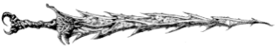

4 SCORPION SWARM
A scuttling mass of stinging, biting scorpions emerges from the darkness and engulfs one of the Warriors. There are 2D6 + 4 scorpions in the swarm. Roll your Warrior’s normal damage for the attack (he does not need to roll to hit). The number rolled is the number of scorpions your Warrior manages to kill for 10 gold each. The number remaining each inflict 1 Wound, with no modifiers for Toughness or armour.

5 POISON DART
With a faint click, a dart shoots from the wall and embeds itself in a random Warrior’s leg. He suffers 1D6 Wounds with no modifiers for Toughness or armour. Now roll another D6. On a score of 1, 2 or 3, the dart was poison, and it has got into the Warrior’s system. While poisoned, the Warrior’s Strength is reduced by -1 for the rest of the adventure, or until he drinks a Healing potion.

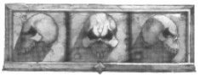

6 LOST
After wandering around the dungeon for what seems like an eternity, the Warriors deduce that they can only be lost. Take another 1D6 Dungeon cards and put them on top of the Dungeon deck.

7 LOST GOLD
A random Warrior realises that his backpack has a small hole in it and he has lost 1D6 x 200 gold.

8 IMPERIAL KNIGHT
The Warriors meet an Imperial Knight Panther on a quest. He warns them about hideous Monsters that lurk nearby. For the next battle, the Warriors have the Ambush ability. If the Monsters also have Ambush, then it is cancelled out, otherwise the Warriors get to make an extra attack before their usual attacks.

9 SPIKED PIT
A random Warrior tumbles head first into a pit. He takes 4D6 Wounds as he lands at the bottom with a thud, impaling himself on the sharpened pits at the bottom. He may only escape from the pit if he, or another Warrior has a rope, or a Levitate spell is cast on him. Otherwise, he must spend the rest of his days at the bottom of the pit.
10 PRISONERS
Three prisoners emerge from the shadows and run towards the Warriors. They explain that they managed to escape their captors, and now seek protection, and safe passage from the dungeon. If the Warriors let them join the party, they hide in the shadows during combat. At the next Settlement the Warriors visit, roll 1D6:
1 The prisoners are rich merchants, and report straight to the Captain of the Guard about their kidnap. Unfortunately, it is the Warriors who have been reported. Each Warrior must pay 1D6 x 100 gold to ‘convince’ the guards that they are innocent.
2-6 The prisoners are rich merchants, and due to the kindness of the Warriors, rewards each one with 2D6 x 100 gold.

11 NOTHING HAPPENS

12 SNOTLING
A small figure runs out of the darkness and weaves his way around the Warriors’ feet. They recognise it as a Snotling, who screams a warning to any Monsters who might be nearby.
While the Snotling is with the Warriors, every time an Unexpected Event reveals Monsters, the Snotling cries out, alerting the Monsters to the Warriors presence. The Monsters now have the Ambush ability, or if they already have it, gain an extra attack each for their first turn. At the end of each turn, roll 1D6. On a score of 1, the Snotling runs off into the darkness. The Warriors may kill the Snotling immediately, but when he dies his death scream echoes around the dungeon. Roll once on the Monster Table one level higher than the Warriors’ to determine what Monsters arrive to investigate.

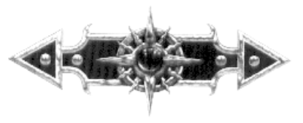

13 DEAD BODY
The Warriors find a dead body lying in the middle of the floor. Clutched in its hands is a small leather bag. A Warrior may take the bag, in which case roll 1D6:
1 Poison Gas! A trap is sprung. Every model on this board section takes 1D6 Wounds with no modifiers for Toughness or Armour. The bag is empty.
2-5 The bag contains 1D6 x 50 gold.
6 The bag is a magical “bag of carrying”. The Warrior who receives it can use it to store one item of equipment. This bag, and the item in it do not count towards a Warrior’s total Treasure items when determining who receives a new one.

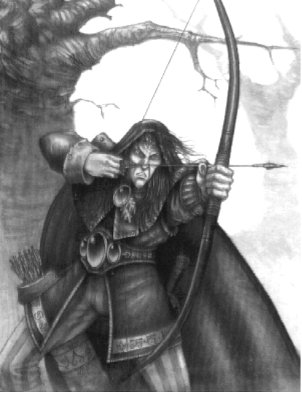
14 CHANGE OF PLAN
A cloaked stooped figure slinks into view, keeping to the shadows and moving with an eerie silence. He approaches the Warriors while looking around him for Monsters, and whispers “I bring important news. Your quest must be immediately abandoned, as the King is in greater danger than you could ever imagine. If you return now, you will each be given 750 gold for your troubles.” If the Warriors abandon their quest, they must return as normal to the beginning of the dungeon entrance. When the Warriors reach the next Settlement, roll 1D6:
1-3 The stranger lied, and the King is perfectly safe. If the Warriors abandoned their mission, each one must lose 1D6 x 100 gold as he tries to make amends for his shame at failure.
4-6 The stranger was telling the truth. If the Warriors abandoned their mission, they are each given 750 gold for their loyalty. Otherwise, if they continued onwards, at the next Settlement they are refused entry, and must either travel on to the next Settlement, or begin the next adventure.

15 LANTERN GOES OUT
A sudden breeze blows out the lantern. Unless the Warriors have another source of light they are in darkness! While in darkness, the Warriors may do nothing each turn while they try to relight the lantern. At the beginning of each turn, roll 1D6. On a score of 5 or 6 the lantern comes back on, and the Warriors may continue their journey. If the Warriors have to fight Monsters in the pitch black, then all their To Hit rolls are at -2.
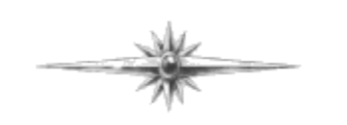

16 TRIP OVER
A random Warrior loses his footing on the flagstones, and trips over. Unfortunately, he has sprained his ankle. For the rest of the adventure he is at -1 Move.

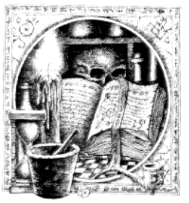

17 DEJA VU
The Warriors seem to think that their surroundings look similar to those encountered before. Roll 1D6:
1-3 They are correct, as they have been going around in circles! Place the Warriors back on the board section where they started. They must continue on from there.
4-6 Although the surroundings do look the same, the Warriors are indeed on the right track.

18 WRONG DUNGEON
The Warriors suddenly realise that they might be in the wrong dungeon. They have had no signs yet that they are in the correct one, and the layout seems different than the one described to them. Draw another Objective Room Dungeon Card from the pile and shuffle it into the last six cards of the Dungeon deck. If the Warriors come across this room first, then they have entered the wrong dungeon. Although they may fight a battle in the Objective Room and receive Treasure for it, they may not claim the reward for finishing the dungeon. If the Objective Room is the correct one, then the Warriors may claim the reward as usual.

19 FOOTPRINTS
The Warriors spot some footprints in the dust that lead to a blank section of the floor. If they investigate roll 1D6:
1 A random Warrior activates a trap! A huge spiked metal ball swings out of the ceiling and slams into the Warrior. He suffers 2D6 Wounds with no modifiers for Toughness or armour.
2-5 The Warriors find nothing.
6 The Warriors find a concealed door in the wall. Take 1D6 extra Dungeon cards and put them face down next to the wall. Now take an Objective Room card and place it on the bottom of the pile. The Warriors may explore this new section of the dungeon as normal. When they reach the Objective Room, roll on the Objective Room Monster Table. If all the Monsters are killed, each Warrior receives 1000 gold each instead of an Objective Room Treasure Card.



20 PIT
A huge pit suddenly opens up in front of the Warriors. Place a Pit of Despair counter in the middle of the room, or corridor. Roll two dice for each Warrior. If anyone scores a double 1 they have fallen into the bottomless pit to their doom. Otherwise, place each Warrior on the side of the pit. If the pit blocks a room, or a corridor section, the Warriors may attempt to search for Hidden Passages as described in White Dwarf 189. If they find one, place the remaining Dungeon cards behind the new door and continue the adventure from there. If the pit separates the Warriors, each group must find a secret passage, then place the board section to try and connect the two doors.
21 COAST IS CLEAR?
The Warrior carrying the lantern creeps up to the corner of the archway and looks cautiously around. Seeing that the coast is clear, he turns back at the other Warriors and beckons for them to follow him. As soon as he looks back again, he sees the slavering face of a <Roll on the Monster Table>. Fortunately there is just 1 of these beasts. If it is killed, do not take a Treasure Card.

22 NOTHING HAPPENS

23 POUCH
The Warriors find a small pouch off to the side of the room. If they decide to open it roll 1D6:
1 As soon as a random Warrior opens the bag, red gas escapes from the opening, affecting the Warrior. He loses 1D3 Permanent Wounds, and 1 Toughness for the rest of the adventure, until he reaches a Settlement.
2 One Warrior finds 1D6 x 50 gold.
3 One Warrior finds 1D6 x100 gold.
4 Each Warrior finds 1D6 x 50 gold.
5 Each Warrior finds 1D6 x 100 gold.
6 One Warrior finds a Treasure Card.

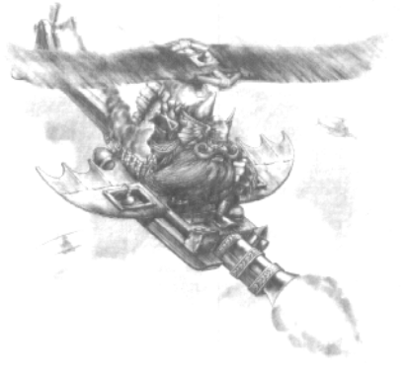

24 RUNES
The Warriors notice that, inscribed on the wall, are strange runes. Roll 1D6 for each Warrior. On a 5, or a 6 that Warrior understands the runes, and explains that they reveal how to open a secret alcove in the wall that contains great riches. If anyone understands the runes, each Warrior may take 1 Treasure Card, but roll twice on the Monster Table to see what arrives to rescue it’s Treasure.

25 WAVE OF MAGIC
The Warriors suddenly experience a strange sensation, as if their surroundings had suddenly changed. Shuffle the remaining dungeon cards from any passages not explored yet and replace them. These passages have now been altered, and could result in the Objective Room being much closer than before, or further away.

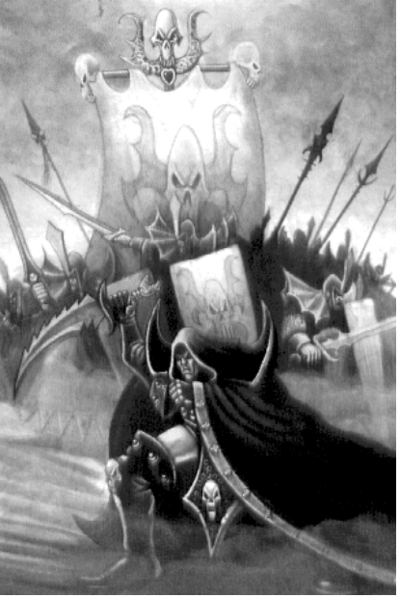

26 WIZENED OLD MAN
A small wizened old man with white hair, and a flowing white beard approaches your Warriors. “Hello to you sirs. Would you help an old man to find his spectacles? I need them to study this map.” He waves a map in front of your Warriors’ noses. The Warriors may refuse to help the old man in which case he walks off with a huff. Otherwise, if the Warriors decide to help him roll 1D6:
1-2 The old man is actually a Thief in disguise. While the Warriors are looking for his spectacles, he backstabs 2 of them. Each stabbed Warrior loses 4 Wounds, with no modifiers whatsoever.
3-4 The Warriors find his spectacles and put them back on his face. “Thankyou very much” he says. “By the way, the room up ahead is supposed to contain a Treasure trove.” The next room the Warriors enter, after killing all of the Monsters present, they may take an extra Treasure Card.
5-6 After finding his spectacles, the Warriors turn to leave. “Don’t be in such a rush” the old man exclaims. “I have something for your kindness.” He reaches into his robes and extracts 1D3 parchment scrolls. Each one contains a random spell for the spellcaster in the party. This spell may be cast once only at a cost of zero power.
Roll 1D6. On a score of 1, 2 or 3 draw another Event card immediately.

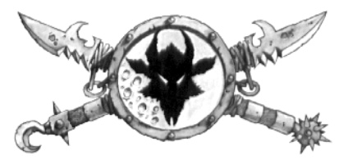

27 GAS MASS
A swirling mass of purple gas twirls around in front of the Warriors. Strange sounds can be heard emanating from the centre, as if there were people on the other side. Each Warrior must roll 1D6 if he decides to step through it:
1 A fierce pain courses through the Warriors veins. He automatically loses (1D6 + Battle Level) Wounds with no modifiers. The Warrior emerges on the other side, just metres in front of the other Warriors. Place him 2 squares away.
2 The Warrior jumps through the gas...and hits his head. Unfortunately, the gas was in front of a wall, and your Warrior loses 1D6+1 Wounds, only modified for Toughness unless the Warrior has a helmet.
3 The Warrior steps through the gas. The Warrior seems to recognise his surroundings, and with just cause. The Warrior has appeared back at the entrance to the Dungeon. Place the Warrior back on the board section where he started. If he has the lantern, the other Warriors must wait for him unless they have an alternate light source. Otherwise, if the other Warriors have the lantern, the teleported Warrior can make his way back to them - he has already traversed this part of the dungeon, and remembers it’s layout.
4 The Warrior steps through the gas, but nothing happens. It appears to be just an illusion.
5 The Warrior steps through the swirling mist. Instantly he is transported to the next City, leaving his fellow Warriors alone. If he had the lantern, fortunately he remembered to hand it to another Warrior before entering.

6 The Warrior steps through the swirling mist. Instantly he is transported to the next Seaport, leaving his fellow Warriors alone. If he had the lantern, fortunately he remembered to hand it to another Warrior before entering.

The gas stays here for the duration of the adventure, and the Warriors may step through at any time.

28 NATURAL LIGHT
This walls of the dungeon have small stones embedded in them, emitting a strange green light. This board section and 1D6 adjacent board sections are lit, and the Warriors may explore them on their own.

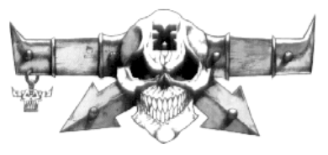

29 STONE PILLARS
Stone pillars suddenly shoot up from the floor and slam into the ceiling. Roll 1D6 for the number of pillars, and randomly determine their position one at a time. If any hit a Warrior, he must make an Initiative test. If he passes, he leaps out of the way just in time - place him in any adjacent squares if there is room. If he fails, he is carried up to the ceiling and squashed. He loses (1D6 + Battle Level) Wounds, with no modifiers, and falls to the ground adjacent to the pillar. For every pillar that a Warrior has to escape, subtract -1 from his Initiative test roll.

30 PORTCULLIS
With a grating sound, a portcullis suddenly slams down behind the last Warrior, cutting them off. The way behind is now blocked. The only way to continue is onwards, or to search for a secret door (White Dwarf 192).
31 CHILL
The moment the Warriors set foot in this section of the dungeon, an eerie chill falls over them, slowly decreasing in temperature. Roll 2D6, subtracting the Warrior’s Battle Level:
1-3 The temperature stops around zero degrees. Although cold, the Warriors press on.
4-6 The below freezing temperature cause 1D6 + 3 Wounds to each Warrior, modified for Toughness only.
7-9 The temperature continues to decrease, chilling the Warriors’ bones. Each Warrior loses 2D6 Wounds, and the use of his arms for 1 turn.
10-12 The temperature drops very drastically, causing frostbite to each Warrior. They each lose 3D6 Wounds, and the use of their arms for the next 1D3 turns.
If the Warriors have frozen arms, they are at -2 To Hit.

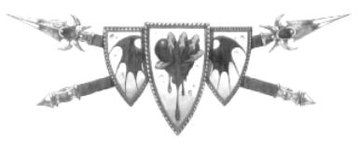

32 LABYRINTH
The Warriors discover a labyrinthine layout of passageways behind a secret door on the board section they are now on. Shuffle the remaining Dungeon cards not used in play along with one Objective Room, and place them behind the door. If the Warriors decide to explore the labyrinth, each room has a door on each side, indicating three other exits from the room. If the Warriors make it to the Objective Room, roll once on the Monster Table two levels above that of the Warriors. Once all the Monsters are killed, take two Objective Room Treasure Cards.
33 NOTHING HAPPENS

34 PRISON
There are 1D6 dungeon cells in this room - all of them contain prisoners. The Warriors may elect to free any number of prisoners, but for each one they give freedom to must roll on the following table:
1 The cell appears to be empty. Moving inside to get a better look, the Warriors hear a metallic clink behind them - the cell door has shut and locked! Each turn, beginning now, a Warrior may try and pick the lock with an Initiative test (9), or force the cell door open with a Strength test (9). If he fails, an electric shock courses through his body, causing 2D6 +4 damage.
2 There was a good reason why the cell was locked. It contained a berserk Barbarian. Have a fight with Barbarian three levels above your Warriors, treating him as berserk automatically each turn. Put him on full Wounds. If the Warriors defeat him, they gain (100 x Barbarian’s Battle Level) Gold.
3 As soon as a Warrior touches the cell door, he changes appearance. Choose a Warrior counter. This is the appearance that the Warrior now takes on. For the rest of the adventure, treat Monster placing as in the example below.

eg. The Warrior Priest has taken on the appearance of the Witch Hunter. It is time for placing Monsters. A counter is drawn, indicating an Orc attacks the Warrior Priest. Roll 1D6. On a roll of 1-3, place the Monster as normal. On a roll of 4-6, the Monster attacks the Witch Hunter instead, as well as any other Monsters he has attacking him.
4 A scraggly old man thanks your Warriors kindly for releasing him, and gives them 1D6 x 50 Gold reward.
5 The Warriors free a respected Nobleman from the clutches of Chaos. As a reward, he offers a Warrior the hand of his daughter in marriage. If he accepts, when he reaches the Settlement roll 1D6. On a roll of 1-5 the daughter rejects your Warrior. On a score of 6 the marriage goes ahead. Your Warrior is now married, and does not have to pay living expenses in any Settlement, as his wife cooks and cleans for him while he is away slaughtering evil. If the Warrior declines the offer of marriage, the Nobleman offers the Warriors lodgings in the next Settlement for free.
6 Behind the door is an old abandoned equipment room. Most of the weapons are old and rusted, but there are two items in good shape. Take two Treasure Cards.

35 SPORES
As soon as the Warriors step into this section, spores erupt from the ground, covering the Warriors with dust. Roll 2D6 for the number of spores, and 1D2 for each spore to determine the damage each Warrior takes (modified only by Toughness against the total damage).

36 GHOST
The Warriors are surprised to see a ghost beckoning to them. As they approach, the ghost seems to indicate something to the Warriors. Each Warrior must make an Initiative test. If someone passes, he realises that the ghost is pointing to his scabbard - his empty scabbard. If a Warrior gives him a sword, then the ghost fades away, happy to be complete in the afterlife. Just before he goes, he points to some amulets in the corner of the room, hidden in the darkness. There are enough for each Warrior to have one. The amulets each have 1D3 points of Luck stored in them, and may be used at any time in the future.

37 TREASURE HOARD
The lucky Warriors have stumbled upon a hoard of Treasure. If they take any, each Warrior must roll 3D6 x 100. Now, starting with a Warrior, draw Treasure Cards until the amount rolled is reached in Gold value. Repeat this for all the Warriors to indicate how much Treasure they take with them. Now, roll 2D6 for each Warrior that took Treasure. For each double, roll on the Objective Room Monster Table as the Monsters arrive to protect their loot.

38 ALTAR
In the corner is a small altar about waist high. There are small imprints on the surface, indicating equipment should be placed there. Each Warrior may lay 1 Treasure Card upon the altar and roll 1D6:
1 The item disappears. The Warrior waits for something to happen, but to no avail. The Treasure is lost!
2-5 The item of Treasure disappears. A few moments later, a pile of Gold appears in its place. Take 1D3 x 100 Gold.
6 The item vanishes, only to be replaced by another such item. Take 1 Treasure Card.

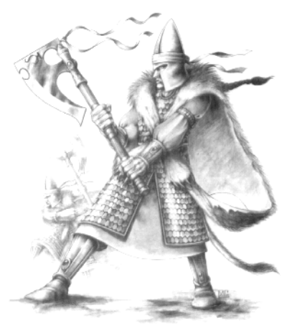
39 FELLOW ADVENTURERS
The Warriors meet up with a fellow band of adventurers. Their mission is (the same mission as the Warriors). Now it seems that there is a race on to complete the mission the fastest. Roll 2D6 and add the number of Warriors in the party. The Warriors must complete the mission within that time or the rival band manages to get to the Objective Room first. When they get there, all the Monsters are dead - they get no reward for completing the adventure.



40 HALL OF DARKNESS
Even with the lantern on, or any other source of light (even magical), this board is pitch black. As soon as all the Warriors are on the board, they cannot see a thing. For each point of Movement expended on this board section roll 1D6:
1 It is so dark the Warrior moves backwards 1 square.
2 The darkness is so complete that the Warrior moves to the right 1 square.
3 Unable to see in the darkness, the Warrior moves left 1 square.
4-6 The Warrior takes a step forward, hoping that he will soon be out of the darkness.
For the purpose of directions, forward depends on which direction the Warrior wants to go. If the Warriors fight Monsters in the darkness, their To Hit rolls are modified by -2. Fortunately for them, the darkness affects the Monsters as well - all their To Hit rolls are modified by -2 also. All special abilities which require light (Fly, Dodge etc...) have no effect. In addition, if a Monster causes Fear or Terror, the Warriors do not need to roll - they cannot see what they are fighting!

41 BLACK AND WHITE
The floor of this section of the dungeon is divided into a pattern which looks like a chess board. The flagstones alternate in black and white. Starting with a random Warrior, roll 1D6. On an even number, the square he is standing in is white. On an odd number, he is standing on a black square. Divide the room up into black and white squares, so that each Warrior is either standing on a black or a white square. Then roll 1D6 for the black squares, and 1D6 for the white Squares:

Black Square
1 From the ceiling burst massive streaks of lightning, targeting each Warrior standing on a Black Square. The Warriors writhe in agony, losing 2D6 Wounds.
2 The flagstone the Warrior is standing on suddenly starts to drop. Unless the Warrior can pass an Inititave test, he fails to catch hold of the surrounding stones, and falls into a pit. He may be rescued by a rope, or by having the Levitation Spell cast upon him. Otherwise he must remain in the pit for the rest of his days...
3 The Warrior suddenly finds himself encased in a strange clear cylinder, it having shot up out of the ground beneath him. He and his fellow Warriors can try and bash through the casing. Each turn, each Warrior rolls 1D6 and adds his Strength. Keep a record of this score. When the combined score is equal to or greater than 30, the casing shatters, and the Warrior takes 2 Wounds, not modified for anything.
4 The lightning strikes the Warriors' Gold, fusing half of it into a single mass. The Warrior can sell this Gold Nugget in a City or a Seaport, but will only get 50% of it's value.
5 The Warrior feels a strange tingling sensation by his side, and when he looks down, he finds that his weapon has been replaced by a strange object. Randomly choose an object belonging to the Warrior, and swap it with a randomly chosen object from another Warrior on a black square.
6 With a strange whizzing sound, each Warrior finds himself having swapped places with another Warrior on a black square.

White Square
1 From the ceiling burst streaks of lightning targeting each Warrior standing on a White Square. The Warriors writhe in agony, losing 2D6 - 3 Wounds.
2 The flagstone the Warrior is standing on suddenly starts to drop. Unless the Warrior can pass an Inititave test, he fails to catch hold of the surrounding stones, and falls into a pit. He may be rescued by a rope, or by having the Levitation Spell cast upon him. Otherwise, in 2D6 turns, the flagstone rises to the surface, and the Warrior is free.
3 The Warrior suddenly finds himself encased in a strange clear cylinder, it having shot up out of the ground beneath him. He and his fellow Warriors can try and bash through the casing. Each turn, each Warrior rolls 1D6 and adds his Strength. Keep a record of this score. When the combined score is equal to or greater than 20, the casing shatters, and the Warrior takes 1 Wound, not modified for anything.
4 The lightning strikes the Warriors' Gold, fusing a quarter of it into a single mass. The Warrior can sell this Gold Nugget in a City, but will only get 50% of it's value.
5 The Warrior feels a strange tingling sensation by his side, and when he looks down, he finds that his weapon has been replaced by a strange object. Randomly choose a non-magical object belonging to the Warrior, and swap it with a randomly chosen non-magical object from another Warrior on a white square.
6 With a strange whizzing sound, the Warrior finds himself having appeared one square alongside another Warrior on a white square.

42 GOBBLEDIGOOK
A random warrior suddenly tries to speak, and finds that no intelligible words come out of his mouth. It must be the legendary curse of this dungeon which has struck him. It is said that all <Warrior's Character> who enter this dungeon will lose the power of speech until they offer a tribute to Khorne. The tribute which the Warrior must give is the bodies of 1D6 Monsters. He will not get their Gold value from having killed them, instead he must offer them to Khorne as a tribute. Once this is done, he will be able to speak again.
Of course, since he cannot speak, he cannot cast any spells, use blessings, or perform any other tasks which require a spoken word, this includes communication with other Warriors.

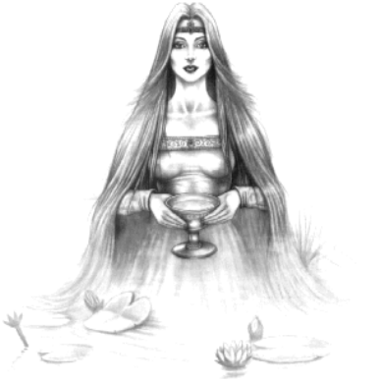
43 SPEED POTION
The Warriors meet up with a wizened old man who seems rather spritely for his age. "Hellotherefriends", he says, rather quickly.You'rejustintimetohelpmetestmyspeedpotion.It'sanewconcoctionofmineanditworkswonders." He produces <no. of Warriors in game> flasks and hands them to the Warriors. There is enough for 2 doses each. They may be drunk at any time, upon which 1D6 should be rolled on the following table (each effect lasts until the end of the adventure - they are not cumulative):
1 The Warrior starts to feel sluggish, and he struggles to catch up to the other Warriors. The potion has had an unfortunate side effect, causing the Warrior's Move to be reduced by 1D2, and his To Hit rolls to be decreased by -1.
2 The potion courses through the Warrior's body, filling him with warmth. Unfortunately, that is all the good it does, as the Warrior suddenly discovers that he cannot move as fast as he used to. His Move is reduced by 1.
3 The potion turns out to be a flask of the local beer from the Alehouse. The Warrior ends up drinking the whole lot as it tastes so good.
4 The Warrior's reflexes start to speed up, and the other Warriors notice a change come across him. He seems to be more active than he was before he drank the potion. It seems that the old man's Speed Potion worked! The Warriors Move is increased by 1.
5 The Warrior's muscles tense, and his eyes open wide. He starts to run on the spot, slowly at first, but gradually increasing speed until his feet are just a blur. His reflexes have also improved. The Warriors Move is increased by +2, and he gets an extra attack, as he leaps nimbly around the Monsters.
6 The Warrior collapses onto the ground, writhing in a spasm of intense strangeness. Suddenly he sits upright, his eyes darting around, staring intently at his surroundings. He leaps to his feet, and runs around the room a few times, which to the other Warriors, seems to take a few seconds. His Move is now increased by 1D4, and he receives an extra +2 Attacks. In addition, all Monsters are at -1 to hit the Warrior as he speeds blindly around them.

44 NOTHING HAPPENS

45 SURPRISE
The Warriors each find a small rock, which seems to be hollow inside. If a Warrior decides to try and break one open, roll 1D6:
1 The rock shatters, covering the Warrior and another random Warrior in spores. The two Warriors break out in fits of coughing, and it seems they will never stop. They seem to be suffocating! Suddenly they stop, and collapse to the ground, minus 2D6 Wounds.
2 The rock breaks open, and out crawls a horde of Scorpions. There are 2D6 in total.
3 The rock is hacked at, shot at, stomped on, and thrown against the wall, but it seems to be just a small rock after all.
4 The small rock splits down the middle, and out tumbles 1D6x50 Gold.
5 The Warrior is enveloped in a purple gas, which twirls up his nostrils and ears, and swirls around his body. The gas will remain in play for 1D6 turns, upon which it will dissipate. While enveloped in the gas, the affected Warrior must subtract -1 from his To Hit rolls, but so must any Monsters, as they cannot see him properly to hit him.
6 The rock cracks in half, revealing…. nothing! Frustrated, the Warrior flings the rock at the wall. With a loud explosion, the wall collapses into a pile of rubble, revealing another passageway through it. Shuffle the remaining dungeon cards, and place half of them through the wall. Luckily for the Warriors they found this secret door otherwise they might never have completed their Quest.

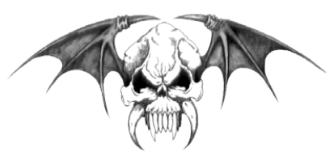

46 BOOK OF …
Your Warrior has discovered the legendary Book of (roll 1D6):
1 Curses
This Book has long been believed to be lost. Now the Warrior has had the unfortunate luck of discovering it. As long as he carries it (and he cannot get rid of it until he pays 2D6 x 100 Gold at the Temple in a City or a Seaport) he will be at -1 To Hit, and Monsters will always attack the Warrior first. (The Warrior must always have a Monster placed next to him in the Monsters Phase.)
2 Taxes
This magical tome, believed to have been conjured up by the Wizards in service to the City Council, has somehow ended up in the dungeon. While in possession of this book, the Warrior must pay 1D6 x 10 Gold each turn whilst in a Settlement as tax for staying there. No one will voluntarily take the book off him, but he may leave it in the next dungeon he travels to.

3 Poetry
The book contains lovely pages of verse by well known poets of Bretonnia.
4 Smells
As the Warrior flips through the pages of this book, strange smells emanate from the pages, wafting through the dungeon. The Warrior may try and use the book to his advantage in a battle. When fighting Monsters which are not undead, the Warrior may try to disorientate them by opening the book and revealing the smells. At the end of each turn the Warrior decides to use the book, roll 1D6. If the result is greater than the amount of Monsters of a particular type left on the board section, they suffer a -1 penalty To Hit, as they are too busy retching to attempt to hit the Warriors properly. If the result is equal to or less than the number of Monsters, the smell is favourable to the Monsters, and they gain +1 To Hit.
5 Spells
The book crackles and arcs with a peculiar energy. Inside, the archaic writing gives indication of spells from an ancient civilisation. There are 1D6 spells in the book, which can be used once each, before the page crumples and blows away in the wind. Randomly choose the spells from any spells available, from any Characters.
6 The Necronomicon
The book is embossed with magical writings on the front and back of its black leather cover. Inside, the pages are bone white, and contain many incantations. If the Warrior decides to read from the book (he may only do this in a combat, as the book draws its power from death), roll 1D6:

1 The Warrior senses that something is wrong, when halfway through the first paragraph, a skeletal hand reaches out from the pages and grasps the Warrior around the neck. Gasping for breath, the Warrior tries to pull away, but the hand has a sturdy hold. His fellow Warriors attempt to help him, but an invisible force seems to prevent them. After what seems like an eternity, the hand retracts back into the pages, leaving the Warrior with a charred neck. The Warrior loses 2D6 Wounds with no modifiers, and also 1D4 Permanent Wounds
2 The Warrior reads the passages aloud, bringing the words to life with his incantation. A wind whips up around the Warriors' legs, slowly building into a fierce hurricane. Although they try to hold on, the wind sweeps them off their feet, and hurls them at the wall. Each Warrior loses 1D8 Wounds, with no modifiers.
3 The Warrior reads aloud the words, summoning 1D6 Zombies to do his bidding. They are placed around the Monsters using the one-on-one rule, and have their turn after all the Warriors' turns. After the battle, they sink back into the ground.
4 The Warrior reads the words aloud, summoning 1D6 Skeletons to do his bidding. They are placed around the Monsters using the one-on-one rule, and have their turn after the Warriors. After the battle, they sink back into the ground.
5 The Warrior reads the words inscribed in the book, summoning 1D3 Mummies to do his bidding. They are placed around the Monsters using the one-on-one rule, and have their turn after all the Warriors' turns. After the battle, they sink back into the ground.
6 The Warrior reads aloud the words, summoning a Lich to do his bidding. He is placed around the Monsters using the one-on-one rule, and has his turn after all the Warriors' turns. After the battle, he sinks back into the ground.

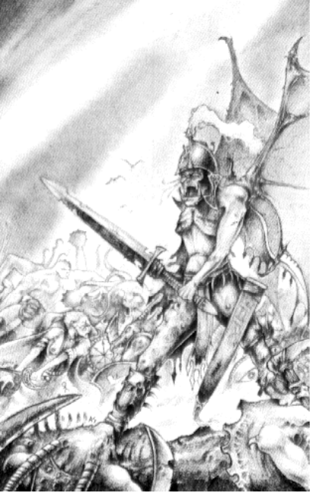

47 LOOSE FLAGSTONE
A random Warrior trips over a loose flagstone, stubbing his nose on the ground. He loses 1D6 Wounds, only modified for Toughness.

48 TREASURE PILE
The Warriors discover a huge pile of Treasure in the corner of the room. Thinking it a bit suspicious, they scour the room looking for any sign of traps. Finding nothing, they take a good long look at the Treasure… If anyone decides to rummage through the pile, roll 1D6:
1 Surprise, surprise, the Treasure is indeed a trap. The image vanishes, and the Warrior in question disappears from sight, having fallen through a large hole in the ground. With a loud squelch the Warrior is impaled upon huge metal spikes at the bottom of the pit. He loses 2D6 + 6 Wounds.
2 The Treasure suddenly vanishes, and out jump <Roll on the Monster Table>. On top of any of their other special abilities, the Monsters have the Ambush ability.
3 The Treasure seems to be only an illusion, for the Warriors cannot touch it.
4 Most of the Treasure seems to be just lead painted to look like Gold. By scraping the paint of the Treasure, the Warrior gathers enough to sell at a Settlement for 1D6 x 50 Gold.
5 The Warrior manages to find <Pick a Treasure Card>.
6 Their is enough Treasure in the pile for each Warrior to take a Treasure Card.

49 WEIGHTLESSNESS
The Warriors suddenly experience weightlessness, and float to the ceiling. In shock, their arms flail around, causing them to fly around the room wildly. What causes the weightlessness is unknown, but as long as they are on this board section, they will be able to fly. If there are any monsters on the board, they will also be flying. Whilst flying, no one may be pinned.

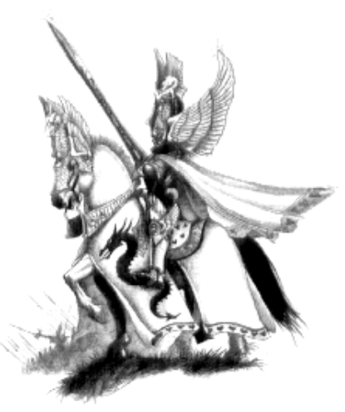

50 DISAPPEARING EQUIPMENT
Without warning, a Wizard leaps out of the shadows, shouting a spell incantation. Almost as quickly as he appeared, he disappears back from where he came from, leaving the Warriors bemused. Each Warrior has lost 1D3 random items of equipment, scattered throughout the dungeon. Use a counter to represent each item, and throw it in the air over the game. Wherever it lands, that is where the item has been sent to. Obviously, if it lands nowhere near the game, due to a crazed throw, use the square it was closest to. To reclaim their equipment, the Warriors must travel to the rooms where their items are in and land on the same square.

51 LOOSE PANTS
A Warrior suddenly trips over with his pants around his ankles. "Must be losing weight", the Warrior mutters, picking himself off the floor and pulling his pants up.

52 LOOK OUT BELOW!
The Warriors hear a shout from above - "Look out below!" Moving quickly to one side, the Warriors witness a Goblinoid figure falling from the roof. Just as he is about to hit the ground, a rubber rope attached to him and the ceiling pulls taut, flinging him up again to the ceiling. This process continues for some time until finally he unties himself and drops to the ground. "Care to try? It's great fun." If any of the Warriors wish to try, roll 1D6. If a 1 is rolled the rope breaks and the Warrior falls to the ground, losing 1D6 Wounds. Otherwise, the Warrior has great fun!

53 SGLOOMI PO
Huddled up in the corner of the room, is a strange blue mass of flesh, with many strange protuberances on it. Moving closer, the Warriors notice that it is a small animal. They are startled when it speaks. "Please help me. My name is Sgloomi Po, and I was attacked by a horde of Nurglings. Although similar in size to me, there were about 20 of them, and they soon overpowered me, leaving me for dead. I have been resting here trying to regain my strength, but I would appreciate it if you could lend me assistance." If the Warriors cast a healing spell on Sgloomi Po, or use bandages or provisions to equal 10 Wounds, Sgloomi Po will reward them with a small wand. The wand has a random Wizard's spell stored in it, which may be cast once per adventure at no Power cost.

54 TREASURE MAP
While searching this room, a Warrior finds an old faded Treasure map underneath an empty crate. Take the Treasure Map card, and follow the rules in White Dwarf 189.

55 NOTHING HAPPENS

56 DUST CLOUD
A strange howling of wind echoes around the passageway. From around the corner, sweeps a huge dust cloud, covering the Warriors from head to foot in dust. Coughing and spluttering, the Warriors try get out of the way of the dust cloud. Fortunately, the cloud soon dissipates, leaving the dust covered Warriors attempting to clear their eyes, and clothes. For the next 1D4 turns, each Warrior is at -2 To Hit, as they try to clear their stinging eyes.

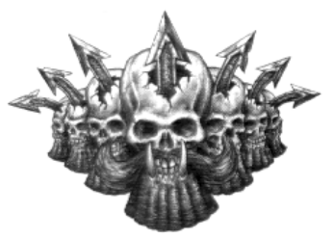

57 PENTOGRAM
The Warriors spot a large pentagram chalked on the floor. On each star point sits a candle, burning brightly. Someone must have recently changed the candles, as there is little wax melted at their bases. Nearby on a pedestal lies an open book, entitled "101 Incantations to summon a Demon". If the Warriors attempt to read from the book, roll 1D6:
1 A random Warrior reads the incantation aloud. On completion, the book starts to glow, and the pentagram ignites in a burst of flame. Any Warriors standing in the middle 4 squares of the board section are engulfed in flame and must lose 2D6 Wounds, with no modifiers. In addition, the Warrior who reads the book is struck in the face by a huge ball of fire which hurls from the pages. Reeling back in agony, the Warrior loses 3D6 Wounds with no modifiers.
2 As the Warrior reads from the pages, the room is plunged into darkness - even the lantern does not throw any light. A voice bellows from the blackness. "Who dares summon the Champions of Khorne. There shall most definitely be Blood for the Blood God today!" The room suddenly lights up, and the Warriors see two Chaos Champions standing on the pentagram. The Warriors must fight them!
3 With a blinding flash of light, the book vanishes, and the pentagram begins to pulse with an eerie red light. Strange forms start to coalesce in the middle of the pentagram. When the forms are solid, the Warriors recognise the shapes as <Roll on the Monster Table>. The Monsters demand a fight!
4 A Chaos Warrior appears in the middle of the pentagram with a puff of smoke. "I am at your bidding, lords" he states. The Chaos Warrior will fight in any battles the Warriors have in the remainder of the dungeon, before returning to the Realm of Chaos to serve his God.
5 As a random Warrior chants the passages from the tome, the Warriors notice an object appearing on the pentagram. The object is a small stone statue of Khorne, the Blood God. Whoever carries this statue can call upon the assistance of Khorne at anytime. Khorne will modify any dice roll by ±1. Each time the stone idol is used, roll 1D6. If a 1 is rolled, the idol becomes red hot, forcing the Warrior to drop it. Upon hitting the floor, the statue shatters, now useless. The statue may be used as many times per turn as the Warriors wish, provided it is not destroyed.

6 With an almighty thunder clap, the entire room starts to shake, and the book bursts in to flames. Aghast, the Warriors take a step backwards, wondering what they have done. Suddenly the floor bursts upwards, and through the gaping hole rises a red figure that is as tall as the room's height. The figure is blood red, and has two crooked horns on the top of its head. It's mouth drips saliva as it opens it to speak. "Why have you summoned me here?" When the Warriors do not answer, it continues. "If you do not have a reason for calling me, then I will go, but beware. Next time you summon me with no reason, you will die!" Each Warrior must make a Fear test against the Demon's Fear of 12. For each Warrior who passes, they may make one request from the Demon before he goes. A request can be anything the player likes, as long as it is reasonable and does not upset the balance of the game, and all other players are agreed. If the Warrior fails the Fear test, then he is stuck to the spot, as the Demon disappears back into the ground, leaving a gaping hole.

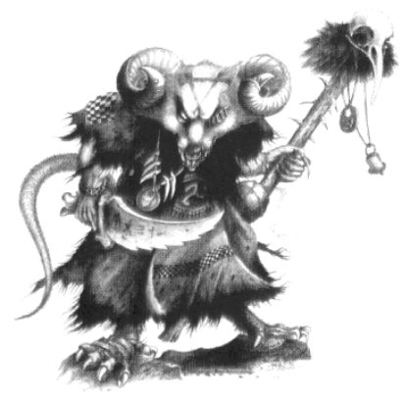

58 BLEEDING WALLS
Oozing from the walls of this room, the Warriors notice a substance which looks like blood. Upon closer inspection they discover that it is indeed blood. If any Warriors pass an Initiative test, they remember from their readings that this is a sign to indicate the time of Khorne's arrival is near. Khorne's blood is inflicted by the powers of Chaos, and as such contains magical properties. Khorne offers his blood to his followers, so that they may clear the world of unbelievers before his arrival. The Warriors may smear the blood over their edged weapons, causing each weapon to become magical. In addition, the weapon now causes an extra <Warrior's Battle Level> Wounds with each hit. The blood will last for the remainder of this adventure, plus one more adventure, unless it is cleared off. Any items coated with Khorne's blood cannot be sold in a Settlement until the blood wears off. If this event is rolled again while the weapons are still coated in blood, treat this as Nothing Happens.

59 CHAOS TRANSFORMATION
The room suddenly glows red with the powers of Chaos. Upon entering, a random Warrior suddenly doubles over in agony, his body becoming twisted with the effects of Chaos. Roll once on the Chaos Warrior's Chaos Attribute Table to see how the Warrior is changed. This change is permanent!

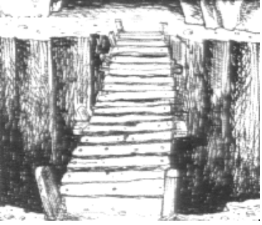
60 CHUTE
The floor suddenly gives way beneath two random Warriors. With loud cries, they tumble feet first down long twisting chutes. When they tumble out at the end of the chutes, they find themselves in the Objective Room! Immediately treat this as if the Warriors had discovered it as normal, placing it on a bare section of the playing surface. Roll for all the Monsters depending on the amount of Warriors in the dungeon. The remaining Warriors will now have to find the Objective Room, while the Warriors already there will have to try and survive! Since the Warriors on this board section do not know where their friends have gone, they cannot give them any assistance in the form of spells, etc.

61 SPEAR TRAP
<No. of Warriors in game> huge spears fly from the walls, one heading for each Warrior. Unless the Warriors can pass Initiative tests, the spears hit them. For each point below 8 that each Warrior scored for their test, roll 1D6. Total the amount - this is the number of Wounds the Warrior must lose.

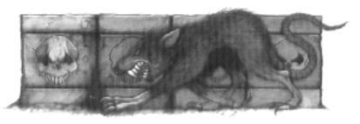

62 SKYLIGHT
A huge stone slab is cut from the roof of this section of the dungeon. Light streams in from above, illuminating the room and all adjacent rooms. On this board section, and all adjacent ones, if any Monsters are fought which have the Ambush ability, then ignore it. Because of the light, the Warriors could see the Monsters coming from a distance. Also, the Warriors may be on either of the board sections around the room and not have to worry about the lantern.
63 TRAP
By entering this room, the Warriors have set off a trap. Roll 1D6 to determine what happens:
1 A huge boulder swings from the wall, attached to the ceiling by a strong rope. A random Warrior takes the full force of the blow. The boulder crushes his side, breaking his sword arm and causing 2D6 Wounds with no modifiers. For the rest of this adventure, until it is healed at the Temple for 1D6 x 100 Gold, he cannot use his arm. He may still fight with his other arm, but is treated as having 1 Weapon Skill. The other Warriors must each make an Initiative test to run past the boulder, or risk the same consequences.
2 An extremely sharp axe blade slices out of the wall, injuring a random Warrior in the stomach. The Warrior must lose (1D6 + Warrior's Battle Level) Wounds and spend 1D3 turns resting. While resting, the Warrior may not move or fight. If he does, he must immediately lose another 1D6 Wounds with no modifiers, and must spend another 1D3 turns resting.
3 The wall beside the Warriors suddenly gives way. A random Warrior standing closest to the wall is buried in rubble. He loses (1D6 + Warrior's Battle Level) Wounds.
4 From the walls shoot many small sharp darts. Determine how many strike each Warrior by taking a Warrior counter one at a time and rolling 1D6. The number rolled is the number of darts which hit the Warrior, causing 1 Wound each, with no modifiers.
5 A random Warrior sets off a trip wire, causing a crossbow bolt to fly across the room and embed itself in the Warriors arm. The Warrior loses 1D6 Wounds.
6 Dust is sprayed over the Warriors, causing them to break out in a coughing fit. Their coughs last for the whole of the next turn, in which they may do nothing. If they need to fight, then they are at -2 To Hit, and have -1 Weapon Skill.

64 BAT SWARM
With a flurry of wings, a swarm of Bats suddenly swoops down out of the darkness, startling the Warriors. Each Warrior should roll 2D6 for the number of Bats that attack, then choose a Warrior Counter. That Warrior has been bitten by the Bats, and must lose 1 Wound for each Bat that bites him. If any Warrior picks his own Warrior Counter, then double damage done to him. The bats then fly off down the passageway.

65 TOAD
A random Warrior carelessly sets off a trap as he enters this room. As his foot touches the trip-wire, he vanishes in a puff of smoke. In his place sits a fat chubby toad. The Warrior has been turned into a toad! Fortunately for him, the spell will wear off after 3 turns. While he is a toad, he may only move 1 square per turn, has a Weapon Skill of 1, Strength of 1, Toughness of 1, cannot use any items. All his items must be dropped on the square he is in. They may either be taken by other Warriors, or at then end of the third turn, if he lands back on the square, the Warrior may take them back himself. If he does not land on the square where he dropped his items, they are lost - stolen by the denizens of the Dungeon.

66 NOTHING HAPPENS

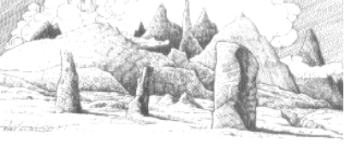
67 MARKSMAN
"Ho there chaps!" The Warriors are greeted by a slim figure who holds his hand out in greeting. "Allow me to introduce myself. My name is <Roll on the Bretonnian Name Table>. I would be honoured to accompany your party back to the nearest Settlement for no charge. I am an excellent marksman with my bow, and a fair warrior with a close combat weapon." If the Warriors decide to take him up on his offer, he will remain with them until they reach the next Settlement. He is armed with the same characteristics as level 3 Imperial Noble, and is armed with a Longbow and a Sword. The Longbow is a Strength 4 weapon, while the Sword has Strength 3. Because the marksman is an expert shot with a bow, he only recquires a 1+ To Hit no matter who he is firing at. Put a counter to represent the marksman in the counter container. He is treated just as another Warrior, thus adjusting the Monsters appearing. The marksman does not count when determining who gets the Treasure at the end of any battle. If he dies before the end of the adventure, the Warriors may not take any of his equipment.



68 THREE QUESTIONS
The reader of this event may not not help the Warriors with their answers.

An old man awaits the Warriors. He leers at them with crooked teeth and foul smelling breath. "I am the guardian of this room. To pass you must answer three questions which I have prepared. If you get them correct, you may pass. But if you answer just one incorrectly, your passage through this room is forfeit." The Warriors may attempt to run past the old man, or even kill him. If this is their choice, they each receive 8D6 Wounds with no modifiers as their bodies are covered from head to foot in a sheet of blue energy. Racked with pain., they watch the old man cackling at them from the corner. "Had enough?" he cackles, stopping the attack. The Warriors can attempt to run past again or answer the questions. To determine which questions are asked, roll 2D6 on the following table 3 times. If the same question is asked more than once, roll again:
2 Q
What is the correct spelling for Bretonnia?
A
B-R-E-T-O-N-N-I-A.
3 Q
What is the capital city of the "Land of the Dead" called?
A
Khemri.
4 Q
Which Dwarf is famous for brewing beer?
A
Bugman.
5 Q
Who or what is the "Grimoire Necris"?
A
A powerful book of dark magic.
6 Q
What is the name of a popular city where many Alchemists seem to reside?
A
Altdorf.
7 Q
What is the name of the force of Chaos whose God is the "Changer of Ways"?
A
Tzeentch.
8 Q
How many beans make four?
A
Four.
9 Q
Where in this world do "Skinks" live?
A
Lustria.
10 Q
What are the names of the Orc Gods?
A
Gork and Mork.
11 Q
What monster vomits a stream of blood, maggots and slime that drowns its victims in diseased filth?
A
A Great Unclean One.
12 Q
Which race are the sworn enemies of the High Elves?
A
Dark Elves.
If the Warriors all move off this board section then enter it again, the old man will still be here, but he will have a new set of questions for them, plus they will have to roll for a new event (if necessary).

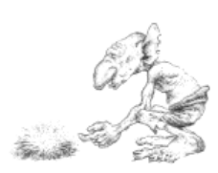
69 DISEASE
One of the Warriors seems to have caught some sort of infliction. His skin breaks out in green lumps, and his hair begins to fall out. If the Warriors do not seek some help for their friend in less than 3D6 turns (a week counts as one turn), he will gradually decline in health. Help can be obtained by visiting a Temple and donating 2D6 x 50 Gold to their healers. If the designated time has elapsed and Warrior has not yet been healed, then he begins to lose Wounds at the rate of 1 Wound per turn (no modifiers), until he reaches zero. If he is not healed before he reaches zero Wounds, then he is dead. Treat this as a fatal disease.

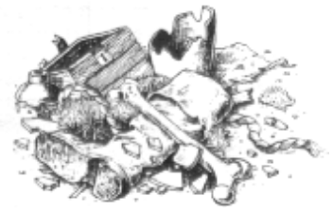

70 FURNITURE
This room is less sparse than most of the other rooms the Warriors encounter. There is a (roll 1D6):
1 Bookshelf (3 x 1)
2 Desk (2 x 3)
3 Tomb (2 x 3)
4 Weapons Rack (1 x 3)
5 Fireplace (1 x 3)
6 Altar (2 x 3)
here. Use the furniture from HeroQuest if you have it. If not the measurements of each item is given in squares. Randomly determine where the item of furniture is placed, and then roll 1D6. If a 6 is rolled, roll again on the table, placing more furniture, etc. Treat this item as an obstruction to movement, line of sight, etc. If it blocks the passageway, the Warriors will have to search for a secret door as detailed in White Dwarf 185 or 189.
71 SMUGGLED LOOT
The Warriors discover some rare jewels in a small bag in this section of the dungeon. Choose a Warrior to carry them. They may be sold in a Settlement for the amount listed below by visiting the Black Market. The Black Market can be found just like any other Special Location, except it requires a 6 to find.
Village 1D6 x 100 Gold
Town 3D6 x 100 Gold
City 6D6 x 100 Gold
Seaport 6D6 x 100 Gold
However, since these are most likely smuggled gems, the authorities will be on the look out for them. At the beginning of each day the Warrior spends in a Settlement, roll 1D6. If the number is in the range listed below, he has been caught trying to pawn off the jewels, and is arrested.
Village 6
Town 5-6
City 3-6
Seaport 3-6
If the Warrior is arrested, he is put in jail, where he spends the next week. During this time he may do nothing else except eat and sleep, but his meals are provided for him by the guards, so he does not have to pay living expenses. The gems are confiscated (naturally), and the Warrior must pay a 2D6 x 100 Gold fine.

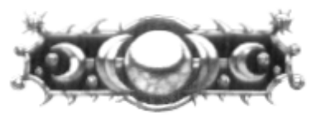

72 COSTUMES
In a rusty old chest, the Warriors find many fine clothes. Fortunately they are just their size. The Warriors may change clothes if they wish. They are now disguised, and any previous events which related to their appearance can be cancelled.
73 EYE PATCH
A Warrior finds a small black patch on the ground. Stitched on the back is a name - Peg Leg Pete. This is an eye patch, which may be worn by the Warrior. If the Warrior already has an eye patch, give it to another Warrior. (Unless he wants to wear two, which is a bit foolish!) While wearing the eye patch, the Warrior looks like a tough hardy adventurer and may add +1 when rolling on the Alehouse Event Table. If he ever encounters anyone called Peg Leg Pete, he must give the eye patch back immediately.

74 STARVATION
In the excitement of the adventure, a random Warrior has forgotten to eat! He must immediately eat one provision even if his Wounds are at maximum, or lose 2 Wounds with no modifiers.

75 BAD LUCK
The Warriors must be cursed! Roll 1D6 to see what mishap befalls them:
1 Roll 1D6. If a one is rolled, a random Warrior drops his backpack down a well. If the Warriors have a rope, they may retrieve it safely, except that all provisions and bandages are soaked with water and must be discarded. If not, then the backpack is gone, along with all the Warrior's equipment, Gold, etc.
2 A Warrior trips over a rock, falling into the other Warriors, and knocking them over as well. They must spend a turn picking themselves up. While down, any Monsters can hit them automatically.
3 A portcullis slams shut behind the Warriors. If they do not have key, they must search for a secret door as explained in White Dwarf 185 or 189.

4 There seems to be hole in a Warrior's backpack. The Warrior has already lost 1D6 x 50 Gold. Until it can be mended (by sticking a bandage on it or some other ingenious method), each turn the Warrior will lose 1D6 Gold.
5 The next battle the Warriors are in, one of them will sneeze, alerting the Monsters, and giving them the Ambush ability.
6 One of the Warriors trips over and bangs his head on a large rock. For the rest of the adventure he has amnesia. He will perform the opposite of his character. For example, if he is a Troll Slayer he will try to run away each turn. If he is a Wizard, he cannot remember how to cast any spells. Amnesia can be cured at a Temple for 1D6 x 50 Gold.

76 SPELL LESSONS
The Warriors seem to be the target of a Wizards spell lessons. Roll 1D3 for the number of spells cast on the unfortunate Warriors, and then randomly determine which ones are cast, and on whom. Although they try, the Warriors cannot locate the Wizard who cast them.

77 NOTHING HAPPENS

78 EARTHQUAKE
The ground beneath the Warriors suddenly shakes violently, and rubble falls from the walls. It must be an earthquake! To simulate the earthquake, take 2D6 square counters from the Warhammer Quest box. Throw them above the board. When they land, line them up to the nearest square. These are parts of the dungeon walls and ceilings which have collapsed. If any land on top of a Warrior then he loses (1D6 + Battle Level) Wounds. A Warriors may dig his way through, by standing next to a piece of rubble, rolling 1D6 and adding his Strength. When the result reaches 30 or more, remove the piece of rubble.
79 POWER SURGE
With a deafening boom, a loud pulsating humming sound echoes around the dungeon. Any spellcasters in the party can sense great power in the room. For the next 1D3 turns, add +1D6 to the Power Dice roll. An unexpected event still happens on a roll of a 1 though.

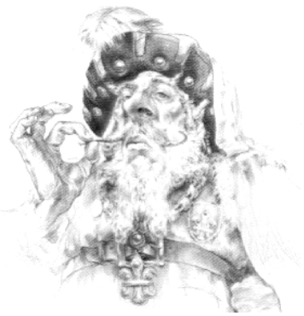

80 STREAM
A trickling underground stream runs through this room. If the Warriors wish to drink from it, roll 1D6:
1 The river is polluted, as it used as the toiletry facilities of the local Monsters who frequent it often. Each Warrior who drunk loses 1D6 Wounds immediately with no modifiers for armour.
2 The river does not contain water, but the polluted run-off from a nearby Dwarven experiment. Each Warrior who drunk from it loses 3 Wounds immediately, with no modifiers.
3-4 The water is nice and refreshing after the long hard battles of the dungeon.
5 The water tastes great. Each Warrior gains 1D6 Wounds if he drank from the stream.
6 Imbued with the magical healing properties of the Elves, each Warrior who drunk from the stream is immediately healed back up to his Starting quota of Wounds.
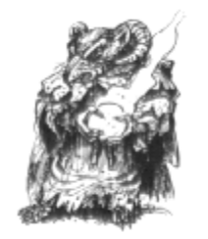

81 IDOL
On a small altar sits a gold idol. Each Warrior may pray to the idol once, before it animates itself and strolls off down the corridor. Roll 1D6 for each Warrior praying:
1 A loud thunderclap booms out, and a streak of white lightning appears from nowhere, striking the Warrior with full force in the chest. He immediately loses 2 Wounds per Battle Level with no modifiers for anything.
2 As the Warrior is praying, the idol somehow dislodges from the altar and topples on to the Warrior. He must lose (1D6 + Battle Level) Wounds. After dusting himself off, he places the idol back onto the altar.
3 The Gods are happy. The Warrior gains 1D6 Wounds.
4 The Gods are pleased. The Warrior gains 2D6 Wounds.
5 The Warrior prays to the idol. Suddenly the idol's eyes light up, and the Warrior feels a warm glow spread throughout his body. He immediately is healed up to his maximum Wounds.
6 The Warrior's prayers are answered. The Warrior may choose one of the following:
- Gain 1D6 Permanent Wounds
- Restore Wounds to maximum
- Gain +1 Toughness
- Gain +1 Weapon Skill
- Gain +1 Move

82 MEDICAL SUPPLIES
In a cupboard, the Warriors find a small white box with a red cross on the lid. If they open it roll 1D6:
1 The box opens with a faint click. Too late, a random Warrior realises that he has been the victim of a trap. He loses 1D3 Wounds immediately with no modifiers.
2 The box is empty.
3 The box contains 1D3 bandages and 1D3 provisions.
4 Inside the box is 1D6 bandages and 1D6 provisions.
5 The box contains 1D6 bandages and 1D6 provisions. Also, underneath everything, the Warriors find a healing potion. There is enough for 2 uses. Each use heals a Warrior of 1D6 Wounds.
6 Inside the box sits a small glowing jewel. The Warriors recognise this as a Trancestone!

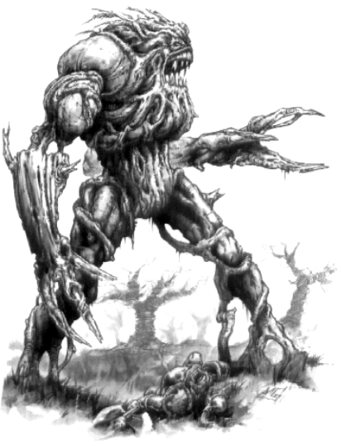

83 SKELETAL REMAINS
Lying on the floor of this room is a pile of bones, the remains of long dead warriors. One of the Warriors thinks he sees a glittering object in the midst of the bodies. If anyone wishes to reach for it, roll 1D6:
1 "Leave it be. It is mine!" A hollow voice rings out around the room. Suddenly the bones start to move, and reform into 2D6 Skeleton Warriors, each armed with a sword. Leading them is a <If the Warriors are between Battle Level 1 and 5, a Mummy, otherwise a Tomb King>. If the Warriors defeat the skeletons they may make a roll on the Monster Magic Items Table. The item they acquire can be used once per Adventure and is worth 800 Gold.
2 While the Warrior has his arm in the pile of bones, reaching for the item, they suddenly animate. The Warrior loses 1D6 Wounds trying to extract his arm form the mass. The bones animate into 1D6 Skeleton Warriors, each armed with a sword. If the Warriors win, they may take 1 Treasure Card.
3 Embarrassingly, the Warrior gets his hand caught in the bone pile and the other Warriors must pull it out. Unfortunately, he finds nothing.
4 After much rummaging around, the Warrior finds 1D6 x 20 Gold.
5 In a small leather bag attached to the skeleton the Warrior finds 2D6 x 20 Gold.
6 The Warrior finds a small ring. When worn, it points the wearer to untold riches. After each battle, roll 1D6 and multiply the result by 10. This is the extra Gold the Warrior has found. If the dice scores a one, then he has found nothing.

84 SPIDER WEBS
This room is overgrown with spider webs. They are everywhere! In the corner, on the ceiling, across the floor. Everywhere the Warriors step there are spider webs. At the end of each turn the Warriors spend in this room, roll 1D6:
1 A Gigantic Spider, alerting by the Warriors movement attacks, aided by 1D6 Giant Spiders.
2 A Gigantic Spider crawls out from beneath a web, attacking the Warriors.
3 Giant Spiders approach the Warriors from all angles and attack. Place a Giant Spider miniature next to each Warrior on this board section.
4-6 Spying beady eyes looking at them from beneath the webs, the Warriors hurry onwards.

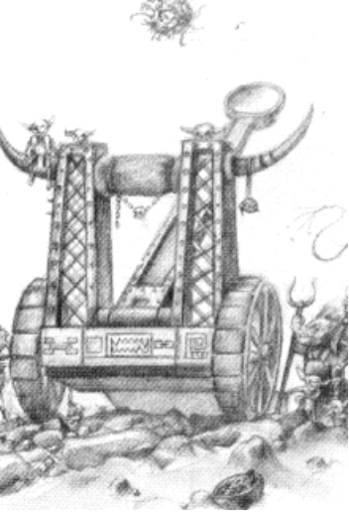

85 ALARM
Somehow, the careless Warriors have set off an alarm. Until the end of the Adventure, if an event is an actual Event, then when it has been completed, roll on the Monster Table as well. This represents the Monsters lying in wait for the Warriors.
86 MESSENGER
The Warriors are greeted by a messenger. Roll 1D6 for his message:
1-3 The messenger informs them that their adventure has already been completed. He says a group of Warriors returned two days ago, having finished the adventure. This is bad luck for the Warriors!. If they continue their adventure, when they get to the Objective Room, there will be no Monsters, and they may exit the dungeon. This means of course, that they get no reward, except 1D6 x 10 Gold for their troubles.
4-6 The Messenger brings a message from <whoever sent them on this adventure>. He says they have new information that forces have been massing to totally eliminate the Warriors. Because of this, any reward they were to have received has been doubled! With this in mind, the Warriors may either turn back or continue. If they reach the Objective Room, there are more Monsters waiting for them. Roll again on the Monster Table one Battle Level higher than the Warriors. They still only receive one Objective Room Treasure Card though.

87 FISH
For some strange reason, fish seem to be falling through the ceiling! All manner of strange and exotic fish from The Great Ocean rain down on the hapless Warriors, who just stand there looking befuddled. Roll 1D6 for each Warrior. This is the amount of fish they can take with them as provisions.

88 NOTHING HAPPENS

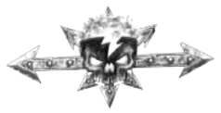
89 WHISPERS
The Warriors think they hear whispering coming from the other side of the wall. If they decide to investigate each Warrior may make one roll on the Hidden Passage Table in White Dwarf 185 or 189 to see if they can discover a secret door. If they find the door and go through, roll 1D6 to see what is on the other side:
1 The Warriors barge through the door, just in time to see two Snotlings giggling at them and pointing above the Warriors' heads. The Warriors look up to see two boulders falling from the ceiling. Draw two Warrior counters to see who the boulders hit. Each Warrior who has been hit loses 2D6 Wounds with no modifiers. Groaning, the Warriors pick themselves up and look around for the Snotlings, but they have vanished.
2 The first Warrior who walks through the door (determine randomly) activates a trip wire. Fortunately for him he trips over , and a crossbow bolt plunges into the nearest Warrior causing (1D6 + Battle Level) Wounds.
3 As the Warriors enter the room they spot two ghostly figures floating off into the shadows. If the Warriors call out, two Wraiths emerge and attack the Warriors. Otherwise, the Warriors can leave the room.
4 The Warriors interrupt two Orcs arguing about some treasure. They both seem to think that a dagger is theirs. Make an Initiative test for all the Warriors. If any pass, then they tell the Orcs to look for a name on the dagger. "Oy, we didn't fink of dat!" Inscribed on the hilt of the dagger are the words "Dis killin' thing is mine." "See", says one of the Orcs, "It is mine!" "No, mine!" bellows the other Orc. The Warriors leave the room in confusement.
5 Behind the door, the Warriors see more rooms and passageways of the dungeon. Divide the remaining dungeon cards in two, and place half behind this door. The Warriors now have two choices as to where the Objective Room might be.
6 As the door slowly opens, sunlight streams into the dungeon. The Warriors have found the exit! If they wish, they may now leave the dungeon and make their way to the nearest Settlement. If they choose to complete their quest, for the rest of this adventure if the Warriors ever need to roll on the escaping table, they may add +2 to their dice roll.

90 BEAUTIFUL WOMAN
Standing in the middle of the room is a beautiful woman, beckoning to the Warriors. For some odd reason, the Warriors feel impelled to approach her. Each Warrior must make a Willpower test (7) to resist her temptation. For those that fail read on…
The Warrior approaches the woman, his arms held wide to embrace her. Upon reaching her he makes to kiss her, when suddenly her arms spread wide, revealing 6 tiny mouths on the inside of each arm - 12 in total. The Warrior is enveloped in her embrace, the tiny mouths gnashing away at his flesh. Subtract the Warriors Toughness (including armour) from the amount of mouths to find out how many actually bite him. Each mouth does 1D3 damage. Add the total damage up, then subtract the Warriors Toughness and armour. The result is the amount of damage the mouths do. For each 10 damage done, the Warrior loses 1 Permanent Wound due to weakness, as the mouths inject their chaotic saliva into him. Fortunately, this brings the Warrior out of his hypnosis, and he may now make his way past the woman.

91 HYSTERICS
A random Warrior suddenly breaks out in hysterics, collapsing on the ground and whimpering softly to himself. Bemused, the other Warriors try to console him, gradually bringing things under control again. For the rest of the dungeon, the affected Warrior must pass a Willpower test at the beginning of each turn or he will be unable to do anything that turn except move. Monsters can hit him automatically, and get +2 To Hit.

92 SONG
A soft song comes drifting through the dungeon, making the Warriors stop in their tracks. When the song finishes, each Warrior has been affected by a spell of Courage. From now until the end of the adventure, the Warriors are unaffected by Fear or Terror.

93 LOST KINGDOM
This dungeon is so huge that it has taken the Warriors beneath the ocean to the Lost Kingdoms! When they exit the dungeon, the Warriors are now in the Lost Kingdoms. From now on they must roll on the appropriate Lost Kingdom Tables. To return to the Old World, the Warriors must travel to a Seaport and find a Captain who is willing to take them back across the ocean.

94 MIRROR
The wall of this dungeon section has a large mirror on it. The warriors approach and look at their ragged selves. Suddenly the mirror glows yellow, and starts to spew out a strange yellow substance. Choose 1D3 Warrior counters at random. If any of them belong to a spellcaster, then he feels suddenly very experienced in the ways of magic. The yellow substance is actually liquid spells! The Warrior gains 1 Spell at random from the appropriate spell deck. The mirror then shatters.
95 SLIME
From the roof drops a green gelatinous blob directly in front of each Warrior. They are Green Slimes. Their profiles are as follows:
Wounds 4
Move 4
Weapon Skill 1
Strength 1
Toughness 1
Attacks 1
Gold (each) 15
Damage 1D6
They have the Ambush Special ability. The Green Slimes can split apart, duplicating themselves. At the end of every turn, each Green Slime remaining on the board splits into a further 1D3 Green Slime. Place these around the Green Slime if there is enough room, otherwise place them in the nearest adjacent square. Once the board section fills up with Green Slime they can not duplicate themselves any more until there is more space again. When all the Slimes are killed, roll for Treasure as normal.

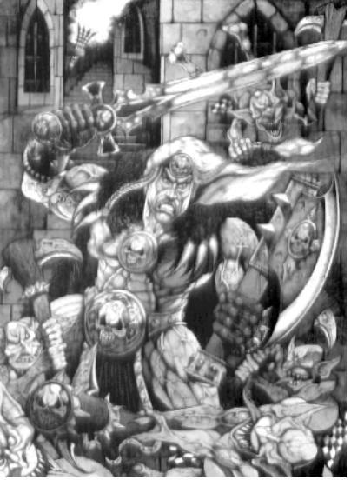

96 SETTLEMENT
The Warriors come across a small civilisation of humans living in the dungeon. If they wish, they can stay here as in a normal Settlement with the following exceptions:
- There are no Special Locations.
- Roll 2D6 when determining stock availability.
- Every item is double in cost, and if the Warriors sell any Treasure, they will only get half its cost..
- Living Expenses must be paid (10 Gold).
- At the beginning of the partys' turns, roll for Power as usual. If an unexpected event occurs, play it as usual, fighting Monsters or solving an Event.
- Each turn, do not roll for the Warriors' Settlement Events. Instead, roll on the Dungeon Events Table for the Warriors as a whole, at the end of their turn.
- At the end of one week, the Warriors must roll on the Catastrophic Events Table.
- This is not treated as a Settlement for the purposes of Dark Secrets, Events, etc. - it is still the Dungeon!

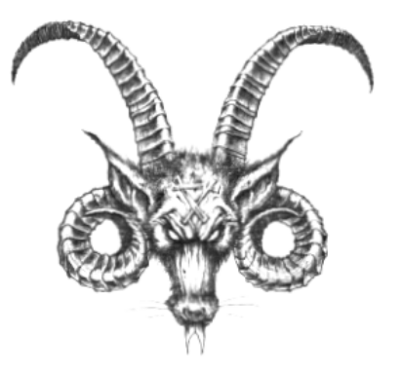

97 WISE MAN
The Warriors meet up with an old man who claims he has the knowledge of a thousand libraries stored in his brain. He recites such proverbs as "If you are injured, then the enemy has struck you", and "He who wields the larger axe must possess the biggest weapon of all". When the Warriors get overwhelmed by all the knowledge he spurts, they may tell him to go away.

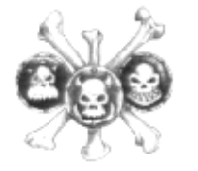

98 TREASURE HORDE
The Warriors discover a huge treasure horde! For each Warrior who takes a piece of Treasure roll 1D6 on following table:
1 Roll as many D6s as you like and multiply the result by 10. However, if any dice come up with a 1 then the Warrior gets nothing.
2 Roll as many D6s as you like and multiply the result by 10. However, if any dice come up with a 1 then the Warrior gets nothing.
3 Roll on the Magic Items Table in the Warhammer Quest Roleplay Book.
4 Roll on the Magic Weapons and Armour Table in the Warhammer Quest Roleplay Book.
5 Draw two Treasure Cards.
6 Roll as many D6s as you wish and multiply the result by 100. However, if any dice come up with a 1 or a 2, roll the same number of dice again, multiply by 100 and subtract it from the first result. If the resulting number is less than zero then treat it as zero. The final result is the amount of Gold the Warrior finds.

99 NOTHING HAPPENS

100 TIME RIP
Due to a rip in the space-time continuum, time seems to go faster for the Warriors. From now until the end of the dungeon (when the Time-Rip has mended itself), if a 6 is rolled in the Power Phase the Warriors may take double turns. After the first Warriors Phase, they can take another one immediately. Fortunately for the Warriors, the Monsters still only get one turn.

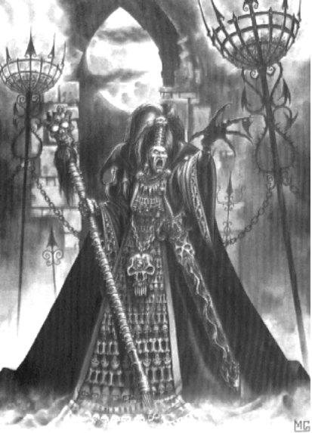

Dungeon Events ©
Andrew Brockhouse

