★ AMAZONS 

Whether the result of long forgotten magic or by natural means, the Amazon population is an entirely female race who live deep in the jungles of Lustria. Rumour has it that they have discovered a strange tropical drug that gives them everlasting youth and longevity. Amazons are very proud of their society and their culture and this makes them very ferocious fighters.

✶ AMAZON WARRIORS 

Amazon Warriors are trained in the ways of warfare and are hardened by a life in the unforgiving nature of the jungle. They are skilled in fighting with a variety of different weapons.

 | Amazon | Amazon Champion | Amazon Princess | Amazon Queen
Wounds | 10 | 18 | 28 | 36
Move | 4 | 4 | 4 | 4
Weapon Skill | 3 | 4 | 5 | 6
Ballistic Skill | 4+ | 3+ | 2+ | 1+
Strength | 3 | 3 | 4 | 5
Toughness | 3 (4) | 3 (5) | 4 (7) | 4 (8)
Armour | 1 | 2 | 3 | 4
Initiative | 4 | 5 | 6 | 8
Attacks | 1 | 2 | 3 | 4
Damage | 1D6 | 1D6 | 2D6 | 3D6
Gold | 110 | 400 | 800 | 1300

ENEMY’S WS 1 2 3 4 5 6 7 8 9 10
Amazon 2 3 4 4 4 4 5 5 5 6
Amazon Champion 2 3 3 4 4 4 4 4 5 5
Amazon Princess 2 2 3 3 4 4 4 4 4 4
Amazon Queen 2 2 3 3 3 4 4 4 4 4

Amazon
Armed with [1-2] Bows (Str 3), [3-4] Spears (Fight in Ranks) or [5-6] Swords.

Amazon Champion
Magic Weapon.

Amazon Princess
Magic Armour; Magic Item; Magic Weapon.

Amazon Queen
Magic Armour; Magic Item x 2; Magic Weapon.

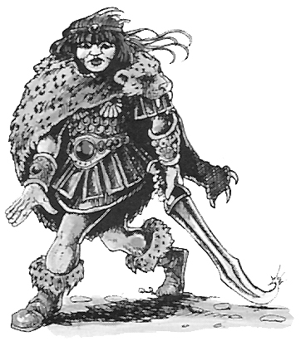

✶ KALIM 

The Kalim are a group of religious fighters who act as the soldiery of the Amazon population and their temples. They are addicted to Koka, a powerful drug which enables them to live mostly without eating or sleeping. Deprived of normal sensory functions they can overcome great pain. This causes them to be slightly insane and very thin looking. Kalim Devout have a specific task of guarding the inner sanctums of the Amazon temples.

 | Kalim | Kalim Devout
Wounds | 15 | 15
Move | 4 | 4
Weapon Skill | 4 | 4
Ballistic Skill | 3+ | 3+
Strength | 3 | 3
Toughness | 3 (4) | 3 (4)
Armour | 1 | 1
Initiative | 6 | 6
Attacks | 2 | 2
Damage | 1D6 | 1D6
Gold | 300 | 500

ENEMY’S WS 1 2 3 4 5 6 7 8 9 10
Kalim 2 3 3 4 4 4 4 4 5 5
Kalim Devout 2 3 3 4 4 4 4 4 5 5

Kalim
Ignore Pain 1.

Kalim Devout
Armed with Old One Artefacts; Ignore Pain 1.

Armed with Old One Artefacts
Kalim Devout carry ancient weapons which are believed to originate from the time of the Old Ones. All Kalim Devout carry both Sunstaffs and Starblades into battle. Sunstaffs are long staffs made from strange multicoloured metal. They are Missile Weapons (Str 4) and therefore when placing Kalim Devout they are placed as missile troops. A Sunstaff fires a concentrated beam of sunlight towards a Warrior that is so intense it ignores all Armour. Starblades are built like daggers but contain magical properties that allow the Kalim Devout to Parry a Warrior’s Attacks. When fighting in hand to hand combat the Kalim Devout have the Parry 4+ special ability.

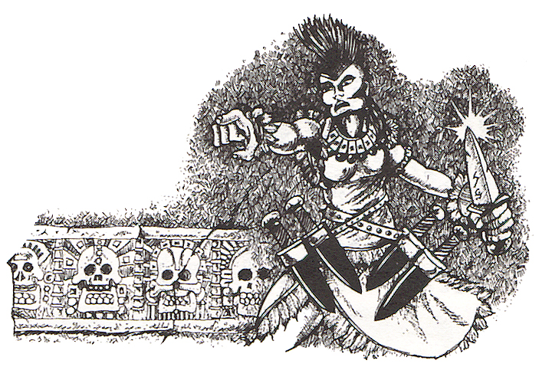

✶ AMAZON TOTEM WARRIOR 

Amazon Totem Warriors are the most bloodthirsty members of the Amazon population. They adorn themselves in the skins and feathers of animals and birds to appease their patron Gods. Before going into battle, Totem Warriors consume large quantities of psychedelic herbs that send them into a killing frenzy.

Amazon
Totem Warrior
Wounds | 18
Move | 4
Weapon Skill | 4
Ballistic Skill | 3+
Strength | 4
Toughness | 3 (4)
Armour | 1
Initiative | 4
Attacks | 2
Damage | 1D6
Gold | 450

ENEMY’S WS 1 2 3 4 5 6 7 8 9 10
Amazon Totem Warrior 2 3 3 4 4 4 4 4 5 5

Amazon Totem Warrior
Frenzy 5+.

✶ WARHORSE 

Warhorses are strong, heavy built horses who strike their enemies with a mighty force.

 | Warhorse
Wounds | 8
Move | 8
Weapon Skill | 3
Ballistic Skill | -
Strength | 3
Toughness | 3 (4)
Armour | 1
Initiative | 3
Attacks | 1
Damage | 1D6
Gold | 90

ENEMY’S WS 1 2 3 4 5 6 7 8 9 10
Warhorse 2 3 4 4 4 4 5 5 5 6

Warhorse
-

Warhorses can be ridden by any Amazon Warriors or Amazon Priestesses.

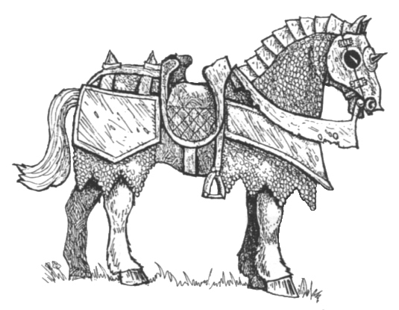
✶ AMAZON PRIESTESS 

Amazon Priestesses are well protected within the tribes of the Amazons. They are part of the religious sisterhood that rules Amazon society and are powerful sorceresses.

 | Amazon Priestess | Amazon Priestess Champion | Great Amazon Priestess | Amazon Priestess Queen
Wounds | 12 | 20 | 30 | 42
Move | 4 | 4 | 4 | 4
Weapon Skill | 4 | 4 | 4 | 4
Ballistic Skill | 5+ | 5+ | 5+ | 5+
Strength | 3 | 4 | 4 | 4
Toughness | 3 | 4 | 4 | 4
Armour | - | - | - | -
Initiative | 5 | 6 | 7 | 8
Attacks | 1 | 1 | 2 | 3
Damage | 1D6 | 1D6 | 2D6 | 3D6
Gold | 590 | 1000 | 1900 | 2400

ENEMY’S WS 1 2 3 4 5 6 7 8 9 10
Amazon Priestess 2 3 3 4 4 4 4 4 5 5
Amazon Priestess Champion 2 3 3 4 4 4 4 4 5 5
Great Amazon Priestess 2 3 3 4 4 4 4 4 5 5
Amazon Priestess Queen 2 3 3 4 4 4 4 4 5 5

Amazon Priestess
Amazon Rituals 1; Magic Item.

Amazon Priestess Champion
Amazon Rituals 2; Magic Item; Magic Weapon.

Great Amazon Priestess
Amazon Rituals 3; Magic Item x 2; Magic Weapon.

Amazon Priestess Queen
Amazon Rituals 4; Magic Item x 3; Magic Weapon.

Amazon Rituals
Amazon Priestesses specialise in performing Amazon Rituals. To see what ritual the Amazon Priestess performs when given the chance, roll 2D6 on the following table. If the Amazon Priestess is killed while she still has active spells in play, they will immediately be dispelled.

2 Failure
The Priestess fails to cast a spell.

3 Singing Wind
The Priestess calls upon the power of Shaekal the Wind Goddess to enter the battlefield. The Goddess appears in the form of singing specks and dancing lights that will entrance any Warrior on the same board section for 1 turn. Warriors may not Move, Attack or Cast Spells and Monsters receive +2 To Hit them.

4 Serpent’s Strength
The Priestess begins the ritual by dancing wildly and screaming in an ancient tongue. All other Amazons on the same board section as the Priestess will be charged with frantic energy and gain +1 Strength until the beginning of the next Monsters’ Phase.

5 Wendala’s Maelstrom
The Priestess summons harsh tropical winds to protect the Amazons from enemy attacks. No Missile Attacks can be made against any Monster on the same board section as the Priestess. In addition, each Warrior’s Move is reduced to 1. The storm lasts until the beginning of the next Monster’s Phase.

6 Shield of Thorns
Moving her arms about in a weaving motion, the Priestess calls upon the plants to protect her. The ritual produces a cocoon of thorns around the Priestess until the beginning of the next Monsters’ Phase. While the cocoon is in play no physical attack against the Priestess will harm her unless a natural 6 is rolled To Hit. Spells will only have effect if they do not cause actual physical damage to the Priestess.

7 The Living Jungle
Drawing upon her will, the Priestess reaches out to the denizens of the jungle, seeking their aid. A random Warrior is swarmed by a savage mix of Snakes, Spiders and Insects. The Warrior suffers 1D6 hits at Strength 2 with no modifiers for Armour.

8 Siren’s Dreams
The Priestess starts to sing with a wondrous voice. The song is so beautiful and mesmerising that it momentarily distracts the Warriors. Every Monster on the same board section can immediately make 1 Attack against an adjacent Warrior.

9 Engaelan’s Mad Dance
The Priestess and any other Amazons on the board start to flail their arms around and dance madly about in a strange ritual. Any Attacks made against Amazons performing Engaelan’s Mad Dance are at -1 To Hit. The dance lasts until the beginning of the next Monsters’ Phase.

10 Wings of the Butterfly
The Priestess gets swarmed by colourful butterflies until she can no longer be seen. With the sound of hundreds of tiny wings flapping, the Priestess is transported out of hand to hand combat with the Warriors. Move the Priestess so that she is no longer adjacent to the Warriors, moving other Monsters out of the way to make room if necessary. If the Priestess is not in hand to hand combat re-roll this result.

11 Serpent’s Bite
The Priestess entwines her arms through the air while chanting, summoning a huge snake. She sends it to bite a random Warrior who suffers (1D6 + 4) Wounds. This damage is treated as being Poison damage.

12 Sting of the Bees
Channelling her anger and wrath, the Priestess chants loudly and calls forth a swarm of frenzied bees. Gesturing with her hand, she sends the bees out to attack the Warriors. There are 4D6 bees in total which are divided evenly between the Warriors. Each bee sting causes 1 unmodified Wound.

