★ ANIMALS 

As well as the multitude of monsters that inhabit the Warhammer world, the wildlife can often pose a threat to the Warriors as well. Whether protecting their homes from invaders, or hungry and looking for a meal, animals do not have the intellect to distinguish man from monster, and will attack all with out hesitation.

✶ BOAR 

Boars are voracious creatures that are constantly hungry. Their aggressive nature proves them a threat to even well armed Warriors. It is often that a Warrior survives a dungeon adventure only to be savaged to death by a pack of wild boar.

 | Boar
Wounds | 7
Move | 7
Weapon Skill | 3
Ballistic Skill | -
Strength | 3
Toughness | 3
Armour | -
Initiative | 3
Attacks | 1
Damage | 1D6
Gold | 50

ENEMY’S WS 1 2 3 4 5 6 7 8 9 10
Boar 2 3 4 4 4 4 5 5 5 6

Boar
Impale.
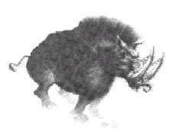

✶ WOLF 

Wolves prowl the lands of the Old World, hunting other weaker animals for prey. Occasionally, they will become very bloodthirsty and attack adventurers instead, especially if they are hungry and are travelling in a large group.

 | Wolf
Wounds | 3
Move | 9
Weapon Skill | 3
Ballistic Skill | -
Strength | 4
Toughness | 3
Armour | -
Initiative | 4
Attacks | 1
Damage | 1D6
Gold | 60

ENEMY’S WS 1 2 3 4 5 6 7 8 9 10
Wolf 2 3 4 4 4 4 5 5 5 6

Wolf
Feed; Frenzy 6+; Gang Up.

Feed
Some Monsters (Wolves) can feed on the bodies of the killed after a battle. If a Monster kills a Warrior who is then not healed in the same turn it will stop and feed on the body. Roll 1D6. On a roll of 1 the Monster starts to eat the body of the dead Warrior. For the next turn he will not move or attack. A dead Warrior who has been eaten by a Monster cannot be resurrected.

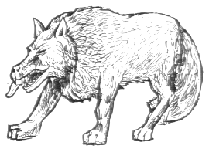

✶ GREAT WOLF 

Great Wolves are about the size of a small pony and very fierce. They normally hunt in packs and once they attack their enemy virtually nothing can stop them.

 | Great Wolf
Wounds | 6
Move | 9
Weapon Skill | 4
Ballistic Skill | -
Strength | 3
Toughness | 3
Armour | -
Initiative | 3
Attacks | 1
Damage | 1D6
Gold | 100

ENEMY’S WS 1 2 3 4 5 6 7 8 9 10
Great Wolf 2 3 3 4 4 4 4 4 5 5

Great Wolf
Frenzy 6+; Gang Up.

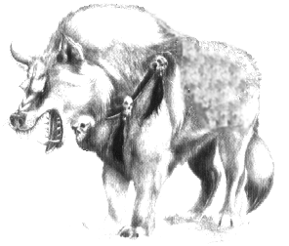
✶ CROCODILE 

Crocodiles, although seemingly slow, attack with deadly speed and accuracy when the Warriors venture too close to their proclaimed territory.

 | Crocodile
Wounds | 12
Move | 3
Weapon Skill | 4
Ballistic Skill | -
Strength | 5
Toughness | 4
Armour | -
Initiative | 4
Attacks | 1
Damage | 1D6
Gold | 140

ENEMY’S WS 1 2 3 4 5 6 7 8 9 10
Crocodile 2 3 3 4 4 4 4 4 5 5

Crocodile
Crocodile Attack.

Crocodile Attack
If a Crocodile attacks a Warrior and kills him (reduces him to zero Wounds) roll 1D6. On a roll of 1 the Crocodile decides to drag his body back to the swamp and eat it. Remove both models from the board.

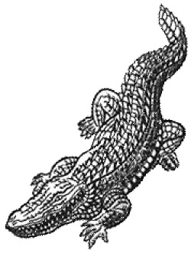

✶ TIGER 

The Lustrian and Old World jungles are home to the mighty tiger. Fearsome and with almost regal bearing, this great cat hunts alone.

 | Tiger
Wounds | 12
Move | 9
Weapon Skill | 4
Ballistic Skill | -
Strength | 4
Toughness | 4
Armour | -
Initiative | 6
Attacks | 2
Damage | 1D6
Gold | 150

ENEMY’S WS 1 2 3 4 5 6 7 8 9 10
Tiger 2 3 3 4 4 4 4 4 5 5

Tiger
-
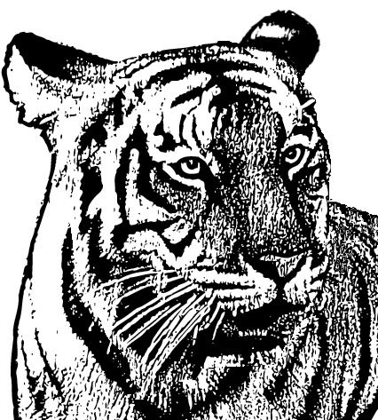

✶ PANTHER 

The black panther is a fierce and sleek hunter, often hiding in the shadows of the jungle and launching itself towards its prey with calculated precision.

 | Panther
Wounds | 10
Move | 9
Weapon Skill | 4
Ballistic Skill | -
Strength | 4
Toughness | 3
Armour | -
Initiative | 6
Attacks | 2
Damage | 1D6
Gold | 160

ENEMY’S WS 1 2 3 4 5 6 7 8 9 10
Panther 2 3 3 4 4 4 4 4 5 5

Panther
Ambush 4+.

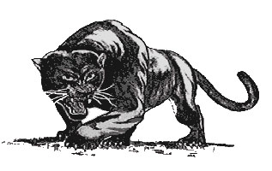
✶ LEOPARD 

A Leopard is crafty as it is quick, stealthily moving through the trees until it makes a sudden fatal attack.

 | Leopard
Wounds | 10
Move | 9
Weapon Skill | 4
Ballistic Skill | -
Strength | 4
Toughness | 4
Armour | -
Initiative | 7
Attacks | 2
Damage | 1D6
Gold | 170

ENEMY’S WS 1 2 3 4 5 6 7 8 9 10
Leopard 2 3 3 4 4 4 4 4 5 5

Leopard
Ambush 3+.

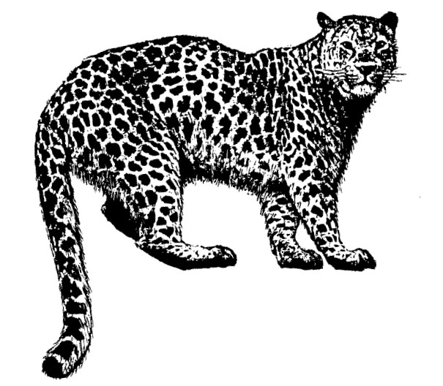

✶ LION 

Strongest and greatest of the carnivorous cats, the lion often hunts in the open savannas of the Old World and Lustria, pursuing its intended victim with single minded purpose.

 | Lion
Wounds | 15
Move | 9
Weapon Skill | 4
Ballistic Skill | -
Strength | 5
Toughness | 4
Armour | -
Initiative | 6
Attacks | 2
Damage | 2D6
Gold | 425

ENEMY’S WS 1 2 3 4 5 6 7 8 9 10
Lion 2 3 3 4 4 4 4 4 5 5

Lion
-

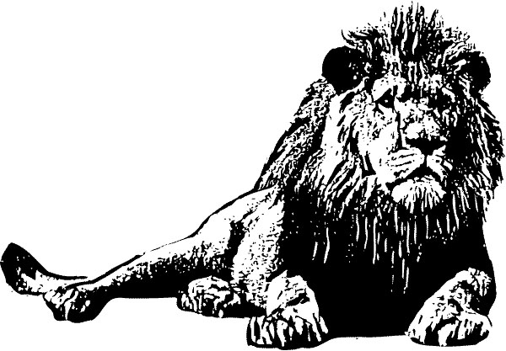

✶ BEARS 

Bears are large animals often found in the forests of the Old World. Normally they are peaceful creatures but when they feel threatened they rip into their opponents with sharp deadly claws. Their strong arms can wrap around a Warrior and slowly squeeze the life out of him.

 | Black Bear | Grizzly Bear
Wounds | 15 | 18
Move | 5 | 5
Weapon Skill | 3 | 3
Ballistic Skill | - | -
Strength | 4 | 5
Toughness | 4 | 5
Armour | - | -
Initiative | 4 | 3
Attacks | 2 | 3
Damage | 2D6 | 2D6
Gold | 450 | 560

ENEMY’S WS 1 2 3 4 5 6 7 8 9 10
Black Bear 2 3 4 4 4 4 5 5 5 6
Grizzly Bear 2 3 4 4 4 4 5 5 5 6

Black Bear
Hug 6+.

Grizzly Bear
Hug 6+.

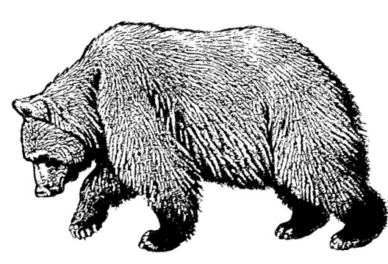
✶ GORILLA

The great gorillas of the jungles of Lustria are very powerful and some almost stand as tall as a Minotaur. They pound their victims into the ground with their vast fists, and slap them playfully around until nothing remains but pulp and shattered bone. Gorillas attack anyone that threatens their home or their young. They almost always attack in groups of two or three.

 | Gorilla
Wounds | 18
Move | 4
Weapon Skill | 3
Ballistic Skill | 6+
Strength | 5
Toughness | 4
Armour | -
Initiative | 4
Attacks | 2
Damage | 3D6
Gold | 580

ENEMY’S WS 1 2 3 4 5 6 7 8 9 10
Gorilla 2 3 3 4 4 4 4 4 5 5

Gorilla
Hug 5+.

