★ CHAOS 

To the far north of the Old World lies a nightmare region known as the Realm of Chaos. Here the forces of Chaos - the armies of Khorne the Blood God, Slaanesh the God of Pleasure, Nurgle the Lord of Pestilence and Tzeentch the Changer of Ways - wage eternal war against each other. Occasionally they combine their forces and sweep down to the south to attack the civilised world, and establish strongholds in the dark, forbidding places such as abandoned Dwarf Holds.

✶ CHAOS RAT 

Chaos Rats have been mutated by the dark powers of Chaos. Some of them have an extra head or tail. Some Chaos Rats have grown to huge proportions, while others will have a thick stone-like covering over their fur.

 | Chaos Rat
Wounds | 2
Move | 6
Weapon Skill | 2
Ballistic Skill | -
Strength | 3
Toughness | 3
Armour | -
Initiative | 4
Attacks | 1
Damage | Special
Gold | 70

ENEMY’S WS 1 2 3 4 5 6 7 8 9 10
Chaos Rat 2 3 4 4 4 4 5 5 5 6

Chaos Rat
Chaos Mutation; Deathleap.

Chaos Mutation
Chaos Rats have been mutated by dark chaos powers. Randomly choose an ability of the Chaos Rat and then add 1 to the ability (for example, roll 1D10 and count from the top of the Chaos Rat’s stats chart. eg. If you rolled a 6 that would mean that the Chaos Rat had +1 Toughness.) This represents the mutation. Each Chaos Rat group has the same mutation. If the Chaos Rat’s Damage is increased by 1, add an extra D6 to the dice rolled for the Deathleap ability.

Deathleap
Chaos Rats make a special attack, called a Deathleap. Roll the Rat’s attack as normal, but if it hits roll 2D6 + 2 for damage. Once a Rat has attacked the Warrior, roll 1D6. On a result of 3-6 the Rat’s suicidal, frenzied attack has opened it up to the Warrior’s attack and he automatically kills it.

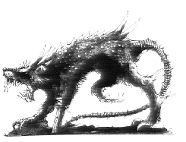
✶ WARHORSE 

Warhorses are strong, heavy built horses with dark black coats. They hate all living things and strike their enemies with a mighty force.

 | Warhorse
Wounds | 8
Move | 8
Weapon Skill | 3
Ballistic Skill | -
Strength | 3
Toughness | 3 (4)
Armour | 1
Initiative | 3
Attacks | 1
Damage | 1D6
Gold | 90

ENEMY’S WS 1 2 3 4 5 6 7 8 9 10
Warhorse 2 3 4 4 4 4 5 5 5 6

Warhorse
Hate All Living.

Warhorses can be ridden by any Chaos Knights, Chaos Warriors, Chaos Sorcerers, Chaos Marauders, Wights, Necromancers, Liches or Vampires.

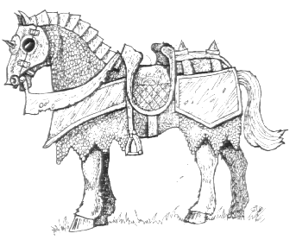
✶ BEASTMEN 

Beastmen fight in warbands led by old, savage warriors who have long since proved their ability to lead. They are powerful and very resilient fighters with big, brutish heads, sharp piercing horns, and hooves that can kick in a man’s rib cage. Ungors are a mixture of man and beast, but more man than beast. They are powerful and tough and make up the bulk of Beastman armies. Gors are huge creatures with massive horns and the hooves of large beasts. Bestigors are the strongest and biggest and also the most powerful. They are completely dedicated to fighting and let nothing stop them.

 | Ungor | Gor | Bestigor | Beastman Champion | Beastman Hero | Beastman Lord
Wounds | 3 | 6 | 18 | 30 | 34 | 47
Move | 4 | 4 | 4 | 4 | 4 | 4
Weapon Skill | 3 | 4 | 5 | 5 | 6 | 7
Ballistic Skill | 5+ | 4+ | 4+ | 3+ | 2+ | 1+
Strength | 3 | 3 | 4 | 4 | 4 | 4
Toughness | 4 | 4 | 4 | 4 | 5 (7) | 5 (7)
Armour | - | - | - | - | 2 | 2
Initiative | 3 | 3 | 3 | 4 | 5 | 6
Attacks | 1 | 1 | 1 | 2 | 3 | 4
Damage | 1D6 | 1D6 | 1D6 | 1D6/2D6 (5+) | 2D6 | 3D6
Gold | 60 | 100 | 200 | 610 | 1300 | 2000

ENEMY’S WS 1 2 3 4 5 6 7 8 9 10
Ungor 2 3 4 4 4 4 5 5 5 6
Gor 2 3 3 4 4 4 4 4 5 5
Bestigor 2 2 3 3 4 4 4 4 4 4
Beastman Champion 2 2 3 3 4 4 4 4 4 4
Beastman Hero 2 2 3 3 3 4 4 4 4 4
Beastman Lord 2 2 2 3 3 3 4 4 4 4

Ungor
Throw Spear (Str 2)

Gor
Throw Spear (Str 3)

Bestigor
Throw Spear (Str 5)

Beastman Champion
Magic Weapon; Throw Spear (Str 8)

Beastman Hero
Magic Armour; Magic Weapon; Throw Spear (Str 9)

Beastman Lord
Magic Armour; Magic Item x 2; Magic Weapon; Throw Spear (Str 10)

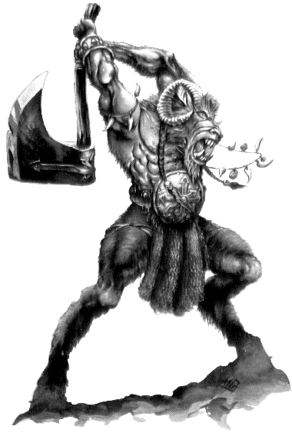

✶ CHAOS STEED 

Chaos Steeds are huge black horses with red eyes and fierce tempers. They are extremely strong and can carry a Chaos Lord into battle with little effort.

 | Chaos Steed
Wounds | 12
Move | 8
Weapon Skill | 4
Ballistic Skill | -
Strength | 4
Toughness | 4 (6)
Armour | 2
Initiative | 4
Attacks | 1
Damage | 2D6
Gold | 180

ENEMY’S WS 1 2 3 4 5 6 7 8 9 10
Chaos Steed 2 3 3 4 4 4 4 4 5 5

Chaos Steed
-

Chaos Steeds can be ridden by any Chaos Knights or Chaos Sorcerers.

. CHAOS CHARIOT 

Sometimes, Chaos Warriors ride into battle in chariots, pulled by two ferocious Chaos Steeds.

 | Chaos Chariot | Chaos Steed
Wounds | 18 | 12
Move | Special | 8
Weapon Skill | 1 | 4
Ballistic Skill | - | -
Strength | 4 | 4
Toughness | 7 | 4 (6)
Armour | - | 2
Initiative | - | 4
Attacks | - | 1
Damage | 1D6 | 2D6
Gold | 75 | 180

ENEMY’S WS 1 2 3 4 5 6 7 8 9 10
Chaos Steed 2 3 3 4 4 4 4 4 5 5

Chariot
Chariot.

Chaos Steed
-

Chaos Chariots can be ridden by any Chaos Warriors or Chaos Sorcerers.
✶ TUSKGOR 

Tuskgors are a cross between a boar and a ram. Their bodies are covered in thick brown fur and they have a large bony crest with sharp horns on their forehead.

 | Tuskgor
Wounds | 8
Move | 7
Weapon Skill | 3
Ballistic Skill | -
Strength | 4
Toughness | 4 (5)
Armour | 1
Initiative | 2
Attacks | 1
Damage | 1D6
Gold | 100

ENEMY’S WS 1 2 3 4 5 6 7 8 9 10
Tuskgor 2 3 4 4 4 4 5 5 5 6

Tuskgor
Impale.

Tuskgors can be ridden by any Beastman or Beastman Shamans.

✶ BEASTMAN CHARIOT 

Beastmen sometimes ride chariots pulled by two fierce Tuskgors into battle. This gives them the ability to move quickly around the battlefield and rain blows on their enemies from the protection of the chariot.

 | Beastman Chariot | Tuskgor
Wounds | 15 | 8
Move | Special | 7
Weapon Skill | 1 | 3
Ballistic Skill | - | -
Strength | 4 | 4
Toughness | 6 | 4 (5)
Armour | - | 1
Initiative | - | 2
Attacks | - | 1
Damage | 1D6 | 1D6
Gold | 70 | 100

ENEMY’S WS 1 2 3 4 5 6 7 8 9 10
Tuskgor 2 3 4 4 4 4 5 5 5 6

Beastman Chariot
Chariot.

Tuskgor
Impale.

Beastman Chariots can be ridden by any Beastman.

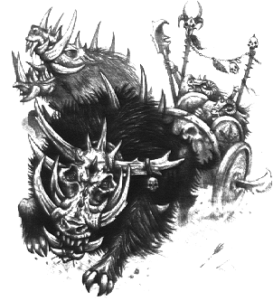

✶ CHAOS SPAWN 

Chaos Spawn are followers of chaos who have failed to pleases their gods. They have been mutated into a hideous mass of limbs, appendages and all manner of mutations. Their minds are gone, leaving nothing but a seething mass of bone and flesh

 | Chaos Spawn
Wounds | (1D6 x Dungeon Level)*
Move | 2D6
Weapon Skill | 3
Ballistic Skill | -
Strength | 4
Toughness | 5
Armour | -
Initiative | 1
Attacks | Special
Damage | Special
Gold | (100 x Dungeon Level)

ENEMY’S WS 1 2 3 4 5 6 7 8 9 10
Chaos Spawn 2 3 4 4 4 4 5 5 5 6

Chaos Spawn
Chaos Spawn Attack; Daemonic -1; Fear 6.

Chaos Spawn Attack
Due to the mass of limbs a Chaos Spawn has, each time it attacks a Warrior, roll 1D6. This is the amount of attacks it has this turn. To calculate the damage done for each attack, divide the Dungeon Level by 2 and round up. eg. A Chaos Spawn on Dungeon Level 7 would cause (7 / 2) = 3.5 = 4 Damage Dice with each successful attack.

* Roll for each Chaos Spawn separately.

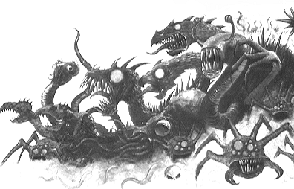
✶ CHAOS MARAUDERS 

Chaos Marauders are barbarians who worship the dark gods. There exist several different tribes of Chaos Marauders, each with their own traits. They have followed the paths of Chaos since birth and believe it to be the only way of life.

 | Chaos Marauder
Wounds | 8
Move | 4
Weapon Skill | 4
Ballistic Skill | 4+
Strength | 4
Toughness | 3 (5)
Armour | 2
Initiative | 4
Attacks | 1
Damage | 1D6/2D6 (6+)
Gold | 150

ENEMY’S WS 1 2 3 4 5 6 7 8 9 10
Chaos Marauder 2 3 3 4 4 4 4 4 5 5

Chaos Marauder
Chaos Marauder Tribes.

Chaos Marauder Tribes
Chaos Marauders worship the four different Chaos Gods and have separated into distinct tribes with their own personalities and traits. Chaos Marauders will be of the alignment of any other Chaos Monsters they appear with. If they are alone, roll 1D4 for the alignment of the Chaos Marauders.

1 Tribe of the Hound
The Tribe of the Hound is devoted to Khorne. They are the greatest of all the tribes and carry fierce axes. Their task is to please their God, and to do this they find great delight in attempting to slaughter every living thing in the world. Chaos Marauders from this Tribe get a +2 bonus to their Strength when attacking with the huge axes.

2 Tribe of the Great Eagle
Members of this tribe are cunning and treacherous. They are forever devising new alliances and breaking others. The Tribe of the Eagle has many Shamans which undergo vast treks through the Mountains of Dusk in their attempts to become mighty Chaos Sorcerers. Chaos Marauders from this tribe get +2 Initiative and will always be accompanied by a Chaos Sorcerer (type is dependant on Dungeon Level) specialising in Tzeentch Magic.

3 Tribe of the Mighty Serpent
Chaos Marauders from the tribe of the Mighty Serpent worship Slaanesh, the God of Pleasure. They take all manner of strange hallucinogens for their own pleasure. These are made by the leaders of the tribe and often contain ingredients to increase a marauders ability in battle. Because of this, Chaos Marauders from this tribe are able to withstand a limited amount of pain. They gain the Ignore Blows 6+ special ability.

4 The Crow Tribe
Members of the Crow Tribe worship Nurgle, who appears to them in the form of a diseased Crow, rotting and maggot infested. They find joy in the horrors of battle and the misery and suffering caused. They pray that they may be infected by plague and disease to please their God. All Chaos Marauders in the Crow Tribe have the Plague special ability.

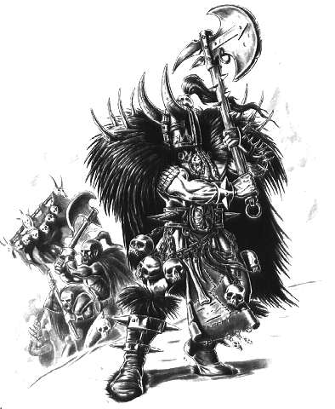

✶ CHAOS HOUND 

Some Warriors of Chaos control packs of snarling, vicious war dogs. These creatures have been cruelly mutated by their exposure to Chaos, and bear barbed tails, skeletal faces and sometimes extra heads and limbs.

 | Chaos Hound
Wounds | 8
Move | 6
Weapon Skill | 4
Ballistic Skill | -
Strength | 4
Toughness | 4 (6)
Armour | 2
Initiative | 4
Attacks | 2
Damage | 1D6
Gold | 160

ENEMY’S WS 1 2 3 4 5 6 7 8 9 10
Chaos Hound 2 3 3 4 4 4 4 4 5 5

Chaos Hound
Ambush 5+; Gang Up.

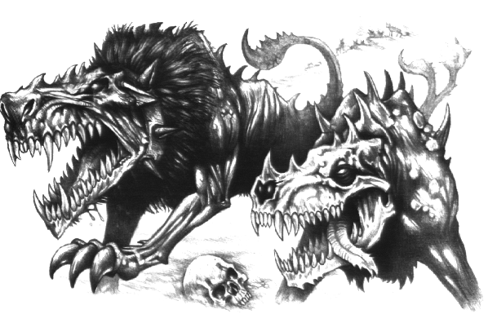
✶ CHAOS WARRIORS 

Chaos Warriors are powerful fighters. Over time they acquire mutations such as huge fangs, horns, bestial claws, strange coloured skin, extra eyes, and countless other deformities, some of which make them extraordinarily tough or strong. Many Chaos Warriors wear all-enclosing suits of thick armour, concealing their true nature. Over time, Chaos Warriors attract the attentions of their capricious gods, becoming Champions or Lords of Chaos and leading the daemonic hordes.

 | Chaos Warrior | Chaos Champion | Chaos Hero | Chaos Lord
Wounds | 12 | 15 | 30 | 35
Move | 4 | 4 | 4 | 4
Weapon Skill | 6 | 7 | 8 | 9
Ballistic Skill | 1+ | A | A | A
Strength | 4 | 5 | 5 | 5
Toughness | 4 (6) | 4 (6) | 5 (11) | 5 (11)
Armour | 2 | 2 | 6 | 6
Initiative | 6 | 7 | 8 | 9
Attacks | 2 | 3 | 4 | 5
Damage | 1D6 | 1D6 | 3D6 | 4D6
Gold | 240 | 910 | 1930 | 3050

ENEMY’S WS 1 2 3 4 5 6 7 8 9 10
Chaos Warrior 2 2 3 3 3 4 4 4 4 4
Chaos Champion 2 2 2 3 3 3 4 4 4 4
Chaos Hero 2 2 2 3 3 3 3 4 4 4
Chaos Lord 2 2 2 2 3 3 3 3 4 4

Chaos Warrior
-

Chaos Champion
Magic Armour; Magic Weapon.

Chaos Hero
Magic Armour; Magic Item x 2; Magic Weapon.

Chaos Lord
Magic Armour; Magic Item x 3; Magic Weapon.

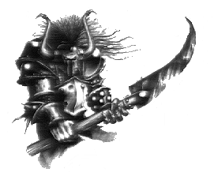
✶ CHAOS KNIGHT 

Chaos Knights are the strong cavalry of Chaos. They ride fearsome Chaos Steeds and wear ornate chaos armour.

 | Chaos Knight | Chaos Steed
Wounds | 18 | 12
Move | 4 | 8
Weapon Skill | 6 | 4
Ballistic Skill | 1+ | -
Strength | 4 | 4
Toughness | 4 (7) | 4 (6)
Armour | 3 | 2
Initiative | 6 | 4
Attacks | 2 | 1
Damage | 1D6 | 2D6
Gold | 500 | 180

ENEMY’S WS 1 2 3 4 5 6 7 8 9 10
Chaos Knight 2 2 3 3 3 4 4 4 4 4
Chaos Steed 2 3 3 4 4 4 4 4 5 5

Chaos Knight
Magic Armour; Magic Weapon.

Chaos Steed
-

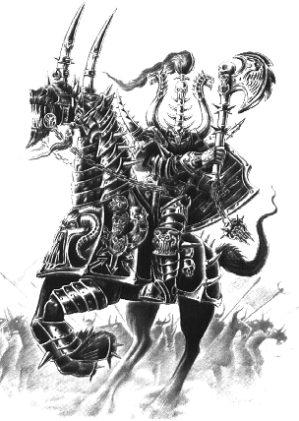
✶ BEASTMAN SHAMANS 

Beastman Shamans are revered by the rest of their kind because of their ability to summon the power of Chaos to cast crude but powerful magic spells.

 | Beastman Shaman | Beastman Shaman Champion | Master Beastman Shaman | Beastman Shaman Lord
Wounds | 26 | 34 | 38 | 42
Move | 4 | 4 | 4 | 4
Weapon Skill | 4 | 4 | 4 | 4
Ballistic Skill | 5+ | 4+ | 4+ | 4+
Strength | 3 | 4 | 4 | 4
Toughness | 5 | 5 | 5 | 5
Armour | - | - | - | -
Initiative | 4 | 4 | 5 | 6
Attacks | 1 | 1 | 2 | 3
Damage | 1D6 | 2D6 | 2D6 | 3D6
Gold | 680 | 1340 | 2000 | 3000

ENEMY’S WS 1 2 3 4 5 6 7 8 9 10
Beastman Shaman 2 3 3 4 4 4 4 4 5 5
Beastman Shaman Champion 2 3 3 4 4 4 4 4 5 5
Beastman Master Shaman 2 3 3 4 4 4 4 4 5 5
Beastman Shaman Lord 2 3 3 4 4 4 4 4 5 5

Beastman Shaman
Beastman Magic 1; Magic Weapon.

Beastman Shaman Champion
Beastman Magic 2; Magic Item; Magic Weapon.

Master Beastman Shaman
Beastman Magic 3; Magic Item x 2; Magic Weapon.

Beastman Shaman Lord
Beastman Magic 4; Magic Item x 3; Magic Weapon.

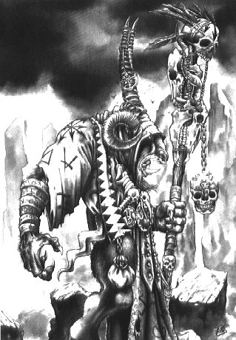
✶ CHAOS TROLLS 

Trolls are large and foul creatures, with gangling limbs and cold, damp hides. Renowned for their strength and unthinking ferocity, Trolls can rip a man apart with their bare hands. Trolls are able to regenerate damaged flesh, and so are all but impossible to kill. Not only that, they have the ability to vomit the corrosive contents over their victim, melting armour, flesh and bone with ease. Chaos Trolls are the largest and the most dangerous type of Troll. Due to the powers of Chaos, these Trolls sometimes grow an extra head, or thick spines on their backs. They are more aggressive than other Trolls and not as stupid.

 | Chaos Troll
Wounds | 35
Move | 6
Weapon Skill | 3
Ballistic Skill | 6+
Strength | 5
Toughness | 4 (5)
Armour | 1
Initiative | 1
Attacks | 4
Damage | 2D6
Gold | 750

ENEMY’S WS 1 2 3 4 5 6 7 8 9 10
Chaos Troll 2 3 4 4 4 4 5 5 5 6

Chaos Troll
Fear 7; Regenerate 2*; Vomit.

Vomit
Chaos Trolls have a special Vomit attack, regurgitating the highly corrosive contents of its stomach all over the Warrior it is attacking. In addition to making such a Chaos Troll's normal attacks, roll 1D6. If the score is a 5 or 6, the Chaos Troll has vomited on its foe. If the victim has any armour (including shields or a helmet) he loses one piece of it as the acid eats it away. The player concerned may choose which item his Warrior loses. If he hasn't got any armour, the target loses 1D6+2 Wounds, with no deductions for Toughness.

* A Chaos Troll cannot regenerate at the end of the turn if its flesh is burnt, either from natural fire or from a magic weapon in the same turn.

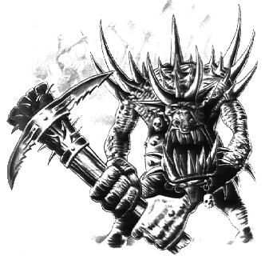
✶ CHAOS SORCERERS 

Chaos Sorcerers are amongst the most feared followers of the dark powers. They wield powerful magic against the enemies of Chaos, whether found on the battlefields of the Warhammer World or in the deepest dungeons that lie below the surface.

 | Chaos Sorcerer | Chaos Sorcerer Champion | Master Chaos Sorcerer | Chaos Sorcerer Lord
Wounds | 15 | 23 | 31 | 45
Move | 4 | 4 | 4 | 4
Weapon Skill | 6 | 6 | 6 | 6
Ballistic Skill | 1+ | 1+ | 1+ | 1+
Strength | 4 | 5 | 5 | 5
Toughness | 5 (6) | 5 (6) | 5 (6) | 5 (6)
Armour | 1 | 1 | 1 | 1
Initiative | 6 | 7 | 8 | 9
Attacks | 2 | 2 | 3 | 4
Damage | 1D6 | 2D6 | 4D6 | 4D6
Gold | 840 | 1500 | 2400 | 3500

ENEMY’S WS 1 2 3 4 5 6 7 8 9 10
Chaos Sorcerer 2 2 3 3 3 4 4 4 4 4
Chaos Sorcerer Champion 2 2 3 3 3 4 4 4 4 4
Master Chaos Sorcerer 2 2 3 3 3 4 4 4 4 4
Chaos Sorcerer Lord 2 2 3 3 3 4 4 4 4 4

Chaos Sorcerer
Chaos Magic 1; Magic Armour; Magic Item; Magic Resistance 4+; Magic Weapon; Parry 5+.

Chaos Sorcerer Champion
Chaos Magic 2; Magic Armour; Magic Item x 2; Magic Resistance 4+; Magic Weapon; Parry 5+.

Master Chaos Sorcerer
Chaos Magic 3; Magic Armour; Magic Dispel 4+; Magic Item x 3; Magic Resistance 4+; Magic Weapon; Parry 5+.

Chaos Sorcerer Lord
Chaos Magic 4; Magic Armour; Magic Dispel 3+; Magic Item x 4; Magic Resistance 3+; Magic Weapon; Parry 5+.

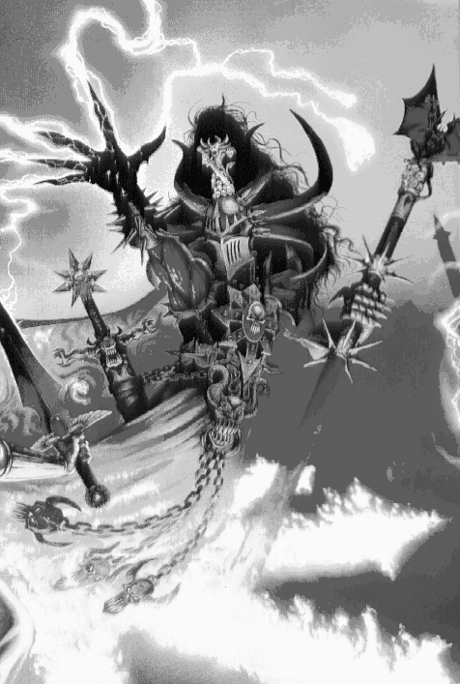
✶ CHAOS DRAGON 

A Chaos Dragon is the mightiest of all Dragons, racked with mutation. It has two heads and two tails. Each head can breathe different devastating flame which can totally destroy a Warrior.

 | Chaos Dragon
Wounds | 90
Move | 6
Weapon Skill | 8
Ballistic Skill | -
Strength | 8
Toughness | 8 (13)
Armour | 5
Initiative | 6
Attacks | 8
Damage | 7D6
Gold | 7500

ENEMY’S WS 1 2 3 4 5 6 7 8 9 10
Chaos Dragon 2 2 2 3 3 3 3 4 4 4

Chaos Dragon
Chaos Dragon Breath (Ambush, Magic A); Chaos Magic 1 (choose God at random); Fly; Ignore Blows 5+; Ignore Pain 8; Large Monster; Never Pinned; Terror 14.

Chaos Dragon Breath
Each head of the Chaos Dragon can breathe a different type of flame at the Warriors. The Dragon attacks with both breath weapon at the beginning of the turn, after the dice has been rolled for Power. This breathe attack is used in addition to a Chaos Dragon’s normal hand-to-hand attacks.

Dark Fire of Chaos
Choose a random Warrior on the same board section as the dragon. Now draw a line from the dragon’s head to the Warrior. Any Warriors underneath the flame, even partially, are affected by the dark flame, and take 3D6 Wounds damage, not modified for Toughness or armour. The power of the flame also mutates anyone affected. Roll 1D6. On a 1 the target has been mutated - roll once on the Chaos Warrior attribute table to see what befalls the Warrior.

Flames of Contagion
The flames of contagion cover a 3 by 3 square area in front of the Chaos Dragon. All Warriors take 2D6 Wounds with no modifiers. In addition, roll 1D6. On a roll of 1 the Warrior loses a permanent (roll 1D6):

1 Strength
2 Toughness
3-6 Permanent Wound

Chaos Dragons can be ridden by any Chaos Knights or Chaos Sorcerers.

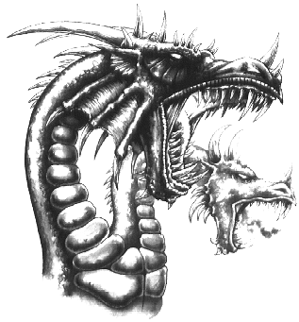
✶ KHORNE 

Khorne is the Blood God, the god of battle. He sits upon a mighty throne of brass upon a sea of skulls. He is a god of warriors and he shows favour to those who fight to become mighty champions of chaos. Khorne is the most powerful of all the Chaos Gods.

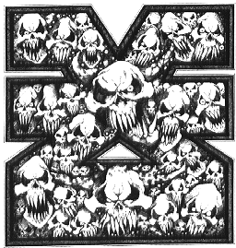

✶ BLOODLETTERS 

Bloodletters have red scaly hide and shiny black claws. These daemonic creatures are furious fighters with strong arms and murderous talons, but their most fearsome weapons are their Hellblades. These weapons glow with deadly enchantment, and cause terrible wounds that can slay the mightiest hero.

 | Bloodletter | Bloodletter Champion
Wounds | 7 | 15
Move | 4 | 4
Weapon Skill | 5 | 6
Ballistic Skill | 2+ | 1+
Strength | 4 | 5
Toughness | 3 | 3
Armour | - | -
Initiative | 6 | 7
Attacks | 2 | 3
Damage | 1D6 | 2D6
Gold | 200 | 450

ENEMY’S WS 1 2 3 4 5 6 7 8 9 10
Bloodletter 2 2 3 3 4 4 4 4 4 4
Bloodletter Champion 2 2 3 3 3 4 4 4 4 4

Bloodletter
Armed with Hellblade; Daemonic -1; Fear 5.

Bloodletter Champion
Armed with Hellblade; Daemonic -1; Fear 6.

Hellblade
A Hellblade causes an extra 1D3 Wounds on the target, with no modifiers for Toughness or armour.

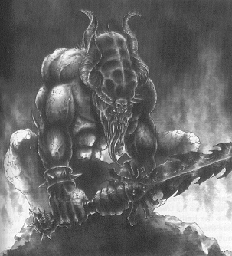

✶ FLESH HOUND 

Flesh Hounds are the hunting beasts of Khorne. They are daemonic hounds with heads both reptilian and canine. They have a thick hide to protect them from harm and wear special collars to nullify the effects of magic against them.

 | Flesh Hound
Wounds | 14
Move | 10
Weapon Skill | 5
Ballistic Skill | -
Strength | 5
Toughness | 4 (6)
Armour | 2
Initiative | 6
Attacks | 2
Damage | 1D6/2D6 (6+)
Gold | 230

ENEMY’S WS 1 2 3 4 5 6 7 8 9 10
Flesh Hound 2 2 3 3 4 4 4 4 4 4

Flesh Hound
Collar of Khorne; Daemonic -1; Fear 5; Gang Up.

Collar of Khorne
The Collar of Khorne is given to the Flesh Hounds by Khorne to protect them from magic. It has been forged in the heat of Khorne’s rage from brass. Treat the Flesh Hounds as having the special ability Magic Resistance 5+.

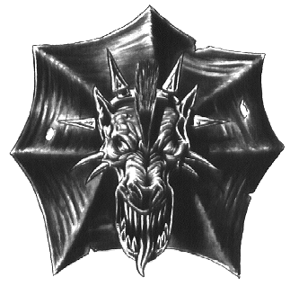
✶ JUGGERNAUT 

Juggernauts are huge daemon beasts whose flesh is brass and whose blood is pure fire. They are brutal and fierce creatures.

 | Juggernaut
Wounds | 35
Move | 7
Weapon Skill | 3
Ballistic Skill | -
Strength | 5
Toughness | 5 (7)
Armour | 2
Initiative | 2
Attacks | 2
Damage | 2D6
Gold | 700

ENEMY’S WS 1 2 3 4 5 6 7 8 9 10
Juggernaut 2 3 4 4 4 4 5 5 5 6

Juggernaut
Crush; Daemonic -1; Fear 7; Magic Resistance 5+; Never Pinned.

Crush
Juggernauts are so huge that their hoofs can crush a Warrior to death. If the Juggernauts first attack hits then the second attack will automatically hit - resolve damage as usual. Otherwise, roll to hit for a normal attack

Juggernauts can be ridden by any Bloodletters or Chaos Warriors.

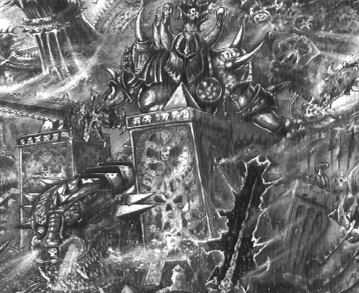

✶ DAEMON PRINCE OF KHORNE 

Daemon Princes are the mortal Champions of Chaos who have pleased the Gods and been promoted to daemonhood. They are incredibly strong as their God has enhanced all parts of their body to reward them for their service. They have the ability to fly, either with wings, or by sheer effort of wills. Princes of Khorne enjoy the cries of anguish from their enemies as they attack them with ferocity.

 | Daemon Prince of Khorne
Wounds | 65
Move | 6
Weapon Skill | 7
Ballistic Skill | A
Strength | 6
Toughness | 5 (9)
Armour | 4
Initiative | 8
Attacks | 6
Damage | 5D6
Gold | 4000

ENEMY’S WS 1 2 3 4 5 6 7 8 9 10
Daemon Prince of Khorne 2 2 2 3 3 3 4 4 4 4

Daemon Prince of Khorne
Daemonic -2; Daemonic Reward; Fly; Ignore Blows 5+; Ignore Pain 6; Terror 10.
✶ BLOODTHIRSTER 

Bloodthirsters are huge terrifying monsters, the greatest and most deadly of all Khorne’s daemons. Their master is the Chaos God of Battle, and Bloodthirsters are the greatest fighters of all daemon-kind. They are savage, bellowing creatures, with the heads of ferocious dogs and snarling teeth. Their blood-stained fur is either red or black, and their armour is ruddy bronze and black iron. A Bloodthirster carries two weapons, an Axe of Khorne and a long, barbed lash. The axe is an enchanted daemon weapon, a living thing that thirsts for blood and slaughter. Although Bloodthirsters have no magical powers they are exceptionally strong and savage fighters, and a single daemon of this kind is a match for an entire mortal army.

 | Bloodthirster
Wounds | 125
Move | 6
Weapon Skill | 10
Ballistic Skill | A
Strength | 8
Toughness | 7
Armour | -
Initiative | 8
Attacks | 10
Damage | 8D6
Gold | 8000

ENEMY’S WS 1 2 3 4 5 6 7 8 9 10
Bloodthirster 2 2 2 2 3 3 3 3 3 4

Bloodthirster
Armed with Axe of Khorne; Armed with Daemon Whip; Daemonic Reward x 2*; Fly; Greater Daemon 14; Ignore Blows 3+; Ignore Pain 12; Large Monster; Magic Drain 5+; Multiple Targets.

Axe of Khorne
Causes +2 Wounds. In addition, if the to hit roll of a blow made with an Axe of Khorne is a natural 6 the blow causes double damage.

Daemonic Whip
At the start of each turn draw a Warrior counter to determine who the Bloodthirster ensnares with the Daemon Whip. That model is immediately moved to a square adjacent to the Bloodthirster, moving other models out of the way as necessary.

Multiple Targets
If the Bloodthirster manages to kill a Warrior and still has some attacks left he may switch to another target to use them.

* A Bloodthirster always carries his Axe and Whip - these count as one Daemonic Reward.

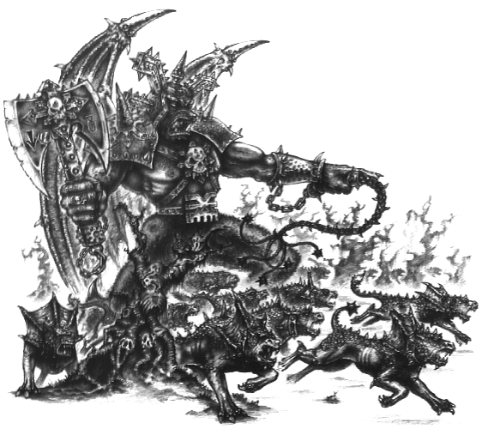

✶ TZEENTCH 

Tzeentch is the Great Sorcerer, the god of magic. He is known as the Changer of Ways because he directs the fate of the Universe. He shows favour to those who use intelligence, especially wizards and magical creatures. He prefers manipulation and intrigue over violence. Tzeentch is almost as powerful as Khorne but his power is that of magic, not war.

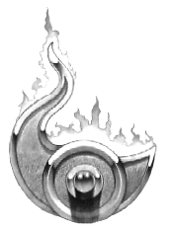

✶ DISC OF TZEENTCH 

Discs of Tzeentch are things from the warp, shark like creatures that exist in the seas of magic. They have no limbs and move by hovering through the air.

 | Disc of Tzeentch
Wounds | 12
Move | 12
Weapon Skill | 3
Ballistic Skill | -
Strength | 3
Toughness | 3
Armour | -
Initiative | 3
Attacks | 1
Damage | 1D6
Gold | 100

ENEMY’S WS 1 2 3 4 5 6 7 8 9 10
Disc of Tzeentch 2 3 4 4 4 4 5 5 5 6

Disc of Tzeentch
Daemonic -1; Fear 4; Fly

Discs of Tzeentch can be ridden by any Chaos Warriors or Chaos Sorcerers.

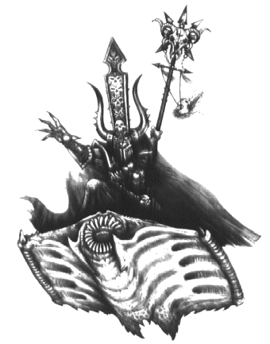
✶ HORRORS OF TZEENTCH 

Horrors of Tzeentch are wild creatures made from raw magic. They are full of boundless energy and spin like tops as they whirl around the dungeon. When a Pink Horror is killed it immediately splits into two Blue Horrors and continues to fight.

 | Pink Horror | Pink Horror Champion | Blue Horror
Wounds | 8 | 10 | 4
Move | 4 | 4 | 4
Weapon Skill | 5 | 6 | 3
Ballistic Skill | 2+ | 1+ | 4+
Strength | 4 | 5 | 3
Toughness | 3 | 3 | 3
Armour | - | - | -
Initiative | 6 | 7 | 7
Attacks | 2 | 3 | 1
Damage | 1D6 | 1D6 | 1D6
Gold | 200 | 300 | 100

ENEMY’S WS 1 2 3 4 5 6 7 8 9 10
Pink Horror 2 2 3 3 4 4 4 4 4 4
Pink Horror Champion 2 2 3 3 3 4 4 4 4 4
Blue Horror 2 3 4 4 4 4 5 5 5 6

Pink Horror
Daemonic -1; Die → Blue Horrors; Fear 6; Magic Resistance 6+.

Pink Horror Champion
Daemonic -1; Die → Blue Horrors; Fear 7; Magic Resistance 5+.

Blue Horror
Daemonic -1; Fear 4; Magic Resistance 6+.

Die → Blue Horrors
Every time a Pick Horror is killed, two Blue Horrors spring up in its place. The Blue Horrors are placed next to the Warrior that killed the Pink Horror that spawned them. If this is not possible they can be placed in the nearest empty squares. As soon as each pair of Blue Horrors appear, make a Fear roll for each Warrior to see if he is afraid of them. The Warrior may not make a Death Blow against any Blue Horrors that spring up this turn, but he may make a normal Death Blow into squares adjacent to the Pink Horror as normal, unless a Blue Horror had to be placed into one of these squares.

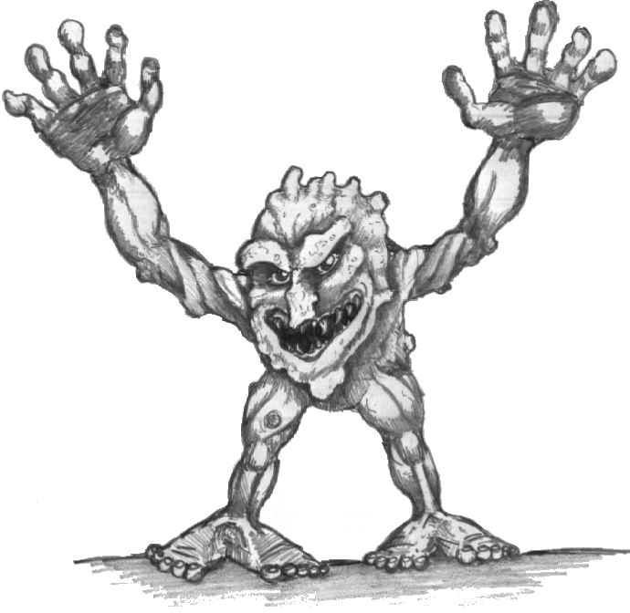
✶ FLAMER OF TZEENTCH 

Flamers are amongst the strangest of all daemons. Their lower portions resemble inverted mushrooms with two flexible arms each spitting magical flames. A Flamer has no head as such, but its eyes and gaping maw lie between its swaying arms.

 | Flamer of Tzeentch
Wounds | 17
Move | 9
Weapon Skill | 3
Ballistic Skill | 2+
Strength | 5
Toughness | 4
Armour | -
Initiative | 4
Attacks | Special
Damage | Special
Gold | 300

ENEMY’S WS 1 2 3 4 5 6 7 8 9 10
Flamer of Tzeentch 2 3 4 4 4 4 5 5 5 6

Flamer of Tzeentch
Ambush, Magic 5+; Daemonic -1; Fear 7; Flamer of Tzeentch Attack; Magic Resistance 6+

Flamer of Tzeentch Attack
Flamers never make a normal hand-to-hand attack. Instead, they set fire to any board section that the Warriors are standing on, immolating the area with the pink fire of Tzeentch. Roll 1D6 per Flamer for each model on that board section to determine how many Wounds it suffers (normal modifiers for Toughness and armour apply). If there are 5 Flamers attacking, for instance, roll 5D6 for each model on that board section. Each Flamer can make this attack once per turn (unless of course if Ambushes successfully) and they themselves are immune to the fire’s effects.

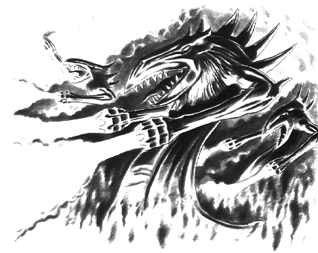
DAEMON PRINCE OF TZEENTCH

Daemon Princes are the mortal Champions of Chaos who have pleased the Gods and been promoted to daemonhood. They are incredibly strong as their God has enhanced all parts of their body to reward them for their service. They have the ability to fly, either with wings, or by sheer effort of wills. Dameon Princes of Tzeentch are granted the power of magic to bring their enemies to their knees.

 | Daemon Prince of Tzeentch
Wounds | 65
Move | 6
Weapon Skill | 7
Ballistic Skill | A
Strength | 6
Toughness | 5 (9)
Armour | 4
Initiative | 8
Attacks | 5
Damage | 5D6
Gold | 4000

ENEMY’S WS 1 2 3 4 5 6 7 8 9 10
Daemon Prince of Tzeentch 2 2 2 3 3 3 4 4 4 4

Daemon Prince of Tzeentch
Daemonic -2; Daemonic Reward; Fly; Ignore Blows 5+; Ignore Pain 6; Terror 10; Tzeentch Magic 3.

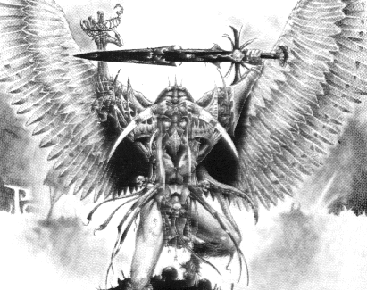
✶ LORD OF CHANGE 

The Lord of Change is huge and awesome in appearance, with cast multicoloured wings and plumed body, its head is that of a monstrous predatory bird, and its scaled legs bear talons that are sharp and deadly.

 | Lord of Change
Wounds | 75
Move | 8
Weapon Skill | 9
Ballistic Skill | A
Strength | 7
Toughness | 7 (11)
Armour | 4
Initiative | 10
Attacks | 6
Damage | 6D6
Gold | 5000

ENEMY’S WS 1 2 3 4 5 6 7 8 9 10
Lord of Change 2 2 2 2 3 3 3 3 4 4

Lord of Change
Ambush, Magic A; Daemonic Reward x 2; Fly; Greater Daemon 13; Ignore Blows 5+; Ignore Pain 7; Large Monster; Magic Item x 3; Magic Source; Tzeentch Magic 5.

Magic Source
A Lord of Change is an extremely powerful sorcerer and unconsciously acts as a source of power for other spellcasters. While there is a Lord of Change on the board, the Wizard doubles the result of his Power roll each turn on anything other than a roll of a 1. If he rolls a 1, the Wizard gets 1 point of Power as normal.

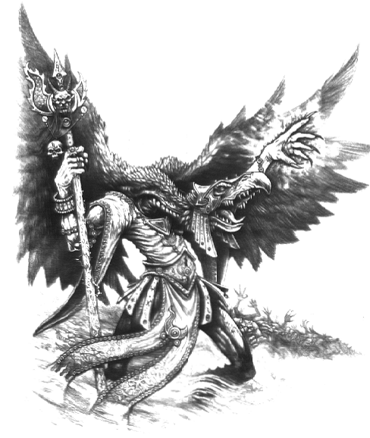
✶ NURGLE 

Nurgle is the Great Lord of Decay who loves disease and putrefaction. For his amusement he devises foul sicknesses and plagues which he inflicts upon the world. Nurgle is third in power of the Chaos Gods.

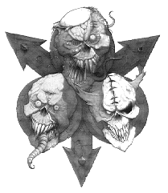

✶ NURGLING 

Nurglings feed upon the pus and slime that dribble from the sores of a Great Unclean One. They are minute images of Nurgle himself with green skin covered with boils and sores. Although Nurglings are tiny there are many of them and they move together in a huge, writhing mass. They have sharp teeth and can overwhelm an enemy by sheer numbers.

 | Nurgling
Wounds | 2
Move | 4
Weapon Skill | 3
Ballistic Skill | 4+
Strength | 3
Toughness | 3
Armour | -
Initiative | 4
Attacks | 2
Damage | 1D6
Gold | 50

ENEMY’S WS 1 2 3 4 5 6 7 8 9 10
Nurgling 2 3 4 4 4 4 5 5 5 6

Nurgling
Ambush A; Daemonic -1; Fear 4; Gang Up; Plague.

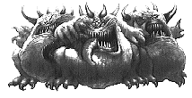
✶ PLAGUEBEARERS 

Plaguebearers are created from all the poor mortal creatures who have died of the dreaded disease Nurgle’s Rot, a terrible and incurable contagion and one of Nurgle’s finest concoctions. Plaguebearers have green, putrid skin, split and rancid like that of Nurgle himself. They have a single eye and one horn which sticks straight out of their foreheads.

 | Plaguebearer | Plaguebearer Champion
Wounds | 9 | 14
Move | 4 | 4
Weapon Skill | 5 | 6
Ballistic Skill | 2+ | 1+
Strength | 4 | 5
Toughness | 3 | 3
Armour | - | -
Initiative | 6 | 7
Attacks | 2 | 3
Damage | 1D6 | 1D6/2D6 (5+)
Gold | 200 | 350

ENEMY’S WS 1 2 3 4 5 6 7 8 9 10
Plaguebearer 2 2 3 3 4 4 4 4 4 4
Plaguebearer Champion 2 2 3 3 3 4 4 4 4 4

Plaguebearer
Daemonic -1; Fear 5; Plague.

Plaguebearer Champion
Daemonic -1; Fear 6; Plague.

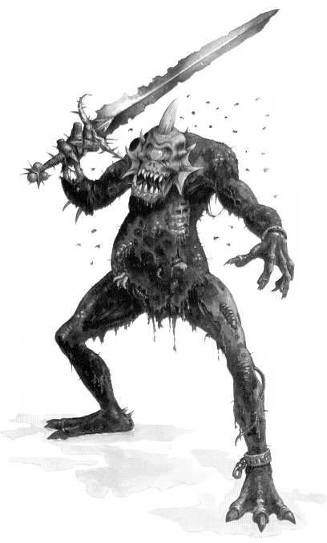

✶ BEAST OF NURGLE 

The Beasts of Nurgle are gigantic and slug-like. Their heads are topped by a fringe of fat tentacles that ooze a paralysing slime. These loathsome creatures also leave a slimy, corrosive trail behind them as they move, like that of a snail or slug, and carry all manner of disfiguring and fatal diseases.

 | Beast of Nurgle
Wounds | 25
Move | 3
Weapon Skill | 3
Ballistic Skill | -
Strength | 3
Toughness | 5
Armour | -
Initiative | 3
Attacks | 1D6
Damage | 2D6
Gold | 750

ENEMY’S WS 1 2 3 4 5 6 7 8 9 10
Beast of Nurgle 2 3 4 4 4 4 5 5 5 6

Beast of Nurgle
Daemonic -1; Fear 7; Paralysis; Plague; Slime Trail.

Slime Trail
Beasts of Nurgle secrete a Slime Trail around them as they move. Any Warrior who finishes his turn in a square adjacent to a Beast of Nurgle suffers 1 Wound, with no modifiers for Toughness or armour, as the poisonous gunk attacks his flesh.

Beasts of Nurgle can be ridden by any Plaguebearers, Chaos Warriors or Chaos Sorcerers.

✶ DAEMON PRINCE OF NURGLE 

Daemon Princes are the mortal Champions of Chaos who have pleased the Gods and been promoted to daemonhood. They are incredibly strong as their God has enhanced all parts of their body to reward them for their service. They have the ability to fly, either with wings, or by sheer effort of wills. Daemon Princes of Nurgle carry the dreaded disease, Nurgle’s Rot.

 | Daemon Prince of Nurgle
Wounds | 65
Move | 6
Weapon Skill | 7
Ballistic Skill | A
Strength | 6
Toughness | 5 (9)
Armour | 4
Initiative | 8
Attacks | 5
Damage | 5D6
Gold | 4000

ENEMY’S WS 1 2 3 4 5 6 7 8 9 10
Daemon Prince of Nurgle 2 2 2 3 3 3 4 4 4 4

Daemon Prince
Daemonic -2; Daemonic Reward; Fly; Ignore Blows 5+; Ignore Pain 6; Nurgle Magic 2; Plague; Terror 10.
✶ GREAT UNCLEAN ONE 

The Great Unclean One resembles Nurgle himself; huge, green-skinned and bloated with disease. Pus and slime dribble over the Daemon’s body, glistening on its leprous skin. A Great Unclean One can vomit a stream of blood, maggots and slime that drowns its victims in diseased filth.

 | Great Unclean One
Wounds | 100
Move | 4
Weapon Skill | 7
Ballistic Skill | A
Strength | 7
Toughness | 8 (12)
Armour | 4
Initiative | 4
Attacks | 7
Damage | 6D6
Gold | 5500

ENEMY’S WS 1 2 3 4 5 6 7 8 9 10
Great Unclean One 2 2 2 3 3 3 4 4 4 4

Great Unclean One
Ambush, Magic 5+; Daemonic Reward x 2*; Greater Daemon 13; Ignore Blows 5+; Ignore Pain 10; Large Monster; Magic Dispel 4+; Magic Resistance 4+; Nurgle Magic 4; Plague; Stream of Corruption.

Stream of Corruption
Great Unclean Ones have a special type of attack where they vomit a foul smelling mass of pus over their foes. This is called a Stream of Corruption. A Great Unclean One may use this attack once per turn, at the start of the Monsters’ Phase. Any Warrior on the same board section as the Great Unclean One may be attacked with the Stream of Corruption. Draw a Warrior counter to determine which Warrior is targeted. Draw a line from the centre of the Great Unclean One’s square to the target square; every square that this line passes through is affected by the Stream of Corruption. Roll 2D6 for each Warrior standing in a targeted square. If the score is less than or equal than his Initiative he manages to dodge the stream and suffers no ill effects. If the score is greater than the Warrior’s Initiative he suffers 3D6 Wounds, with no modifiers for Toughness or armour. If a Warrior is reduced to 0 Wounds by the Stream of Corruption his Toughness is permanently reduced by -1. If a Warrior is reduced to 0 Toughness he is killed and is removed from play.

* A Great Unclean One will always have the Stream of Corruption - this counts as one Daemonic Reward.

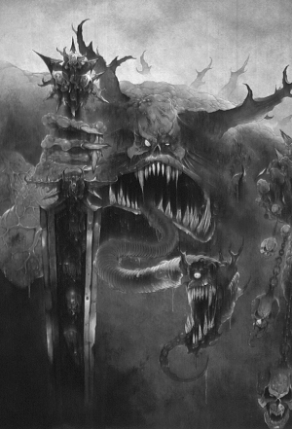
✶ SLAANESH 

Slaanesh is the youngest of the Chaos Gods and is known as the Prince of Chaos. Slaanesh is seductive and beguiling, drawn to mortals possessed by beauty and charm. He offers temptations to his followers that only a God can offer, and no one can resists his lure.

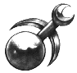

✶ FIEND OF SLAANESH 

The Fiend of Slaanesh is a bizarre daemon, a mixture of scorpion, reptile and human. With its long barbed tail, the Fiend can strike directly over its head to stab its opponents.

 | Fiend of Slaanesh
Wounds | 8
Move | 6
Weapon Skill | 3
Ballistic Skill | -
Strength | 3+
Toughness | 3
Armour | -
Initiative | 3
Attacks | 3
Damage | 1D6
Gold | 250

ENEMY’S WS 1 2 3 4 5 6 7 8 9 10
Fiend of Slaanesh 2 3 4 4 4 4 5 5 5 6

Fiend of Slaanesh
Aura of Slaanesh; Daemonic -1; Fear 6.

Aura of Slaanesh
Fiends of Slaanesh can beguile and hypnotise their foes, holding them immobile while they attack them. Once in combat with such a Monster a Warrior cannot try to escape from pinning (and that includes the Elf!) and is at -1 to all his to hit rolls.

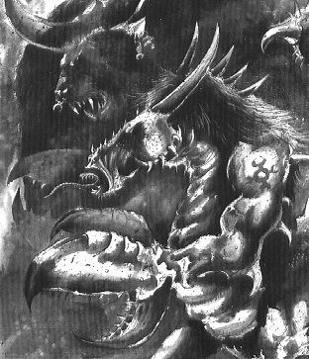
✶ STEED OF SLAANESH 

Steeds of Slaanesh are strange beasts on two feet that can be ridden. Their skin is brightly coloured and they have a green mane. They have a long tubular tongue which is bright blue in colour.

 | Steed of Slaanesh
Wounds | 22
Move | 12
Weapon Skill | 3
Ballistic Skill | -
Strength | 4
Toughness | 5
Armour | -
Initiative | 6
Attacks | 1
Damage | S
Gold | 250

ENEMY’S WS 1 2 3 4 5 6 7 8 9 10
Steed of Slaanesh 2 3 4 4 4 4 5 5 5 6

Steed of Slaanesh
Daemonic -1; Fear 6; Tongue Attack.

Tongue Attack
Place the Steeds of Slaanesh as missile troops. For their attack, they will attempt to ensnare a random Warrior with their long tongue. Make a missile attack using a Ballistic Skill of 4+. If the attack succeeds, the Steed has wrapped its tongue around the Warrior. Place the Warrior in a square adjacent to the Steed of Slaanesh, moving other models out of the way if necessary. While captured, all Monsters get +1 To Hit against the Warrior. He may try and break free at the start of the turn by rolling 1D6, adding his Strength and scoring 8 or more. While a Steed of Slaanesh has a Warrior ensnared, it will not attempt to target any other Warriors.

Steeds of Slaanesh can be ridden by any Daemonettes, Chaos Warriors or Chaos Sorcerers.

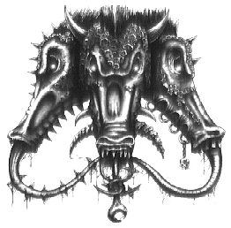
✶ DAEMONETTE 

The Daemonettes are the most numerous of all Slaanesh’s daemons. They have a perverse beauty, unnatural and disturbing, but at the same time are undeniably potent.

 | Daemonette | Daemonette Champion
Wounds | 15 | 20
Move | 4 | 4
Weapon Skill | 6 | 7
Ballistic Skill | 2+ | 1+
Strength | 4 | 5
Toughness | 3 | 3
Armour | - | -
Initiative | 6 | 7
Attacks | 3 | 4
Damage | 1D6 | 1D6
Gold | 300 | 680

ENEMY’S WS 1 2 3 4 5 6 7 8 9 10
Daemonette 2 2 3 3 3 4 4 4 4 4
Daemonette Champion 2 2 2 3 3 3 4 4 4 4

Daemonette
Ambush 5+; Daemonic -1; Fear 6; Magic Resistance 6+.

Daemonette Champion
Ambush 5+; Daemonic -1; Fear 6; Magic Resistance 5+.

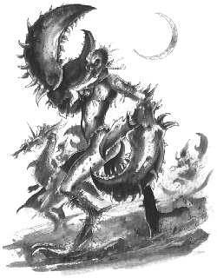
DAEMON PRINCE OF SLAANESH

Daemon Princes are the mortal Champions of Chaos who have pleased the Gods and been promoted to daemonhood. They are incredibly strong as their God has enhanced all parts of their body to reward them for their service. They have the ability to fly, either with wings, or by sheer effort of wills. Daemon Princes of Slaanesh take great pleasure in the extreme pain that normal mortals experience.

 | Daemon Prince of Slaanesh
Wounds | 65
Move | 6
Weapon Skill | 7
Ballistic Skill | A
Strength | 6
Toughness | 5 (9)
Armour | 4
Initiative | 8
Attacks | 5
Damage | 5D6
Gold | 4000

ENEMY’S WS 1 2 3 4 5 6 7 8 9 10
Daemon Prince of Slaanesh 2 2 2 3 3 3 4 4 4 4

Daemon Prince of Slaanesh
Daemonic -2; Daemonic Reward; Fly; Ignore Blows 5+; Ignore Pain 8; Slaanesh Magic 3; Terror 10.

✶ KEEPER OF SECRETS 

The Keeper of Secrets is a bull-headed monster with two pairs of arms, one pair ending in awesome crab-claws. Its body is decked with gorgeous jewels and delicate silks, and its razor sharp claws are decorated with brightly coloured lacquers.

 | Keeper of Secrets
Wounds | 84
Move | 6
Weapon Skill | 9
Ballistic Skill | A
Strength | 7
Toughness | 7 (11)
Armour | 4
Initiative | 7
Attacks | 6
Damage | 6D6
Gold | 5500

ENEMY’S WS 1 2 3 4 5 6 7 8 9 10
Keeper of Secrets 2 2 2 2 3 3 3 3 4 4

Keeper of Secrets
Ambush, Magic 2+; Aura of Slaanesh; Daemonic Reward x 2; Greater Daemon 13; Ignore Blows 5+; Ignore Pain 7; Large Monster; Magic Dispel 4+; Magic Resistance 4+; Never Pinned; Slaanesh Magic 4.

Aura of Slaanesh
The Keeper of Secrets can beguile and hypnotise his foes, holding them immobile while he attacks them. Once in combat with such a Monster a Warrior cannot try to escape from pinning (and that includes the Elf!) and is at -1 to all his to hit rolls.
