★ CHAOS DWARFS 

The Chaos Dwarfs have been twisted by the dark forces until they are a cruel mockery of the Dwarf Warrior and his kind. Ruled by mighty Sorcerers, the Chaos Dwarfs use the powers of lava, magma and fire to work their evil deeds. They employ powerful spells and engines of destruction to do their work, and are ever seeking to discover the lost secrets of their Dwarf kin that lie buried beneath the mountains.

✶ CHAOS DWARFS 

Chaos Dwarfs are evil, self-centred creatures, caring nothing for the life of others. They worship Hashut, the Father of Darkness, who appears to them in the form of a giant bull. To appease him, the Chaos Dwarfs sacrifice captives by throwing them into cauldrons or roaring furnaces.

 | Chaos Dwarf | Chaos Dwarf Champion | Chaos Dwarf Hero | Chaos Dwarf Lord
Wounds | 8 | 16 | 25 | 33
Move | 3 | 3 | 3 | 3
Weapon Skill | 4 | 5 | 6 | 7
Ballistic Skill | 4+ | 3+ | 2+ | 1+
Strength | 3 | 4 | 4 | 4
Toughness | 4 (6) | 4 (6) | 5 (8) | 5 (8)
Armour | 2 | 2 | 3 | 3
Initiative | 2 | 3 | 4 | 5
Attacks | 1 | 2 | 3 | 4
Damage | 1D6/2D6 (6+) | 2D6/3D6 (5+) | 3D6 | 3D6
Gold | 140 | 480 | 900 | 1600

ENEMY’S WS 1 2 3 4 5 6 7 8 9 10
Chaos Dwarf 2 3 3 4 4 4 4 4 5 5
Chaos Dwarf Champion 2 2 3 3 4 4 4 4 4 4
Chaos Dwarf Hero 2 2 3 3 3 4 4 4 4 4
Chaos Dwarf Lord 2 2 2 3 3 3 4 4 4 4

Chaos Dwarf
Magic Resistance 6+.

Chaos Dwarf Champion
Magic Armour; Magic Item; Magic Resistance 6+; Magic Weapon.

Chaos Dwarf Hero
Magic Armour; Magic Item x 2; Magic Resistance 6+; Magic Weapon.

Chaos Dwarf Lord
Magic Armour; Magic Item x 3; Magic Resistance 5+; Magic Weapon.
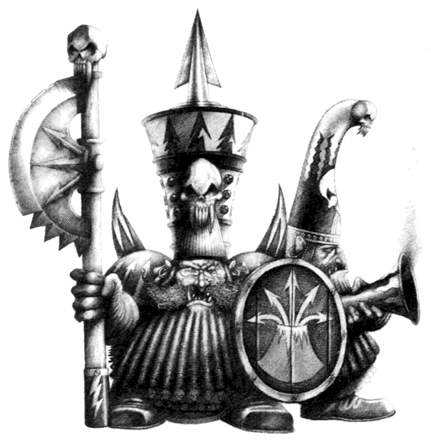
✶ CHAOS DWARF BLUNDERBUSS 

The blunderbuss is a ranged weapon of devastating effect. When it fires, spinning razor sharp pieces of iron plough through the flesh of the Chaos Dwarf’s enemies, causing untold devastation to those unfortunate to be hit.

 | Chaos Dwarf Blunderbuss
Wounds | 8
Move | 3
Weapon Skill | 4
Ballistic Skill | 4+
Strength | 3
Toughness | 4 (5)
Armour | 1
Initiative | 2
Attacks | 1
Damage | 1D6
Gold | 140

ENEMY’S WS 1 2 3 4 5 6 7 8 9 10
Chaos Dwarf Blunderbuss 2 3 3 4 4 4 4 4 5 5

Chaos Dwarf Blunderbuss
Armed with Blunderbuss; Magic Resistance 6+.

Blunderbuss
Some Chaos Dwarfs use huge blunderbusses to fire a hail of deadly metal shards at the Warriors. Chaos Dwarfs armed with blunderbusses are placed like missile troops. A blunderbuss attack is different from a normal missile attack: it fires a spread of lead shot at multiple targets in a single direction at a 90 degree angle, making a single To Hit roll to determine if none or all of the targets in the area are hit. Each blast causes 1D6 Wounds, modified for Toughness and armour, on each of the Warriors in the area of effect. Note that the Chaos Dwarfs’ allies are not affected by the shot as they always seem able to dodge out of the way. Perhaps they have some arcane and magical warning signals...
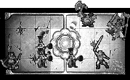

eg. Three Chaos Dwarfs armed with blunderbusses open fire at the Warriors. Their To Hit dice score a 3, a 5 and a 6. With a 4+ To Hit, this gives them 2 shots on target. Each Warrior in the area of effect therefore suffers 2D6 Wounds. In the attack above, the Barbarian Warrior counter was drawn, indicating that all Chaos Dwarfs fire towards him. The lightened area indicates which squares are affected by each Chaos Dwarf’s Blunderbuss as a result of this. Notice that the Elf is out of the area of effect, as all the Chaos Dwarfs must fire in the same direction (towards the Barbarian).

✶ CHAOS DWARF SORCERERS 

Chaos Dwarf Sorcerers rule over the Tower of Zharr-Naggrund as the masters of the Chaos Dwarfs and high priests of Hashut. They study machines and magic combined, to produce arcane engines of power and destruction.

 | Chaos Dwarf Sorcerer | Chaos Dwarf Sorcerer Champion | Master Chaos Dwarf Sorcerer | Chaos Dwarf Sorcerer Lord
Wounds | 8 | 16 | 26 | 40
Move | 3 | 3 | 3 | 3
Weapon Skill | 4 | 4 | 4 | 4
Ballistic Skill | 4+ | 4+ | 4+ | 4+
Strength | 3 | 4 | 4 | 4
Toughness | 5+1* (8) | 5 (8) | 5 (8) | 5 (8)
Armour | 2 | 3 | 3 | 3
Initiative | 3 | 3 | 4 | 5
Attacks | 1 | 1 | 2 | 3
Damage | 1D6/2D6 (6+) | 2D6 | 2D6 | 3D6/4D6 (5+)
Gold | 590 | 1480 | 2190 | 3280

ENEMY’S WS 1 2 3 4 5 6 7 8 9 10
Chaos Dwarf Sorcerer 2 3 3 4 4 4 4 4 5 5
Chaos Dwarf Sorc. Champ.ion 2 3 3 4 4 4 4 4 5 5
Master Chaos Dwarf Sorcerer 2 3 3 4 4 4 4 4 5 5
Chaos Dwarf Sorcerer Lord 2 3 3 4 4 4 4 4 5 5

Chaos Dwarf Sorcerer
Chaos Dwarf Magic 1; Magic Dispel 4+; Magic Resistance 4+; Protection Ring (+1 T*).

Chaos Dwarf Sorcerer Champion
Chaos Dwarf Magic 2; Magic Armour; Magic Dispel 4+; Magic Item; Magic Resistance 4+; Magic Weapon.

Master Chaos Dwarf Sorcerer
Chaos Dwarf Magic 3; Magic Armour; Magic Dispel 4+; Magic Item x 2; Magic Resistance 4+; Magic Weapon.

Chaos Dwarf Sorcerer Lord
Chaos Dwarf Magic 4; Magic Armour; Magic Dispel 4+; Magic Item x 3; Magic Resistance 3+; Magic Weapon.

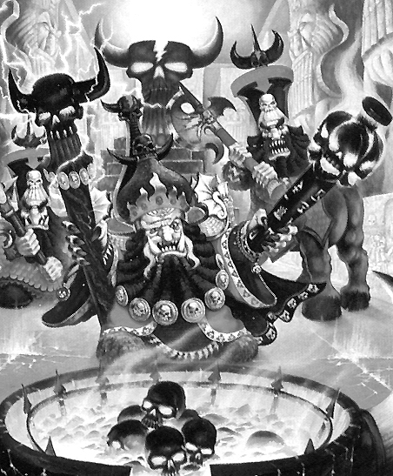
Chaos Dwarf Magic
Chaos Dwarf Sorcerers specialise in casting Chaos Dwarf Magic. To see what spell the Chaos Dwarf Sorcerer casts when given the chance, roll 2D6 on the following table. If the Chaos Dwarf Sorcerer is killed while he still has active spells in play, they will immediately be dispelled.

2 FAILURE
The Chaos Dwarf Sorcerer fails to cast a spell.

3 FIST OF FIRE
The Chaos Dwarf Sorcerer targets a random Monster on the board and creates a huge ball of fire on the end of his arm instead of his hand. For the remainder of this turn the affected Monster receives +1 Damage Dice.

4 DOOMROAR
The Chaos Dwarf Sorcerer takes on the shape of the mighty Bull God Hashut and, with a shake of his horned head, gives a terrifying roar that goads his minions into action. This turn, all Monsters on the board get +1 Attacks.

5 ASH CLOUD
The dungeon is suddenly filled with clouds of smoke and ash. All of the Warriors are at -2 on their To Hit rolls for the next Warriors’ Phase.

6 SORCERER’S CURSE
Cackling hideously, the Chaos Dwarf Sorcerer utters a terrible curse on a random Warrior. Unless he is given a healing potion or a healing spell is cast on him then the cursed Warrior is turned to stone and is out of the game. If he is given treatment, roll 1D6. On a score of 1-4 the Warrior is at -1 Movement, -1 Initiative and -1 To Hit until the Sorcerer is dead. On a score of 5-6 the Chaos Dwarf Sorcerer’s spell has no effect at all.

7 SHADOWS OF HASHUT
A mighty shadow bull rushes away from the Chaos Dwarf Sorcerer, heading towards a random Warrior in his line of sight. The Warrior must immediately take a Fear 7 test. If he succeeds then he stands his ground and the shadow plunges into him, causing 1D6 Wounds unmodified damage. Otherwise, with a scream, he runs towards the entrance of the dungeon. Make a roll on the Escape table to see what happens to the Warrior.

8 LAVA STORM
With a majestic sweep of his arm the Chaos Dwarf Sorcerer creates a stream of balls of molten lava. There are 2D6 balls and they are distributed amongst the Warriors evenly. Each causes 2D6 Wounds with no modifier for armour.

9 FLAMES OF AZGORH
The Chaos Dwarf Sorcerer breathes out whirling tendrils of flame. Draw a Warrior counter to determine who is attacked. The target and every model adjacent to him, whether friend or foe, take 2D6 Wounds each with no modifiers for Toughness or armour. The Chaos Dwarf Sorcerer is the only model immune to the effects of the spell.

10 ERUPTION
The ground beneath one of the Warrior’s feet erupts in a plume of magma. The affected Warrior suffers 5D6 Wounds, modified as usual.

11 FLAMING HIDE
The Chaos Dwarf Sorcerer casts this spell on himself. His skin hardens, and small flames burn on the surface. He now has the Ignore Blows 6+ skill. If this spell is cast again, add +1 to the number required to Ignore Blows.

12 MAGMA POOL
A huge fiery pit of lava opens up in the floor of the room. Take a 2 x 2 square counter and randomly position it in the board section the Chaos Dwarf Sorcerer is on. Any model who is in it suffers 3D6 Wounds with no modifiers and must move to an adjacent square unless they are dead. If there are no free adjacent squares, the model is dead, as it sinks down beneath the magma. No one can move into the magma pool until the Chaos Dwarf Sorcerer is killed.

✶ BULL CENTAURS 

Bull Centaurs are creatures of Chaos, beings with the upper torso of a Chaos Dwarf and the body of a ferocious bull. They are keen-witted creatures and powerful fighters.

 | Bull Centaur | Bull Centaur Champion | Bull Centaur Hero | Bull Centaur Lord
Wounds | 12 | 23 | 32 | 42
Move | 8 | 8 | 8 | 8
Weapon Skill | 4 | 5 | 6 | 7
Ballistic Skill | 4+ | 3+ | 2+ | 1+
Strength | 4 | 5 | 5 | 5
Toughness | 4 (6) | 4 (6) | 5 (8) | 5 (8)
Armour | 2 | 2 | 3 | 3
Initiative | 3 | 4 | 5 | 6
Attacks | 2 | 3 | 4 | 5
Damage | 1D6/2D6 (5+) | 2D6 | 3D6/4D6 (5+) | 3D6/4D6 (5+)
Gold | 410 | 1060 | 2320 | 3680

ENEMY’S WS 1 2 3 4 5 6 7 8 9 10
Bull Centaur 2 3 3 4 4 4 4 4 5 5
Bull Centaur Champion 2 2 3 3 4 4 4 4 4 4
Bull Centaur Hero 2 2 3 3 3 4 4 4 4 4
Bull Centaur Lord 2 2 2 3 3 3 4 4 4 4

Bull Centaur
Fear 5; Magic Resistance 6+.

Bull Centaur Champion
Fear 7; Magic Armour; Magic Item; Magic Resistance 5+; Magic Weapon.

Bull Centaur Hero
Fear 7; Magic Armour; Magic Item x 2; Magic Resistance 5+; Magic Weapon.

Bull Centaur Lord
Fear 7; Magic Armour; Magic Item x 3; Magic Resistance 4+; Magic Weapon.

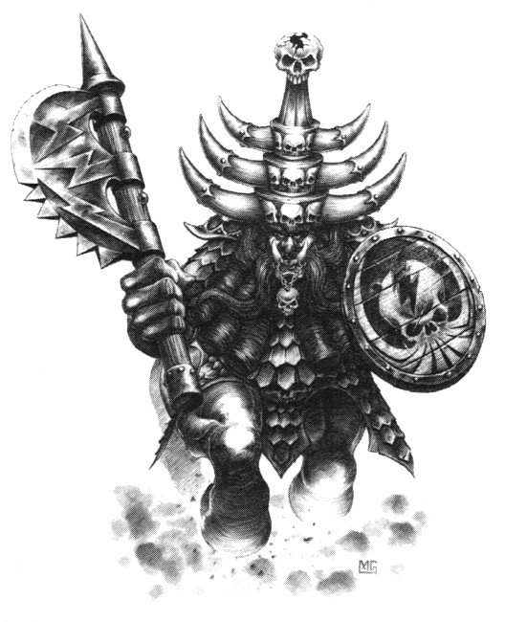
✶ EARTHSHAKER CANNON 

The Earthshaker Cannon is a massive weapon of destruction that fires a heavy shell full of powerful explosives. When the shell lands it buries itself in the ground before exploding, creating devastating shock waves.

 | Earthshaker Cannon
Wounds | 25
Move | -
Weapon Skill | 1
Ballistic Skill | -
Strength | 7
Toughness | 7
Armour | -
Initiative | -
Attacks | 1
Damage | 4D6
Gold | 1000

Earthshaker Cannon
Earthshaker Cannon.

Earthshaker Cannon
Earthshaker Cannons will be accompanied by 2 Chaos Dwarf crew who stand directly behind the Cannon and will remain there for the entire combat operating it. It takes 2 crew to operate the Cannon, so if there is less than 2 left in an adjacent rear square it cannot be used. Any Chaos Dwarfs manning the Earthshaker Cannon do not get to make their normal attacks. If one of the original Chaos Dwarfs manning the Cannon dies, another Chaos Dwarf that is the closest will move behind the Cannon to help operate it (randomly decide if necessary). That Chaos Dwarf ignores Pinning for this turn only. Only the lowest rank of Chaos Dwarfs will operate the Earthshaker Cannon, so Chaos Dwarf Lords, etc. will not use it. The Cannon takes its turn using the Initiative value of the Chaos Dwarf operating it. Due to it’s size, once placed, it cannot be moved. The Earthshaker Cannon can fire even if a Warrior is adjacent to it. It will aim for a different target each turn - randomly determine who it goes for. When firing, roll on the following table:

1 Boom!
The shell explodes as it is being loaded. The Earthshaker Cannon and any adjacent crew are destroyed. Any models adjacent are thrown to the ground as described in result 4-6 below, but do not take damage. The Warriors do not get any Gold or Treasure Cards for the Earthshaker Cannon or Chaos Dwarf crew that blow up.

2-3 Miss
The shell explodes in mid-air, missing the Warrior.

4-6 Hit
The shell embeds itself at the Warrior’s feet and explodes. Work out the damage caused and apply it to the Warrior. In addition, any Warriors adjacent to the Warrior suffer half damage (rounding up). The Warrior and any models adjacent to him are knocked over by the force of the blast for one turn; Warriors are considered to be Prone.

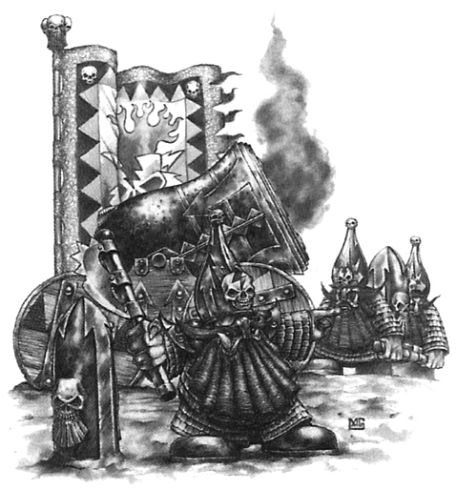
✶ DEATH ROCKET 

The Death Rocket is a crazy invention of Chaos Dwarf Sorcerers. It consists of a tubular rocket about 7 feet long packed full of a chemical propellant. The chemical is highly unstable and extremely toxic. The rocket tip contains a highly explosive charge which detonates on impact.

 | Death Rocket
Wounds | 25
Move | -
Weapon Skill | 1
Ballistic Skill | -
Strength | 5
Toughness | 7
Armour | -
Initiative | -
Attacks | 1
Damage | 3D6
Gold | 1000

Death Rocket
Death Rocket.

Death Rocket
Death Rockets will be accompanied by 2 Chaos Dwarf crew who stand directly behind the Rocket and will remain there for the entire combat operating it. It takes 2 crew to operate the Rocket, so if there is less than 2 left in an adjacent rear square it cannot be used. Any Chaos Dwarfs manning the Death Rocket do not get to make their normal attacks. If one of the original Chaos Dwarfs manning the Rocket dies, another Chaos Dwarf that is the closest will move behind the Rocket to help operate it (randomly decide if necessary). That Chaos Dwarf ignores Pinning for this turn only. Only the lowest rank of Chaos Dwarfs will operate the Death Rocket, so Chaos Dwarf Lords, etc. will not use it. The Rocket takes its turn using the Initiative value of the Chaos Dwarf operating it. Due to it’s size, once placed, it cannot be moved. The Death Rocket can fire even if a Warrior is adjacent to it. It will aim for a different target each turn - randomly determine who it goes for. When firing, roll on the following table:

1 Boom!
The rocket explodes as it is being loaded. The Death Rocket and any adjacent crew are destroyed. Any other models adjacent take 1D6 unmodified poison damage from the fumes. The Warriors do not get any Gold or Treasure Cards for the Death Rocket or Chaos Dwarf crew that blow up.

2-3 Miss
The rocket misses the Warrior, exploding nearby.

4-6 Hit
The rocket lands directly at the Warrior’s feet, exploding in his face. Work out the damage caused and apply it to the Warrior. In addition, the Warrior and any other Warriors adjacent to the target suffer 1D6 unmodified Poison damage due to the toxic fumes.

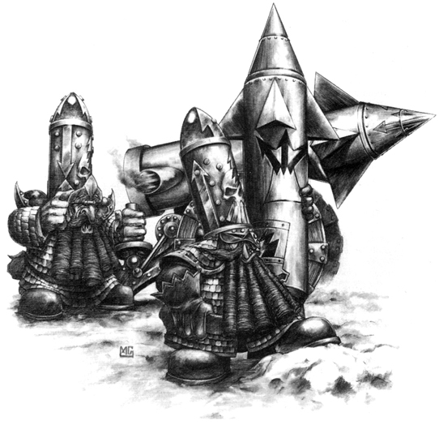
✶ LAMMASU 

Believed to be a rare mutation of the Great Taurus, the Lammasu is a winged beast with the body of a vast bull and a monstrous face. Rather than air it breathes raw magic, and its poisonous breath is known as a Sorcerous Exhalation.

 | Lammasu
Wounds | 50
Move | 6
Weapon Skill | 6
Ballistic Skill | -
Strength | 6
Toughness | 7
Armour | -
Initiative | 6
Attacks | 3
Damage | 4D6
Gold | 2000

ENEMY’S WS 1 2 3 4 5 6 7 8 9 10
Lammasu 2 2 3 3 3 4 4 4 4 4

Lammasu
Fly; Magic Resistance 4+; Sorcerous Exhalation; Terror 10.

Sorcerous Exhalation
A Lammasu breathes out whirling tendrils of magic that provide protection against magical attacks. All Attacks made with a magical weapon against a Lammasu have a -2 To Hit modifier.

Lammasus can be ridden by any Chaos Dwarfs or Chaos Dwarf Sorcerers.

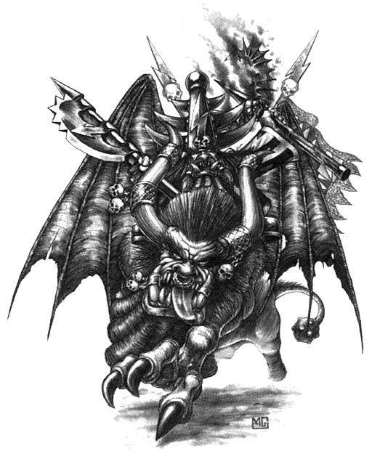

✶ GREAT TAURUS 

The most fearsome of all the servants of the Chaos Dwarfs, the Great Taurus is a massive, fire-breathing, winged bull. When it moves it strikes sparks on the floor, and its whole body is wreathed in fire and smoke.

 | Great Taurus
Wounds | 50
Move | 6
Weapon Skill | 6
Ballistic Skill | -
Strength | 6
Toughness | 6 (9)
Armour | 3
Initiative | 7
Attacks | 4
Damage | 4D6
Gold | 2250

ENEMY’S WS 1 2 3 4 5 6 7 8 9 10
Great Taurus 2 2 3 3 3 4 4 4 4 4

Great Taurus
Breathe Fire 3; Fly; Terror 10.

Great Tauruses can be ridden by any Chaos Dwarfs or Chaos Dwarf Sorcerers.

