★ DARK ELVES 

The Dark Elves are the evil kin of the High Elves. They are masters of dark sorcery and arguably the cruellest race in the Warhammer World. Long ago they embraced the Dark Gods of Chaos and followed the path into darkness. From their black realm of Naggaroth, they send Dark Elf Warriors, Sorcerers and Assassins forth to spread their poisonous doctrines across the Warhammer World.

✶ DARK ELF SLAVE MASTER 

A Slave Master is in charge of leading the slaves of the Dark Elves into battle. He is an expert with his whip, and if the slaves do not perform adequately, a Slave Master will kill them where they stand.

 | Dark Elf  Slave Master | Slave
Wounds | 5 | 3
Move | 5 | 3
Weapon Skill | 4 | 2
Ballistic Skill | 2+ | 6+
Strength | 4 | 2
Toughness | 3 (4) | 3
Armour | 1 | -
Initiative | 5 | 3
Attacks | 1 | 1
Damage | 1D6 | 1D6
Gold | 90 | 20

ENEMY’S WS 1 2 3 4 5 6 7 8 9 10
Dark Elf Slave Master 2 3 3 4 4 4 4 4 5 5
Slave 3 4 4 4 5 5 6 6 6 6

Dark Elf Slave Master
Armed with Whip (Fight in Ranks); Hate Elves; Slave Master.

Slave
Break.

Slave Master
The Slave Master uses his whip to keep his slaves in line. When encountered, he will be accompanied by a number of slaves as indicated in the Monster Tables. These slaves are placed before the Slave Master. Dark Elf Slave Masters are very harsh on their slaves, and if one does not perform to their satisfaction, the Slave Master will whip him to death as a lesson to all the other slaves. To represent this, if a Slave fails to hit a Warrior the Slave Master will strike him down if he is within range. Remove the Slave model from the board - the Warriors do not get any Gold from it at all. If the Slaves break, the Slave Master will pursue them and slaughter them all - remove all the models from the board - no Treasure Card is received for the battle, although Gold is still received for anyone the Warriors have killed.

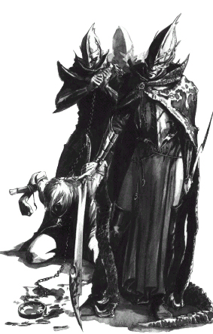
✶ DARK ELF WARRIORS

Dark Elf Warriors are cruel and fierce fighters. Like all Elves, Dark Elves are lithe and sinuous, with strong muscles and reactions every bit as quick as their agile minds.

 | Dark Elf Warrior | Dark Elf Champion | Dark Elf Hero | Dark Elf Lord
Wounds | 6 | 14 | 25 | 34
Move | 5 | 5 | 5 | 5
Weapon Skill | 4 | 5 | 6 | 7
Ballistic Skill | 3+ | 2+ | 1+ | A
Strength | 3 | 4 | 4 | 4
Toughness | 3 (4) | 3 (5) | 4 (8) | 4 (8)
Armour | 1 | 2 | 4 | 4
Initiative | 6 | 7 | 8 | 9
Attacks | 1 | 2 | 3 | 4
Damage | 1D6 | 2D6 | 2D6 | 3D6
Gold | 100 | 480 | 1040 | 1600

ENEMY’S WS 1 2 3 4 5 6 7 8 9 10
Dark Elf Warrior 2 3 3 4 4 4 4 4 5 5
Dark Elf Champion 2 2 3 3 4 4 4 4 4 4
Dark Elf Hero 2 2 3 3 3 4 4 4 4 4
Dark Elf Lord 2 2 2 3 3 3 4 4 4 4

Dark Elf Warrior
Armed with [1-2] Crossbows (Str 4), [3-4] Spears (Fight in Ranks) or [5-6] Swords; Dodge 6+; Hate Elves.

Dark Elf Champion
Dodge 6+; Hate Elves; Magic Weapon.

Dark Elf Hero
Dodge 4+; Hate Elves; Magic Armour; Magic Resistance 5+; Magic Weapon.

Dark Elf Lord
Dodge 4+; Hate Elves; Magic Armour; Magic Item x 2; Magic Resistance 5+; Magic Weapon.
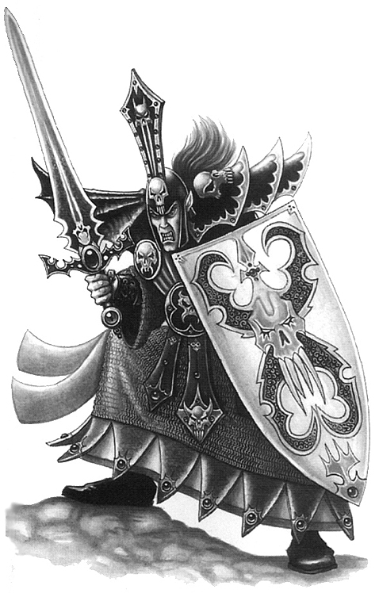
✶ DARK RIDER 

Dark Riders are expert horsemen and are deadly shots with their crossbows. They ride strong, dark steeds with red glowing eyes. When attacking, they fire off a volley of arrows and then retreat, relying on the speed of their Dark Steeds to outrun any pursuers.

 | Dark Rider | Dark Steed
Wounds | 6 | 8
Move | 5 | 9
Weapon Skill | 4 | 3
Ballistic Skill | 3+ | -
Strength | 3 | 3
Toughness | 3 | 3
Armour | - | -
Initiative | 6 | 4
Attacks | 1 | 1
Damage | 1D6 | 1D6
Gold | 100 | 90

ENEMY’S WS 1 2 3 4 5 6 7 8 9 10
Dark Rider 2 3 3 4 4 4 4 4 5 5
Dark Steed 2 3 4 4 4 4 5 5 5 6

Dark Rider
Armed with Crossbow (Str 4); Fire and Flee; Hate Elves.

Dark Steed
-

Fire and Flee
Dark Riders on Dark Steeds are missile troops and are placed as such. At the beginning of the Monsters’ Phase if a Dark Rider is adjacent to a Warrior, he will fire his Crossbow. Distribute any hits from Dark Riders amongst the Warriors as normal. The Dark Rider will then attempt to flee from the battle. Move the Dark Rider away from the combat, ignoring all Pinning. Note that this is the only time in the game that a Monster may attack before moving. Dark Riders will not move so that they cannot see the Warriors and thus be unable to fire at them during their turn. If a Dark Steed is killed, a Dark Rider will attack as normal.

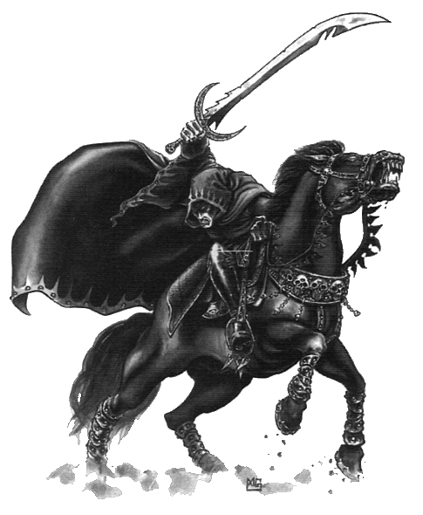

✶ DARK STEED

Dark Steeds are pure black horses with evil tempers and glowing red eyes.

 | Dark Steed
Wounds | 8
Move | 9
Weapon Skill | 3
Ballistic Skill | -
Strength | 3
Toughness | 3
Armour | -
Initiative | 4
Attacks | 1
Damage | 1D6
Gold | 90

ENEMY’S WS 1 2 3 4 5 6 7 8 9 10
Dark Steed 2 3 4 4 4 4 5 5 5 6

Dark Steed
-

Dark Steeds can be ridden by any Dark Elf Warriors, Dark Elf Sorcerers, Dark Elf Sorcereress’ or Dark Riders.

Dark Steeds will always be encountered with a rider.

✶ SHADES 

Shades are a silent and deadly brotherhood of warriors. They live apart from the rest of Dark Elf society, waging an endless war against the enemies of Malekith, the Witch King. Shades make excellent scouts and infiltrators, as none are more adept at the art of infiltration and reconnaissance.

 | Shade | Bloodshade
Wounds | 6 | 12
Move | 5 | 5
Weapon Skill | 4 | 5
Ballistic Skill | 3+ | 2+
Strength | 3 | 3
Toughness | 3 | 3
Armour | - | -
Initiative | 5 | 5
Attacks | 1 | 1
Damage | 1D6 | 1D6
Gold | 140 | 220

ENEMY’S WS 1 2 3 4 5 6 7 8 9 10
Shade 2 3 3 4 4 4 4 4 5 5
Bloodshade 2 2 3 3 4 4 4 4 4 4

Shade
Armed with Crossbow (Str 4); Dodge 6+; Hate Elves; Never Pinned.

Bloodshade
Armed with Crossbow (Str 4); Dodge 5+; Hate Elves; Never Pinned.
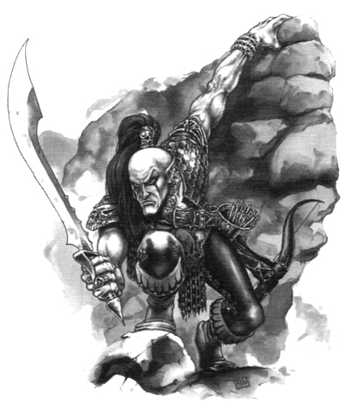

✶ WITCH ELVES 

Witch Elves are wedded to Khaine, the God of Murder in midnight sacrifices of blood and magic. Witch Elves are the most cruel, evil and savage of all Dark Elves. They do not carry shields, caring nothing for their own protection, and are armed with sharp swords and long knives.

 | Witch Elf | Witch Elf Champion | Witch Elf Heroine | Hag Queen
Wounds | 11 | 13 | 17 | 20
Move | 5 | 5 | 5 | 5
Weapon Skill | 4 | 5 | 6 | 7
Ballistic Skill | 3+ | 2+ | 1+ | A
Strength | 3 | 4 | 4 | 4
Toughness | 3 | 3 | 4 | 4
Armour | - | - | - | -
Initiative | 6 | 7 | 8 | 9
Attacks | 1 | 2 | 3 | 4
Damage | 1D6 | 1D6 | 1D6 | 2D6
Gold | 140 | 600 | 900 | 1300

ENEMY’S WS 1 2 3 4 5 6 7 8 9 10
Witch Elf 2 3 3 4 4 4 4 4 5 5
Witch Elf Champion 2 2 3 3 4 4 4 4 4 4
Witch Elf Heroine 2 2 3 3 3 4 4 4 4 4
Hag Queen 2 2 2 3 3 3 4 4 4 4

Witch Elf
Frenzy 4+; Hate Elves.

Witch Elf Champion
Frenzy 3+; Hate Elves.

Witch Elf Heroine
Frenzy 2+; Hate Elves.

Hag Queen
Frenzy 2+; Hate Elves; Poison Attack.

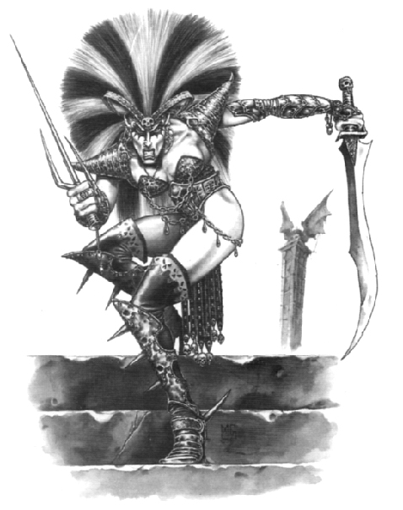

. BLACK ARK CORSAIRS 

Expert weapon masters, the Black Ark Corsairs specialise in the use of light weapons that will not get in the way of the wild and disorganised combats they are required to fight. They wear no armour, but wear special cloaks made from the scales of Sea Dragons.

 | Black Ark Corsair | Black Ark Reaver
Wounds | 6 | 16
Move | 5 | 5
Weapon Skill | 4 | 5
Ballistic Skill | 3+ | 3+
Strength | 3 | 4
Toughness | 3 | 3
Armour | - | -
Initiative | 6 | 6
Attacks | 1 | 2
Damage | 1D6 | 1D6
Gold | 150 | 320

ENEMY’S WS 1 2 3 4 5 6 7 8 9 10
Black Ark Corsair 2 3 3 4 4 4 4 4 5 5
Black Ark Reaper 2 2 3 3 4 4 4 4 4 4

Black Ark Corsair
Dodge 6+; Dragon Cloaks; Hate Elves.

Black Ark Reaver
Dodge 5+; Dragon Cloaks; Hate Elves.

Dragon Cloaks
The Dragon Cloaks are made from Sea Dragon scales and are very tough. To represent this, when rolling for damage against the Black Ark Corsair, ignore any dice that score a 1 or a 2.

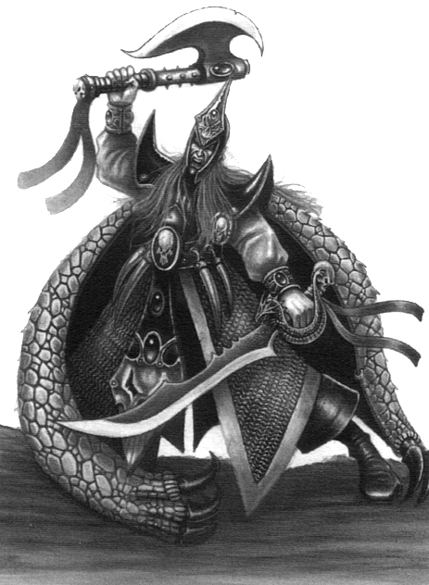

✶ NAGGAROTH BLACK GUARD 

The Black Guard are the fiercest and most vicious fighters in Naggaroth. They are renowned among the Dark Elves for their murderous attacks using their great halberds.

 | Naggaroth Black Guard | Naggaroth Black Guard Master
Wounds | 6 | 20
Move | 5 | 5
Weapon Skill | 5 | 5
Ballistic Skill | 3+ | 3+
Strength | 4 | 5
Toughness | 3 (5) | 3 (5)
Armour | 2 | 2
Initiative | 7 | 7
Attacks | 1 | 2
Damage | 1D6 | 2D6
Gold | 150 | 500

ENEMY’S WS 1 2 3 4 5 6 7 8 9 10
Naggaroth Black Guard 2 2 3 3 4 4 4 4 4 4
Nag. Black Guard Master 2 2 3 3 4 4 4 4 4 4

Naggaroth Black Guard
Armed with Halberds (Fight in Ranks); Hate Elves.

Naggaroth Black Guard Master
Armed with Halberds (Fight in Ranks); Hate Elves.

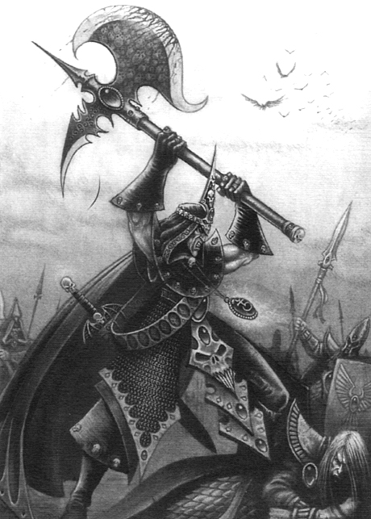

✶ HAR GANETH EXECUTIONER 

Executioners are guardians of the city of Har Ganeth. They are expert axemen whose axes are always ready to spill blood. They enjoy hearing the groans and screams of victims as their axes cleave into their bodies.

 | Har Ganeth Executioner | Har Ganeth Draich-master
Wounds | 6 | 18
Move | 5 | 5
Weapon Skill | 5 | 5
Ballistic Skill | 3+ | 3+
Strength | 4 | 5
Toughness | 3 (4) | 3 (4)
Armour | 1 | 1
Initiative | 6 | 6
Attacks | 1 | 2
Damage | 1D6 | 2D6
Gold | 170 | 520

ENEMY’S WS 1 2 3 4 5 6 7 8 9 10
Har Ganeth Executioner 2 2 3 3 4 4 4 4 4 4
Har Ganeth Drach-master 2 2 3 3 4 4 4 4 4 4

Har Ganeth Executioner
Hate Elves; Expert Axemen.

Har Ganeth Draich-master
Hate Elves; Expert Axemen.

Expert Axemen
The Executioners of Har Ganeth are expert axemen and therefore can ignore the first miss each turn when rolling To Hit with their axes and roll again, although they must keep the second roll.

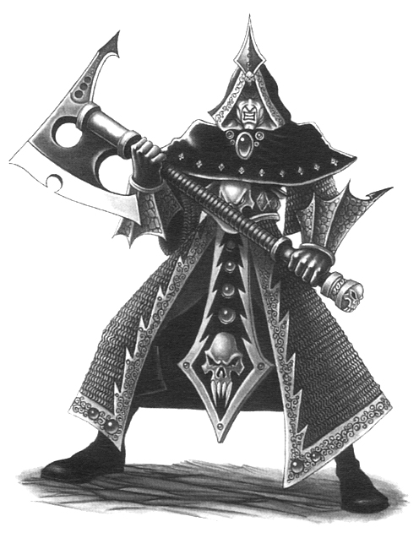

✶ DARK ELF KNIGHTS 

Dark Elf Knights have been specially trained to ride the deadly Cold Ones. Only a few can take up the arms of a Dark Elf Knight, for the Cold Ones attack anyone that comes near.

 | Dark Elf Knight | Dark Elf Dread Knight | Cold One
Wounds | 8 | 20 | 30
Move | 5 | 5 | 8
Weapon Skill | 5 | 5 | 3
Ballistic Skill | 3+ | 3+ | -
Strength | 3 | 3 | 4
Toughness | 3 (5) | 3 (5) | 4
Armour | 2 | 2 | 3
Initiative | 5 | 5 | 1
Attacks | 1 | 2 | 2
Damage | 1D6 | 2D6 | 3D6
Gold | 180 | 540 | 770

ENEMY’S WS 1 2 3 4 5 6 7 8 9 10
Dark Elf Knight 2 2 3 3 4 4 4 4 4 4
Dark Elf Dread Knight 2 2 3 3 4 4 4 4 4 4
Cold One 2 3 4 4 4 4 5 5 5 6

Dark Elf Knight
Armed with Soul Eater Lance (Fight in Ranks); Hate Elves.

Dark Elf Dread Knight
Armed with Soul Eater Lance (Fight in Ranks); Hate Elves.

Cold One
Fear 6; Ignore Pain 1.

Dark Elf Knights will always be encountered riding Cold Ones.

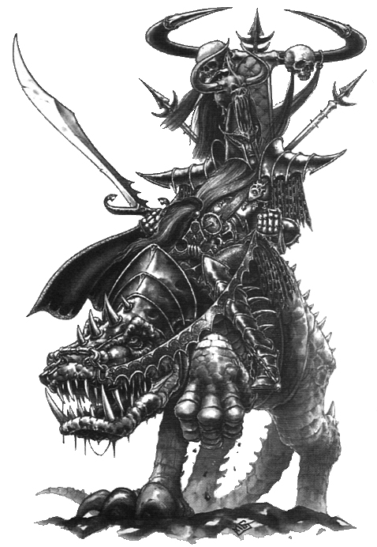

✶ COLD ONES

Cold Ones are ancient green skinned reptiles with brutish claws and razor sharp teeth. They are somewhat immune to pain, having such thick skin.

 | Cold One
Wounds | 30
Move | 8
Weapon Skill | 3
Ballistic Skill | -
Strength | 4
Toughness | 4
Armour | 3
Initiative | 1
Attacks | 2
Damage | 3D6
Gold | 770

ENEMY’S WS 1 2 3 4 5 6 7 8 9 10
Cold One 2 3 4 4 4 4 5 5 5 6

Cold One
Fear 6; Ignore Pain 1.

Cold Ones can be ridden by any Dark Elf Warriors, Dark Elf Knights, Dark Elf Sorcerers or Dark Elf Sorceress’.

✶ DARK ELF BEASTMASTER 

Dark Elf Beastmasters are Dark Elf Warriors who control a pack of snarling Chaos Hounds or Warhounds in combat, directing them towards the Warriors using whips.

 | Dark Elf Beastmaster | Warhound | Chaos Hound | War Hydra
Wounds | 15 | 6 | 8 | 70
Move | 5 | 5 | 6 | 6
Weapon Skill | 5 | 4 | 4 | 3
Ballistic Skill | 2+ | - | - | -
Strength | 4 | 3 | 4 | 5
Toughness | 3 (5) | 3 | 4 (6) | 6 (9)
Armour | 2 | - | 2 | 3
Initiative | 7 | 6 | 4 | 3
Attacks | 2 | 1 | 2 | 6
Damage | 1D6 | 1D6 | 1D6 | 4D6
Gold | 150 | 130 | 160 | 2400

ENEMY’S WS 1 2 3 4 5 6 7 8 9 10
Dark Elf Beastmaster 2 2 2 3 3 3 4 4 4 4
Warhound 2 3 3 4 4 4 4 4 5 5
Chaos Hound 2 3 3 4 4 4 4 4 5 5
War Hydra 2 3 4 4 4 4 5 5 5 6

Dark Elf Beastmaster
Armed with Crossbow (Str 5); Beast Handler (Dark Elf); Hate Elves.

Warhound
Ambush 5+; Gang Up.

Chaos Hound
Ambush 5+; Gang Up.

War Hydra
Breathe Fire 4 (Ambush A); Ignore Blows 5+; Ignore Pain 7; Large Monster; Magic Resistance 5+; Never Pinned; Terror 11.

Beast Handler (Dark Elf)
Dark Elf Beastmasters control a pack of beasts in combat, directing them towards the Warriors using whips. The composition of the Beastmaster's pack will be indicated on the Monster Table. When placing the Beastmaster on the board, the beasts are always placed first. While the Beastmaster is on the same board section as them, Monsters that he controls can reroll their first Attack that misses each turn, although they must keep the result of the second roll.

✶ DARK ELF SORCERERS 

Dark Elves long ago embraced dark magic in all its evil majesty and have since become the ultimate masters of dark sorcery.

 | Dark Elf Sorcerer | Dark Elf Sorcerer Champion | Dark Elf Master Sorcerer | Dark Elf Sorcerer Lord
Wounds | 12 | 20 | 30 | 41
Move | 5 | 5 | 5 | 5
Weapon Skill | 4 | 4 | 4 | 4
Ballistic Skill | 3+ | 3+ | 3+ | 3+
Strength | 3 | 4 | 4 | 4
Toughness | 4 | 4 (5) | 4 (6) | 4 (7)
Armour | - | 1 | 2 | 3
Initiative | 7 | 7 | 8 | 9
Attacks | 1 | 1 | 2 | 3
Damage | 1D6 | 1D6 | 2D6 | 3D6
Gold | 590 | 1210 | 2190 | 3280

ENEMY’S WS 1 2 3 4 5 6 7 8 9 10
Dark Elf Sorcerer 2 3 3 4 4 4 4 4 5 5
Dark Elf Sorcerer Champion 2 3 3 4 4 4 4 4 5 5
Dark Elf Master Sorcerer 2 3 3 4 4 4 4 4 5 5
Dark Elf Sorcerer Lord 2 3 3 4 4 4 4 4 5 5

Dark Elf Sorcerer
Dark Elf Magic 1; Hate Elves; Magic Item; Magic Resistance 6+.

Dark Elf Sorcerer Champion
Dark Elf Magic 2; Hate Elves; Magic Item; Magic Resistance 5+; Magic Weapon.

Dark Elf Master Sorcerer
Dark Elf Magic 3; Hate Elves; Magic Item x 2; Magic Dispel 4+; Magic Resistance 4+; Magic Weapon.

Dark Elf Sorcerer Lord
Ambush, Magic A; Dark Elf Magic 4; Hate Elves; Magic Item x 3; Magic Dispel 4+; Magic Resistance 3+; Magic Weapon.

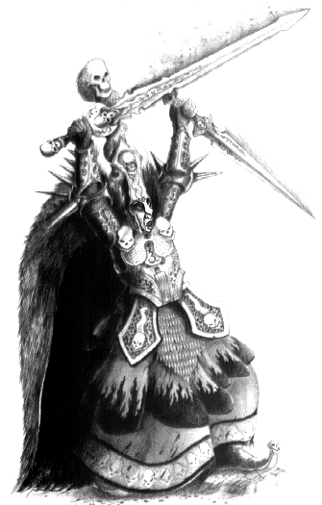
✶ DARK ELF SORCERESS’ 

Dark Elf Sorceress’ study Dark Magic just like their male counterparts. They are extremely beautiful and often lure human men to their deaths with a magical enchantment.

 | Dark Elf Sorceress | Dark Elf Sorceress Champion | Dark Elf Master Sorceress | Dark Elf Sorceress Queen
Wounds | 12 | 20 | 28 | 38
Move | 5 | 5 | 5 | 5
Weapon Skill | 4 | 4 | 4 | 4
Ballistic Skill | 3+ | 3+ | 3+ | 3+
Strength | 3 | 4 | 4 | 4
Toughness | 4 | 4 (5) | 4 (6) | 4 (7)
Armour | - | 1 | 2 | 3
Initiative | 7 | 7 | 8 | 9
Attacks | 1 | 1 | 2 | 3
Damage | 1D6 | 1D6 | 2D6 | 3D6
Gold | 690 | 1310 | 2290 | 3380

ENEMY’S WS 1 2 3 4 5 6 7 8 9 10
Dark Elf Sorceress 2 3 3 4 4 4 4 4 5 5
Dark Elf Sorceress Champion 2 3 3 4 4 4 4 4 5 5
Dark Elf High Sorceress 2 3 3 4 4 4 4 4 5 5
Dark Elf Sorceress Queen 2 3 3 4 4 4 4 4 5 5

Dark Elf Sorceress
Dark Elf Magic 1; Hate Elves; Lure; Magic Item; Magic Resistance 6+.

Dark Elf Sorceress Champion
Dark Elf Magic 2; Hate Elves; Lure; Magic Item; Magic Resistance 5+; Magic Weapon.

Dark Elf High Sorceress
Dark Elf Magic 3; Hate Elves; Lure; Magic Item x 2; Magic Dispel 4+; Magic Resistance 4+; Magic Weapon.

Dark Elf Sorceress Queen
Ambush, Magic A; Dark Elf Magic 4; Hate Elves; Lure; Magic Item x 3; Magic Dispel 4+; Magic Resistance 3+; Magic Weapon.

Lure
A Dark Elf Sorceress is extremely beautiful, and magically enchants Warriors to her embrace. The Warrior then has his throat cut and is left to bleed to death. At the beginning of each turn, each Warrior adjacent to the Dark Elf Sorceress must roll 1D6 and add his Willpower. If the result is 7 or more the Warrior resists the Sorcereress’ lure. If the result is less than 7 the Warrior has succumbed to her power. He enters into a trance which no other Warriors can break him out of. The Dark Elf Sorceress will automatically slit the Warrior’s throat if there are no other Warriors left standing, or if they too are all in a trance. Monsters will not attack the lured Warrior unless there is no one else to attack, and he cannot be the sole target of spell effects. If the Dark Elf Sorceress is killed, any Warriors affected by her lure will automatically break out of it.

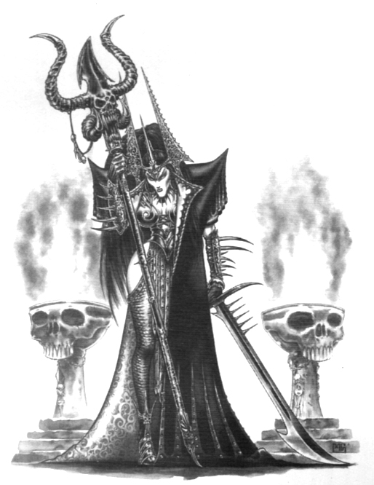

Dark Elf Magic
Dark Elf Sorcerers and Sorceress’ specialise in casting Dark Elf Magic. To see what spell they cast when given the chance, roll 2D6 on the following table. If the Dark Elf Sorcerer or Sorceress is killed while they still have active spells in play, they will immediately be dispelled.

2 FAILURE
The Sorcerer fails to cast a spell.

3 BATTLE LUST
The Sorcerer gives an extra (Dungeon Level) Attacks to all Monsters currently in combat with the Warriors, distributed as evenly as possible.

4 DOOMBOLT
A bolt of black fire bursts from the Sorcerer’s palm towards one of the Warriors. The Doombolt inflicts (2 x Dungeon Level) Wounds with no modifiers for Toughness or armour.

5 DARK HAND OF DESTRUCTION
The Sorcerer may attack any single adjacent Warrior. If there is more than one eligible target choose one at random. Roll 1D6 for the chosen Warrior and add his Strength. Now roll 1D6 for the Sorcerer and add his Strength to the score. The highest score wins. If the Warrior wins the spell fails. If the Sorcerer wins, the Warriors suffers deep cuts all over his body from the Sorcerer’s sharp talons. Now, and at the start of each subsequent turn, the Warrior loses (Dungeon Level) Wounds with no modifiers for Toughness or armour until the Sorcerer is dead. If the Sorcerer is not in hand to hand combat ignore this result and roll again.

6 BLADE WIND
The Sorcerer summons a storm of slashing blades which spin towards a random Warrior. That Warrior suffers (Dungeon Level)D6 Wounds.

7 SOUL DRAIN
The Sorcerer creates a storm of dark magic. Roll 1D6 for each Warrior adding his Toughness to the score. If the total is less than the Dungeon Level he suffers no ill effects from the spell. If the score is greater than or equal to the Dungeon Level the Warrior suffers (1D6 + Dungeon Level) unmodified Wounds and the Sorcerer gains the same amount. The Sorcerer may never gain more Wounds than he started with - any extra Wounds are lost in the warp. A Warrior reduced to zero Wounds by this spell is immediately killed and may not be raised by any means other than those spells and magic items that raise the dead.

8 ARNIZIPAL’S BLACK HORROR
A black cloud issues from the Sorcerer’s mouth, engulfing the Warriors in darkness. For the next Warriors’ Phase, the Warriors are at -2 To Hit due to the darkness. Any Monsters attacking the Warriors receive +2 To Hit.

9 THE TRANSFORMATION OF KADON
The Sorcerer transforms himself into one of the following monsters. Roll 1D6:

1-2 Wyvern
3-4 Chimera
5 Manticore
6 Hydra

If the transformation turns the Sorcerer into a Monster of less value than himself, re-roll for a different spell. The Sorcerer remains transformed until either he or all of the Warriors are dead. While transformed he may not cast any more spells.

10 WITCH FLIGHT
If pinned by a Warrior, the Sorcerer transports himself and any adjacent Monsters to another square in the dungeon away from the Warriors so that he is safe.

11 DEATH SPASM
A bolt of pure Dark Magic hits a Warrior on the same board section as the Sorcerer. The bolt causes (5 x Dungeon Level) Wounds with no modifiers for armour. If this kills the Warrior then he is dead and cannot be healed except for resurrection.

12 POWER OF KHAINE
Khaine, the God of Murder smiles at the slaughter the Dark Elf Sorcerer has caused. He decides to grant the Sorcerer more power. The Sorcerer now has +1 to the number of spells he can cast per turn.
✶ DARK ELF ASSASSIN 

Dark Elf Assassins have few equals in combat. They are master swordsmen and their weapons are rendered even more deadly by being tipped with Black Venom.

 | Dark Elf Assassin
Wounds | 12
Move | 5
Weapon Skill | 9
Ballistic Skill | A
Strength | 4
Toughness | 4
Armour | -
Initiative | 10
Attacks | 2
Damage | 1D6
Gold | 410

ENEMY’S WS 1 2 3 4 5 6 7 8 9 10
Dark Elf Assassin 2 2 2 2 3 3 3 3 4 4

Dark Elf Assassin
Ambush, Magic 5+; Assassinate 6+; Dodge 5+; Hate Elves; Poison Attack.

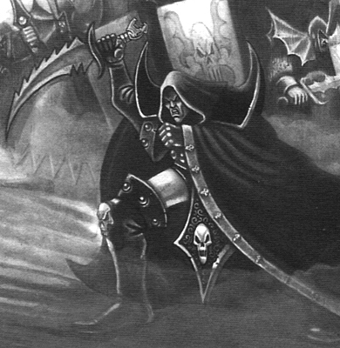

✶ HARPY 

Harpies are winged beasts with a savage, primeval beauty. They are scavengers who prey upon the sick, the weary, the battle-worn and the dying. Their screeching cries cleave the air and cast a shadow of dread on those below.

 | Harpy
Wounds | 22
Move | 6
Weapon Skill | 4
Ballistic Skill | -
Strength | 4
Toughness | 4
Armour | -
Initiative | 2
Attacks | 1
Damage | 1D6/2D6 (5+)
Gold | 180

ENEMY’S WS 1 2 3 4 5 6 7 8 9 10
Harpy 2 3 3 4 4 4 4 4 5 5

Harpy
Claw 6+; Fly.
✶ CAULDRON OF BLOOD 

The Cauldron of Blood is a solid brass cauldron filled with the blood of the Witch Elves victims. At the end of the battle, the Witch Elves bathe in the cauldron to renew their youthfulness and vigour.

 | Cauldron of Blood
Wounds | 40
Move | 4
Weapon Skill | 1
Ballistic Skill | -
Strength | -
Toughness | 7
Armour | -
Initiative | 1
Attacks | -
Damage | -
Gold | 600

Cauldron of Blood
Cauldron of Blood.

Cauldron of Blood
Place the Cauldron of Blood and the Witch Elves that appear with it as if they were armed with missile weapons. These Witch Elves Guard the Cauldron. The Cauldron of Blood is filled with the blood of the Witch Elves enemies. By bathing in it they renew their vigour and youthfulness. At the end of the Monsters’ Phase, any Monsters adjacent to the Cauldron of Blood receive 1D6 Wounds (up to their Starting Wounds) if they roll a 4 or over on 1D6.

A Cauldron of Blood will always appear with Witch Elves.

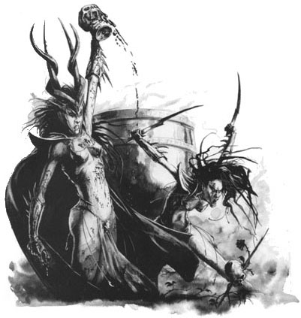

✶ REPEATER BOLT THROWER 

The Repeater Bolt Thrower is a huge crossbow on a wooden frame. It shoots incredibly thick bolts with sharp blades on the end into the enemy. The Dark Elves have modified it so it is able to shoot multiple bolts at different targets.

 | Repeater Bolt Thrower
Wounds | 20
Move | -
Weapon Skill | 1
Ballistic Skill | -
Strength | 15
Toughness | 7
Armour | -
Initiative | -
Attacks | 1D3
Damage | 2D6
Gold | 450

Bolt Thrower
Bolt Thrower.
✶ DARK PEGASUS 

A Dark Pegasus has been tainted by the blood of Chaos. They attack anyone who comes near, sometimes even their Dark Elf riders.

 | Dark Pegasus
Wounds | 35
Move | 8
Weapon Skill | 3
Ballistic Skill | -
Strength | 4
Toughness | 4 (6)
Armour | 2
Initiative | 4
Attacks | 3
Damage | 3D6
Gold | 1000

ENEMY’S WS 1 2 3 4 5 6 7 8 9 10
Dark Pegasus 2 3 4 4 4 4 5 5 5 6

Dark Pegasus
Terror 10; Fly.

Dark Pegasi can be ridden by any Dark Elf Warriors, Dark Elf Sorcerers or Dark Elf Sorceress’.

✶ MANTICORE 

The Manticore is a gigantic lion-like monster with large leathery wings and a spiked tail. They are devastating fighters attacking with raking claws and long, sharp teeth.

 | Manticore
Wounds | 50
Move | 6
Weapon Skill | 6
Ballistic Skill | -
Strength | 7
Toughness | 7
Armour | -
Initiative | 4
Attacks | 4
Damage | 4D6
Gold | 2000

ENEMY’S WS 1 2 3 4 5 6 7 8 9 10
Manticore 2 2 3 3 3 4 4 4 4 4

Manticore
Fly; Manticore Sting (Ambush, Magic A); Terror 11.

Manticore Sting
During the Monsters’ Phase, in addition to making its normal attacks and after it has moved, a Manticore may make a special poisonous Sting Attack. Each Warrior adjacent to the Manticore is automatically hit and suffers 3D6 Wounds, modified for Toughness and armour. As this Attack is poisonous, all the rules for the Poison special ability also apply.

Manticores can be ridden by any Dark Elf Warriors, Dark Elf Sorcerers or Dark Elf Sorceress’.

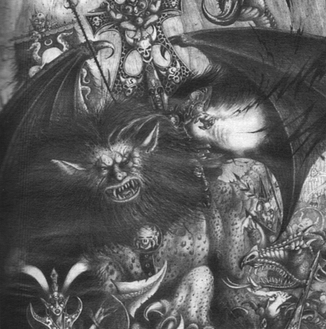
✶ WAR HYDRA 

The Hydra is a many headed monster with a scaly, reptilian body. It’s serpentine heads belch out smoky flame, but they can also attack by biting enemies with their sharp teeth, and crushing them in the coils of their necks. Their bodies are low and squat, heavily muscled and covered with thick scales which are as hard as iron. A War Hydra has been specially trained for battle by a Dark Elf Beastmaster who has raised the creature since it was hatched.

 | War Hydra
Wounds | 70
Move | 6
Weapon Skill | 3
Ballistic Skill | -
Strength | 5
Toughness | 6 (9)
Armour | 3
Initiative | 3
Attacks | 6
Damage | 4D6
Gold | 2400

ENEMY’S WS 1 2 3 4 5 6 7 8 9 10
War Hydra 2 3 4 4 4 4 5 5 5 6

War Hydra
Breathe Fire 4 (Ambush A); Ignore Blows 5+; Ignore Pain 7; Large Monster; Magic Resistance 5+; Never Pinned; Terror 11.

War Hydras will always appear with a Dark Elf Beastmaster.

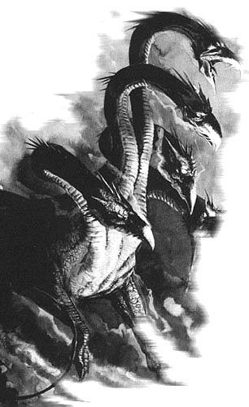

✶ BLACK DRAGON 

Black Dragons live under the peaks of the Blackspire mountains Woe betide any foolish Warrior who rouses them, as there is little to rival a dragon in combat. Some say that Black Dragons are the servants of Khaine, the God of Murder.

 | Dragon
Wounds | 74
Move | 6
Weapon Skill | 6
Ballistic Skill | -
Strength | 6
Toughness | 6 (12)
Armour | 6
Initiative | 8
Attacks | 7
Damage | 6D6
Gold | 4500

ENEMY’S WS 1 2 3 4 5 6 7 8 9 10
Black Dragon 2 2 3 3 3 4 4 4 4 4

Black Dragon
Breathe Smoke (Ambush, Magic A); Fly; Ignore Blows 5+; Ignore Pain 7; Large Monster; Terror 12.

Breathe Smoke
At the start of each turn roll 1D6. The number rolled indicates how many of the Warriors are engulfed in the oily fumes. If the score is higher than the number of Warriors present all of them have been hit. If not all of the Warriors are hit use the Warrior counters to determine who escapes. Roll 1D6 for each Warrior hit by the smoke, subtract his Toughness from the score and multiply the result by 2. The total shows how many D6 Wounds the Warrior suffers, with no modifiers for Toughness or armour. For example, a 6 is rolled for a Warrior of Toughness 4. He suffers ((6-4) x 2) = 4D6 Wounds, with no modifiers for Toughness or armour.

Black Dragons can be ridden by any Dark Elf Warriors, Dark Elf Sorcerers or Dark Elf Sorceress’.

