★ LIZARDMEN 

Deep within the jungles of Lustria the Lizardmen live in their mighty pyramid temples and ruined cities. Ready to defend themselves against any invaders, they unleash their fury upon anyone who dares to defile their cities.

✶ GIANT INSECT 

Giant Insects are native of Lustria - they are suited to the hot and humid climate. Many of the insects are blood-suckers and will attack with frenzy anyone that they see.

 | Giant Insect
Wounds | 1
Move | 8
Weapon Skill | 2
Ballistic Skill | -
Strength | 1
Toughness | 1
Armour | -
Initiative | 5
Attacks | 1
Damage | 1D3
Gold | 5

ENEMY’S WS 1 2 3 4 5 6 7 8 9 10
Giant Insect 3 4 4 4 5 5 6 6 6 6

Giant Insect
Fly; Gang Up.

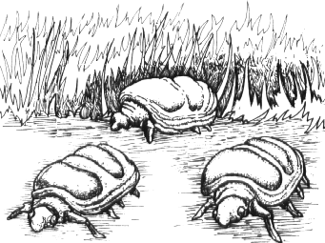

✶ LIZARD 

Lizards have been living in Lustria for many centuries. They are a fair size larger than normal lizards - the humid climate has allowed them to prosper. They have also grown to be carnivorous over the years.

 | Lizard
Wounds | 2
Move | 4
Weapon Skill | 2
Ballistic Skill | -
Strength | 1
Toughness | 3 (1)
Armour | 1
Initiative | 2
Attacks | 1
Damage | 1D6
Gold | 20

ENEMY’S WS 1 2 3 4 5 6 7 8 9 10
Lizard 3 4 4 4 5 5 6 6 6 6

Lizard
Ambush 6+.

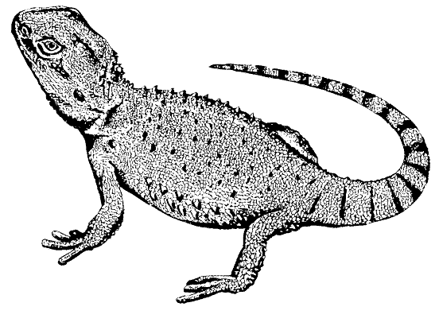

✶ GIANT TOAD 

Deep in the jungles of Lustria, undisturbed for many long years, toads have been sitting near noxious swamps, keeping to themselves. The fumes from these swamps have affected the toads, causing them to grow to twice their normal size. It has also affected their behaviour - now they attack anyone that comes near.

 | Giant Toad
Wounds | 1
Move | 4
Weapon Skill | 2
Ballistic Skill | -
Strength | 1
Toughness | 3
Armour | -
Initiative | 2
Attacks | 1
Damage | 1D6
Gold | 20

ENEMY’S WS 1 2 3 4 5 6 7 8 9 10
Giant Toad 3 4 4 4 5 5 6 6 6 6

Giant Toad
Bounce; Never Pinned.

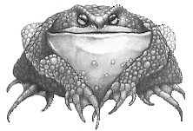

✶ GIANT CENTIPEDE 

Left undisturbed for years in the Lustrian jungles, centipedes have fed on the bodies of the slain and injured. Some of these have been Skaven, infected by warpstone, and therefore the centipedes have been affected. Now they are twice the size, with fierce sharp teeth and tough skin.

 | Giant Centipede
Wounds | 2
Move | 3
Weapon Skill | 4
Ballistic Skill | -
Strength | 1
Toughness | 3 (1)
Armour | 1
Initiative | 2
Attacks | 1
Damage | 1D6
Gold | 30

ENEMY’S WS 1 2 3 4 5 6 7 8 9 10
Giant Centipede 2 3 3 4 4 4 4 4 5 5

Giant Centipede
Poison Attack.

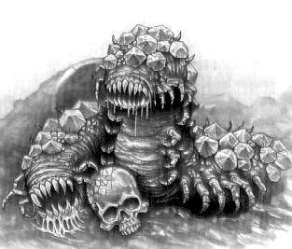

✶ SNAKES 

There are many different species of snakes in the Warhammer World. Lustrian Snakes differ from Old World snakes by being greater in size and having an appetite for flesh. They have been evolving for centuries undisturbed by man and have yet to learn to fear him, making them dangerous foes. Giant Snakes are vast serpentine beasts often kept in deep pits, used by Skink Shamans to sacrifice captives in the name of Sotek.

 | Snake | Giant Snake
Wounds | 2 | 18
Move | 4 | 6
Weapon Skill | 2 | 3
Ballistic Skill | - | -
Strength | 1 | 4
Toughness | 2 | 4
Armour | - | -
Initiative | 3 | 3
Attacks | 1 | 3
Damage | 1D6 | 2D6
Gold | 30 | 570

ENEMY’S WS 1 2 3 4 5 6 7 8 9 10
Snake 3 4 4 4 5 5 6 6 6 6
Giant Snake 2 3 4 4 4 4 5 5 5 6

Snake
Ambush, Magic 6+; Poison Attack.

Giant Snake
Coil; Poison Attack.

Coil
If two consecutive attacks of the Giant Snake’s hit a Warrior, it has succeeded in enveloping the Warrior with it’s coils. While trapped, a Warrior cannot move. He can still attack, although Monsters have a +1 bonus to hit him and he cannot use any skills such as Dodge etc. At the end of each turn, a Warrior who is smothered in the Giant Snake’s coils will lose 1D3 unmodified Wounds. If the trapped Warrior hits the Snake, it will immediately release him. A Giant Snake is so huge that it can coil many Warriors at the same time.

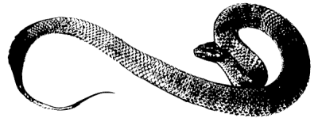

✶ GIANT LEECH 

Giant Leeches live in the swamps of Lustria, wherever it is damp and humid. They are about one foot long, and drop out of trees onto their victims and suck the blood out of them.

 | Giant Leech
Wounds | 2
Move | 2
Weapon Skill | 2
Ballistic Skill | -
Strength | 1
Toughness | 3
Armour | -
Initiative | 2
Attacks | 1
Damage | Special
Gold | 35

ENEMY’S WS 1 2 3 4 5 6 7 8 9 10
Giant Leech 3 4 4 4 5 5 6 6 6 6

Giant Leech
Ambush, Magic A; Bloodsucker.

Bloodsucker
Giant Leeches can suck the blood from the Warriors. If a Giant Leech manages to make a successful attack, it has managed to attach itself to the Warrior. A Giant Leech attached to a Warrior will suck the blood from him for his attack. He loses 1 unmodified Wound for each Giant Leech which is on him. An attack by a Giant Leech is treated as being poison. At the beginning of the Warriors’ Phase, a Warrior may try to rip a Giant Leech from him, but only one Giant Leech each turn. Roll 1D6 and add the Warrior’s Strength. On a score of 7 or more the Giant Leech is ripped from the Warriors body. Place it in a square adjacent to the Warrior. Other Warriors may also attempt to remove the Giant Leech from an adjacent Warrior’s body.

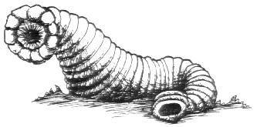
✶ SKINKS 

Skinks are fast, agile reptiles, best suited for scouting. They make superb archers and hardly anyone can match their marksmanship. Skinks rarely travel alone, preferring to move about in large groups.

 | Skink | Skink  Champion | Skink Hero
Wounds | 2 | 5 | 8
Move | 6 | 6 | 6
Weapon Skill | 2 | 3 | 4
Ballistic Skill | 4+ | 3+ | 2+
Strength | 3 | 4 | 4
Toughness | 2 (3) | 2 (3) | 3 (4)
Armour | 1 | 1 | 1
Initiative | 4 | 5 | 6
Attacks | 1 | 2 | 3
Damage | 1D6 | 1D6 | 1D6
Gold | 40 | 130 | 350

ENEMY’S WS 1 2 3 4 5 6 7 8 9 10
Skink 3 4 4 4 5 5 6 6 6 6
Skink Champion 2 3 4 4 4 4 5 5 5 6
Skink Hero 2 3 3 4 4 4 4 4 5 5

Skink
Armed with [1-2] Short Bows (Str 1), [3-4] Javelins (Fight in Ranks), or [5-6] Swords; Poison Attack.

Skink Champion
Armed with [1-2] Short Bows (Str 3), [3-4] Javelins (Fight in Ranks), or [5-6] Swords; Magic Item; Poison Attack.

Skink Lord
Magic Item; Magic Weapon; Poison Attack.

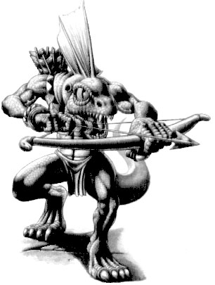
✶ CHAMELEON SKINKS 

Chameleon Skinks are a rare breed of Skinks able to change colour and patterning to match whatever the surroundings are. By doing this they are able to confuse their opponents and therefore sneak up on them, undetected.

 | Chameleon Skink | Chameleon Skink  Champion | Chameleon Skink Hero
Wounds | 2 | 5 | 8
Move | 6 | 6 | 6
Weapon Skill | 2 | 3 | 4
Ballistic Skill | 4+ | 3+ | 2+
Strength | 3 | 4 | 4
Toughness | 2 (3) | 2 (3) | 3 (4)
Armour | 1 | 1 | 1
Initiative | 4 | 5 | 6
Attacks | 1 | 2 | 3
Damage | 1D6 | 1D6 | 1D6
Gold | 60 | 160 | 390

ENEMY’S WS 1 2 3 4 5 6 7 8 9 10
Chameleon Skink 3 4 4 4 5 5 6 6 6 6
Chameleon Skink Champion 2 3 4 4 4 4 5 5 5 6
Chameleon Skink Hero 2 3 3 4 4 4 4 4 5 5

Chameleon Skink
Ambush 4+; Armed with Blowpipe (Str 1, Poison Attack); Chameleon.

Chameleon Skink Champion
Ambush 4+; Armed with Blowpipe (Str 2, Poison Attack); Chameleon; Magic Item; Poison Attack.

Chameleon Skink Lord
Ambush 4+; Chameleon; Magic Item; Magic Weapon; Poison Attack.

Chameleon
Chameleon Skinks can change the colour of their skin to match their surroundings. In the wilderness any Warriors who attack a Chameleon Skink must subtract -2 from their to hit roll. In the dungeon, because it is so much harder to hide, Warriors only have a -1 penalty to hit.

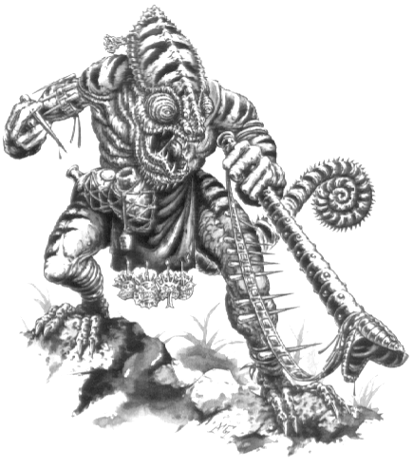
✶ GREAT CRESTED SKINK 

Great Crested Skinks are larger and stronger than normal Skinks and more intelligent, therefore only they have the talent to control a Horned One in battle.

 | Great Crested Skink
Wounds | 3
Move | 6
Weapon Skill | 2
Ballistic Skill | 4+
Strength | 4
Toughness | 2 (3)
Armour | 1
Initiative | 4
Attacks | 1
Damage | 1D6
Gold | 80

ENEMY’S WS 1 2 3 4 5 6 7 8 9 10
Great Crested Skink 3 4 4 4 5 5 6 6 6 6

Great Crested Skink
Armed with Spears (Fight in Ranks); Poison Attack.

✶ SKINK SHAMAN 

Skink Shamans are extremely rare, for casting magic is the task of the Slann Mage Priests. However, sometimes a Skink learns the ways of magic. Because they are weak shamans, their magic is not as strong as the much more powerful Slann Mage Priests.

 | Skink Shaman
Wounds | 3
Move | 6
Weapon Skill | 2
Ballistic Skill | 4+
Strength | 3
Toughness | 3 (4)
Armour | 1
Initiative | 5
Attacks | 1
Damage | 1D6
Gold | 300

ENEMY’S WS 1 2 3 4 5 6 7 8 9 10
Skink Shaman 3 4 4 4 5 5 6 6 6 6

Skink Shaman
Lizardman Magic 1.
✶ SAURUS 

Saurus are slow moving and slow reacting creatures, even for Lizardmen. They are very ferocious however, and make excellent fighters.

 | Saurus | Saurus  Champion | Saurus Hero
Wounds | 10 | 20 | 30
Move | 4 | 4 | 4
Weapon Skill | 3 | 4 | 5
Ballistic Skill | - | - | -
Strength | 4 | 5 | 5
Toughness | 4 (6) | 4 (6) | 5 (7)
Armour | 2 | 2 | 2
Initiative | 1 | 2 | 3
Attacks | 2 | 3 | 4
Damage | 1D6 | 2D6 | 3D6
Gold | 150 | 350 | 850

ENEMY’S WS 1 2 3 4 5 6 7 8 9 10
Saurus 2 3 4 4 4 4 5 5 5 6
Saurus Champion 2 3 3 4 4 4 4 4 5 5
Saurus Hero 2 2 3 3 4 4 4 4 4 4

Saurus
Armed with [1-3] Spears (Fight in Ranks) or [4-6] Axes; Bite Attack.

Saurus Champion
Armed with [1-3] Spears (Fight in Ranks) or [4-6] Axes; Bite Attack; Magic Item.

Saurus Hero
Bite Attack; Magic Item; Magic Weapon.

Bite Attack
Saurus Warriors have large sharp teeth which they use to bite their opponents. The Saurus Warrior’s first Attack will be a Bite Attack. If it hits it causes 1D6 damage with no modifiers for armour. The damage caused by the bite is treated as being poison.

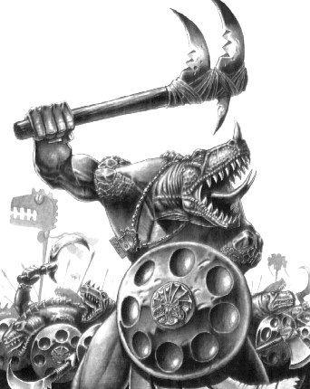
✶ TEMPLE GUARD 

Each Pyramid Temple is guarded by specially trained Saurus Warriors. They are the best Warriors of all the Lizardmen. They usually are given the best weapons and armour produced, and will guard the temple to the death.

 | Temple Guard
Wounds | 25
Move | 4
Weapon Skill | 4
Ballistic Skill | -
Strength | 4
Toughness | 4 (7)
Armour | 3
Initiative | 2
Attacks | 2
Damage | 2D6/3D6 (5+)
Gold | 500

ENEMY’S WS 1 2 3 4 5 6 7 8 9 10
Temple Guard 2 3 3 4 4 4 4 4 5 5

Temple Guard
-

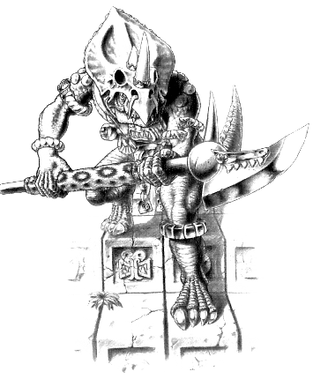

✶ COATL 

Coatl are large feathered serpents native to the jungles of Lustria. They have wings on their back which enable them to fly. They prefer to attack from the air, swooping down low before dropping on the enemy.

 | Coatl
Wounds | 15
Move | 8
Weapon Skill | 3
Ballistic Skill | -
Strength | 3
Toughness | 3 (4)
Armour | 1
Initiative | 2
Attacks | 2
Damage | 2D6
Gold | 500

ENEMY’S WS 1 2 3 4 5 6 7 8 9 10
Coatl 2 3 4 4 4 4 5 5 5 6

Coatl
Fly.
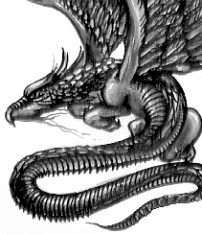

✶ KROXIGOR 

Kroxigor are much larger and fiercer than Saurus and tower above them. They are extremely unintelligent and their only means of communication is a blood curdling roar.

 | Kroxigor
Wounds | 38
Move | 6
Weapon Skill | 3
Ballistic Skill | -
Strength | 3
Toughness | 4 (7)
Armour | 3
Initiative | 1
Attacks | 3
Damage | 3D6
Gold | 750

ENEMY’S WS 1 2 3 4 5 6 7 8 9 10
Kroxigor 2 3 4 4 4 4 5 5 5 6

Kroxigor
Armed with Two Handed Axe (Fight in Ranks); Fear 7.

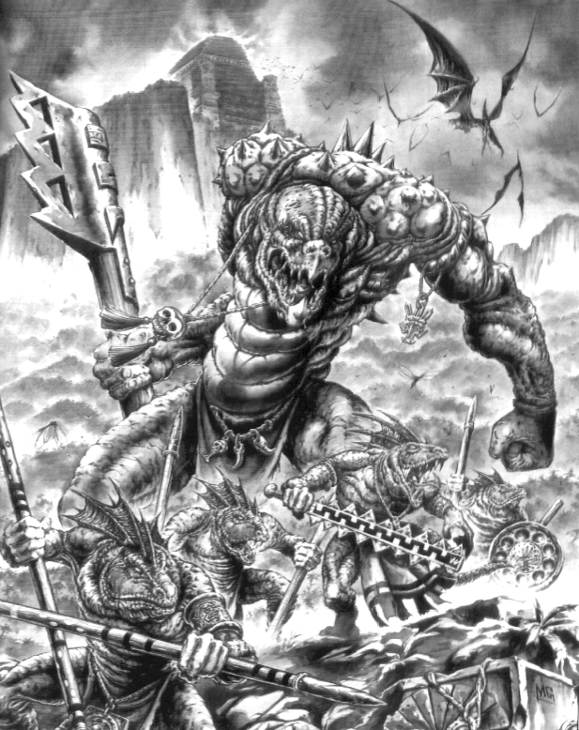
✶ SALAMANDER 

Salamanders are great amphibians that live deep in the jungles and swamps of Lustria. They are violently fierce and spit venom at their prey. Once the venom has partially dissolved their victims, the Salamanders devour them with their huge jaws.

 | Salamander
Wounds | 40
Move | 6
Weapon Skill | 3
Ballistic Skill | -
Strength | 4
Toughness | 4 (7)
Armour | 3
Initiative | 2
Attacks | 3
Damage | 4D6
Gold | 900

ENEMY’S WS 1 2 3 4 5 6 7 8 9 10
Salamander 2 3 4 4 4 4 5 5 5 6

Salamander
Fear 9; Ignore Pain 1; Spit Venom.

Spit Venom
At the beginning of each Monsters’ Phase the Salamander will shoot a stream of corrosive venom towards the Warriors. Choose a Warrior at random. Roll to hit as normal for a Ballistic Attack using a value of 4+. If the attack hits, the Warrior takes 1D6 Wounds with no modifiers for Toughness and armour. The damage is counted as being poison. If a 6 is rolled to hit, the venom strikes the Warrior’s eyes and he is blinded. He can be healed at a Settlement for 1D6 x 100 Gold, but until then he has Weapon Skill 1, Ballistic Skill 6+, Initiative 1, Pinning 6+ and a Movement of 1, unless another Warrior stands adjacent to him and guides him. All Monsters that attack the blinded Warrior can add +2 to their To Hit rolls.

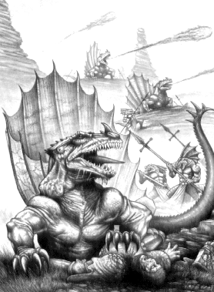

✶ TERRADON 

Terradons are large flying reptiles who live high in the crags and mountains of Lustria. Skinks have mastered the art of riding Terradons into battle but they are so strong it takes two to control them.

 | Terradon
Wounds | 18
Move | 10
Weapon Skill | 3
Ballistic Skill | -
Strength | 4
Toughness | 4 (6)
Armour | 2
Initiative | 2
Attacks | 1
Damage | 1D6/2D6 (5+)
Gold | 400

ENEMY’S WS 1 2 3 4 5 6 7 8 9 10
Terradon 2 3 4 4 4 4 5 5 5 6

Terradon
Drop Rock 4+ (Strength 6); Fear 5; Fly.

Terradons can be ridden by any Skinks.

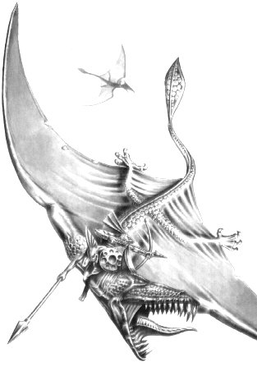
✶ COLD ONES 

Cold Ones live in dark caves and tunnels beneath Lustria and also roam the jungles. Their bodies exude poisonous slime and they are somewhat immune to pain, having such thick skin. Dark Elves have also learnt to ride Cold Ones although with much more difficulty than Skinks. There also exists an almost extinct breed of Cold One called a Horned One. A Horned One only exists in Lustria and is very aggressive and territorial. It will attack any other opponent, regardless of size. They are ridden by special Skinks called Great Crested Skinks. Great Crested Skinks are larger and stronger than normal Skinks and more intelligent, therefore only they have the talent to control a Horned One in battle.

 | Cold One | Horned One | Great Crested Skink
Wounds | 30 | 35 | 3
Move | 8 | 8 | 6
Weapon Skill | 3 | 4 | 2
Ballistic Skill | - | - | 4+
Strength | 4 | 4 | 4
Toughness | 4 (7) | 4 (7) | 2 (3)
Armour | 3 | 3 | 1
Initiative | 1 | 1 | 4
Attacks | 2 | 3 | 1
Damage | 3D6 | 3D6 | 1D6
Gold | 770 | 850 | 80

ENEMY’S WS 1 2 3 4 5 6 7 8 9 10
Cold One 2 3 4 4 4 4 5 5 5 6
Horned One 2 3 3 4 4 4 4 4 5 5
Great Crested Skink 3 4 4 4 5 5 6 6 6 6

Cold One
Fear 6; Ignore Pain 1.

Horned One
Fear 7; Ignore Pain 1.

Great Crested Skink
Armed with Spears (Fight in Ranks); Poison Attack.

Cold Ones can be ridden by any Skinks or Chameleon Skinks.

Horned Ones can only be ridden by a Great Crested Skink.

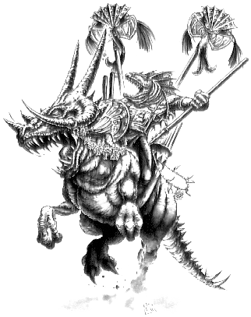
✶ CULCHAN 

Culchan are huge flightless birds that live in the grasslands of Lustria. They are prized by Pygmies and Lizardmen for their brightly coloured feathers for adorning weapons and helmets. They are extremely fierce and can use their huge beaks to rip into a Warriors flesh, tearing chunks from his body.

 | Culchan
Wounds | 18
Move | 6
Weapon Skill | 3
Ballistic Skill | -
Strength | 4
Toughness | 4
Armour | -
Initiative | 2
Attacks | 2
Damage | 3D6
Gold | 750

ENEMY’S WS 1 2 3 4 5 6 7 8 9 10
Culchan 2 3 4 4 4 4 5 5 5 6

Culchan
-

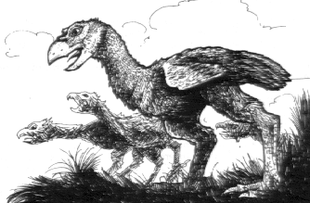

✶ SLANN MAGE PRIESTS 

Slann are the most intelligent of the Lizardmen. They are bloated toad type creatures who must be carried around on a palanquin by servants. They live for centuries - all the ones alive today are the same ones that served the Old Ones many centuries ago. They are the masters of Lizardman Magic.

 | Slann Mage Priest | Slann Mage Priest Champion | Slann Master Mage Priest | Slann Mage Lord
Wounds | 25 | 35 | 50 | 70
Move | 4 | 4 | 4 | 4
Weapon Skill | 3 | 4 | 5 | 6
Ballistic Skill | 5+ | 4+ | 3+ | 2+
Strength | 4 | 6 | 6 | 6
Toughness | 4 (5) | 4 (6) | 5 (8) | 5 (9)
Armour | 1 | 2 | 3 | 4
Initiative | 2 | 3 | 5 | 6
Attacks | 2 | 3 | 5 | 7
Damage | 2D6 | 3D6 | 4D6 | 5D6
Gold | 1500 | 2500 | 3500 | 4500

ENEMY’S WS 1 2 3 4 5 6 7 8 9 10
Slann Mage Priest 2 3 4 4 4 4 5 5 5 6
Slann Mage Priest Champion 2 3 3 4 4 4 4 4 5 5
Master Slann Mage Priest 2 2 3 3 4 4 4 4 4 4
SlannMage Lord 2 2 3 3 3 4 4 4 4 4

Slann Mage Priest
Fear 10; Ignore Pain 1; Lizardman Magic 1; Magic Item; Magic Weapon; Shield of the Old Ones.

Slann Mage Priest Champion
Fear 10; Ignore Pain 1; Lizardman Magic 2; Magic Item x 2; Magic Weapon; Shield of the Old Ones.

Master Slann Mage Priest
Fear 10; Ignore Pain 2; Lizardman Magic 3; Magic Item x 3; Magic Weapon; Shield of the Old Ones.

Slann Mage Lord
Fear 10; Ignore Pain 3; Lizardman Magic 4; Magic Item x 4; Magic Weapon; Shield of the Old Ones.

Shield of the Old Ones
The Shield of the Old Ones is not a magic item, but an ancient sorcerous ability of the Slann Mage Priests. It gives protection to the Mage Priest and his servants. They all have the Ignore Blows 4+ skill.

Palanquin
The Mage Priest sits on a palanquin carried by his servants. Every time a Slann Mage Priest is encountered he will be accompanied by four Temple Guards, one carrying each corner of the palanquin. The Warriors must kill all of the Temple Guards before attacking the Mage Priest. Each time a Temple Guard is killed the remaining ones will reposition themselves immediately to carry the palanquin, thus losing one point of movement. If there is only one Temple Guard left the palanquin may not move.

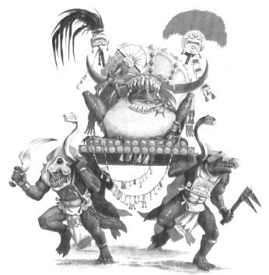
✶ STEGADON 

Stegadons are huge lumbering primitive dinosaur like beasts who have dwelt in the jungles of Lustria since before the coming of the Old Ones. They have several large horns on their forehead which they use to skewer their enemies before trampling them to death. Skinks sometimes build a howdah on the back of a Stegadon that can hold about 12 Skinks. These Skinks are armed with missile weapons so they can aim at the Warriors over the top of all the other Monsters.

 | Stegadon | Howdah
Wounds | 90 | 15
Move | 6 | -
Weapon Skill | 2 | 1
Ballistic Skill | - | -
Strength | 7 | -
Toughness | 6 (14) | 5
Armour | 8 | -
Initiative | 2 | -
Attacks | 5 | -
Damage | 4D6 | -
Gold | 6000 | 20

ENEMY’S WS 1 2 3 4 5 6 7 8 9 10
Stegadon 3 4 4 4 5 5 6 6 6 6

Stegadon
Ignore Blows 4+; Ignore Pain 2D6; Large Monster; Terror 12; Trample 4.

Howdah
The Warriors cannot attack the Howdah except with spells or missile weapons. If the Howdah is destroyed, all the Skinks on it will fall off - place them on adjacent squares, moving any other models out of the way if necessary. If the Warriors succeed in killing the Stegadon, the Howdah will topple over, depositing the Skinks as above. The Howdah is so heavy that the Stegadon carrying it has its movement value reduced by -2.

