★ MONSTERS 

In the deep labyrinthine tunnels and halls that stretch below the mountains of the Warhammer World, there are many evil creatures lurking in the darkness. Some are small and malicious, their evil hearts set on spiteful evils. Others are raging beasts of such immense power and fury that they strike terror into the hearts of those who behold them.

✶ GIANT BAT 

Out of the darkest caves fly the twittering, screeching clouds of Giant Bats. These fanged monstrosities, held aloft on great leathery wings, hide in the shadows, then swoop silently down upon their prey and rip them to shreds with teeth and talons.

 | Giant Bat
Wounds | 1
Move | 8
Weapon Skill | 2
Ballistic Skill | -
Strength | 2
Toughness | 2
Armour | -
Initiative | 1
Attacks | 1
Damage | 1D6
Gold | 15

ENEMY’S WS 1 2 3 4 5 6 7 8 9 10
Giant Bat 3 4 4 4 5 5 6 6 6 6

Giant Bat
Ambush A; Fly.

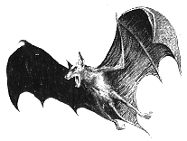

✶ GIANT SPIDERS 

Beneath the mountains, in the darkest, deepest caves, lurk the Giant Spiders. Their bodies are covered by thick, horny, chitinous plates, and their fangs drip nerve-shattering poison. Huddled in the darkness, they lie in wait, spinning webs to ensnare their unsuspecting victims.

 | Giant Spider | Gigantic Spider
Wounds | 1 | 20
Move | 6 | 5
Weapon Skill | 2 | 3
Ballistic Skill | - | -
Strength | 1 | 3
Toughness | 2 | 4
Armour | - | -
Initiative | 1 | 1
Attacks | 1 | 2
Damage | Special | Special
Gold | 15 | 450
ENEMY’S WS 1 2 3 4 5 6 7 8 9 10
Giant Spider 3 4 4 4 5 5 6 6 6 6
Gigantic Spider 2 3 4 4 4 4 5 5 5 6

Giant Spider
Web (1D3).

Gigantic Spider
Fear 5; Web (1D6).

Web
Spiders attempt to ensnare their prey in a web, so that they can finish it off at their leisure. Each turn a Spider may attempt to web a Warrior as many times as it has Attacks. If the Spider hits the Warrior he has been caught in its web - place a Webbed counter next to the Warrior. While webbed a Warrior may not do and may be bitten automatically with the rest of the Spider’s Attacks (no to hit roll is needed) for 1Dn Wounds per bite (where n is the value after the Web entry), with no modifiers for Toughness or armour. A Spider may not use its bite Attack(s) if its opponent has not been webbed. Monsters without the ability to use webs that may also be involved in the combat get +2 to their to hit rolls against a webbed Warrior. At the start of each Warriors' Phase, roll 1D6 for each Warrior that has been webbed and add his Strength. If the total is 7 or more, he pulls himself free from the sticky strands and may act normally this turn. Other Warriors may also attempt to remove the web from an adjacent Warrior’s body.

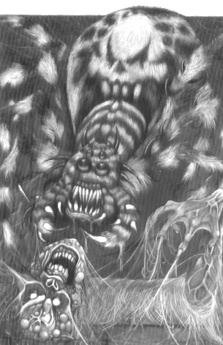
✶ GIANT RAT 

No less dangerous than the more intelligent monsters are the packs of Giant Rats that dwell in the dirtiest corners of the Warhammer World. Bloated by eating indescribable foul things, these rats have grown to immense proportions. When cornered, Giant Rats hurl themselves at their opponent in a maniacal frenzy, lunging for their enemy’s jugular vein with no thought to their own safety.

 | Giant Rat
Wounds | 1
Move | 6
Weapon Skill | 2
Ballistic Skill | -
Strength | 2
Toughness | 3
Armour | -
Initiative | 4
Attacks | 1
Damage | Special
Gold | 25

ENEMY’S WS 1 2 3 4 5 6 7 8 9 10
Giant Rat 3 4 4 4 5 5 6 6 6 6

Giant Rat
Deathleap.

Deathleap
Giant Rats make a special attack, called a Deathleap. Roll the Rat’s attack as normal, but if it hits roll 2D6 + 2 for damage. Once a Rat has attacked the Warrior, roll 1D6. On a result of 3-6 the Rat’s suicidal, frenzied attack has opened it up to the Warrior’s attack and he automatically kills it.

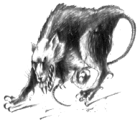

✶ WARHOUND 

Warhounds are sometimes driven into combat by Dark Elf Beastmasters, using their whips to control them.

 | Warhound
Wounds | 6
Move | 5
Weapon Skill | 4
Ballistic Skill | -
Strength | 3
Toughness | 3
Armour | -
Initiative | 6
Attacks | 1
Damage | 1D6
Gold | 130

ENEMY’S WS 1 2 3 4 5 6 7 8 9 10
Warhound 2 3 3 4 4 4 4 4 5 5

Warhound
-
✶ HARPY 

Harpies live high in crags in the mountains, but they often venture across the land in search of prey.

 | Harpy
Wounds | 22
Move | 6
Weapon Skill | 4
Ballistic Skill | -
Strength | 4
Toughness | 4
Armour | -
Initiative | 2
Attacks | 1
Damage | 1D6/2D6 (5+)
Gold | 180

ENEMY’S WS 1 2 3 4 5 6 7 8 9 10
Harpy 2 3 3 4 4 4 4 4 5 5

Harpy
Claw 6+; Fly.

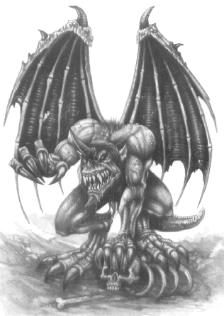

✶ NIGHTMARE 

A Nightmare appears out of the night, spitting fire from its nostrils and eyes blazing with light. Its mane and hooves glow with bright fire. It charges recklessly at anything in its path before vanishing almost instantly.

 | Nightmare
Wounds | 6
Move | 8
Weapon Skill | 3
Ballistic Skill | -
Strength | 4
Toughness | 3
Armour | -
Initiative | 8
Attacks | 1
Damage | 1D6/2D6 (6+)
Gold | 190

ENEMY’S WS 1 2 3 4 5 6 7 8 9 10
Nightmare 2 3 4 4 4 4 5 5 5 6

Nightmare
Ambush 5+.
✶ CENTAURS 

More often found on the plains of the Northern Wastes, the brutish Chaos Centaurs sometimes descend into the ancient Dwarf Holds along with Beastmen and Chaos Warriors in search of treasure. Their vicious tempers can only be sated by deeds of the most bloodthirsty nature.

 | Centaur | Centaur Champion | Centaur Hero
Wounds | 12 | 27 | 40
Move | 8 | 8 | 8
Weapon Skill | 3 | 4 | 5
Ballistic Skill | 3+ | 2+ | 1+
Strength | 4 | 5 | 5
Toughness | 3 | 3 (5) | 4 (8)
Armour | - | 2 | 4
Initiative | 3 | 4 | 5
Attacks | 2 | 3 | 4
Damage | 2D6 | 2D6/3D6 (5+) | 3D6
Gold | 300 | 1000 | 2200

ENEMY’S WS 1 2 3 4 5 6 7 8 9 10
Centaur 2 3 4 4 4 4 5 5 5 6
Centaur Champion 2 3 3 4 4 4 4 4 5 5
Centaur Hero 2 2 3 3 4 4 4 4 4 4

Centaur
Armed with Bow (Str 4); Fear 4.

Centaur Champion
Armed with Bow (Str 7; Fear 8; Magic Armour; Magic Weapon.

Centaur Hero
Armed with Bow (Str 8; Fear 9; Magic Armour; Magic Item; Magic Weapon.

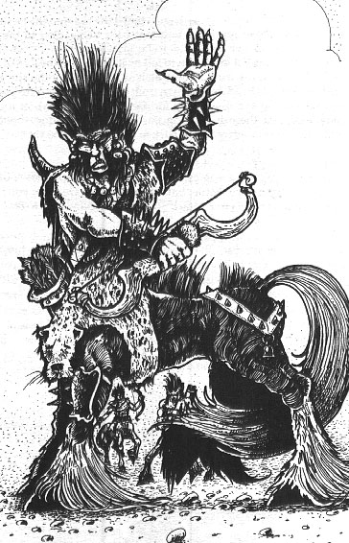
✶ OGRES 

Ogres stand twice as tall as a man, with massive muscles, jutting jaws and thick bony foreheads. Once an Ogre decides to act it is all but unstoppable.

 | Ogre | Ogre Champion | Ogre Chieftain | Ogre  War Chief
Wounds | 13 | 22 | 29 | 38
Move | 6 | 6 | 6 | 6
Weapon Skill | 3 | 4 | 5 | 6
Ballistic Skill | 5+ | 4+ | 3+ | 2+
Strength | 4 | 5 | 5 | 5
Toughness | 5 | 5 | 6 | 6 (8)
Armour | - | - | - | 2
Initiative | 3 | 4 | 5 | 6
Attacks | 2 | 3 | 4 | 5
Damage | 1D6/2D6 (5+) | 2D6 | 2D6/3D6 (5+) | 3D6
Gold | 400 | 800 | 1300 | 2500

ENEMY’S WS 1 2 3 4 5 6 7 8 9 10
Ogre 2 3 4 4 4 4 5 5 5 6
Ogre Champion 2 3 3 4 4 4 4 4 5 5
Ogre Chieftain 2 2 3 3 4 4 4 4 4 4
Ogre War Chief 2 2 3 3 3 4 4 4 4 4

Ogre
Fear 5.

Ogre Champion
Fear 6; Magic Weapon.

Ogre Chieftain
Fear 7; Magic Item; Magic Weapon.

Ogre War Chief
Fear 8; Magic Armour; Magic Item; Magic Weapon.

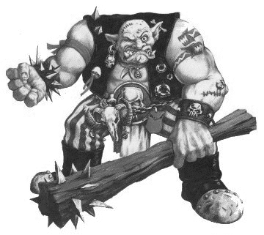
✶ MINOTAURS 

Minotaurs are large creatures, and have the torso of a hugely-muscled human, but the horned head of a wild bull. Their immense faces are broad, squat and evil, with beady eyes, jutting fangs and snorting, flared nostrils.

 | Minotaur | Minotaur Champion | Minotaur Hero | Minotaur Lord
Wounds | 15 | 34 | 48 | 60
Move | 6 | 6 | 6 | 6
Weapon Skill | 4 | 5 | 6 | 7
Ballistic Skill | 4+ | 3+ | 2+ | 1+
Strength | 4 | 5 | 5 | 5
Toughness | 4 | 4 | 5 | 5 (9)
Armour | - | - | - | 4
Initiative | 3 | 4 | 5 | 6
Attacks | 2 | 3 | 4 | 5
Damage | 2D6 | 3D6 | 3D6/4D6 (5+) | 4D6
Gold | 440 | 1100 | 2400 | 3000

ENEMY’S WS 1 2 3 4 5 6 7 8 9 10
Minotaur 2 3 3 4 4 4 4 4 5 5
Minotaur Champion 2 2 3 3 4 4 4 4 4 4
Minotaur Hero 2 2 3 3 3 4 4 4 4 4
Minotaur Lord 2 2 2 3 3 3 4 4 4 4

Minotaur
Fear 5.

Minotaur Champion
Fear 6; Magic Weapon.

Minotaur Hero
Fear 9; Magic Item x 2; Magic Weapon.

Minotaur Lord
Fear 10; Magic Armour; Magic Item x 3; Magic Weapon.

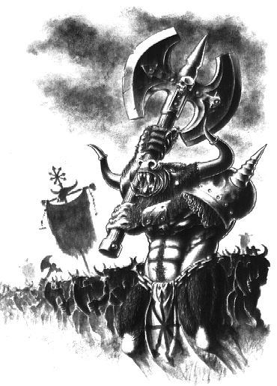

✶ DRAGON OGRES 

Dragon Ogres are ancient, brutish reptiles that live in the deepest mountain caves, only emerging during mighty storms to do battle on the mountain tops.

 | Dragon Ogre | Dragon Ogre Champion | Dragon Ogre Hero | Dragon Ogre Lord
Wounds | 40 | 44 | 53 | 60
Move | 6 | 6 | 6 | 6
Weapon Skill | 4 | 5 | 6 | 7
Ballistic Skill | 5+ | 4+ | 3+ | 2+
Strength | 5 | 6 | 6 | 6
Toughness | 5 (7) | 5 (7) | 6 (8) | 6 (9)
Armour | 2 | 2 | 2 | 3
Initiative | 2 | 3 | 4 | 5
Attacks | 3 | 4 | 5 | 6
Damage | 2D6 | 2D6 | 3D6 | 4D6
Gold | 870 | 1550 | 3300 | 4000

ENEMY’S WS 1 2 3 4 5 6 7 8 9 10
Dragon Ogre 2 3 3 4 4 4 4 4 5 5
Dragon Ogre Champion 2 2 3 3 4 4 4 4 4 4
Dragon Ogre Hero 2 2 3 3 3 4 4 4 4 4
Dragon Ogre Lord 2 2 2 3 3 3 4 4 4 4

Dragon Ogre
Fear 8.

Dragon Ogre Champion
Fear 8; Magic Armour; Magic Weapon.

Dragon Ogre Hero
Fear 9; Magic Armour; Magic Item; Magic Weapon.

Dragon Ogre Lord
Fear 10; Magic Armour; Magic Item x 2; Magic Weapon.

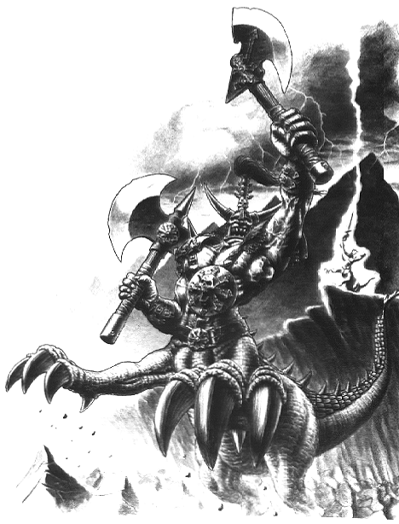

✶ GIANT SCORPION 

The dank underground passageways and caverns of the Worlds Edge Mountains conceal many huge and evil Monsters. They breed in the darkness and grow huge and fat on a diet of unnameable crawling things that live deep below the earth. The Giant Scorpion has a shiny armoured shell and chitinous claws with saw edges and knife-like bristles. Its most deadly weapon is its venomous sting.

 | Giant Scorpion
Wounds | 20
Move | 5
Weapon Skill | 3
Ballistic Skill | -
Strength | 5
Toughness | 6
Armour | -
Initiative | 1
Attacks | 2
Damage | 2D6
Gold | 450

ENEMY’S WS 1 2 3 4 5 6 7 8 9 10
Giant Scorpion 2 3 4 4 4 4 5 5 5 6

Giant Scorpion
Sting (2D6).

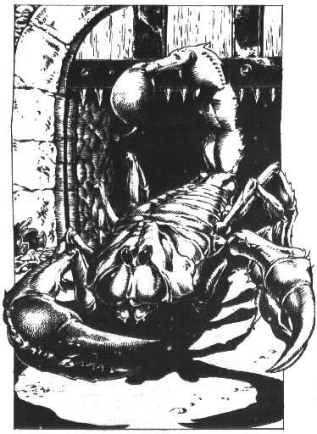
✶ DRYAD 

Dryads are tree spirits who inhabit the trees of the forests of Loren. In their solid form, they resemble a miniature version of a Treeman, with soft, damp woody flesh. They are very violent if threatened and will use their branch like arms with claws of sharp thorns and twigs to their best advantage.

 | Dryad
Wounds | 15
Move | 5
Weapon Skill | 4
Ballistic Skill | 4+
Strength | 4
Toughness | 4
Armour | -
Initiative | 4
Attacks | 2
Damage | 2D6
Gold | 550

ENEMY’S WS 1 2 3 4 5 6 7 8 9 10
Dryad 2 3 3 4 4 4 4 4 5 5

Dryad
Aspects.

Aspects
Dryads can shape shift into different types of trees when under attack. When the battle starts, roll 1D6 to see which aspect the Dryads will be in for the duration of the combat. Roll once for all the Dryads in the group. If a Dryad is killed, roll again to see what the remainder of the Dryads will change into.

1-2 Oak Aspect
The Dryad becomes more robust, able to withstand more pain. It develops green-brown skin and its limbs thicken. The Dryad gains +1 Strength and +1 Toughness.

3-4 Willow Aspect
The Dryad’s skin turns green and his hair becomes long and green. His fingers are incredibly long, whip like willow twigs. A Dryad in this form makes a Warrior attacking him in hand-to-hand combat lose his first attack each turn. If this means he has no attacks then he can not attack them at all.

5-6 Birch Aspect
The Dryad takes on a silvery white appearance with yellow-green foliage for hair. They are extremely vicious and lash the Warriors with their sharp fingers. Each Dryad gains +1 extra Attack.

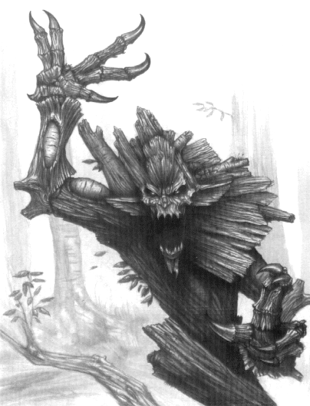
✶ TROLLS 

Trolls are large and foul creatures, with gangling limbs and cold, damp hides. Renowned for their strength and unthinking ferocity, Trolls can rip a man apart with their bare hands. Trolls are able to regenerate damaged flesh, and so are all but impossible to kill. Not only that, they have the ability to vomit the corrosive contents over their victim, melting armour, flesh and bone with ease. One particularly vicious form of Troll is the Stone Troll, whose hide is as tough as rock. They have the strange ability of sucking the very power of magic out of the surrounding area. River Trolls live in the marshlands or swamps near the banks of rivers. Their flesh exhumes a vile slime which chokes anyone nearby.

 | Troll | Stone Troll | River Troll | Chaos Troll
Wounds | 30 | 30 | 30 | 35
Move | 6 | 6 | 6 | 6
Weapon Skill | 3 | 3 | 3 | 3
Ballistic Skill | 6+ | 6+ | 6+ | 6+
Strength | 5 | 5 | 5 | 5
Toughness | 4 | 5 | 4 | 4 (5)
Armour | - | - | - | 1
Initiative | 1 | 1 | 1 | 1
Attacks | 3 | 3 | 3 | 4
Damage | 2D6 | 2D6 | 2D6 | 2D6
Gold | 650 | 650 | 650 | 750

ENEMY’S WS 1 2 3 4 5 6 7 8 9 10
Troll 2 3 4 4 4 4 5 5 5 6
Stone Troll 2 3 4 4 4 4 5 5 5 6
River Troll 2 3 4 4 4 4 5 5 5 6
Chaos Troll 2 3 4 4 4 4 5 5 5 6

Troll
Fear 6; Regenerate 2*; Vomit.

Stone Troll
Fear 6; Magic Drain 6+; Regenerate 2*.

River Troll
Fear 6; Regenerate 2*; Slime.

Chaos Troll
Fear 7; Regenerate 2*; Vomit.

Slime
The River Trolls skin exhumes poisonous fumes which make the Warriors choke. When standing adjacent to the River Troll any Warrior is at -1 To Hit.

Vomit
Trolls have a special Vomit attack, regurgitating the highly corrosive contents of its stomach all over the Warrior it is attacking. In addition to making such a Troll's normal attacks, roll 1D6. If the score is a 5 or 6, the Troll has vomited on its foe. If the victim has any armour (including shields or a helmet) he loses one piece of it as the acid eats it away. The player concerned may choose which item his Warrior loses. If he hasn't got any armour, the target loses 1D6+2 Wounds, with no deductions for Toughness.

* Trolls cannot regenerate when their flesh is burnt, either from natural fire or from a magic weapon.

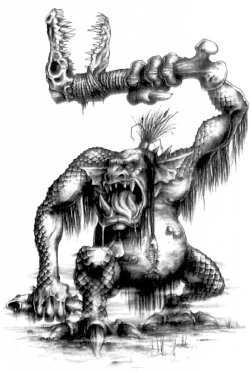

✶ GORGON 

The Gorgon is a horrifying snake-headed monster with long thin claws and sharp teeth through which the creature hisses like a serpent. Like a Cockatrice the gaze of a Gorgon is magical and can turn a victim to stone. Gorgons sometimes carry weapons which they clutch awkwardly in their misshapen hands, and they dress in robes pulled from battle corpses.

 | Gorgon
Wounds | 35
Move | 4
Weapon Skill | 2
Ballistic Skill | 4+
Strength | 3
Toughness | 3
Armour | -
Initiative | 5
Attacks | 1
Damage | 2D6
Gold | 1100

ENEMY’S WS 1 2 3 4 5 6 7 8 9 10
Gorgon 3 4 4 4 5 5 6 6 6 6

Gorgon
Fear 9; Petrify.

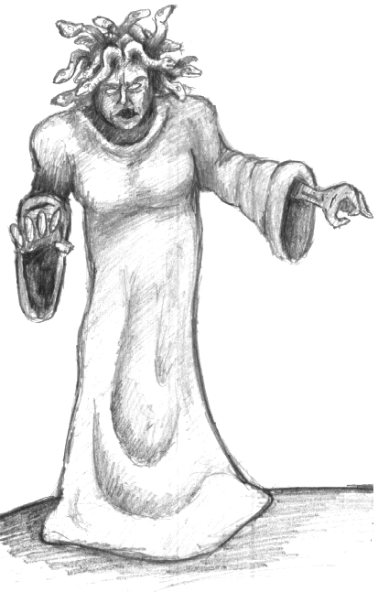

✶ HIPPOGRIF 

A Hippogrif is a large and extremely ferocious beast. Its head is feathered like a great bird of prey, and it can slash at enemies with its deadly beak. The forequarters of a Hippogrif are furry, with legs and claws like a great cat such as a lion. Its rear quarters more resemble those of a horse, with hooves and a sweeping tail. The colour of Hippogrifs’ fur and feathers can vary tremendously.

 | Hippogrif
Wounds | 55
Move | 8
Weapon Skill | 5
Ballistic Skill | -
Strength | 6
Toughness | 5
Armour | -
Initiative | 6
Attacks | 3
Damage | 3D6/4D6 (5+)
Gold | 1450

ENEMY’S WS 1 2 3 4 5 6 7 8 9 10
Hippogrif 2 2 3 3 4 4 4 4 4 4

Hippogrif
Fly; Terror 10.

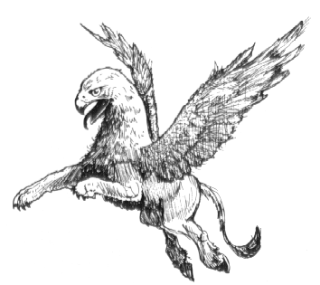

✶ COCKATRICE 

The Cockatrice is a fearsome creature whose squat, strong body is covered with scales and feathers. Powerful leathery wings propel it through the sky, from where it swoops down upon its enemy and rends them apart with its sharp claws. The Cockatrice’s head has a fierce beak and is covered with ugly reed wattles, which makes it look both bizarre and frightening. The Cockatrice can petrify its foes with its magical gaze, literally turning them to stone. This weird ability makes it very difficult to fight.

 | Cockatrice
Wounds | 26
Move | 4
Weapon Skill | 3
Ballistic Skill | -
Strength | 4
Toughness | 4
Armour | -
Initiative | 4
Attacks | 3
Damage | 3D6/4D6 (5+)
Gold | 1500

ENEMY’S WS 1 2 3 4 5 6 7 8 9 10
Cockatrice 2 3 4 4 4 4 5 5 5 6

Cockatrice
Fear 10; Fly; Petrify.

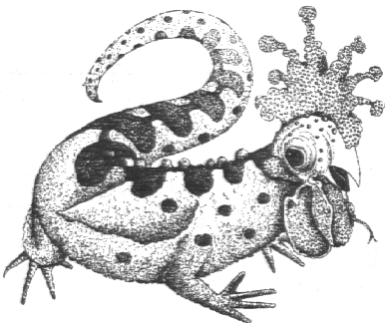

✶ GRIFFON 

Griffons have fierce heads with a hooked beak like that of a huge bird of prey. Their forequarters too a feathered, with scaly limbs bearing foreclaws which are bird-like and razor sharp. Behind its huge feathered wings the Griffon’s body is furred and it has huge clawed feet and a tail like that of a great hunting cat such as a lion or tiger. Some Griffons have great golden pelts like mountain lions, others have skins which are spotted or striped, or black as night.

 | Griffon
Wounds | 52
Move | 6
Weapon Skill | 5
Ballistic Skill | -
Strength | 6
Toughness | 5
Armour | -
Initiative | 7
Attacks | 4
Damage | 4D6
Gold | 1500

ENEMY’S WS 1 2 3 4 5 6 7 8 9 10
Griffon 2 2 3 3 4 4 4 4 4 4

Griffon
Fly; Terror 10.

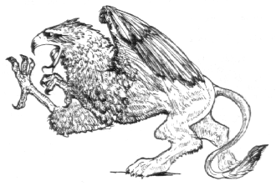

✶ WYVERN 

Wyverns are similar in appearance to dragons, though they are longer and more sinuous and do not have front limbs. Wyverns are scaly beasts, with thick plates of horn covering their bodies from head to foot. This makes them very difficult to slay, as their hide protects them from harm much like armour. Wyverns have long sinuous necks, which dart forward and back with lightning speed. Their heads are spiny and their mouths full of barbed teeth, while their constant screeching and roaring is extremely frightening. Their tails are barbed and topped with a deadly sting.

 | Wyvern
Wounds | 46
Move | 6
Weapon Skill | 5
Ballistic Skill | -
Strength | 5
Toughness | 6 (9)
Armour | 3
Initiative | 4
Attacks | 3
Damage | 3D6/4D6 (5+)
Gold | 1800

ENEMY’S WS 1 2 3 4 5 6 7 8 9 10
Wyvern 2 2 3 3 4 4 4 4 4 4

Wyvern
Drag and Rend; Fly; Ignore Blows 5+; Ignore Pain 6; Large Monster; Never Pinned; Sting (3D6); Terror 10.

Drag and Rend
At the start of each turn draw a Warrior counter to determine which Warrior the Wyvern attacks. The Wyvern stretches out its long neck and attempts to ensnare and drag him near. The Wyvern makes a normal to hit roll. If it succeeds it doesn’t cause any damage, but instead has clutched the Warrior and dragged him. That model is immediately moved to the nearest adjacent square to the Wyvern, moving other models out of the way as necessary. All of the Wyvern’s attacks are then carried out against the captured Warrior as normal. If 2 or more of these remaining attacks hit home, the Warrior has been stung. Note that the Warrior may only attempt to dodge the initial grab and not any subsequent attacks.

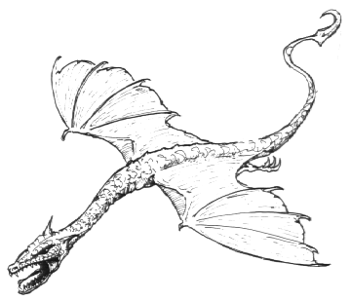
✶ TREEMAN 

Treemen have the appearance of huge trees, many times the height of a human. They are often mistaken for trees in the forest as their clawed feet look like roots, and their legs look like the trunk of the tree.

 | Treeman
Wounds | 60
Move | 6
Weapon Skill | 8
Ballistic Skill | 4+
Strength | 6
Toughness | 7 (11)
Armour | 4
Initiative | 2
Attacks | 4
Damage | 3D6
Gold | 2000

ENEMY’S WS 1 2 3 4 5 6 7 8 9 10
Treeman 2 2 2 3 3 3 3 4 4 4

Treeman
Ambush 5+; Fear 8; Fight in Ranks; Ignore Blows 5+; Ignore Pain 4; Large Monster; Whack.

Whack
Roll 1D6 at the beginning of each Monsters’ Phase. If the result is a 6 the Treeman whacks a random adjacent Warrior with his huge thick arms. A Whack attack hits automatically and is a Strength 10 attack (+damage dice) with modifiers for Toughness and armour as normal. The Warrior who was hit is now counted as being prone for one turn.

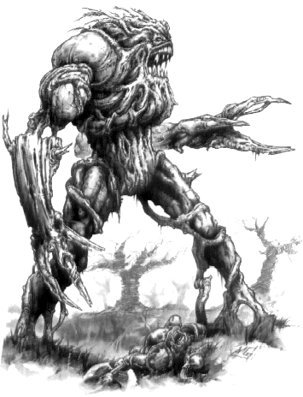
✶ MANTICORE 

The Manticore is a gigantic lion-like monster with large leathery wings and a spiked tail. They are devastating fighters attacking with raking claws and long, sharp teeth.

 | Manticore
Wounds | 50
Move | 6
Weapon Skill | 6
Ballistic Skill | -
Strength | 7
Toughness | 7
Armour | -
Initiative | 4
Attacks | 4
Damage | 4D6
Gold | 2000

ENEMY’S WS 1 2 3 4 5 6 7 8 9 10
Manticore 2 2 3 3 3 4 4 4 4 4

Manticore
Fly; Manticore Sting (Ambush, Magic A); Terror 11.

Manticore Sting
During the Monsters’ Phase, in addition to making its normal attacks and after it has moved, a Manticore may make a special poisonous Sting attack. Each Warrior adjacent to the Manticore is automatically hit and suffers 3D6 Wounds, modified for armour and Toughness. As this attack is poisonous, all the rules for the Poison special ability also apply.

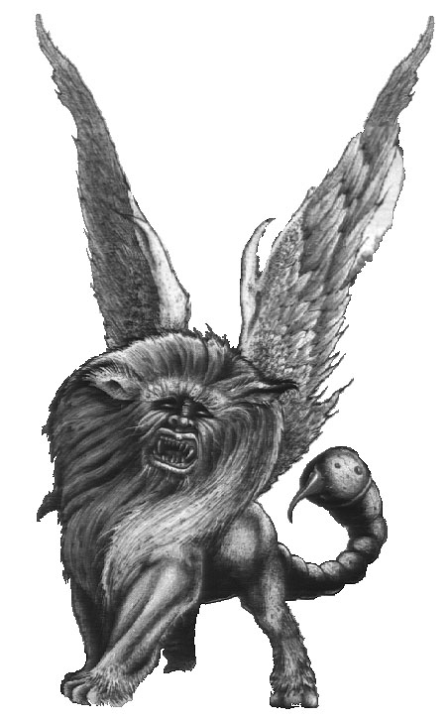
✶ GIANT 

Giants are rare in the settled parts of the Old World, having long since been hunted down and destroyed by chivalrous Bretonnian Knights and crazed Dwarf Giant Slayers. In the northlands they are more common because the lands are wild and untamed, and full of the sort of caves that Giants like to make their homes. Giants are, as their name suggests, very big. However, they are not especially bright - in fact, many are positively dim-witted. They are notorious drunkards and regard anything smaller than themselves as potential food, including men and other intelligent creatures.

 | Giant
Wounds | 64
Move | 6
Weapon Skill | 3
Ballistic Skill | 4+
Strength | 7
Toughness | 6 (11)
Armour | 5
Initiative | 3
Attacks | Special
Damage | 5D6
Gold | 2000

ENEMY’S WS 1 2 3 4 5 6 7 8 9 10
Giant 2 3 4 4 4 4 5 5 5 6

Giant
Fear 11; Giant Attacks; Ignore Blows 5+; Ignore Pain 10; Large Monster; Never Pinned.

Giant Attacks
Giants are huge and unpredictable creatures and it is by no means certain what form of attack they will make. At the start of each Monsters’ Phase roll 1D6 on the following table for each Giant on the board to determine what it does this turn.

1 Thump with Club
Because of his reach the Giant can hit any Warrior up to two squares away. Take a Warrior counter to determine which Warrior is attacked. The Giant makes 1D6 attacks against the target, rolling to hit as normal. Calculate damage as normal but ignore any modifier for the target’s armour.

2 Swing with Club
Because of his reach the Giant hits all of the Warriors up to two squares away. Roll 3D6 for each eligible target. Each dice that scores a 4, 5 or 6 causes that many Wounds with no modifier for armour. Any dice that scores 1, 2 or 3 misses as the Warrior manages to avoid the mighty weapon.

3 Kick down Corridor
The Giant raises a huge booted foot and drop-kicks an adjacent Warrior into the darkness. If there is more than one eligible target draw a Warrior counter to determine who is hit. The Warrior is kicked up to 7 squares in a straight line directly away from the Giant. If he hits a wall before reaching the distance he suffers 1D6 Wounds, with no modifier for armour, for each square short of 7 he flew, plus the Giant’s Strength of 7. For example, if the booted Warrior flies 2 squares then hits a wall, he suffers (7-2)=5D6 Wounds, plus 7 for the Giant’s Strength, with no modifier for armour (total roll therefore equals 5D6 + 7).

4 Pick Up
Because of his reach the Giant can pick up a Warrior up to two squares away. Take a Warrior to see who is picked up. Place that model on the Giant’s base and roll 1D6 on the following sub-table.

1 Squeeze
The Giant squeezes the Warrior with his mighty fist. The Warrior takes 7D6 Wounds. Roll again on this sub-table.

2 Hurl at Warriors
The Giant picks up the Warrior and hurls him at his companions. Take a Warrior counter to see which Warrior is targeted. Roll 7D6 and separate those that have an even score from those that have an odd square. The Warrior being thrown suffers a number of Wounds equal to the sum of the even dice, while the targeted Warrior suffers a number of Wounds equal to the sum of the odd dice. Neither Warrior gets any modifiers on the damage roll for Toughness or armour. The throw Warrior is placed prone in the square originally occupied by the target Warrior. The target Warrior is pushed into an adjacent square, shuffling other models around as necessary.

3 Smash Against the Roof
The Giant grabs the Warrior by the feet to get a good swing and begins to smash him repeatedly against the roof of the cave in a cheerfully enthusiastic fashion. This does the Warrior no good at all. The Giant smashes the Warrior against the roof 1D6 times, inflicting 7 Wounds, with no modifiers for Toughness or armour, each time. Then roll on this sub-table again.

4 Chew
The Giant begins to chew on the Warrior with teeth the size and shape of old tombstones. The Warrior suffers 1D6 Wounds, with no modifiers for Toughness or armour. If the score on the dice is 2, 3, 4, 5 or 6 the Giant continues to chew the Warrior next turn, even if he is at 0 Wounds or less. Roll another 1D6 for Wounds. This process continues until the roll for Wounds is a 1 at which point the Giant finds a gristly bit, loses interest and drops the Warrior in the square he got him from. Place the Warrior prone. If the Warrior is reduced to -50 Wounds the Giant swallows him whole, effectively taking him out of the game.

5 Stuff into Bag
The Giant picks up the Warrior and pops him into his bag, saving him for later. The inside of the bag is smelly and dark, full of all sorts of horrible things. In one corner is a wizened old Dwarf Prospector, who wearily gives the Warrior a key and says “This is the key to the portcullis…” in a tired and cracked voice. The Warrior suffers no ill effects as long as the Giant has other foes to fight. If the Giant kills all of the other Warriors he is carried off and eaten at the Giant’s leisure. He may escape from the bag once the Giant is killed - place him in an empty square on the same board section. Once free he remains out of action for 1 turn due to shock.
6 Snatch and Grab
The Giant pops the Warrior into his bag, as above. As it’s a long time since he had the prospect of such a juicy succulent feast the Giant reaches down for another Warrior immediately. Make another 1D6 roll on this sub-table.

5 Jump Up and Down
Striking sparks off the stone floor with his hob-nailed feet, the Giant jumps up and down on any single Warrior in an adjacent square. If there is more than one eligible target draw a Warrior counter to determine which Warrior is attacked. The chosen Warrior suffers 1D6 hits, taking damage for each hit as normal. If the target is reduced to 0 Wounds the Giant will make another 1D6 jump attacks on the next nearest adjacent Warrior. This process continues until the Giant fails to kill a Warrior within the number of attacks he has rolled or he has reduced all the Warriors to 0 Wounds.

6 Yell and Bawl
Feeling a good shout coming on, the Giant bends over until his head is at the same level as the Warriors and proceeds to yell and bellow at the top of his voice. Roll 2D6 for each Warrior. If the total is equal to or greater than the sum of the Warrior’s Toughness and Strength he is knocked prone by the blast. He takes no Wounds from the attack.

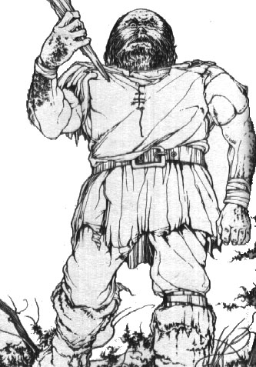
✶ HYDRA 

The Hydra is a many headed monster with a scaly, reptilian body. Its serpentine heads belch out smoky flame, but they can also attack by biting enemies with their sharp teeth, and crushing them in the coils of their necks. Their bodies are low and squat, heavily muscled and covered with thick scales which are as hard as iron.

 | Hydra
Wounds | 70
Move | 6
Weapon Skill | 3
Ballistic Skill | -
Strength | 5
Toughness | 6 (9)
Armour | 3
Initiative | 3
Attacks | 5
Damage | 4D6
Gold | 2250

ENEMY’S WS 1 2 3 4 5 6 7 8 9 10
Hydra 2 3 4 4 4 4 5 5 5 6

Hydra
Breathe Fire 4 (Ambush A); Ignore Blows 5+; Ignore Pain 7; Large Monster; Magic Resistance 5+; Never Pinned; Terror 11.

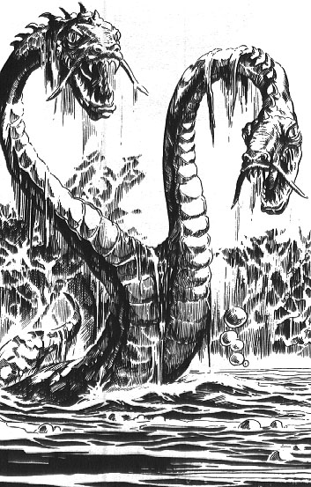
✶ CHIMERA 

The Chimera is a huge and vicious monster, one of the most fearsome that stalks the Old World. This ferocious creature has three bestial heads; a lions head, a fierce ram’s head and a dragon’s head. Its hulking body is powerful and quick and its claws are long and sharp. The Chimera also has a lashing tail which is barbed with venomous stings.

 | Chimera
Wounds | 60
Move | 6
Weapon Skill | 4
Ballistic Skill | -
Strength | 7
Toughness | 6 (9)
Armour | 3
Initiative | 4
Attacks | 6
Damage | 3D6/4D6 (5+)
Gold | 2500

ENEMY’S WS 1 2 3 4 5 6 7 8 9 10
Chimera 2 3 3 4 4 4 4 4 5 5

Chimera
Breathe Fire 4 (Ambush A); Ignore Blows 5+; Ignore Pain 7; Large Monster; Sting (3D6); Terror 11.

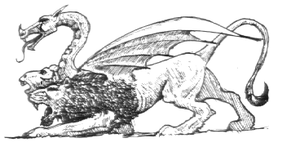
✶ DRAGONS 

The ancient dragons slumber in the caves below the world, guarding their treasure through the long years. Woe betide any foolish Warrior who attempts to steal their hoard, as when roused there is little to rival a dragon in combat.

 | Dragon | Great Dragon | Emperor Dragon
Wounds | 74 | 84 | 94
Move | 6 | 6 | 6
Weapon Skill | 6 | 7 | 8
Ballistic Skill | - | - | -
Strength | 6 | 7 | 8
Toughness | 6 (12) | 7 (14) | 8 (16)
Armour | 6 | 7 | 8
Initiative | 8 | 7 | 6
Attacks | 7 | 8 | 9
Damage | 6D6 | 6D6/7D6 (5+) | 8D6
Gold | 4500 | 6000 | 7500

ENEMY’S WS 1 2 3 4 5 6 7 8 9 10
Dragon 2 2 3 3 3 4 4 4 4 4
Great Dragon 2 2 2 3 3 3 4 4 4 4
Emperor Dragon 2 2 2 3 3 3 3 4 4 4

Dragon
Dragon Breath (Ambush, Magic A); Fly; Ignore Blows 5+; Ignore Pain 7; Large Monster; Terror 12; Treasure Hoard +0.

Great Dragon
Chaos Magic 1 (choose God at random); Dragon Breath (Ambush, Magic A); Fly; Ignore Blows 4+; Ignore Pain 7; Large Monster; Terror 13; Treasure Hoard +1.

Emperor Dragon
Chaos Magic 2 (choose God at random); Dragon Breath (Ambush, Magic A); Fly; Ignore Blows 4+; Ignore Pain 3D6; Large Monster; Terror 14; Treasure Hoard +2.

Dragon Breath
There are many different types of dragon in the dark caverns and tunnels beneath the mountains of the Warhammer World, each with a different breath weapon (not all dragons possess the archetypical fiery breath). To determine which sort of dragon the Warriors have encountered, and therefore what type of breath weapon it has, roll 1D6 on the following table:

1-2 Fire Dragon - Breathes Fire
At the start of each turn roll 1D6. The number rolled indicates how many of the Warriors are engulfed in flame and fire. If the score is higher than the number of Warriors present all of them have been hit. If not all of the Warriors are hit use the Warrior counters to determine who escapes. Each Warrior hit by the fire suffers 3D6 Wounds, with no modifier for armour.

3 Black Dragon - Breathes Smoke
At the start of each turn roll 1D6. The number rolled indicates how many of the Warriors are engulfed in the oily fumes. If the score is higher than the number of Warriors present all of them have been hit. If not all of the Warriors are hit use the Warrior counters to determine who escapes. Roll 1D6 for each Warrior hit by the smoke, subtract his Toughness from the score and multiply the result by 2. The total shows how many D6 Wounds the Warrior suffers, with no modifiers for Toughness or armour. For example, a 6 is rolled for a Warrior of Toughness 4. He suffers ((6-4) x 2) = 4D6 Wounds, with no modifiers for Toughness or armour.

4 Green Dragon - Breathes Corrosive Fumes
Roll 1D6 for each Warrior and add his Toughness. If the score is 7 or more that Warrior is unaffected. If the score is 6 or less that Warrior suffers 3D6 Wounds, with no modifiers for Toughness or armour.

5 Blue Dragon - Spits Electricity
Blue Dragons actually generate electricity that arcs from their mouths in the form of lightning, rather than breathe a noxious substance. Take one Warrior counter to determine who is hit. That Warrior suffers 2D6 Wounds, with no modifier for armour. After resolving that attack, roll another 1D6. On a score of 3, 4, 5 or 6 the lightning bolt arcs across to another Warrior. Take another Warrior counter to determine who. He also takes 2D6 Wounds with no modifier for armour. This process continues until the lightning bolt fails to arc across to another Warrior.

6 White Dragon - Breathes Chilling Mist
At the start of each turn roll 1D6. The number rolled indicates how many of the Warriors are engulfed by the mist. If the score is higher than the number of Warriors present all of them have been hit. If not all of the Warriors are hit use the Warrior counters to determine who escapes. Each Warrior hit by the fire suffers 3D6 Wounds, with no modifier for armour. Each Warrior suffers 1D6 Wounds, with no modifiers for Toughness or armour. In addition, while he thaws out, for 1 turn he has a Movement of 1, he may be hit automatically, and any dice rolls made for his actions only succeed on a natural 6. Actions that do not require a dice roll may be carried out as normal.

Treasure Hoard +n
Dragons have their own treasure hoards above and beyond the treasure that is otherwise found. When a dragon is killed roll 1D6 + n, where n is the number after the Treasure Hoard entry, on the following table to determine what it contains.

1 Gold
Each Warrior may roll as many D6 as he likes, adding up the score and multiplying it by 10 to determine how much gold his Warrior finds. However, if any of the dice score a 1 his Warrior finds nothing.

2-3 Dungeon Room Treasure
Make one roll on the Dungeon Room Treasure Table for each Warrior to determine what he finds.

4-5 Dungeon Room Treasure and Gold
Make one roll on the Dungeon Room Treasure Table for each Warrior to determine what he finds. In addition, each Warrior may roll as many D6 as he likes, adding up the score and multiplying it by 10 to determine how much gold his Warrior finds. However, if any of the dice score a 1 his Warrior finds nothing.

6 Objective Room Treasure
Make one roll on the Objective Room Treasure Table for each Warrior to determine what he finds.

