★ NEHEKHARA 

For thousands of years they have lain within their mighty burial monuments. Called from their sleep of death, the ancient Kings of Nehekhara march forth from their tombs to seek vengeance on those who would disturb their slumber. Loyal even in death, the armies of the Tomb Kings march at the side of their lords, seeking to reclaim the kingdoms that were once their own.

✶ SCARAB BEETLE 

The Scarab Beetle is an important symbol of creation, resurrection and everlasting life in the religious mythology of Nehekhara. Small jars and coffins containing mummified Scarab Beetles are often placed in tombs as part of the ancient Nehekharan funeral rites to ensure eternal resurrection.

 | Scarab Beetle
Wounds | 2
Move | 4
Weapon Skill | 2
Ballistic Skill | -
Strength | 2
Toughness | 2 (3)
Armour | 1
Initiative | 4
Attacks | 1
Damage | 1D3
Gold | 25

ENEMY’S WS 1 2 3 4 5 6 7 8 9 10
Scarab Beetle 3 4 4 4 5 5 6 6 6 6

Scarab Beetle
Fly; Gang Up; Swarm.

Swarm
If a Warrior is reduced to 0 Wounds from a Scarab Beetle attack, they swarm over his dead body, devouring his flesh. He cannot be healed in any way, nor resurrected from the dead.

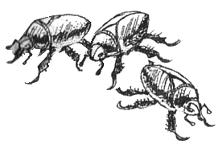

✶ SCORPION 

Waiting motionless and camouflaged, a Scorpion will strike any prey that comes too close. Its two front claw-like pincers grab hold, and with a whip of its tail, the stinger delivers a deadly dose of poison.

 | Scorpion
Wounds | 2
Move | 4
Weapon Skill | 2
Ballistic Skill | -
Strength | 2
Toughness | 2 (3)
Armour | 1
Initiative | 4
Attacks | 1
Damage | 1D6
Gold | 25

ENEMY’S WS 1 2 3 4 5 6 7 8 9 10
Scorpion 3 4 4 4 5 5 6 6 6 6

Scorpion
Gang Up; Never Pinned; Poison Attack.

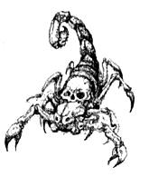

✶ SNAKES 

Several deadly snakes live in the deserts if Nehekhara. The Asp is a deadly snake with a poisonous bite. A Cobra has a head as big as a man’s hand and two deadly fangs. It can strike with a stunning speed

 | Asp | Cobra
Wounds | 1 | 2
Move | 6 | 6
Weapon Skill | 3 | 4
Ballistic Skill | - | -
Strength | 2 | 2
Toughness | 1 | 2
Armour | - | -
Initiative | 5 | 6
Attacks | 1 | 1
Damage | 1D6 | 1D6
Gold | 25 | 35

ENEMY’S WS 1 2 3 4 5 6 7 8 9 10
Asp 2 2 3 3 4 4 4 4 4 4
Cobra 2 2 3 3 4 4 4 4 4 4

Asp
Ambush, Magic 6+; Poison Attack.

Cobra
Ambush, Magic 6+; Poison Attack.

Cobra Strike
Cobras are blindingly fast and are able to slip past all of a Warrior's defences with ease. If a Cobra gets 5+ on his To Hit roll, then the Cobra causes maximum damage and ignores the Warrior's armour.

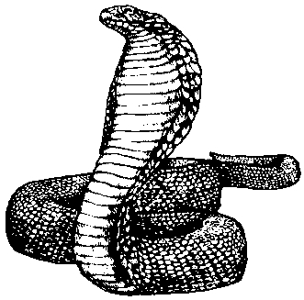

✶ SKELETONS 

Skeletons claw themselves out of the sand to attack the living. They wield rusty swords and axes and remnants of armour still cling to their frame. Skeletons in Nehekhara possess great shields which have stood the test of time and are in almost as good a condition as when the Skeletons were killed. Skeleton Kings were, in life, Pharaohs of great armies. Although not mummified and resurrected as Tomb Kings, these mighty undead leaders are just as powerful and still hold much of their original magic and intelligence.

 | Skeleton | Skeleton Champion | Skeleton Hero | Skeleton King
Wounds | 5 | 13 | 26 | 40
Move | 4 | 4 | 4 | 4
Weapon Skill | 2 | 3 | 4 | 5
Ballistic Skill | 5+ | 5+ | 5+ | 5+
Strength | 3 | 3 | 4 | 5
Toughness | 3 (4) | 3 (4) | 5 (7) | 5 (8)
Armour | 1 | 1 | 2 | 3
Initiative | 2 | 2 | 3 | 3
Attacks | 1 | 2 | 3 | 4
Damage | 1D6 | 1D6 | 2D6 | 3D6
Gold | 90 | 140 | 1600 | 3000

ENEMY’S WS 1 2 3 4 5 6 7 8 9 10
Skeleton 3 4 4 4 5 5 6 6 6 6
Skeleton Champion 2 3 4 4 4 4 5 5 5 6
Skeleton Hero 2 3 3 4 4 4 4 4 5 5
Skeleton King 2 2 3 3 4 4 4 4 4 4

Skeleton
Armed with [1-2] Bows (Str 3), [3-4] Spears (Fight in Ranks) [5-6] Swords; Fear 5; Regenerate 1D6.

Skeleton Champion
Fear 6; Regenerate 1D6.

Skeleton Hero
Fear 7; Magic Armour; Magic Weapon; Skeleton Magic 1; Regenerate 1D6.

Skeleton King
Fear 8; Magic Armour; Magic Item; Magic Weapon; Skeleton Magic 2; Regenerate 2D6.

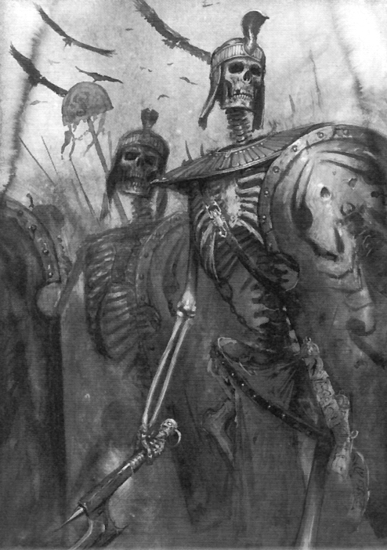
Skeleton Magic
Skeleton Heroes and Skeleton Kings specialise in casting Skeleton Magic. To see what spell they cast when given the chance, roll 2D6 on the following table. If the Skeleton is killed while he still has active spells in play, they will immediately be dispelled.

2 FAILURE
The Skeleton fails to cast a spell.

3 CONTROL
The Skeleton points at a random Warrior, his hand swirling with blue magic. The Skeleton tries to control the Skeletal frame inside the Warrior! The Warrior must make a Willpower test of 8. If the test is passed then he fights the magic off. If he fails the test, the Warrior’s Skeleton is under the caster’s control. The Skeleton moves the Warrior in a random direction. Randomly determine which direction the Warrior moves in, then roll 1D6 for how many squares he is moved. If he moves into something that is impassable, then he stops instantly and suffers 1 unmodified Wound for each point of Move he has left. If the Warrior moves into a pit or any other hazard, then make any appropriate rolls with a -1 modifier. The Warrior is not affected by Pinning while he is under the Skeleton’s control.

4 UNHOLY ENHANCEMENT
The Skeleton seems to move his hands around an invisible ball, when in the centre of this ball appears a brilliant sphere of green light, no bigger than a man’s fist. He then shoots the ball at a random Skeleton in play. The ball smashes through the back of its targets skull and stops, where it hovers in the skull’s brain cavity. An unholy green light emanates from the Skeleton’s eye sockets and when its mouth opens. If there are no other Skeletons in play then the caster smashes it into his own head, with the same results. The sphere enhances the Skeleton with one of the following attributes until it is dead.

1 +1 Toughness
2 +1 Strength
3 +1 Weapon skill
4 +1 Attack
5 +1 Damage dice
6 Roll twice on this table (re-roll any more 6’s)

The effects of this spell are cumulative, but a Skeleton can only hold a maximum of 4 spheres in its head.

5 STRENGTH DRAIN
The Skeleton’s eyes glow red as he focuses on a random Warrior. The Warrior must make a Strength test of 8 otherwise the Skeleton drains 1 Strength from him permanently. The Strength is added to the Skeleton’s own Strength total. Any Warrior who is reduced to 0 Strength is instantly killed. Once the Skeleton is slain the Strength is returned to the Warrior.

6 DARK WINGS
The Skeleton makes two fists and punches them together, making a bolt of green lighting shoot out and hit a random Undead Monster. If there are none then roll for another spell. Large skeletal wings grow from the target’s back and he lifts off the ground into the air. The skeletal wings don’t actually help their owner to fly physically but hold a very powerful magic enabling the owner to fly. The Monster now has the Fly ability. This change lasts until either the caster or the Monster with wings is killed.

7 BONE MUTATION EXPLOSION
The Skeleton yells at a random Warrior on the same board section, clenching his fists as they swirl with mystic energies. Suddenly, barbs grow out of the Warrior’s own bones, piercing through his flesh from the inside. The Warrior takes 2D6 unmodified damage. The Warrior’s bones then return to normal, well... mostly normal.

8 SKELETAL HANDS
The Skeleton makes quick straight movements with his hands. Suddenly 1D6 skeletal hands come from the ground underneath a random Warrior, grabbing his legs. The Warrior is now ensnared by these hands and cannot move. While ensnared, any Monster attacking the Warrior has +2 To Hit. To escape the hands’ grasp, the Warrior must kick them off by passing a Strength test of 8. Only one hand can be kicked off per turn.
9 BLACK CURSE
The Skeleton looks at a random Warrior in his line of sight who meets the soulless gaze of his empty sockets. The Warrior must roll 2D6 and score under his Willpower. If this test is failed the Warrior feels oddly drained of his will to go on and starts fighting half heartedly, trying to find meaning in what he is doing. The Warrior only has half of his Attacks for the next 1D3 turns (rounding down).

10 SUMMON SKELETONS
The Skeleton summons 1D6 Skeleton Champions, which are placed on the board immediately and can move and fight this turn.

11 POWER BURST
The Skeleton’s eye sockets burn with an orange fire as he performs this spell. All remaining Power on the Power Dice is instantly sucked into the Skeleton. The Skeleton then moves his arms in a wide arc as a burst of orange magic bursts forth from him in every direction. Every Warrior up to 1D6 squares away from the caster is automatically hit for 3D6 damage of unmodified Wounds damage. In addition, for every point of Power sucked from the Power Dice add another 1D3 unmodified damage. The Skeleton can only cast this spell once per turn. Roll again if this spell is rolled by the caster in the same turn.

12 FLAMING SKULL
The Skeleton reaches into a bag hanging from his shoulder and pulls out a blackened skull. After moving his skeletal fingers across its brow and chanting an incantation, the skull burst into a blue flame and moves, without any assistance, out of the Skeleton’s hand and hovers next to him. Once per turn, starting immediately, the skull fires a blue fireball from its grinning jaws at a random Warrior in its line of sight. With a successful Ballistic Skill roll of 4+, the blue fireball inflicts 1D6 unmodified Wounds damage to the Warrior. The skull stays in play until the Skeleton is killed, but will not move of its own accord, only hovering next to the Skeleton. Each skull will Attack at the start of the Monsters' Phase, after the Skeleton has cast any more spells. The skulls do not take up a square.

✶ CHARIOT 

The ancient armies of Nehekhara included strong forces of chariots, drawn by a pair of horses. These forces were considered the elite of the army and consequently were entombed in the Pyramids of the Tomb Kings.

 | Chariot | Skeletal Steed
Wounds | 18 | 6
Move | - | 8
Weapon Skill | 1 | 2
Ballistic Skill | - | -
Strength | - | 3
Toughness | 7 | 3
Armour | - | -
Initiative | - | 2
Attacks | - | 1
Damage | - | 1D6
Gold | 50 | 70

ENEMY’S WS 1 2 3 4 5 6 7 8 9 10
Skeletal Steed 3 4 4 4 5 5 6 6 6 6

Chariot
Chariot; Regenerate 1D6.

Skeletal Steed
Fear 5; Regenerate 1D6.

Chariot
Chariots always charge into the combat and as such, surprise the Warriors. The steeds and their riders have Ambush, Magic A. Warriors are not Pinned by riders in a Chariot.

Chariots can be ridden by up to 2 of any Skeletons, Mummies or Liche Priests.

✶ SKELETAL STEED 

Skeletal Steeds are ghastly creatures. They were once normal horses, but when they died their flesh decomposed. When all that was left of them was their bones, evil Liche Priests raised them from the dead.

 | Skeletal Steed
Wounds | 6
Move | 8
Weapon Skill | 2
Ballistic Skill | -
Strength | 3
Toughness | 3
Armour | -
Initiative | 2
Attacks | 1
Damage | 1D6
Gold | 70

ENEMY’S WS 1 2 3 4 5 6 7 8 9 10
Skeletal Steed 3 4 4 4 5 5 6 6 6 6

Skeletal Steed
Fear 5; Regenerate 1D6.

Skeletal Steeds can be ridden by any Skeletons or Liche Priests.

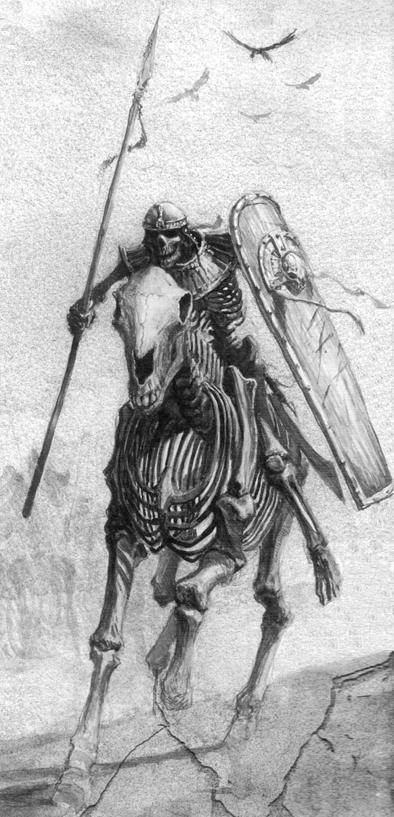

✶ TOMB GUARDS 

Tomb Guards are the bravest and best of the Tomb King’s elite guards. They protect the inner sanctums of the Pyramids from enemy attacks. Entombed with the finest weapons, they will awaken and defend their lord if intruders violate the sacred tomb.

 | Tomb Guard | Tomb Guard Champion
Wounds | 13 | 20
Move | 4 | 4
Weapon Skill | 3 | 3
Ballistic Skill | 4+ | 4+
Strength | 4 | 4
Toughness | 4 (5) | 4 (6)
Armour | 1 | 2
Initiative | 3 | 3
Attacks | 1 | 2
Damage | 2D6 | 2D6
Gold | 160 | 500

ENEMY’S WS 1 2 3 4 5 6 7 8 9 10
Tomb Guard 2 3 4 4 4 4 5 5 5 6
Tomb Guard Champion 2 3 4 4 4 4 5 5 5 6

Tomb Guard
Fear 5; Regenerate 1D6.

Tomb Guard Champion
Fear 5; Magic Weapon; Regenerate 1D6.

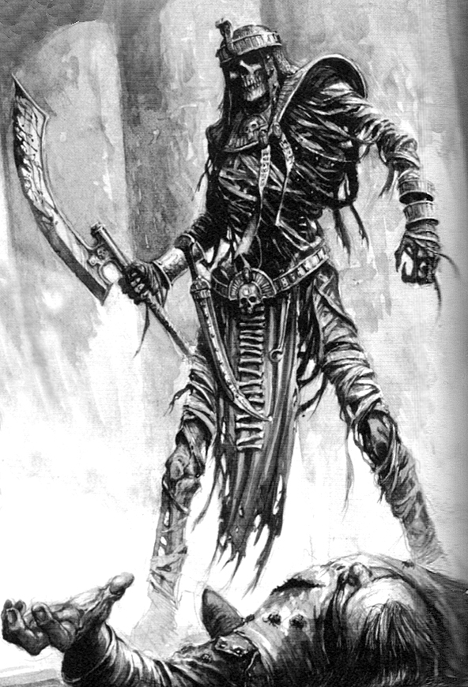

✶ ANUBIS WARRIORS

Anubis Warriors are an ancient Nehekaran race. Hunting in desert groups, these jackal headed warriors often attack trade caravans and anything else that may wander into their territory. They have quick reflexes and hide out of site, where at the last minute they leap into battle, surprising the enemy.

 | Anubis Warrior | Anubis Champion | Anubis Hero | Anubis Lord
Wounds | 10 | 18 | 30 | 38
Move | 5 | 5 | 5 | 5
Weapon Skill | 4 | 5 | 6 | 7
Ballistic Skill | 4+ | 3+ | 2+ | 1+
Strength | 3 | 4 | 5 | 5
Toughness | 3 | 4 | 5 | 5
Armour | - | - | - | -
Initiative | 5 | 6 | 6 | 7
Attacks | 1 | 2 | 3 | 4
Damage | 1D6 | 1D6 | 2D6 | 3D6
Gold | 100 | 400 | 900 | 1400

ENEMY’S WS 1 2 3 4 5 6 7 8 9 10
Anubis Warrior 2 3 3 4 4 4 4 4 5 5
Anubis Champion 2 2 3 3 4 4 4 4 4 4
Anubis Hero 2 2 3 3 3 4 4 4 4 4
Anubis Lord 2 2 2 3 3 3 4 4 4 4

Anubis Warrior
Ambush 4+.

Anubis Champion
Ambush 4+; Magic Weapon.

Anubis Hero
Ambush 4+; Magic Armour; Magic Weapon.

Anubis Lord
Ambush 4+; Magic Armour; Magic Item; Magic Weapon.

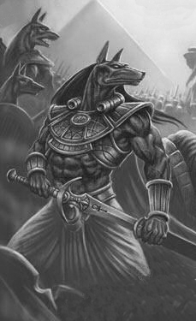

✶ ANUBIS PRIESTS

Anubis Priests have mastered the magic of the ancient Nehekharan Anubis God.

 | Anubis Priest | Anubis Priest Champion | Master Anubis Priest | Anubis Priest Lord
Wounds | 12 | 20 | 32 | 40
Move | 5 | 5 | 5 | 5
Weapon Skill | 3 | 3 | 3 | 3
Ballistic Skill | 5+ | 5+ | 5+ | 5+
Strength | 3 | 4 | 4 | 4
Toughness | 3 | 3 | 3 | 3
Armour | - | - | - | -
Initiative | 5 | 6 | 6 | 7
Attacks | 1 | 1 | 2 | 3
Damage | 1D6 | 1D6 | 2D6 | 3D6
Gold | 600 | 1200 | 2200 | 3100

ENEMY’S WS 1 2 3 4 5 6 7 8 9 10
Anubis Priest 2 3 4 4 4 4 5 5 5 6
Anubis Priest Champion 2 3 4 4 4 4 5 5 5 5
Master Anubis Priest 2 3 4 4 4 4 5 5 5 6
Anubis Priest Lord 2 3 4 4 4 4 5 5 5 6

Anubis Priest
Anubis Magic 1; Magic Item.

Anubis Priest Champion
Anubis Magic 2; Magic Item; Magic Weapon.

Master Anubis Priest
Anubis Magic 3; Magic Item x 2; Magic Weapon.

Anubis Priest Lord
Anubis Magic 4; Magic Armour; Magic Item x 3; Magic Weapon.

Anubis Magic
Anubis Priests specialise in casting Anubis Magic. To see what spell the Anubis Priest casts when given the chance, roll 2D6 on the following table. If the Anubis Priest is killed while he still has active spells in play, they will immediately be dispelled.

2 FAILURE
The Anubis Priest fails to cast a spell.

3 WRATH OF THE JACKAL
The Anubis Priest brings forth an old jackal skull and throws it at the feet of a random Warrior on the same board section. Within seconds, an ethereal giant jackal skull appears above the Warrior, which then bites down on him for 2D6 unmodified damage.

4 ENCHANTMENT
The Anubis Priest lets out a great howl, summoning all of the energies deep within himself until he is literally glowing with power! The Priest now has +1 to a random attribute, including Damage Dice, until the end of the combat.

5 ANUBIS BITE
The Anubis Priest points to a random Anubis Warrior on the board section and utters a series of yapping incantations. That Anubis Warrior now has an extra Bite Attack that does normal damage, but at -1 To Hit. If there are no other Anubis Warriors on the board section then the Priest casts the spell on himself.

6 JACKAL BROTHERS
The Anubis Priest slaps his hands together and howls, bringing forth two ethereal jackal spirits. These jackals Move and Attack with the following statistics.

Wnds M WS BS S T Arm At Dam Gold
(Dun. Level) x 3 5 4 - 3 3 - 1 Chill 1 (Dun. Level) x 200

The Jackal Brothers have Ethereal 1.

7 CALL OF THE WILD
The Anubis Priest start to chuckle and brings forth an Anubis skull that has writing all over it, written in blood. He lifts it high above his head and calls out to his jackal gods. Within moments, the Priest begins changing, his muscles bulge and grow as he grows taller and wider. Suddenly the Priest is huge and bears down on the Warriors with his new might! For 1D6 turns, the Priest cannot cast any spells, but gains +2 Damage Dice and +1D6 Toughness. He loses these bonuses after the specified duration.
8 TOOTH AND CLAW
The Anubis Priest spreads his fingers and grins cruelly, as a hail of teeth and claws fly from his finger tips, assailing a random Warrior for 3D6 Wounds.

9 SCARAB ATTACK
Taking out a bag from his belongings, the Anubis Priest reaches in and pulls out a handful of stones. He throws these over a random Warrior’s head and yaps quickly at them. As the stones fall, they turn into scarab beetles that attack the Warrior, inflicting 1D6 unmodified Wounds damage.

10 SAND OF AGES
The Anubis Priest points under the feet of a random Warrior. Suddenly, the ground turns to quicksand and he begins to sink rapidly. Make an Initiative test of 7. If the Warrior succeeds, he manages to jump to an adjacent square. If there are no adjacent squares free or he fails his roll, he gets sucked down into the quick sand. While in the sand the Warrior may do nothing except try to escape. The Warrior has one more turn to make it out of the sand with a -1 modifier to his Initiative roll. If the Warrior is still in the sand at the end of the next Warriors’ Phase, he sinks beneath the sand where he meets his doom. Obviously, the Warrior cannot be resurrected as the ground reforms over the top of him.

11 HOWL
The Anubis Priest howls into the air so loudly that the Warriors are forced to hold their ears from the pain. As a result they each lose 1 Attack next turn and Monsters are at +1 To Hit them.

12 ANUBIS IMMORTAL
The Anubis Priest scratches strange shapes in the air in front of him until an odd symbol appears in a yellow haze. It then dissipates into nothing. From now on whenever an Anubis Warrior dies, a spectral form of him rises from his corpse to fight the Warriors once again. This new threat has the same statistics except now is treated as being Undead and has Chill 1. A Warrior only receives one lot of Gold for killing both the Anubis Warrior and his ghost. Once the ghost is killed the Anubis Warrior is finally dead. This spell does not affect the caster.

✶ MUMMIES

Mummies are protected by powerful magics to preserve them and cheat death itself. They are deadly opponents, capable of delivering crushing blows upon their enemies.

 | Mummy | Mummy Champion | Tomb Prince | Tomb King
Wounds | 40 | 45 | 55 | 70
Move | 4 | 4 | 4 | 4
Weapon Skill | 3 | 4 | 5 | 6
Ballistic Skill | 5+ | 4+ | 3+ | 3+
Strength | 4 | 4 | 4 | 5
Toughness | 5 | 5 | 5 (7) | 5 (8)
Armour | - | - | 2 | 3
Initiative | 3 | 3 | 3 | 3
Attacks | 2 | 2 | 3 | 4
Damage | 2D6 | 2D6 | 2D6 | 3D6
Gold | 450 | 1000 | 2800 | 3600

ENEMY’S WS 1 2 3 4 5 6 7 8 9 10
Mummy 2 3 4 4 4 4 5 5 5 6
Mummy Champion 2 3 3 4 4 4 4 4 5 5
Tomb Prince 2 2 3 3 4 4 4 4 4 4
Tomb King 2 2 3 3 3 4 4 4 4 4

Mummy
Fear 7; Tomb Rot (1D3).

Mummy Champion
Fear 8; Magic Item; Tomb Rot (1D3).

Tomb Prince
Fear 9; Magic Armour; Magic Item; Mummy Magic 1; Regenerate 1D6; Tomb Rot (1D3+1).

Tomb King
Terror 10; Magic Armour; Magic Item; Magic Weapon; Mummy Magic 2; Regenerate 2D6; Tomb Rot (1D6).

Attacking a Mummy with a source of fire causes an extra +1D6 Wounds damage with each hit.
Mummy Magic
Tomb Princes and Tomb Kings specialise in casting Mummy Magic. To see what spell they cast when given the chance, roll 2D6 on the following table. If the Tomb Prince or Tomb King is killed while they still have active spells in play, they will immediately be dispelled.

2 FAILURE
The Mummy fails to cast a spell.

3 WRAPPINGS OF DOOM
Wrappings of cloth fly from the caster’s body, wrapping around a random Warrior’s neck (in line of sight). The Warrior is then pulled towards the Mummy. Place the Warrior in a random adjacent square to the Mummy, moving other models out of the way if necessary. The Mummy will attack the Warrior from now on.

4 POTENT ROT
The Mummy seems to cast nothing, but in fact, all Tomb Rot from the caster is doubled this turn.

5 BREATH OF DECAY
The Mummy suddenly turns to an adjacent Warrior (if none, then re-roll) and breathes a deadly green cloud of decay at him. The Warrior is engulfed in it and coughs continuously. Roll 1D6. On a 6 the Warrior is unaffected by the spell. On any other number he has inhaled too much and begins to decay from the inside! At the end of every turn roll 1D6. On a result of 1-3 the Warrior loses -1 Toughness (down to a minimum of 1 Toughness). On a 4-6 the Warrior is unaffected. Continue rolling for the decay until the end of the combat, when it wears off, and any lost Toughness is regained. Unlike other spells, this one is not dispelled when the caster dies.

6 CLAP OF DUST
The Mummy spreads his arms wide, and then slams his hands together in a mighty clap. The noise of the clap is ear shattering and every model (apart from Undead) on the board section instantly take 1D6 unmodified damage. Also due to the clap, endless dust shoots out and covers the Mummy in a thick cloud which lasts for 1D6 turns. The Warriors are at -1 To Hit anyone in the cloud (which does not move with the caster). The cloud also grants Magic Resistance 6+ to the Mummy. If the caster already has Magic Resistance then subtract -1 from the current roll needed.

7 GAZE OF DEATH
A random Warrior within 5 squares of the Mummy catches the gaze of the Mummy through straps of rotting cloth. Its undead eyes burn with power and the Warrior is overcome by it. The Warrior instantly attacks an adjacent Warrior with the most powerful weapon he has (and can use at that time). If there is no adjacent Warrior then he turns the weapon on himself, hacking and slashing at his own body. When the Warrior attacks either another Warrior or himself he uses his full amount of Attacks available to him. He does not however, activate runes or other special abilities of the weapon such as once per adventure abilities.

8 THE DARK SARCOPHAGUS
The Mummy moves his hands in a strange pattern. A large black marble sarcophagus forms around him. While in the Dark Sarcophagus the Mummy is protected from any Attacks, magical or otherwise and also regains 3D6 Wounds. However, he cannot cast spells, Move or Attack while he is encased. At the beginning of the next Monsters’ Phase the sarcophagus dissipates.

9 HEART OF THE MUMMY
The Mummy reaches in between its wrappings and into its chest. He then rips from his chest what looks like his heart, a shrivelled black chunk of meat. The Mummy then points it at a random Warrior in line of sight and squeezes it. The Warrior feels his chest tighten and he feels a great pain in his heart. Roll 1D6. On a 2-6 the Warrior’s heart manages to withstand the strain. On a 1 the Warrior’s heart is crushed also and he falls to the ground, dead! The Warrior can only be brought back to life by magic.

10 SUMMON UNDEAD
The Mummy lets out a deep moan that echoes through the Pyramid. From the ground and nearby corridors come Undead to protect the Mummy.

Roll 1D6 to see what the Mummy summons.

1 1D6 Skeletons
2 1D6 Skeleton Champions
3 1D3 Mummies
4 1D6 Mummies
5 1D3 Tomb Guard
6 1 Ushabti

Place the new Monsters around the caster who will Guard him.

11 SURGE OF POWER
The Mummy lets out a loud moan, causing all Mummies on the same board section (including the caster) to inflict the Tomb Rot instantly. Warriors also suffer Tomb Rot at the end of the turn as usual.

12 MUMMIFICATION
The Mummy thrusts its arms out and begins to shake under the strain of building up so much power. He then lets out a mighty yell. A sheet of almost transparent grey magic, which reaches from the roof to the floor begins moving out from the Mummy’s position. The sheet of magic moves out to every square around the caster. If it moves into a square that is occupied by a Warrior or Monster (not other Undead) roll 1D6. On a 5-6 the model manages to jump to an adjacent square away from the magic. If there is no free adjacent square, or if a 1-4 was rolled, the sheet of magic passes over the living substance, instantly mummifying it and turning it shrivelled, black, and lifeless. Roll 1D6.

1 The target slips on the floor and can’t get up in time. The sheet passes over him. His legs become mummified, then his torso, then his chest and arms, and then, as he screams out “NOOOOOOOOO,” his head. The victim has become a permanent resident of the Pyramid. He is dead, and cannot be resurrected.

2 The target is too late to flee from the magic’s path and is engulfed in it. The sheet of magic passes over him, shrivelling his flesh into a black mass. The model takes 2D6 unmodified Wounds that are classed as Fatal Damage. If any model is reduced to 0 Wounds he stays standing, a twisted statue that can never be resurrected.

3 The target manages to leap to an adjacent square after all, but not before the sheet of magic passes over his non weapon arm. It lies black and useless at his side and soon tears loose from his shoulder. He takes 1D6+3 unmodified Wounds. While the victim has only one arm he is at -2 Weapon Skill (min 1). If he ends up with no arms he cannot Attack or use any items and can only cast spells on a roll of 5-6. If there is no adjacent square to leap to go to result number 2 on this table.

4 The target manages to leap to an adjacent square after all, but not before the sheet of magic passes over his weapon arm. It lies black and useless at his side and soon tears from his shoulder. He takes 1D6+3 unmodified Wounds. While the victim has lost this arm he is at -3 Weapon Skill (min 1). If he ends up with no arms he cannot Attack or use any items and can only cast spells on a roll of 5-6. If there is no adjacent square to leap to go to result number 2 on this table.
5 The target manages to leap to an adjacent square after all, but not before the sheet of magic passes over his left leg. It lies black and useless at his hip and soon tears from its socket. While the model has only one leg he is at -2 Move and adds 2 weeks to wilderness travel time. If the Warrior ends up with no legs then he is at 1 Move to represent him crawling, -5 Weapon Skill (min 1) and adds 4 weeks to wilderness travel. If there is no adjacent square to leap to go to result number 2 on this table.

6 The target manages to leap to an adjacent square after all, but not before the sheet of magic passes over his right leg. It lies black and useless at his hip and soon tears from its socket. While the victim has only one leg he is at -2 Move and adds 2 weeks to wilderness travel time. If he ends up with no legs then he is at 1 Move to represent him crawling, -5 Weapon Skill (min 1) and adds 4 weeks to wilderness travel. If there is no adjacent square to leap to go to result number 2 on this table.

At the end of the turn the sheet of magic may continue to move away from the Mummy. Roll 1D6. If a 5-6 is rolled then the sheet dissipates. On any other number the sheet continues to move outwards to every adjacent square. Continue to roll each turn until the sheet of magic dissipates or the spell is dispelled. A model does not need to roll again if he is still within the field as it expands. However, if he escapes to a new square and the field chases him and engulfs him again, then he must make another roll.

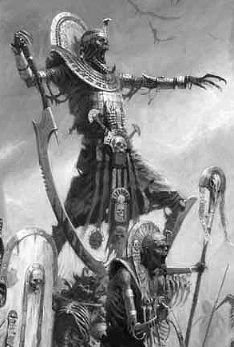

✶ LICHE PRIESTS 

Liche Priests are incredibly old High Priests that have managed to stave off death. Instead, their skin withers until they are little more than living corpses.

 | Liche Priest | Liche Priest Champion | Master Liche Priest | Liche High Priest
Wounds | 25 | 29 | 34 | 39
Move | 4 | 4 | 4 | 4
Weapon Skill | 3 | 3 | 3 | 3
Ballistic Skill | 4+ | 4+ | 4+ | 4+
Strength | 3 | 3 | 3 | 3
Toughness | 3 | 3 | 3 | 3
Armour | - | - | - | -
Initiative | 2 | 2 | 2 | 2
Attacks | 1 | 2 | 3 | 3
Damage | 1D6 | 2D6 | 3D6 | 4D6
Gold | 580 | 1400 | 2300 | 3600

ENEMY’S WS 1 2 3 4 5 6 7 8 9 10
Liche Priest 2 3 4 4 4 4 5 5 5 6
Liche Priest Champion 2 3 4 4 4 4 5 5 5 6
Master Liche Priest 2 3 4 4 4 4 5 5 5 6
Liche High Priest 2 3 4 4 4 4 5 5 5 6

Liche Priest
Liche Priest Incantations 1; Magic Resistance 5+; Magic Weapon; Regenerate 2D6.

Liche Priest Champion
Liche Priest Incantations 2; Magic Resistance 4+; Magic Item x 2; Magic Weapon; Regenerate 2D6.

Master Liche Priest
Liche Priest Incantations 3; Magic Dispel 4+; Magic Resistance 4+; Magic Item x 3; Magic Weapon; Regenerate 2D6.

Liche High Priest
Ambush, Magic A; Liche Priest Incantations 4; Magic Dispel 4+; Magic Resistance 4+; Magic Item x 4; Magic Weapon; Regenerate 2D6.

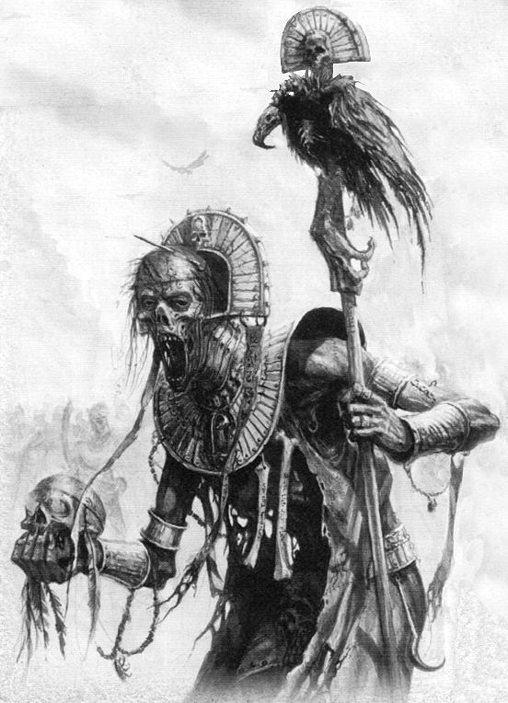
Liche Priest Incantations
The magic of Liche Priests is based on long monotonous enchantments that connect the mortal world to the realms beyond. These incantations have been recorded for millennia, transcribed in Nehekhara’s ancient hieroglyphs. Liche Priest incantations work differently to other types of magic and to represent this, Liche Priest Incantations cannot be dispelled or resisted using any abilities or items. Liche Priest Incantations are recited after all other Monster spellcasters have cast spells. To see what incantation a Liche Priest will recite when given the chance, roll 1D6 on the following table.

1 FAILURE
The Liche Priest fails to recite an incantation.

2 UALATP’S INCANTATION OF SWIFTNESS
With surprising speed, the Liche Priest performs a complex series of movements with his decaying hands. The Liche Priest and any Undead models on the board get +1 To Hit. In addition, any Attacks made by the Liche Priest hit automatically.

3 SEKHUBI’S INCANTATION OF VENGEANCE
The Liche Priest reaches out with his withered hand and points at a random Warrior within Line of Sight. A bright flash of light shoots from the Liche Priest’s outstretched hand, hitting the Warrior in the chest. The Warrior suffers 1D6 Strength 8 hits. Any damage caused by this Incantation is considered to be Fatal Damage.

4 HOREKHAH’S INCANTATION OF RIGHTEOUS SMITING
The Liche Priest’s chanting becomes increasingly louder, and he raises his arms outward. A soft glow emanates from his body and irradiates the board. All Monsters on the board (including those with missile weapons and the Liche Priest himself) are infused with energy and can make an additional Attack this turn. Any extra Attacks that are made cause double damage on a To Hit roll of 6. If this Incantation is cast on Monsters multiple times, as well as receiving additional Attacks, the bonus Attacks do double damage on a dice roll 1 better than its current value. For example, if a Master Liche Priest casts this Incantation three times, all Monsters will get a bonus 3 Attacks, which do double damage on a To Hit roll of 4+.

5 DJEDRA’S INCANTATION OF SUMMONING
Arms upraised, the Liche Priest cries out the name of ancient Nehekharan Gods. Suddenly, the dead walk once again! Roll 1D6 for every Monster that has been killed this combat. (refer to the models on the Warrior’s adventure record sheets to determine which Monster’s have died). On a roll of 5-6 the Incantation causes them to rise and continue fighting. Place the Monsters that have risen on the board according to the one-on-one rule. If a Monster rises that was not initially Undead, it will now have the Regenerate 1D6 special ability and Fear 3, and is considered Undead for all intents and purposes. If no Monsters have fallen in this combat then roll again for a different Incantation. Only one amount of Gold is received for Monsters that have been raised from the dead.

6 MANKARA’S INCANTATION OF URGENCY
The Liche Priest completes the complex incantation, and promptly vanishes. This incantation moves the Liche Priest and any allied Monsters using missile weapons out of hand to hand combat with the Warriors. Move the Monsters so that they are no longer adjacent to the Warriors, moving other Monsters out of the way to make room if necessary. In addition, the Liche Priest has gained 3D6 Wounds. After casting this Incantation, roll 1D6. On a roll of 4 to 6, the Liche Priest may immediately cast another Incantation. If the Liche Priest is not in hand to hand combat then roll for another Incantation.

✶ CARRION 

Carrion are the undead remains of ancient flying birds that live in the mountains to the east of Nehekhara. Their broad wings darken the sky, spreading the shadow of doom upon those dying in the desert. In ancient times, it was believed that Carrion bore the spirits of slain warriors to the sky to fight in endless battles against the daemons of darkness. This led to many Carrion being buried in the Pyramids of the Tomb Kings, ready to do battle at the will of the Liche Priests.

 | Carrion
Wounds | 18
Move | 5
Weapon Skill | 3
Ballistic Skill | -
Strength | 3
Toughness | 4
Armour | -
Initiative | 3
Attacks | 2
Damage | 1D6
Gold | 480

ENEMY’S WS 1 2 3 4 5 6 7 8 9 10
Carrion 2 3 4 4 4 4 5 5 5 6

Carrion
Carrion Attack (Ambush, Magic A); Fear 6; Fly.

Carrion Attack
For each of its original two Attacks that hit, the Carrion may make an additional Attack.

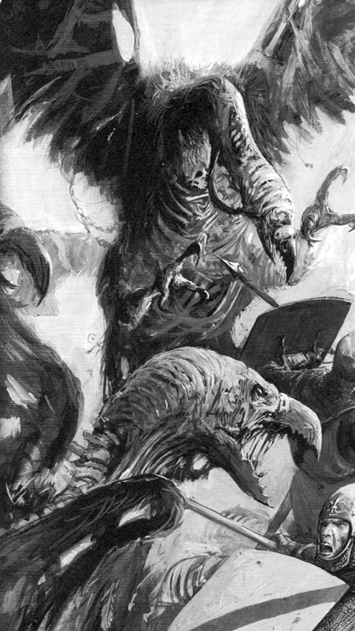

✶ NEHEKHARAN ASSASSIN 

Nehekharan Assassins are humans that have trained their entire lives to be highly skilled fighters. They are master swordsmen and their weapons are made even more deadly by being coated with a quick acting poison.

 | Nehekharan Assassin
Wounds | 14
Move | 4
Weapon Skill | 8
Ballistic Skill | 4+
Strength | 3
Toughness | 3
Armour | -
Initiative | 6
Attacks | 2
Damage | 1D6
Gold | 380

ENEMY’S WS 1 2 3 4 5 6 7 8 9 10
Nehekharan Assassin 2 2 2 3 3 3 3 4 4 4

Nehekharan Assassin
Ambush, Magic 5+; Assassinate 6+; Dodge 5+; Poison.

✶ SAND GOLEM 

Sand Golems are humanoid creatures that are about the size of an Ogre. Their bodies are completely made out of sand, and are created by Liche Priests. Although they are large, they make little noise as they walk, since they blend in with the sand and their feet spread out on the ground as they walk. They are created in most cases to guard valuable items of treasure or as a virtually unstoppable assassin.

 | Sand Golem
Wounds | 40
Move | 4
Weapon Skill | 3
Ballistic Skill | -
Strength | 6
Toughness | 5
Armour | -
Initiative | 4
Attacks | 2
Damage | 2D6
Gold | 580

ENEMY’S WS 1 2 3 4 5 6 7 8 9 10
Sand Golem 2 3 4 4 4 4 5 5 5 6

Sand Golem
Ambush 5+; Regenerate 2D6; Sand Golem.

Sand Golem
A Sand Golem is composed entirely of sand and is able to reform its body after being hit. Warriors attacking a Sand Golem with non magical weapons are at -1 To Hit.

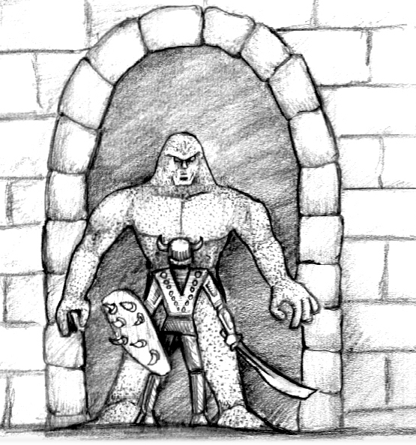

✶ ORGUTS 

Orguts are distant relatives of Ogres. Many centuries ago Ogres lived in Nehekhara, although there are no writings of how they came to be there. Throughout the years and generations of their kind, the Ogres adapted to their environment. Their bodies changed in many ways. Their two eyes, from the burning light, turned into one. Their bodies packed out fat as an energy storage for the long treks of the desert. The harsh conditions seem to have added to their evolution in other ways such as a much greater size and strength. Because they were so different they could no longer be called Ogres, so the Pharaohs named them Orguts.

 | Orgut | Orgut Chieftain
Wounds | 35 | 50
Move | 4 | 4
Weapon Skill | 7 | 8
Ballistic Skill | 4+ | 4+
Strength | 6 | 7
Toughness | 6 | 8
Armour | - | -
Initiative | 5 | 6
Attacks | 2 | 3
Damage | 2D6 | 3D6
Gold | 750 | 1800

ENEMY’S WS 1 2 3 4 5 6 7 8 9 10
Orgut 2 2 2 3 3 3 4 4 4 4
Orgut Chieftain 2 2 2 3 3 3 3 4 4 4

Orgut
Fear 8; Torture.

Orgut Chieftain
Fear 9; Torture.

Torture
Orguts seem to delight in torture. It is not enough to just kill a victim, they love to inflict pain and see how much a victim’s body can take before death. If an Orgut rolls a 6 To Hit, roll 1D6. On a 1-3, the blow hits the Warrior squarely on the head (inflicting normal damage) and has knocked him into a daze. On a 4-6 work out the damage as normal. Once the Warrior is dazed, the Orgut picks him up and takes him to the closest empty square that is not adjacent to a Warrior, breaking all Pinning to do so. He then begins to torture the unfortunate Warrior. Roll 1D6 for how many turns the Warrior is dazed, then for each of these turns roll on the following table once for each Attack the Orgut has.

Torture Table

1 The Orgut spends the turn gathering torture implements from his belongings (usually on his belt). Add +1 to the next roll on this table.

2-3 The Orgut twists and stabs at the Warrior’s body in various ways, chuckling cruelly. The Warrior takes 1D3 unmodified damage.

4 The Orgut Laughs as he pushes a metal pin into the Warrior’s gizzards. The Warrior takes 1D6 unmodified damage.

5 The Orgut pushes and pulls harshly at the Warrior’s limbs, making them crack and tear. The Warrior suffers 2D6 Wounds.

6 The Orgut skewers the Warrior, making him wince and call out in pain much to his torturer’s delight. The Warrior loses 1 Starting Wound, permanently.

Once the Warrior comes out of his daze he crawls into an adjacent square. Place the Warrior on the nearest free square.

If the Orgut is attacked by another Warrior while he is torturing, his attention is diverted to the attacking Warrior, leaving the tortured Warrior to crawl away in his dazed state to the nearest free square where he waits out the rest of his dazed state. While dazed the Warrior is considered to be Prone.

If another Orgut becomes pinned by a dazed Warrior, he will immediately pick him up and start torturing him (in the Monsters’ Phase), as long as the Orgut is not in contact with another Warrior.

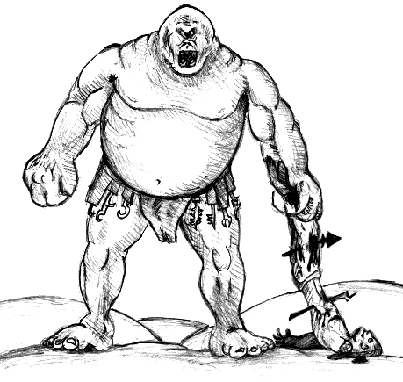

✶ TOMB SCORPION 

Tomb Scorpions are powerful creations of the Liche Priests, giant constructs carved and moulded into representations of the giant, mystical creatures said to guard the entrance to the Nehekharan underworld. They are formed from a combination of stone, wood and metal, together with the bones and shells of the long dead. Through laborious and precise incantations, the Liche Priests join the materials into a single form. The Tomb Scorpion acts as a tomb, for the shell of the construct is formed around the mummified body of an ancient Liche Priest.

 | Tomb Scorpion
Wounds | 30
Move | 7
Weapon Skill | 4
Ballistic Skill | -
Strength | 5
Toughness | 5
Armour | -
Initiative | 3
Attacks | 4
Damage | 2D6
Gold | 1000

ENEMY’S WS 1 2 3 4 5 6 7 8 9 10
Tomb Scorpion 2 3 3 4 4 4 4 4 5 5

Tomb Scorpion
Fear 10; Magic Resistance 6+; Sting (2D6).

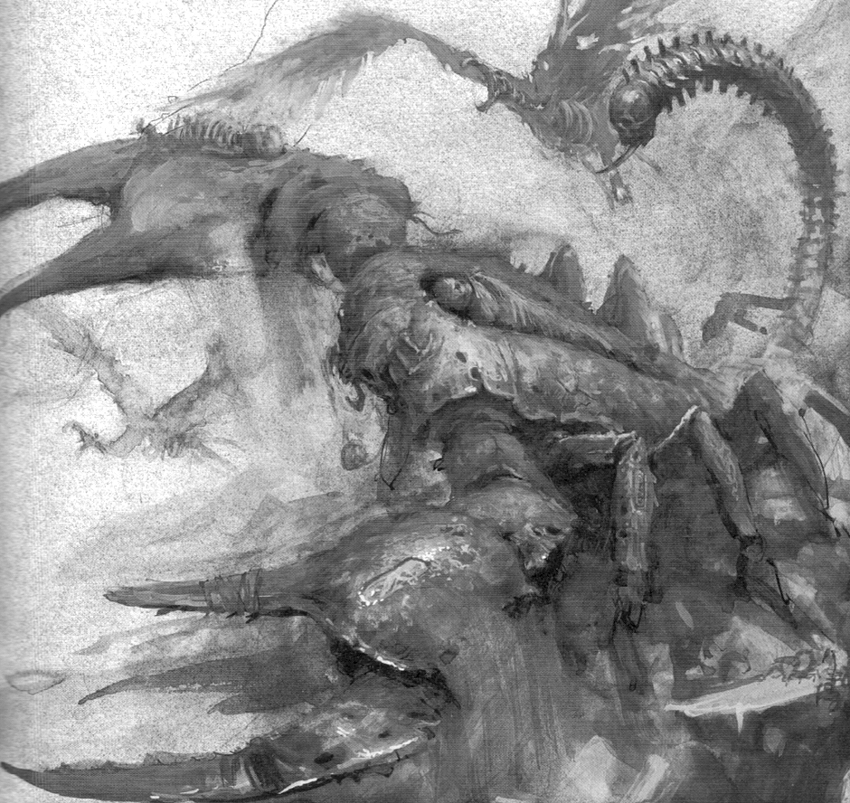
✶ CASKET OF SOULS 

Within the tombs of the mightiest kings there lies a casket inscribed with hieroglyphs of malediction and warning. Within this sacred casket reside the souls of those who have committed the sacrilege of inciting the Tomb King’s rage. The spirits of those condemned have been ensnared by the dire power of the casket and trapped within for eternity. Powerful inscriptions ensure that these souls may never leave their prison until the moment comes when the casket is opened. If the seals are broken and the lid opened, blinding light spills from the casket as countless lost souls scream into the air, seeking freedom from the madness and torment of their confinement.

 | Casket of Souls
Wounds | 30
Move | -
Weapon Skill | 1
Ballistic Skill | -
Strength | -
Toughness | 6
Armour | -
Initiative | -
Attacks | Special
Damage | Special
Gold | 1000

Casket of Souls
Casket of Souls; Light of Death; Terror 12.

Casket of Souls
Place the Casket of Souls as if it was armed with a missile weapon. A Casket of Souls will always be accompanied by a Liche Priest (rank dependant on Dungeon Level) and 2 Tomb Guard Champions. Place the Liche Priest behind the Casket, and the Tomb Guard Champions at the front 2 corners. Warriors cannot Attack the Casket if they are pinned by either the Liche Priest or the Tomb Guard Champions.

Light of Death
When the Casket of Souls is opened, the souls within the magical casket are unleashed. They erupt in a great burst of light that sears the eyes and flesh of unbelievers who look upon it. When the Casket is first placed, it will contain 30 souls. As damage is inflicted upon it, the number of souls will decrease. The Casket will always have a number of souls equal to the amount of Wounds it currently has. At the beginning of the Monsters’ Phase, after any spells have been cast and if the Liche Priest is still standing, he will open the Casket of Souls. The Light of Death from the souls will pour through the Pyramid. Each soul will cause 1 unmodified Wound to the Warriors, divided evenly between them. eg. If there are 24 souls released, the Warriors will need to divide 24 unmodified Wounds evenly between them. Souls can affect Warriors anywhere on the board.

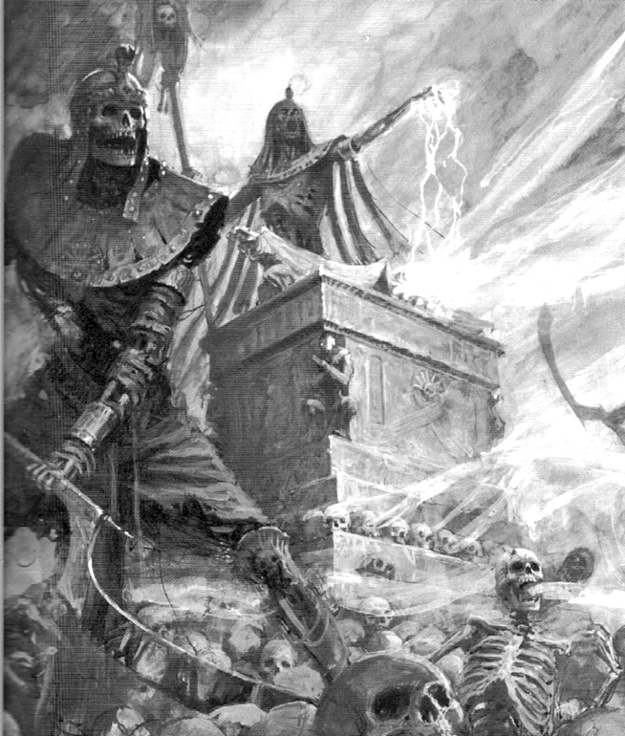
✶ USHABTI 

Carved into the likenesses of the many Gods and Goddesses of Nehekhara, the Ushabti stand as guardian statues in the Pyramids of the Tomb Kings. They are almost three times the height of a man and wield mighty ritual blades. Liche Priests imbue the Ushabti with tremendous power, animating them in combat.

 | Ushabti
Wounds | 40
Move | 5
Weapon Skill | 4
Ballistic Skill | -
Strength | 6
Toughness | 4 (6)
Armour | 2
Initiative | 3
Attacks | 3
Damage | 3D6
Gold | 1350

ENEMY’S WS 1 2 3 4 5 6 7 8 9 10
Ushabti 2 3 3 4 4 4 4 4 5 5

Ushabti
Fear 10; Ignore Blows 5+.

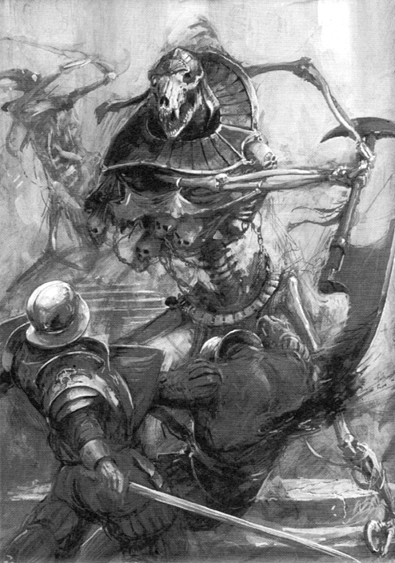

✶ BONE GIANT 

Constructed from all manner of elements to resemble an immense warrior of Nehekharan legend, Bone Giants are mighty beings of immense stature. Armed with enormous weapons and armour, it is a Bone Giant’s task to guard the ancient Pyramids of the Tomb Kings from invaders.

 | Bone Giant
Wounds | 60
Move | 6
Weapon Skill | 3
Ballistic Skill | 6+
Strength | 6
Toughness | 5 (10)
Armour | 5
Initiative | 1
Attacks | Special
Damage | 5D6
Gold | 1900

ENEMY’S WS 1 2 3 4 5 6 7 8 9 10
Bone Giant 2 3 4 4 4 4 5 5 5 6

Bone Giant
Terror 12; Bone Giant Attacks; Ignore Blows 5+; Ignore Pain 10; Large Monster; Never Pinned.

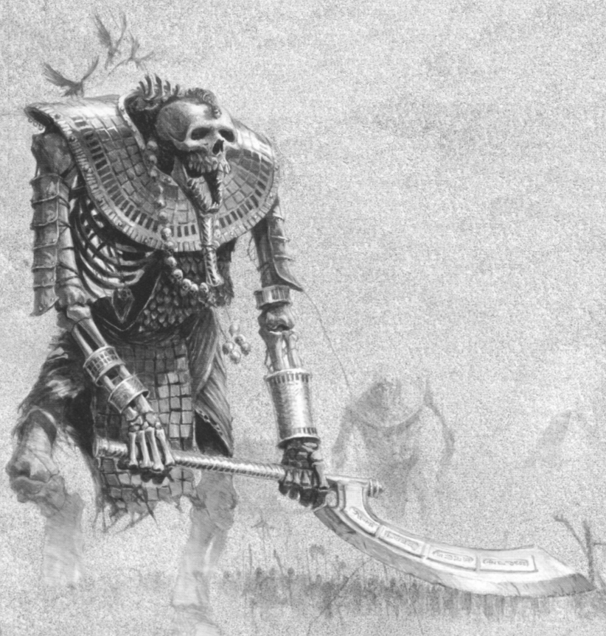
Bone Giant Attacks
Bone Giants are huge and unpredictable creatures and it is by no means certain what form of attack they will make. A Bone Giant will attack a random Warrior up to 2 squares away each turn. At the start of each Monsters’ Phase roll 1D6 on the following table for each Bone Giant on the board to determine what it does this turn.

1 Squeeze
The Bone Giant squeezes the Warrior with his mighty fist. The Warrior takes 6D6 Wounds.

2 Throw
The Bone Giant picks up the Warrior and hurls him at his companions. Take a Warrior counter to see which Warrior is targeted. Roll 7D6 and separate those that have an even score from those that have an odd score. The Warrior being thrown suffers a number of Wounds equal to the sum of the even dice, while the targeted Warrior suffers a number of Wounds equal to the sum of the odd dice. Neither Warrior gets any modifiers for Toughness or armour. The thrown Warrior is placed Prone in the square originally occupied by the target Warrior. The target Warrior is pushed into an adjacent square, shuffling other models around as necessary.

3 Smash Against the Roof
The Bone Giant grabs the Warrior by the feet to get a good swing and begins to smash him repeatedly against the roof of the cave. The Bone Giant smashes the Warrior against the roof 1D6 times, inflicting 7 Wounds with no modifiers for Toughness or armour each time.

4 Chew
The Bone Giant begins to chew on the Warrior with teeth the size and shape of old tombstones. The Warrior suffers 1D6 Wounds, with no modifiers for Toughness or armour. If the score on the dice is 2-6 the Bone Giant continues to chew the Warrior next turn, even if he is at 0 Wounds or less. Roll another 1D6 for Wounds. This process continues until the roll for Wounds is a 1 at which point the Bone Giant finds a gristly bit, loses interest and drops the Warrior in the square he got him from. Place the Warrior Prone. If the Warrior is reduced to -50 Wounds the Bone Giant swallows him whole, effectively taking him out of the game.

5 Swing with Weapon
Because of his reach the Bone Giant hits all of the Warriors up to two squares away. Roll 3D6 for each eligible Warrior. Each dice that scores a 4, 5 or 6 causes that many Wounds with no modifier for armour. Any dice that scores 1, 2 or 3 misses as the Warrior manages to avoid the mighty weapon.

6 Attack with Weapon
The Bone Giant makes 1D6 Attacks against the Warrior.

