★ NORSE 

In the cold north of the Warhammer World lies the country of Norsca. The Norse are a warrior race and like nothing better than a good fight. When not raiding settlements in the Old World, they spend their time drinking and fighting amongst themselves. They have no fear of death - this leads them to perform heroic or stupid actions in battle that no ordinary man would dare try.

✶ THRALL 

Thrall is the name given to enemies of the Norse captured in a raid. They are forced to perform deeds for their captors before they can be released. They are armed with crude missile weapons. They are used in battles to act as disposable troops.

 | Thrall
Wounds | 4
Move | 4
Weapon Skill | 3
Ballistic Skill | 5+
Strength | 2
Toughness | 3
Armour | -
Initiative | 3
Attacks | 1
Damage | 1D6
Gold | 35

ENEMY’S WS 1 2 3 4 5 6 7 8 9 10
Thrall 2 3 4 4 4 4 5 5 5 6

Thrall
Armed with Slings (Str 1).

✶ HUSCARL 

A Huscarl has the responsibility to defend his village from attack while the other Norse warriors are out adventuring. They are usually skilled fighters and are expert with missile weapons to pick off the enemy before they invade.

 | Huscarl
Wounds | 9
Move | 3
Weapon Skill | 4
Ballistic Skill | 4+
Strength | 3
Toughness | 3 (4)
Armour | 1
Initiative | 2
Attacks | 1
Damage | 1D6
Gold | 90

ENEMY’S WS 1 2 3 4 5 6 7 8 9 10
Huscarl 2 3 3 4 4 4 4 4 5 5

Huscarl
Throw Spear (Str 3).
✶ NORTHERN STEED 

The Norse have bred horses to live in the cold weather of Norsca. These horses are called Northern Steed. They are very feisty animals, and it takes a great degree of skill to control one.

 | Northern Steed
Wounds | 5
Move | 8
Weapon Skill | 3
Ballistic Skill | -
Strength | 3
Toughness | 3
Armour | -
Initiative | 3
Attacks | 1
Damage | 1D6
Gold | 45

ENEMY’S WS 1 2 3 4 5 6 7 8 9 10
Northern Steed 2 3 4 4 4 4 5 5 5 6

Northern Steed
-

Northern Steed can be ridden by Norse Beastmasters, Norse Hunters, Valkyries, Norse Warriors, Huscarls, and Vikings.

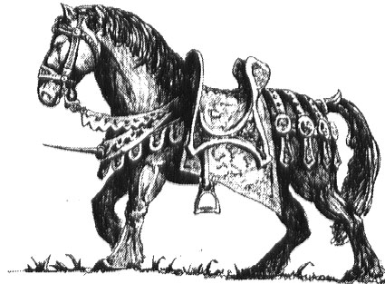

✶ ULFWERENAR 

Ulfwerenar are men who have been bitten by a wolf infected by warpstone. Ulfwerenar have the ability to change into a wolf and back into a man, but unfortunately they have no control over when the change will happen.

 | Man | Wolf
Wounds | 10 | 3
Move | 4 | 9
Weapon Skill | 4 | 3
Ballistic Skill | 4+ | -
Strength | 3 | 4
Toughness | 3 | 3
Armour | - | -
Initiative | 3 | 4
Attacks | 1 | 1
Damage | 1D6 | 1D6
Gold | 40 | 60

ENEMY’S WS 1 2 3 4 5 6 7 8 9 10
Man 2 3 3 4 4 4 4 4 5 5
Wolf 2 3 4 4 4 4 5 5 5 6

Man
Transformation.

Wolf
Feed; Frenzy 6+; Gang Up.

Feed
Wolves can feed on the bodies of the killed after a battle. If a Wolf kills a Warrior who is then not healed in the same turn it will stop and feed on the body. Roll 1D6. On a roll of 1 the Wolf starts to eat the body of the dead Warrior. For the next turn he will not move or attack. A dead Warrior who has been eaten by a Wolf cannot be resurrected.

Transformation
At the beginning of the Monsters’ Phase roll 1D6 and add the number of dead bodies from this combat. If the amount is equal to or greater than 7 then the Monster begins the transformation to a wolf. Roll for each Ulfwerenar separately.

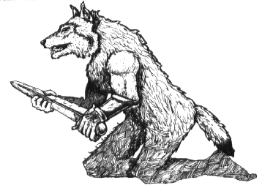
✶ NORSE BEASTMASTER 

Beastmasters have spent most of their lives in the wild, getting to know the various beasts that exist. Over the years the beasts come to know the Beastmaster and he is able to call on their assistance in battle.

 | Norse Beastmaster
Wounds | 10
Move | 4
Weapon Skill | 4
Ballistic Skill | 4+
Strength | 3
Toughness | 3
Armour | -
Initiative | 3
Attacks | 1
Damage | 1D6
Gold | 50

ENEMY’S WS 1 2 3 4 5 6 7 8 9 10
Norse Beastmaster 2 3 3 4 4 4 4 4 5 5

Norse Beastmaster
Beast Handler (Norse); Throw Axe (Str 3).

Beast Handler (Norse)
A Norse Beastmaster is accompanied in combat by many beasts which he has trained over the years. When a Beastmaster is placed on the board, first roll 1D6 to see what beasts accompany him. Place the beasts first before placing the Beastmaster.

1 1D3 Wolves
2 1D3 Great Wolves
3 1D3 Dire Wolves
4 1 Polar Bear
5 1 Snow Troll
6 Roll again and add 1 to the number of beasts which appear.

✶ OATHBREAKER 

Norse which have committed a crime become outcasts from normal society. They live far away from any Norse settlements. Sometimes they are given a chance to redeem themselves through combat.

 | Oathbreaker
Wounds | 8
Move | 4
Weapon Skill | 4
Ballistic Skill | 4+
Strength | 4
Toughness | 3 (4)
Armour | 1
Initiative | 4
Attacks | 1
Damage | 1D6
Gold | 90

ENEMY’S WS 1 2 3 4 5 6 7 8 9 10
Oathbreaker 2 3 3 4 4 4 4 4 5 5

Oathbreaker
-
✶ VALKYRIES 

Many Norse females give up their traditional paces in Norse Society and join the Valkyries - female warriors who dedicate their lives to the service of Odin. They are skilled fighters - swift of movement and blade.

 | Valkyrie | Valkyrie Leader | Valkyrie Heroine | Valkyrie Queen
Wounds | 10 | 18 | 29 | 35
Move | 5 | 5 | 5 | 5
Weapon Skill | 4 | 4 | 5 | 6
Ballistic Skill | 4+ | 3+ | 2+ | 1+
Strength | 3 | 3 | 4 | 4
Toughness | 3 (4) | 3 (4) | 4 (6) | 4 (6)
Armour | 1 | 1 | 2 | 2
Initiative | 5 | 6 | 7 | 9
Attacks | 1 | 2 | 3 | 4
Damage | 1D6 | 1D6 | 2D6 | 3D6
Gold | 60 | 300 | 800 | 1350

ENEMY’S WS 1 2 3 4 5 6 7 8 9 10
Valkyrie 2 3 3 4 4 4 4 4 5 5
Valkyrie Leader 2 3 3 4 4 4 4 4 5 5
Valkyrie Heroine 2 2 3 3 4 4 4 4 4 4
Valkyrie Queen 2 2 3 3 3 4 4 4 4 4

Valkyrie
Parry 6+.

Valkyrie Leader
Magic Item; Parry 6+.

Valkyrie Heroine
Magic Item; Magic Weapon; Parry 5+.

Valkyrie Queen
Magic Armour; Magic Item; Magic Weapon; Parry 5+.

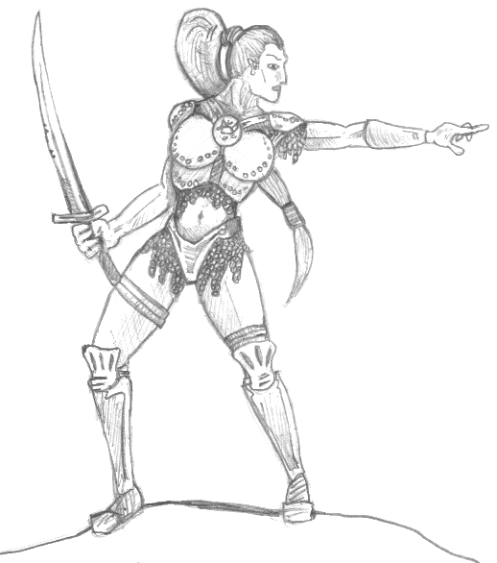
✶ NORSE WARRIORS 

Norse are big burly men with bulging muscles who love to fight. They have long hair which is sometimes twisted in plaits.

 | Bondsman | Norse Leader | Norse Jarl | Norse King
Wounds | 12 | 20 | 35 | 40
Move | 4 | 4 | 4 | 4
Weapon Skill | 4 | 4 | 5 | 6
Ballistic Skill | 4+ | 3+ | 2+ | 1+
Strength | 3 | 4 | 4 | 5
Toughness | 3 (4) | 3 (5) | 4 (7) | 4 (8)
Armour | 1 | 2 | 3 | 4
Initiative | 3 | 4 | 5 | 6
Attacks | 1 | 2 | 3 | 4
Damage | 1D6 | 2D6 | 3D6 | 4D6
Gold | 60 | 350 | 900 | 1600

ENEMY’S WS 1 2 3 4 5 6 7 8 9 10
Bondsman 2 3 3 4 4 4 4 4 5 5
Norse Leader 2 3 3 4 4 4 4 4 5 5
Norse Jarl 2 2 3 3 4 4 4 4 4 4
Norse King 2 2 3 3 3 4 4 4 4 4

Bondsman
-

Norse Leader
Magic Item.

Norse Jarl
Ignore Pain 1; Magic Item; Magic Weapon.

Norse King
Ignore Pain 2; Magic Armour; Magic Item; Magic Weapon.

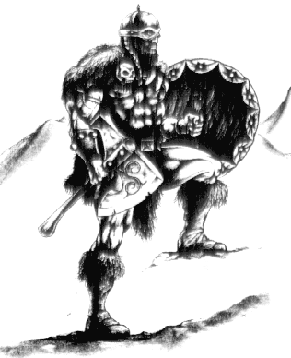

✶ NORSE HUNTER 

Norse Hunters are expert scouts. They are skilled in the construction of bows which they use to hunt for food for the village. It has been known for a Norse Hunter to be gone for entire weeks hunting many animals.

 | Norse Hunter
Wounds | 6
Move | 4
Weapon Skill | 3
Ballistic Skill | 3+
Strength | 3
Toughness | 3
Armour | -
Initiative | 3
Attacks | 1
Damage | 1D6
Gold | 80

ENEMY’S WS 1 2 3 4 5 6 7 8 9 10
Norse Hunter 2 3 4 4 4 4 5 5 5 6

Norse Hunter
Armed with Bow (Str 3).

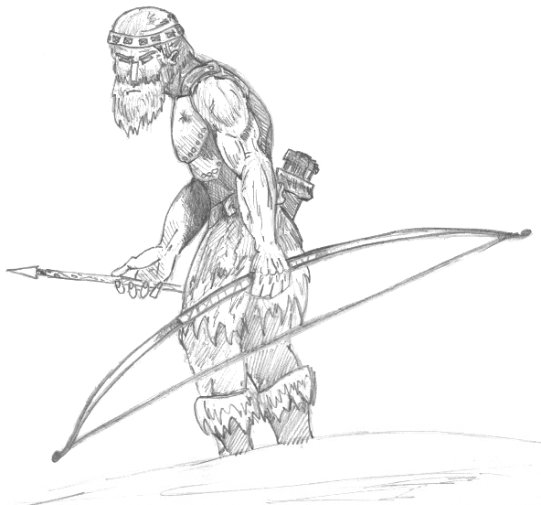

✶ VIKINGS 

The Vikings boast of being the greatest warriors in the whole world. They like nothing more than a good battle, except of course for drinking. Hoards of Vikings often sail to the mainland and raid small villages. There, they rape the woman and steal any treasure they find.

 | Viking | Viking Leader
Wounds | 11 | 13
Move | 4 | 4
Weapon Skill | 5 | 5
Ballistic Skill | 3+ | 3+
Strength | 4 | 5
Toughness | 4 (5) | 4 (5)
Armour | 1 | 1
Initiative | 4 | 5
Attacks | 1 | 2
Damage | 1D6 | 1D6
Gold | 150 | 230

ENEMY’S WS 1 2 3 4 5 6 7 8 9 10
Viking 2 2 3 3 4 4 4 4 4 4
Viking Leader 2 2 3 3 4 4 4 4 4 4

Viking
Throw Axe (Str 4).

Viking Leader
Throw Axe (Str 5).
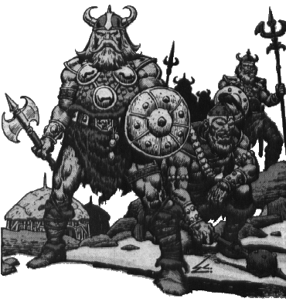

✶ EINHERJAR 

The Einherjar are great Norse warriors that have come back from the afterlife to help their fellow Norse in battle. They skills have been enhanced by the Gods, making them extremely difficult to kill.

 | Einherjar | Einherjar Leader | Einherjar Jarl | Einherjar King
Wounds | 12 | 20 | 30 | 40
Move | 4 | 4 | 4 | 4
Weapon Skill | 7 | 8 | 9 | 10
Ballistic Skill | 2+ | 2+ | 1+ | A
Strength | 4 | 4 | 4 | 5
Toughness | 4 (5) | 4 (6) | 4 (7) | 4 (8)
Armour | 1 | 2 | 3 | 4
Initiative | 6 | 7 | 8 | 9
Attacks | 1 | 2 | 3 | 4
Damage | 1D6 | 2D6 | 3D6 | 4D6
Gold | 150 | 500 | 1400 | 2300

ENEMY’S WS 1 2 3 4 5 6 7 8 9 10
Einherjar 2 2 2 3 3 3 4 4 4 4
Einherjar Leader 2 2 2 3 3 3 3 4 4 4
Einherjar Jarl 2 2 2 2 3 3 3 3 4 4
Einherjar King 2 2 2 2 3 3 3 3 3 4

Einherjar
Regenerate 1D3.

Einherjar Leader
Magic Item; Regenerate 1.

Einherjar Jarl
Magic Armour; Magic Item; Magic Weapon; Regenerate 1.

Einherjar King
Magic Armour; Magic Item x 2; Magic Weapon; Regenerate 2.
✶ BEARMAN OF URSLO 

Bearmen are heavily affected by the dark powers of Chaos. This has made them into beasts, sometimes more than they are men. Most Bearmen are in some stage of transformation between a man and a bear.

 | Bearman of Urslo
Wounds | 13
Move | 4
Weapon Skill | 4
Ballistic Skill | 4+
Strength | 4
Toughness | 3
Armour | 1
Initiative | 4
Attacks | 1
Damage | 1D6
Gold | 90

ENEMY’S WS 1 2 3 4 5 6 7 8 9 10
Bearman of Urslo 2 3 3 4 4 4 4 4 5 5

Bearman of Urslo
Bear Mutation.

Bear Mutation
Most Bearman are in some partial stage of transformation between a man and a bear. Some have wickedly sharp claws, others have hairy faces, while some even have thick bear skin. Each group of Bearmen has the same mutation - roll 1D6 for the whole group.

1 Nothing
The Bearmen have not yet mutated.

2 Hairy Face
The Bearmen have grown hair all over their bodies. Apart from looking scruffy, this has no effect on their combat ability.

3 Slow Intellect
The Bearmen are extremely slow to react due to their partial transformation of their minds. They now must attack last in the Monsters' Phase each turn.

4 Strength
The arms and legs of the Bearmen have developed the muscles of a bear. Their Strength is increased by +1.

5 Sharp Claws
Sharp Claws have grown on the fingers of the Bearmen. They cause an extra +1 damage.

6 Thick Skin
The Thick skin of a bear protects the Bearmen from harm. Each Bearman gains +1 Toughness.

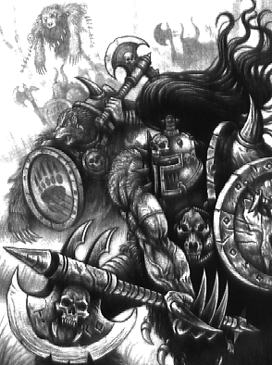

✶ POLAR BEAR 

Polar bears are cousins of the bears found in the Old World. They have a thick layer of white fur to protect them from the freezing cold conditions in Norsca.

 | Polar Bear
Wounds | 15
Move | 6
Weapon Skill | 3
Ballistic Skill | -
Strength | 4
Toughness | 4
Armour | -
Initiative | 3
Attacks | 2
Damage | 2D6
Gold | 400

ENEMY’S WS 1 2 3 4 5 6 7 8 9 10
Polar Bear 2 3 4 4 4 4 5 5 5 6

Polar Bear
-
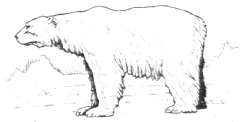

✶ JOTUNN 

A Jotunn is a Norse Warrior enhanced in size almost to the size of a Giant. However, a Jotunn is more intelligent than a Giant, preferring just to beat the innards out of anyone that comes near.

 | Jotunn
Wounds | 58
Move | 7
Weapon Skill | 5
Ballistic Skill | 3+
Strength | 7
Toughness | 6 (10)
Armour | 4
Initiative | 3
Attacks | 4
Damage | 4D6
Gold | 2400

ENEMY’S WS 1 2 3 4 5 6 7 8 9 10
Jotunn 2 2 3 3 4 4 4 4 4 4

Jotunn
Fear 11; Ignore Blows 5+; Ignore Pain 8; Large Monster; Mighty Blow; Never Pinned; Throw Rock (Str 5, One at end of each Monsters’ Phase).

Mighty Blow
A Jotunn is extremely large and heavy. When he attacks a Warrior, the attack carries into the next square. Treat this ability as a death blow, although the Warrior doesn’t have to be dead for the Jotunn to carry on his attacks.
✶ ULFJARL 

Ulfjarl are Ulfwerenar who have learnt to control their transformation and can stop halfway through. They prefer to remain that way for fights, giving the manoeuvrability of man and the ferocity of a wolf.

 | Ulfjarl
Wounds | 12
Move | 6
Weapon Skill | 4
Ballistic Skill | 6+
Strength | 5
Toughness | 4
Armour | -
Initiative | 8
Attacks | 2
Damage | 1D6
Gold | 290

ENEMY’S WS 1 2 3 4 5 6 7 8 9 10
Ulfjarl 2 3 2 4 4 4 4 4 5 5

Ulfjarl
Fear 5; Frenzy 5+.

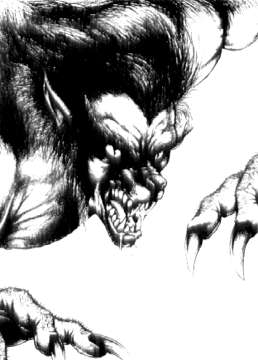

✶ DOOMBRINGERS 

Doombringers are the most deadliest of the Norse Warriors. In battle, they think nothing of the consequences of their actions, charging at their nearest enemy, whether it be a Goblin or a Dragon.

 | Doombringer | Doombringer Leader | Doombringer Jarl | Doombringer King
Wounds | 20 | 23 | 32 | 40
Move | 6 | 6 | 6 | 6
WS | 3 | 4 | 5 | 6
BS | - | - | - | -
Strength | 6 | 6 | 6 | 7
Toughness | 4 | 4 | 4 | 4
Armour | - | - | - | -
Initiative | 6 | 7 | 8 | 9
Attacks | 3 | 4 | 5 | 6
Damage | 1D6 | 2D6 | 3D6 | 4D6
Gold | 450 | 900 | 1500 | 2000

ENEMY’S WS 1 2 3 4 5 6 7 8 9 10
Doombringer 2 3 4 4 4 4 5 5 5 6
Doombringer Leader 2 3 3 4 4 4 4 4 5 5
Doombringer Jarl 2 2 3 3 4 4 4 4 4 4
Doombringer King 2 2 3 3 3 4 4 4 4 4

Doombringer
Immune to Fear.

Doombringer Leader
Immune to Fear; Magic Item.

Doombringer Jarl
Immune to Fear; Magic Item; Magic Weapon.

Doombringer King
Immune to Fear; Magic Item x 2; Magic Weapon.

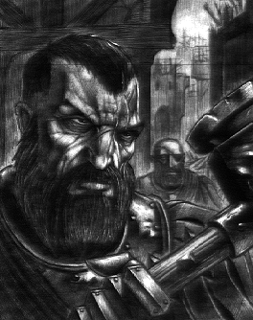
✶ NORSE SHAMANS 

Norse Shamans are raggedly dresses, unkempt men who carry belts adorned with dead birds, small dead animal and all manner of strange and disgusting items. When they fight their mouth froths and their eyes go wild. They leap around chanting at the top of their voices.

 | Norse Shaman | Norse Shaman Champion | Master Norse Shaman | Norse Shaman Lord
Wounds | 8 | 15 | 24 | 30
Move | 4 | 4 | 4 | 4
Weapon Skill | 3 | 3 | 4 | 4
Ballistic Skill | 4+ | 4+ | 3+ | 3+
Strength | 3 | 4 | 4 | 4
Toughness | 4 | 4 | 4 | 4
Armour | - | - | - | -
Initiative | 4 | 4 | 5 | 6
Attacks | 1 | 1 | 2 | 3
Damage | 1D6 | 2D6 | 3D6 | 3D6
Gold | 420 | 1200 | 2190 | 3250

ENEMY’S WS 1 2 3 4 5 6 7 8 9 10
Norse Shaman 2 3 4 4 4 4 5 5 5 6
Norse Shaman Champion 2 3 4 4 4 4 5 5 5 6
Master Norse Shaman 2 3 3 4 4 4 4 4 5 5
Norse Shaman Lord 2 3 3 4 4 4 4 4 5 5

Norse Shaman
Ice Magic 1; Fear 4; Hate All; Magic Item; Magic Resistance 6+.

Norse Shaman Champion
Ice Magic 2; Fear 4; Hate All; Magic Item; Magic Resistance 6+; Magic Weapon.

Master Norse Shaman
Ice Magic 3; Fear 4; Hate All; Magic Item x 2; Magic Resistance 5+; Magic Weapon.

Norse Shaman Lord
Ice Magic 4; Fear 4; Hate All; Magic Item x 3; Magic Resistance 5+; Magic Weapon.

✶ RUNEPRIESTS 

Some Norse receive visions of runes when they are young. If they seek the meaning of these runes and learn how to invoke them, they will become Runepriests. Runepriests are able to call upon the power of the runes to aid their comrades in battle.

 | Runedreamer | Runeseeker | Runemaster | Godi
Wounds | 10 | 20 | 30 | 40
Move | 4 | 4 | 4 | 4
WS | 3 | 4 | 5 | 6
BS | 4+ | 4+ | 3+ | 2+
Strength | 3 | 4 | 4 | 5
Toughness | 4 | 5 | 5 | 6
Armour | - | - | - | -
Initiative | 4 | 5 | 5 | 6
Attacks | 1 | 2 | 3 | 4
Damage | 1D6 | 2D6 | 3D6 | 3D6
Gold | 500 | 1000 | 2000 | 3000

ENEMY’S WS 1 2 3 4 5 6 7 8 9 10
Runedreamer 2 3 4 4 4 4 5 5 5 6
Runeseeker 2 3 3 4 4 4 4 4 5 5
Runemaster 2 2 3 3 4 4 4 4 4 4
Godi 2 2 3 3 3 4 4 4 4 4

Runedreamer
Invoke Runes 1; Magic Item.

Runeseeker
Invoke Runes 2; Magic Item; Magic Weapon.

Runemaster
Invoke Runes 3; Magic Item x 2; Magic Weapon.

Godi
Invoke Runes 4; Magic Item x 3; Magic Resistance 6+; Magic Weapon.

Invoke Runes
Norse Runepriests have the power to invoke the runes. At the beginning of each turn roll 1D6 on the Runepriest Rune table to determine which runes he invokes. All Norse troops can have Norse Runes invoked on them except for Monsters (eg. Polar Bear, Jotunn etc). When the Runepriest invokes the runes he selects a group of Norse at random (eg. Norse Warriors, Vikings, etc) and applies the effects of the rune to them. All models in the group are affected the same way. A group of Norse can have more than 1 rune invoked on them in a battle. The effects of the runes will last until each Monster is killed.

Runepriests Runes
When the Norse Runepriest is required to invoke the power of the runes, roll 1D6 on the following table to determine which type he invokes.

1-2 Common Rune
3-5 Arcane Rune
6 Power Rune

Common Runes

1 Rune of Swiftness
The Monster’s senses become increased, increasing its reactions. It gains +1 Initiative.

2 Rune of Speed
The Monster can move much faster and gains +1 to its Movement.

3 Rune of Hunting
The Monster’s eyesight becomes sharper and it is able to pick out details at a longer range. It gains +1 Ballistic Skill.

4 Rune of Glory
This rune bestows upon its target the ability to become a better fighter. The Monster gains +1 Weapon Skill.

5 Rune of Strength
The Monster’s muscles ripple and enlarge. It gains +1 Strength.

6 Rune of Protection
This rune hardens the skin of the Monster, giving it +1 Toughness.

Arcane Runes

1 Rune of Fear
This rune creates an illusion of a fearsome Monster around the target. It has Fear 5. The Warriors must immediately make a Fear test. If they fail they are scared of the target Monster.

2 Rune of Skill
The rune increases the skill of the Monster. It gains +1 to all of its To Hit rolls, either hand to hand or missile combat.
3 Rune of Battle
This rune increases the Monster’s Attacks by +1, making him more deadly.

4 Rune of Regeneration
The Monster’s body is able to heal itself. The Monster gains the Regenerate 1 skill.

5 Rune of Might
The Monster gains an extra Damage Dice.

6 Rune of Life
The Monster feels rejuvenated. It has its Wounds healed back to full!

Power Runes

A Power Rune may only be invoked on the Norse Runepriest himself. It enables him to cast 1 Ice Magic Spell per turn at the beginning of the Monsters’ Phase. A Norse Runepriest may only ever have one Power Rune. If he invokes another one, roll again on the Runepriests Runes table.

✶ YETI 

Yetis live in caves in the mountains of Norsca. They rarely let themselves be seen by man, but when they do it is to kill them and drag them back to their caves, before eating them.

 | Yeti
Wounds | 20
Move | 6
Weapon Skill | 4
Ballistic Skill | 6+
Strength | 4
Toughness | 4
Armour | -
Initiative | 3
Attacks | 2
Damage | 2D6
Gold | 550

ENEMY’S WS 1 2 3 4 5 6 7 8 9 10
Yeti 2 3 3 4 4 4 4 4 5 5

Yeti
Fear 5; Hug 6.

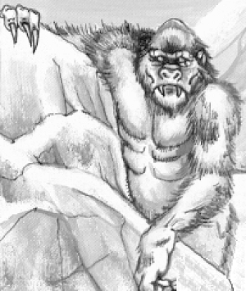

✶ DIRE WOLF 

Dire Wolves have been tainted by warpstone and thus differ from normal wolves. They find great delight in hunting and slaying other creatures and have incredibly sharp claws which rip into flesh and snap bones with ease.

 | Dire Wolf
Wounds | 9
Move | 10
Weapon Skill | 5
Ballistic Skill | -
Strength | 4
Toughness | 4
Armour | -
Initiative | 7
Attacks | 2
Damage | 2D6
Gold | 700

ENEMY’S WS 1 2 3 4 5 6 7 8 9 10
Dire Wolf 2 2 3 3 4 4 4 4 4 4

Dire Wolf
Death Frenzy; Frenzy 5+.

Death Frenzy
When a Dire Wolf knows that it is about to die it goes into an uncontrollable rage. It lashes out at all models adjacent to it, whether fried or foe. When a Dire Wolf is reduced to 0 Wounds, before removing the model from the table make a To Hit roll on each adjacent model with a -1 modifier. Any model that suffers a hit takes normal damage.

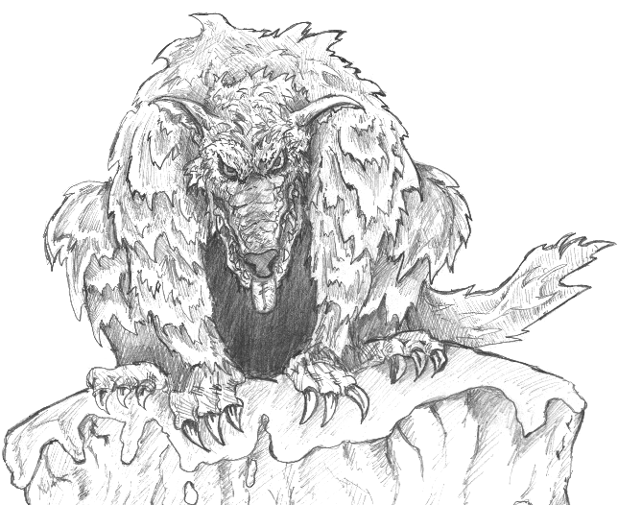
✶ SNOW TROLL 

Snow Trolls are excellent trackers and can follow their prey for many hundreds of miles if need be. They have wickedly sharp claws which can slice through their prey with one slash. Snow Trolls excel in fighting and once in battle they are devastating.

 | Snow Troll
Wounds | 25
Move | 6
Weapon Skill | 4
Ballistic Skill | 6+
Strength | 5
Toughness | 4
Armour | -
Initiative | 1
Attacks | 3
Damage | 2D6
Gold | 850

ENEMY’S WS 1 2 3 4 5 6 7 8 9 10
Snow Troll 2 3 3 4 4 4 4 4 5 5

Snow Troll
Fear 6; Frenzy 6+; Regenerate 2*.

* A Snow Troll cannot regenerate in the same turn as its flesh is burnt, either from natural fire or from a magic weapon.

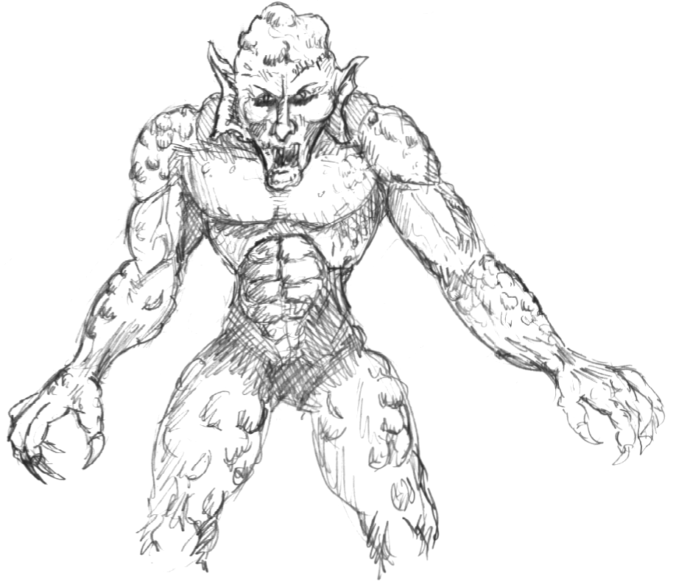

✶ MAMMOTH 

A Mammoth is one of the largest land creatures in the Warhammer World. It is very thick skinned and has a layer of white fur which protects it from harm and the cold. Its huge tusks can skewer anyone within reach and it can trample a normal human to death in seconds. The War Mammoth Battle Tower consists of a small tower strapped to the back of the Mammoth. Inside the tower are a small number of Norse warriors with missile weapons. They fire these through small slits at their enemies while staying protected inside the tower.

 | Mammoth | Battle Tower
Wounds | 60 | 25
Move | 8 | -
Weapon Skill | 3 | -
Ballistic Skill | - | -
Strength | 7 | -
Toughness | 6 (9) | 6
Armour | 3 | -
Initiative | 1 | -
Attacks | 4 | -
Damage | 4D6 | -
Gold | 2500 | 250

ENEMY’S WS 1 2 3 4 5 6 7 8 9 10
Mammoth 2 3 4 4 4 4 5 5 5 6

Mammoth
Ignore Blows 5+; Ignore Pain 6; Large Monster; Rampage; Terror 11; Trample 4.

Battle Tower
The Warriors cannot attack the Battle Tower except with spells or missile weapons. If the Battle Tower is destroyed, all the Norse on it will fall off - place them on adjacent squares, moving any other models out of the way if necessary. If the Warriors succeed in killing the Mammoth, the Battle Tower will topple over, depositing the Norse as above. The Howdah is so heavy that the Mammoth carrying it has its movement value reduced by -2.

