★ ORCS & GOBLINS 

Orcs, Goblins and their smaller cousins, Snotlings, are all greenskins. They are ferocious raiders and relentless warriors, and their constant attacks threaten to engulf the human lands of the Old World. All Orcs live to wage war, and it is this that makes them so dangerous. Yet this love of combat is also their greatest weakness, as it means they expend much of their energy fighting each other. Goblins are smarter than Orcs but nowhere near as warlike. They are cunning rather than strong, and rely a great deal on their Orc cousins when it comes to the serious business of fighting.

✶ SNOTLING 

Snotlings are the smallest of the green-skinned races. They are not very intelligent and behave very much like extremely enthusiastic and uncontrollable puppies. They can fetch and carry for other Goblin or Orc races, and do other rather limited tasks, but they are little use for any real work.

 | Snotling
Wounds | 1
Move | 4
Weapon Skill | 1
Ballistic Skill | -
Strength | 1
Toughness | 1
Armour | -
Initiative | 1
Attacks | 1
Damage | 1D6
Gold | 10

ENEMY’S WS 1 2 3 4 5 6 7 8 9 10
Snotling 4 4 5 6 6 6 6 6 6 6

Snotling
Ambush, Magic A; Gang Up.

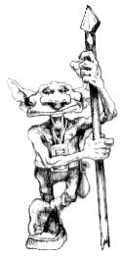

✶ GOBLINS 

Goblins vary in size although they are typically smaller than Orcs and usually smaller than a man. Goblins have quick, nimble fingers and small darting eyes and their teeth are tiny and very pointy. Goblins look rather thin and scrawny with gangly arms and have high pitched voices.

 | Goblin | Goblin Boss | Goblin  Big Boss | Goblin War Boss
Wounds | 2 | 6 | 12 | 20
Move | 4 | 4 | 4 | 4
Weapon Skill | 2 | 3 | 4 | 5
Ballistic Skill | 5+ | 3+ | 2+ | 1+
Strength | 3 | 4 | 4 | 4
Toughness | 3 | 3 (5) | 4 (6) | 4 (7)
Armour | - | 2 | 2 | 3
Initiative | 2 | 3 | 4 | 5
Attacks | 1 | 2 | 3 | 4
Damage | 1D6 | 1D6 | 1D6 | 2D6
Gold | 20 | 150 | 330 | 500

ENEMY’S WS 1 2 3 4 5 6 7 8 9 10
Goblin 3 4 4 4 5 5 6 6 6 6
Goblin Boss 2 3 4 4 4 4 5 5 5 6
Goblin Big Boss 2 3 3 4 4 4 4 4 5 5
Goblin War Boss 2 2 3 3 4 4 4 4 4 4

Goblin
Armed with [1-2] Bows (Str 1), [3-4] Spears (Fight in Ranks) or [5-6] Swords.

Goblin Boss
Magic Weapon.

Goblin Big Boss
Magic Resistance 6+ (Ring); Magic Weapon.

Goblin War Boss
Magic Item; Magic Resistance 5+ (Ring); Magic Weapon.
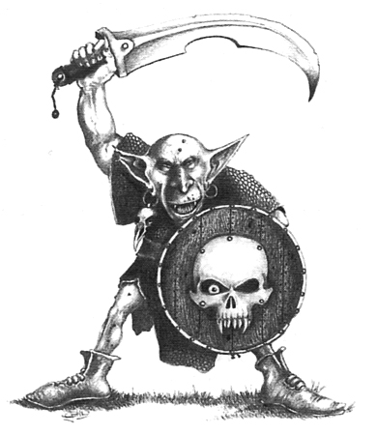
✶ GOBLIN DOOM DIVER 

Ever seeking new ways to kill their enemies, the Goblins have manufactured a devious weapon. A Goblin wears a set of wings that have been constructed for him out of animal hide, and a small helmet with a large pointy spike on top. He then launches himself from a small catapult and hopes he strikes his target. Of course, this means the probable death of the Goblin, but they don’t seem to mind.

 | Goblin Doom Diver
Wounds | 2
Move | 4
Weapon Skill | 2
Ballistic Skill | 5+
Strength | 3
Toughness | 3
Armour | -
Initiative | 2
Attacks | 1
Damage | 1D6
Gold | 60

ENEMY’S WS 1 2 3 4 5 6 7 8 9 10
Goblin Doom Diver 3 4 4 4 5 5 6 6 6 6

Goblin Doom Diver
Ambush, Magic A; Doom Diver Catapult.

Doom Diver Catapult
Treat the Goblin Doom Diver as a missile troop. A Goblin launches himself at the Warriors with the Doom Diver Catapult. Instead of rolling To Hit as normal the Goblin rolls 1D6 on the following table:

1-2 Miss
The Goblin sails way over the heads of all the Warriors and lands with a splat miles away. Obviously he takes no part in this combat - remove the model from the board. The Warriors receive no Gold or Treasure Cards for the Goblin Doom Diver.

3-4 Destroyed
The Goblin stretches the rubber catapult too far and it breaks in two. Remove the Goblin Doom Diver model from the game and replace it with a normal Goblin model.

5 Hit
Before the Warrior has time to move out of the way, the Goblin Doom Diver strikes him on the top of the head, knocking him Prone. The Warrior takes 1D6 + 5 Wounds damage, but with no modifiers for Armour unless the Warrior is wearing a helmet. After resolving the damage, remove the Goblin Doom Diver model from the table and replace it with a normal Goblin model adjacent to the Warrior.

6 Bounce
The Goblin hits the intended target and bounces up again. Resolve damage against the Warrior as in result 5 above and then choose another random Warrior. Roll on this table again to determine what the Goblin Doom Diver does, treating a 3 or 4 as a miss. The same Warrior can be struck multiple times.
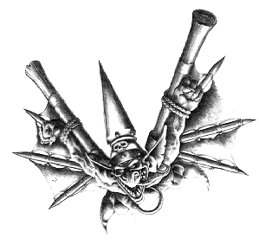
✶ GOBLIN SHAMANS 

Goblin Shamans practice a crude form of Orcish magic, drawing on the power of the Waaagh! generated by other Goblins around them.

 | Goblin Shaman | Goblin Shaman Champion | Master Goblin  Shaman | Goblin Shaman Lord
Wounds | 3 | 14 | 23 | 35
Move | 4 | 4 | 4 | 4
Weapon Skill | 2 | 2 | 2 | 2
Ballistic Skill | 4+ | 4+ | 4+ | 4+
Strength | 3 | 4 | 4 | 4
Toughness | 4 | 4 | 4 | 4
Armour | - | - | - | -
Initiative | 3 | 3 | 4 | 5
Attacks | 1 | 1 | 2 | 3
Damage | 1D6 | 1D6 | 1D6 | 2D6
Gold | 280 | 840 | 1600 | 2550

ENEMY’S WS 1 2 3 4 5 6 7 8 9 10
Goblin Shaman 3 4 4 4 5 5 6 6 6 6
Goblin Shaman Champion 3 4 4 4 5 5 6 6 6 6
Master Goblin Shaman 3 4 4 4 5 5 6 6 6 6
Goblin Shaman Lord 3 4 4 4 5 5 6 6 6 6

Goblin Shaman
Magic Resistance 5+ (Ring); Orc & Goblin Magic 1.

Goblin Shaman Champion
Magic Resistance 5+ (Ring); Magic Weapon; Orc & Goblin Magic 2.

Master Goblin Shaman
Magic Dispel 5+; Magic Item; Magic Resistance 4+ (Ring); Magic Weapon; Orc & Goblin Magic 3.

Goblin Shaman Lord
Magic Dispel 4+; Magic Item x 2; Magic Resistance 4+ (Ring); Magic Weapon; Orc & Goblin Magic 4.

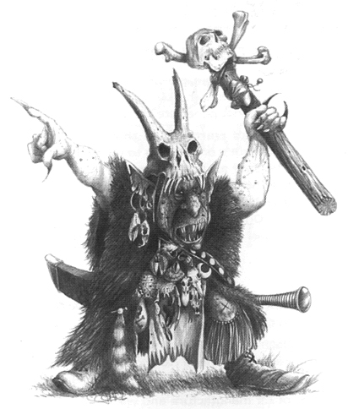
✶ FOREST GOBLINS 

Forest Goblins are more primitive than their Goblin cousins, and dress themselves with feathers and war paint. They are expert in riding spiders which they have especially bred for battle.

 | Forest Goblin | Forest Goblin Boss | Forest Goblin  Big Boss | Forest Goblin War Boss
Wounds | 2 | 5 | 10 | 20
Move | 4 | 4 | 4 | 4
Weapon Skill | 2 | 3 | 4 | 5
Ballistic Skill | 5+ | 3+ | 2+ | 1+
Strength | 3 | 4 | 4 | 4
Toughness | 3 | 3 | 4 | 4
Armour | - | - | - | -
Initiative | 2 | 3 | 4 | 5
Attacks | 1 | 2 | 3 | 4
Damage | 1D6 | 1D6 | 1D6 | 2D6
Gold | 20 | 150 | 330 | 500

ENEMY’S WS 1 2 3 4 5 6 7 8 9 10
Forest Goblin 3 4 4 4 5 5 6 6 6 6
Forest Goblin Boss 2 3 4 4 4 4 5 5 5 6
Forest Goblin Big Boss 2 3 3 4 4 4 4 4 5 5
Forest Goblin War Boss 2 2 3 3 4 4 4 4 4 4

Forest Goblin
Armed with [1-2] Bows (Str 1), [3-4] Spears (Fight in Ranks) or [5-6] Swords; Tattoos 6+.

Forest Goblin Boss
Magic Weapon; Tattoos 6+.

Forest Goblin Big Boss
Magic Resistance 6+ (Ring); Magic Weapon; Tattoos 5+.

Forest Goblin War Boss
Magic Item; Magic Resistance 5+ (Ring); Magic Weapon; Tattoos 5+.

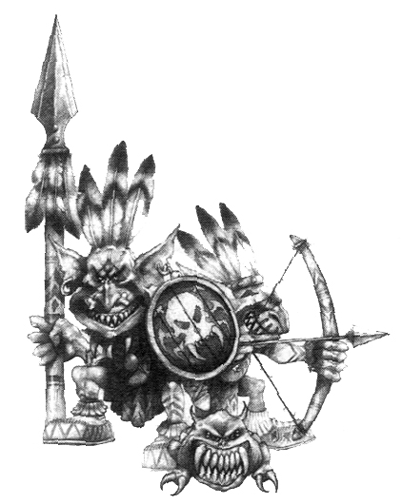
✶ FOREST GOBLIN SHAMANS 

Forest Goblin Shamans keep small poisonous spiders in their mouths. These bite the Shaman on the tongue so that his body is constantly flooded with an intoxicating poison. This drives the Shaman mad, but also stimulates the part of the brain which controls magic.

 | Forest Goblin Shaman | Forest Goblin Shaman Champion | Master Forest Goblin  Shaman | Forest Goblin Shaman Lord
Wounds | 3 | 12 | 20 | 31
Move | 4 | 4 | 4 | 4
Weapon Skill | 2 | 2 | 2 | 2
Ballistic Skill | 4+ | 4+ | 4+ | 4+
Strength | 3 | 4 | 4 | 4
Toughness | 4 | 4 | 4 | 4
Armour | - | - | - | -
Initiative | 3 | 3 | 4 | 5
Attacks | 1 | 1 | 2 | 3
Damage | 1D6 | 1D6 | 1D6 | 2D6
Gold | 280 | 840 | 1600 | 2550

ENEMY’S WS 1 2 3 4 5 6 7 8 9 10
Forest Goblin Shaman 3 4 4 4 5 5 6 6 6 6
For. Gob. Sham. Champion 3 4 4 4 5 5 6 6 6 6
Master Forest Goblin Shaman 3 4 4 4 5 5 6 6 6 6
Forest Goblin Shaman Lord 3 4 4 4 5 5 6 6 6 6

Forest Goblin Shaman
Orc & Goblin Magic 1; Tattoos 5+.

Forest Goblin Shaman Champion
Magic Weapon; Orc & Goblin Magic 2; Tattoos 5+.

Master Forest Goblin Shaman
Magic Dispel 5+; Magic Item; Magic Weapon; Orc & Goblin Magic 3; Tattoos 4+.

Forest Goblin Shaman Lord
Magic Dispel 4+; Magic Item x 2; Magic Weapon; Orc & Goblin Magic 4; Tattoos 4+.

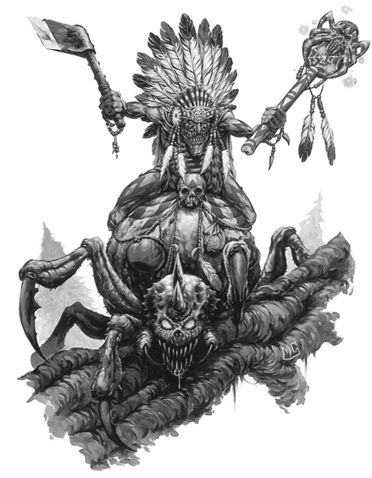
✶ GREAT SPIDER 

Forest Goblins have bred enormous Spiders especially for riding. These spiders are known as Great Spiders. They are larger than Giant Spiders, but much smaller than a Gigantic Spider.

 | Great Spider
Wounds | 10
Move | 7
Weapon Skill | 3
Ballistic Skill | -
Strength | 2
Toughness | 3
Armour | -
Initiative | 1
Attacks | 1
Damage | Special
Gold | 40

ENEMY’S WS 1 2 3 4 5 6 7 8 9 10
Great Spider 2 3 4 4 4 4 5 5 5 6

Great Spider
Web 1D3+1.

Great Spiders can be ridden by any Forest Goblins and Forest Goblin Shamans.

Great Spiders will always be encountered with a rider.

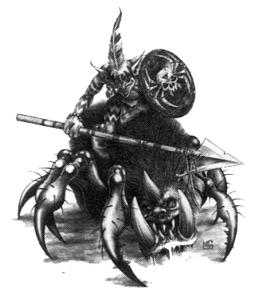

✶ NIGHT GOBLINS 

Night Goblins have adapted to life underground where they survive on fungi, Cave Squigs, beetles and bits of each other. They live underneath the mountains of the Old World in cool, dark caverns and tunnels.

 | Night Goblin | Night Goblin Boss | Night Goblin  Big Boss | Night Goblin War Boss
Wounds | 2 | 5 | 10 | 18
Move | 4 | 4 | 4 | 4
Weapon Skill | 2 | 3 | 4 | 5
Ballistic Skill | 5+ | 3+ | 2+ | 1+
Strength | 3 | 4 | 4 | 4
Toughness | 3 | 3 (5) | 4 (6) | 4 (7)
Armour | - | 2 | 2 | 3
Initiative | 2 | 3 | 4 | 5
Attacks | 1 | 2 | 3 | 4
Damage | 1D6 | 1D6 | 1D6 | 2D6
Gold | 20 | 150 | 330 | 500

ENEMY’S WS 1 2 3 4 5 6 7 8 9 10
Night Goblin 3 4 4 4 5 5 6 6 6 6
Night Goblin Boss 2 3 4 4 4 4 5 5 5 6
Night Goblin Big Boss 2 3 3 4 4 4 4 4 5 5
Night Goblin War Boss 2 2 3 3 4 4 4 4 4 4

Night Goblin
Armed with [1-2] Bows (Str 1), [3-4] Spears (Fight in Ranks) or [5-6] Swords.

Night Goblin Boss
Magic Weapon.

Night Goblin Big Boss
Magic Resistance 6+ (Ring); Magic Weapon.

Night Goblin War Boss
Magic Item; Magic Resistance 5+ (Ring); Magic Weapon.

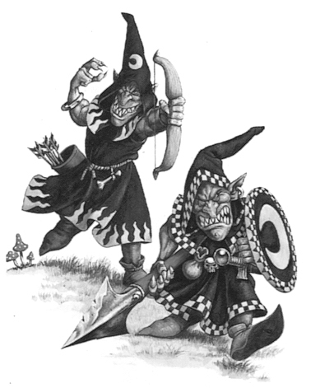
NIGHT GOBLIN
SQUIG HUNTERS

The Goblins that live in the caves and tunnels under the Worlds Edge Mountains hunt the wild Squigs that also live there. When trained (and even if they’re not!) the Squigs are used as guard dogs or herded into battle.

 | Night Goblin Squig Hunter | Trained Cave Squig
Wounds | 2 | 3
Move | 4 | 6
Weapon Skill | 2 | 4
Ballistic Skill | 5+ | -
Strength | 3 | 5
Toughness | 3 | 3
Armour | - | -
Initiative | 2 | 5
Attacks | 1 | 2
Damage | 1D6 | 1D6
Gold | 20 | 200

ENEMY’S WS 1 2 3 4 5 6 7 8 9 10
Night Goblin Squig Hunter 3 4 4 4 5 5 6 6 6 6
Trained Cave Squig 2 3 3 4 4 4 4 4 5 5

Night Goblin Squig Hunter
Herd Squigs.

Trained Cave Squig
Never Pinned.

Herd Squigs
Being rather vicious creatures, each Squig requires two Night Goblin Squig Hunters to control it, moving it forward with a long pointed stick called a ‘prodder’. When placing Night Goblin Squig Hunters and Squigs on the board, place one Squig on the board first, then the two Squig Hunters that mind it, then a second Squig and its two minders and so on. Each Squig Hunter in the team is a normal Night Goblin, but they must move as a pair and remain in adjacent squares. To keep control of their Squig both members of the team must be present on the same board section as the Squig. As long as there are two Squig Hunters for every Squig on the board section, the Squigs never fall asleep and only attack another Squig on a natural roll of a 6. If there are not enough Squig Hunters to control a Squig it becomes wild. Together, the two Squig Hunters make one combined attack each turn with their prodder for 2D6 + Strength damage. If one of the Squig Hunters is killed the remaining one will make a normal attack.

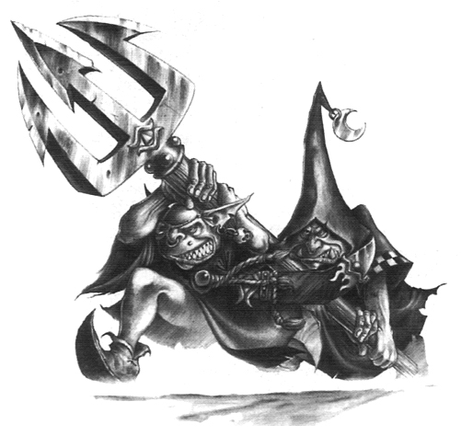

✶ NIGHT GOBLIN
NETTERS AND CLUBBERS 

 | Night Goblin Netter | Night Goblin  Clubber
Wounds | 2 | 2
Move | 4 | 4
Weapon Skill | 2 | 2
Ballistic Skill | 5+ | 5+
Strength | 3 | 3
Toughness | 3 | 3
Armour | - | -
Initiative | 2 | 2
Attacks | 1 | 1
Damage | 1D6 | 1D6
Gold | 35 | 35

ENEMY’S WS 1 2 3 4 5 6 7 8 9 10
Night Goblin Netter 3 4 4 4 5 5 6 6 6 6
Night Goblin Clubber 3 4 4 4 5 5 6 6 6 6

Night Goblin Netter
Netter and Clubber.

Night Goblin Clubber
Netter and Clubber.

Netter and Clubber
Night Goblin Netters and Clubbers are placed in pairs. The Netters will attack first - roll To Hit as normal. If the net hits, the Warrior is caught and can do nothing until he breaks free. Place a Netted counter next to him. The Clubbers then attack, and if they are attacking a netted Warrior they add +2 to their To Hit roll. Any Monster attacking a netted Warrior can add +2 to his To Hit roll. At the start of each Warriors’ Phase netted Warriors may try to get free. Each netted Warrior must roll 1D6 + Strength and score 7 or more to break free. Once he has broken out of the net, a Warrior can move and attack as normal. Warriors who don’t manage to break free must wait until the next Warriors’ Phase and try again. If there is no one for a Netter to net he will whip out his club and smack someone with it instead. If there are no Netters left the Clubbers will just attack normally with their clubs.

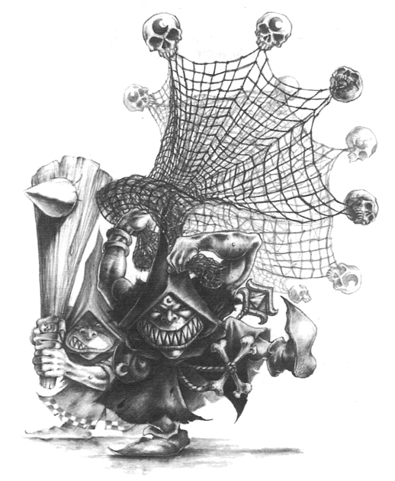
✶ NIGHT GOBLIN FANATIC 

Night Goblins cultivate many kinds of toxic fungi in their dark caves. One particular variety known as the Mad Cap Mushroom is much valued for its hallucinogenic properties. During battle, Night Goblin Fanatics gobble down handfuls of these mushrooms to turn them into whirling green killing machines. The Goblins become impervious to pain, almost completely unaware of their environment, hugely strong, and completely fearless.

 | Night Goblin Fanatic
Wounds | 2
Move | 4
Weapon Skill | 2
Ballistic Skill | 5+
Strength | 3
Toughness | 3
Armour | -
Initiative | 2
Attacks | 1
Damage | Special
Gold | 300

ENEMY’S WS 1 2 3 4 5 6 7 8 9 10
Night Goblin Fanatic 3 4 4 4 5 5 6 6 6 6

Night Goblin Fanatic
Armed with Ball and Chain; Never Pinned.

Ball and Chain
The ball and chain is swung around the Goblin’s head and is a danger to all Warriors standing nearby and, unfortunately, to the Goblin himself. Place each Fanatic as close to as many Warriors as possible. Fanatics attack immediately they are placed. All Warriors adjacent to a Night Goblin Fanatic automatically take 1D6 + 3 Wounds with no modifier for armour. However, if the damage roll is a natural 1 the Fanatic has also managed to strangle himself with his own ball and chain and is killed. At the beginning of each Monsters’ Phase, the Fanatic will move up to 4 squares and attempt to get as close to as many Warriors as possible to attack them with his ball and chain.

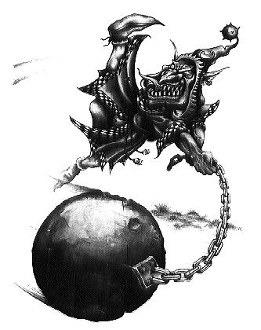
✶ NIGHT GOBLIN SHAMANS 

Night Goblin Shamans are very similar to Goblin Shamans although slightly weaker. They get their power from eating special magic mushrooms that tap into the power of the Orc and Goblin Gods - Mork and Gork.

 | Night Goblin Shaman | Night Goblin Shaman Champion | Master Night Goblin  Shaman | Night Goblin Shaman Lord
Wounds | 3 | 12 | 20 | 31
Move | 4 | 4 | 4 | 4
Weapon Skill | 2 | 2 | 2 | 2
Ballistic Skill | 4+ | 4+ | 4+ | 4+
Strength | 3 | 4 | 4 | 4
Toughness | 4 | 4 | 4 | 4
Armour | - | - | - | -
Initiative | 3 | 3 | 4 | 5
Attacks | 1 | 1 | 2 | 3
Damage | 1D6 | 1D6 | 1D6 | 2D6
Gold | 280 | 830 | 1590 | 2530

ENEMY’S WS 1 2 3 4 5 6 7 8 9 10
Night Goblin Shaman 3 4 4 4 5 5 6 6 6 6
Night Goblin Shaman Champion 3 4 4 4 5 5 6 6 6 6
Master Night Goblin Shaman 3 4 4 4 5 5 6 6 6 6
Night Goblin Shaman Lord 3 4 4 4 5 5 6 6 6 6

Night Goblin Shaman
Magic Resistance 5+ (Ring); Orc & Goblin Magic 1.

Night Goblin Shaman Champion
Magic Resistance 5+ (Ring); Magic Weapon; Orc & Goblin Magic 2.

Master Night Goblin Shaman
Magic Dispel 5+; Magic Item; Magic Resistance 4+ (Ring); Magic Weapon; Orc & Goblin Magic 3.

Night Goblin Shaman Lord
Magic Dispel 4+; Magic Item x 2; Magic Resistance 4+ (Ring); Magic Weapon; Orc & Goblin Magic 4.

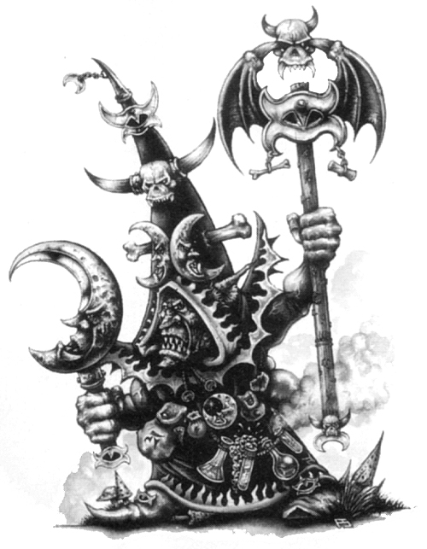
✶ GREAT WOLF 

Great Wolves are about the size of a small pony and very fierce, so not many Goblins wish to ride them. Those that do, however, are looked upon with respect by the rest of the Goblin community - that is, until the Great Wolf decides to eat them!

 | Great Wolf
Wounds | 6
Move | 9
Weapon Skill | 4
Ballistic Skill | -
Strength | 3
Toughness | 3
Armour | -
Initiative | 3
Attacks | 1
Damage | 1D6
Gold | 100

ENEMY’S WS 1 2 3 4 5 6 7 8 9 10
Great Wolf 2 3 3 4 4 4 4 4 5 5

Great Wolf
Frenzy 6+.

Great Wolves can be ridden by any Goblins, Goblin Shamans, Night Goblins, Night Goblin Shamans or Hobgoblins.
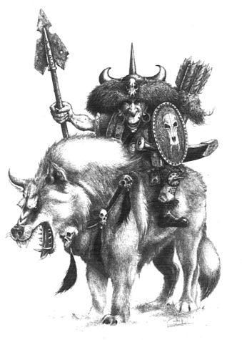

✶ SQUIG HOUND 

A Squig Hound is slightly larger than a normal Cave Squig and walks on four legs. It has a tendency to follow an Orc or Goblin around thinking that they are his master. Although Orcs and Goblins don’t usually want the Squig Hound pestering them, a Squig Hound is a good form of protection and will attack anyone who threatens his master.

 | Squig Hound
Wounds | 6
Move | 5
Weapon Skill | 4
Ballistic Skill | -
Strength | 6
Toughness | 4
Armour | -
Initiative | 5
Attacks | 2
Damage | 1D6
Gold | 350

ENEMY’S WS 1 2 3 4 5 6 7 8 9 10
Squig Hound 2 3 3 4 4 4 4 4 5 5

Squig Hound
Fear 4; Never Pinned.

✶ CAVE SQUIGS 

Part fungus and part flesh, these strange ferocious creatures are almost all teeth, easily able to take a man’s leg off with a single bite.

 | Wild Cave Squig | Trained Cave Squig | Hopping Cave Squig
Wounds | 3 | 3 | 10
Move | 6 | 6 | 2D6
Weapon Skill | 4 | 4 | 4
Ballistic Skill | - | - | -
Strength | 5 | 5 | 5
Toughness | 3 | 3 | 3
Armour | - | - | -
Initiative | 5 | 5 | 5
Attacks | 2 | 2 | 2
Damage | 1D6 | 1D6 | 1D6
Gold | 200 | 200 | 230

ENEMY’S WS 1 2 3 4 5 6 7 8 9 10
Wild Cave Squig 2 3 3 4 4 4 4 4 5 5
Trained Cave Squig 2 3 3 4 4 4 4 4 5 5
Hopping Cave Squig 2 3 3 4 4 4 4 4 5 5

Wild Cave Squig
Never Pinned; Wild Squig Attack.

Trained Cave Squig
Never Pinned.

Hopping Cave Squig
Bounce; Never Pinned.

Wild Squig Attack
At the start of the phase during which they appear, and each Monsters’ Phase thereafter, roll 1D6 for each Wild Squig. On a score of 1 the Squig falls asleep and does nothing this turn. On a score of 2-4 it immediately moves and attacks a random Warrior. On a score of 5-6 the Squig bounds off and immediately attacks the nearest Monster. If there is more than one potential target determine a Monster at random.

Hopping Cave Squigs can be ridden by any Night Goblins.

Hopping Cave Squigs will always be encountered with a rider.
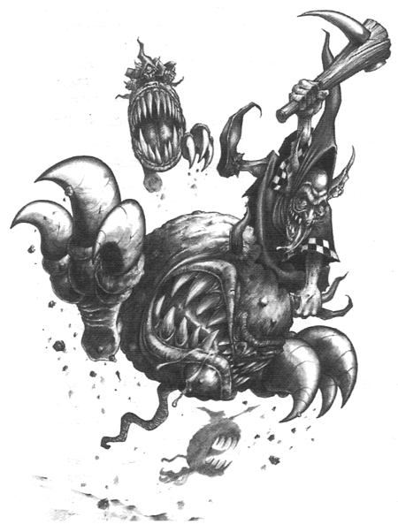
✶ HOBGOBLINS 

Hobgoblins are close relatives of the other green-skinned races, but are quite distinctive in appearance, being taller than Goblins yet not as burly as Orcs. They are extremely cowardly and sneaky and are often found in the employ of Chaos Dwarfs.

 | Hobgoblin | Hobgoblin Champion | Hobgoblin Boss | Hobgoblin Chieftain
Wounds | 4 | 16 | 25 | 33
Move | 4 | 4 | 4 | 4
Weapon Skill | 3 | 4 | 5 | 6
Ballistic Skill | 4+ | 3+ | 2+ | 1+
Strength | 3 | 4 | 4 | 4
Toughness | 3 (4) | 3 (4) | 4 (6) | 4 (6)
Armour | 1 | 1 | 2 | 2
Initiative | 2 | 3 | 4 | 5
Attacks | 1 | 2 | 3 | 4
Damage | 1D6 | 1D6 | 2D6 | 2D6
Gold | 50 | 200 | 500 | 800

ENEMY’S WS 1 2 3 4 5 6 7 8 9 10
Hobgoblin 2 3 4 4 4 4 5 5 5 6
Hobgoblin Champion 2 3 3 4 4 4 4 4 5 5
Hobgoblin Boss 2 2 3 3 4 4 4 4 4 4
Hobgoblin Chieftain 2 2 3 3 3 4 4 4 4 4

Hobgoblin
Ambush, Magic A; Armed with [1-3] Bows (Str 3) or [4-6] Axes; Break.

Hobgoblin Champion
Ambush, Magic A; Magic Item; Magic Weapon.

Hobgoblin Boss
Ambush, Magic A; Magic Armour; Magic Item; Magic Weapon.

Hobgoblin Chieftain
Ambush, Magic A; Magic Armour; Magic Item x 2; Magic Weapon.

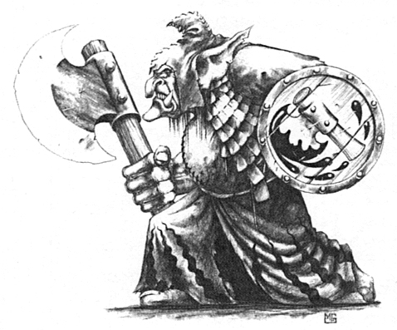
✶ HOBGOBLIN SNEAKY GITS

Sneaky Gits fight in battle with two long curved knives. These weapons are ideally suited to murdering victims while they sleep - the Hobgoblins favourite tactic. If they have to fight conscious foes however, they prefer to gang up on them in overwhelming numbers.

 | Hobgoblin Sneaky Git | Hobgoblin  Sneaky Git Champion
Wounds | 4 | 16
Move | 4 | 4
Weapon Skill | 3 | 4
Ballistic Skill | 4+ | 3+
Strength | 3 | 4
Toughness | 3 | 3
Armour | - | -
Initiative | 2 | 3
Attacks | 1 (2) | 2 (3)
Damage | 1D6 | 1D6
Gold | 50 | 200

ENEMY’S WS 1 2 3 4 5 6 7 8 9 10
Hobgoblin Sneaky Git 2 3 4 4 4 4 5 5 5 6
Hob. Sneaky Git Champion 2 3 3 4 4 4 4 4 5 5

Hobgoblin Sneaky Git
Ambush, Magic A; Armed with Curved Daggers; Break; Gang Up.

Hobgoblin Sneaky Git Champion
Ambush, Magic A; Armed with Curved Daggers; Gang Up; Magic Item.

Curved Daggers
Hobgoblin Sneaky Gits are armed with two long curved daggers - one in each hand. This gives them an extra Attack if their first Attack hits.

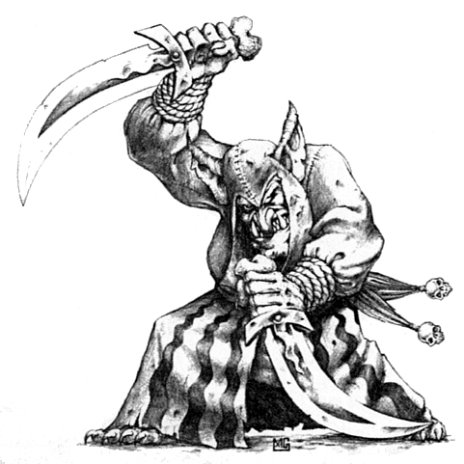
✶ ORCS 

Orcs vary in height and physical appearance more than humans - some are no taller than a man but most are substantially larger. They are also much broader than humans, with big deep chests, massive shoulders and powerfully muscled arms. Orcs have large heads with huge jaws but they have tiny foreheads behind which lurk a thick skull and a little brain.

 | Orc | Orc Boss | Orc  Big Boss | Orc War Boss
Wounds | 3 | 18 | 25 | 33
Move | 4 | 4 | 4 | 4
Weapon Skill | 3 | 4 | 5 | 6
Ballistic Skill | 4+ | 3+ | 2+ | 1+
Strength | 3 | 4 | 4 | 4
Toughness | 4 | 4 (6) | 5 (8) | 5 (8)
Armour | - | 2 | 3 | 3
Initiative | 2 | 3 | 4 | 5
Attacks | 1 | 2 | 3 | 4
Damage | 1D6 | 2D6 | 2D6 | 2D6/3D6 (5+)
Gold | 55 | 330 | 720 | 1100

ENEMY’S WS 1 2 3 4 5 6 7 8 9 10
Orc 2 3 4 4 4 4 5 5 5 6
Orc Boss 2 3 3 4 4 4 4 4 5 5
Orc Big Boss 2 2 3 3 4 4 4 4 4 4
Orc War Boss 2 2 3 3 3 4 4 4 4 4

Orc
Armed with [1-2] Bows (Str 3) [3-4] Spears (Fight in Ranks) or [5-6] Swords.

Orc Boss
Magic Weapon.

Orc Big Boss
Ignore Blows 6+; Magic Armour; Magic Weapon.

Orc War Boss
Ignore Blows 5+; Magic Armour; Magic Item x 2; Magic Weapon.

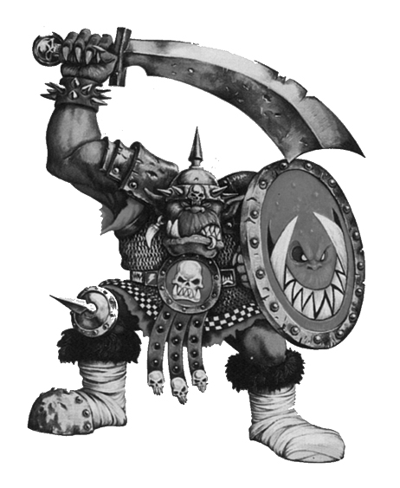

✶ ORC BIG ‘UNS 

Orc Big ‘Uns were once normal sized Orcs, but for some reason continued to grow until they were big and powerful.

 | Orc Big ‘Un
Wounds | 5
Move | 4
Weapon Skill | 4
Ballistic Skill | 4+
Strength | 4
Toughness | 4 (5)
Armour | 1
Initiative | 3
Attacks | 1
Damage | 1D6
Gold | 65

ENEMY’S WS 1 2 3 4 5 6 7 8 9 10
Orc Big ‘Un 2 3 3 4 4 4 4 4 5 5

Orc Big Un
-
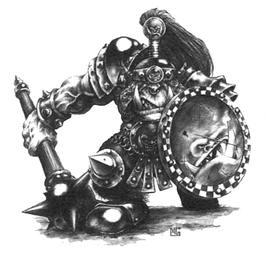

✶ ORC SHAMANS 

Orc Shamans are more powerful than their Goblin cousins, soaking up the psychic energy of the greenskins around them to create raw Waaagh! Magic to hurl at their foes.

 | Orc Shaman | Orc Shaman Champion | Master Orc Shaman | Orc Shaman Lord
Wounds | 16 | 20 | 30 | 42
Move | 4 | 4 | 4 | 4
Weapon Skill | 3 | 3 | 3 | 3
Ballistic Skill | 5+ | 5+ | 4+ | 4+
Strength | 3 | 4 | 4 | 4
Toughness | 5 | 5 | 5 | 5
Armour | - | - | - | -
Initiative | 3 | 3 | 4 | 5
Attacks | 1 | 1 | 2 | 3
Damage | 1D6 | 1D6/2D6 (5+) | 2D6 | 2D6/3D6 (5+)
Gold | 590 | 1180 | 2000 | 2870

ENEMY’S WS 1 2 3 4 5 6 7 8 9 10
Orc Shaman 2 3 4 4 4 4 5 5 5 6
Orc Shaman Champion 2 3 4 4 4 4 5 5 5 6
Master Orc Shaman 2 3 4 4 4 4 5 5 5 6
Orc Shaman Lord 2 3 4 4 4 4 5 5 5 6

Orc Shaman
Magic Resistance 6+; Magic Weapon; Orc & Goblin Magic 1.

Orc Shaman Champion
Magic Resistance 5+; Magic Weapon; Orc & Goblin Magic 2.

Master Orc Shaman
Magic Dispel 6+; Magic Item; Magic Resistance 5+; Magic Weapon; Orc & Goblin Magic 3.

Orc Shaman Lord
Magic Dispel 5+; Magic Item x 2; Magic Resistance 4+; Magic Weapon; Orc & Goblin Magic 4.

✶ SAVAGE ORCS 

Savage Orcs are more primitive than other Orcs, due to the addling effect of heat and strong sunlight on the Orcish brain. They dress in furs and skins, and decorate their bodies with tattoos and lucky charms.

 | Savage Orc | Savage Orc Boss | Savage Orc  Big Boss | Savage Orc War Boss
Wounds | 5 | 20 | 27 | 35
Move | 4 | 4 | 4 | 4
Weapon Skill | 3 | 4 | 5 | 6
Ballistic Skill | 4+ | 3+ | 2+ | 1+
Strength | 3 | 4 | 4 | 4
Toughness | 4 | 4 | 5 | 5
Armour | - | - | - | -
Initiative | 2 | 3 | 4 | 5
Attacks | 1 | 2 | 3 | 4
Damage | 1D6 | 2D6 | 2D6 | 2D6/3D6 (5+)
Gold | 65 | 360 | 750 | 1150

ENEMY’S WS 1 2 3 4 5 6 7 8 9 10
Savage Orc 2 3 4 4 4 4 5 5 5 6
Savage Orc Boss 2 3 3 4 4 4 4 4 5 5
Savage Orc Big Boss 2 2 3 3 4 4 4 4 4 4
Savage Orc War Boss 2 2 3 3 3 4 4 4 4 4

Savage Orc
Armed with [1-2] Bows (Str 4) [3-4] Spears (Fight in Ranks) or [5-6] Clubs; Tattoos 6+.

Savage Orc Boss
Magic Weapon; Tattoos 6+.

Savage Orc Big Boss
Ignore Blows 6+; Magic Item; Magic Weapon; Tattoos 5+.

Savage Orc War Boss
Ignore Blows 5+; Magic Item x 2; Magic Weapon; Tattoos 4+.

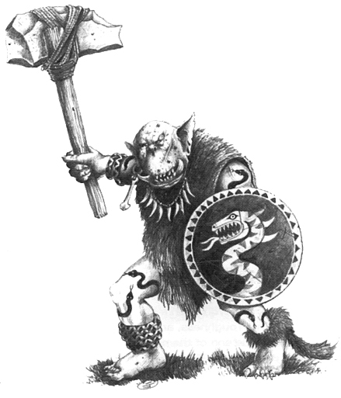
✶ SAVAGE ORC SHAMANS 

Savage Orc Shamans are more primitive than normal Orc Shamans. They are close to nature, making them good Shamans. The majority of Savage Orc Shamans are wildly deranged and unstable individuals.

 | Savage Orc Shaman | Savage Orc Shaman Champion | Master Savage Orc Shaman | Savage Orc Shaman Lord
Wounds | 18 | 22 | 32 | 45
Move | 4 | 4 | 4 | 4
Weapon Skill | 3 | 3 | 3 | 3
Ballistic Skill | 5+ | 5+ | 4+ | 4+
Strength | 3 | 4 | 4 | 4
Toughness | 5 | 5 | 5 | 5
Armour | - | - | - | -
Initiative | 3 | 3 | 4 | 5
Attacks | 1 | 1 | 2 | 3
Damage | 1D6 | 1D6/2D6 (5+) | 2D6 | 2D6/3D6 (5+)
Gold | 600 | 1200 | 2050 | 2920

ENEMY’S WS 1 2 3 4 5 6 7 8 9 10
Savage Orc Shaman 2 3 4 4 4 4 5 5 5 6
Savage Orc Shaman Champion 2 3 4 4 4 4 5 5 5 6
Master Savage Orc Shaman 2 3 4 4 4 4 5 5 5 6
Savage Orc Shaman Lord 2 3 4 4 4 4 5 5 5 6

Savage Orc Shaman
Magic Resistance 6+; Magic Weapon; Orc & Goblin Magic 1; Tattoos 6+.

Savage Orc Shaman Champion
Magic Resistance 5+; Magic Weapon; Orc & Goblin Magic 2; Tattoos 6+.

Master Savage Orc Shaman
Magic Dispel 6+; Magic Item; Magic Resistance 5+; Magic Weapon; Orc & Goblin Magic 3; Tattoos 5+.

Savage Orc Shaman Lord
Magic Dispel 5+; Magic Item x 2; Magic Resistance 4+; Magic Weapon; Orc & Goblin Magic 4; Tattoos 4+.

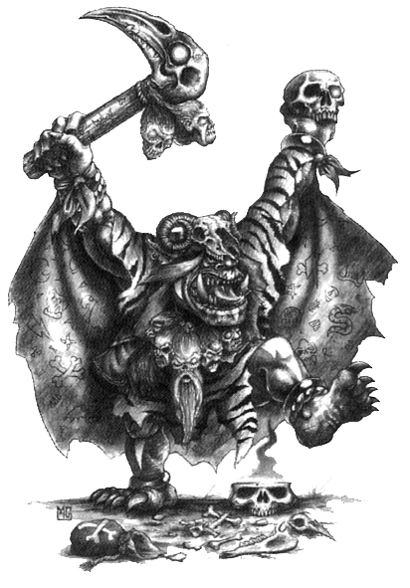

✶ BLACK ORCS 

Black Orcs are the biggest and strongest of all Orcs. They are the most powerful, disciplined warriors, and regard all other Orcs and Goblins as puny weaklings.

 | Black Orc | Black Orc  Boss | Black Orc Big Boss | Black Orc War Boss
Wounds | 7 | 22 | 31 | 41
Move | 4 | 4 | 4 | 4
Weapon Skill | 4 | 5 | 6 | 6
Ballistic Skill | 4+ | 3+ | 2+ | 2+
Strength | 4 | 5 | 5 | 5
Toughness | 4 (5) | 5 (7) | 5 (8) | 6 (9)
Armour | 1 | 2 | 3 | 3
Initiative | 2 | 3 | 4 | 4
Attacks | 1 | 2 | 3 | 4
Damage | 1D6 | 2D6 | 2D6 | 3D6
Gold | 90 | 420 | 910 | 1300

ENEMY’S WS 1 2 3 4 5 6 7 8 9 10
Black Orc 2 3 3 4 4 4 4 4 5 5
Black Orc Boss 2 3 3 4 4 4 4 4 5 5
Black Orc Big Boss 2 2 3 3 4 4 4 4 4 4
Black Orc War Boss 2 2 3 3 3 4 4 4 4 4

Black Orc
-

Black Orc Boss
Magic Weapon.

Black Orc Big Boss
Ignore Blows 6+; Magic Armour; Magic Weapon.

Black Orc War Boss
Ignore Blows 5+; Magic Armour; Magic Item x 2; Magic Weapon.

✶ WAR BOAR 

Orcs have bread a special breed of Boar designed for fighting called the War Boar. War Boars are incredibly vicious, with long sharp tusks that can rip a Warrior to shreds.

 | War Boar
Wounds | 12
Move | 7
Weapon Skill | 4
Ballistic Skill | -
Strength | 3
Toughness | 4
Armour | -
Initiative | 3
Attacks | 1
Damage | 1D6
Gold | 110

ENEMY’S WS 1 2 3 4 5 6 7 8 9 10
War Boar 2 3 3 4 4 4 4 4 5 5

War Boar
Impale.

War Boars can be ridden by any Orcs, Orc Shamans, Savage Orcs or Savage Orc Shamans.

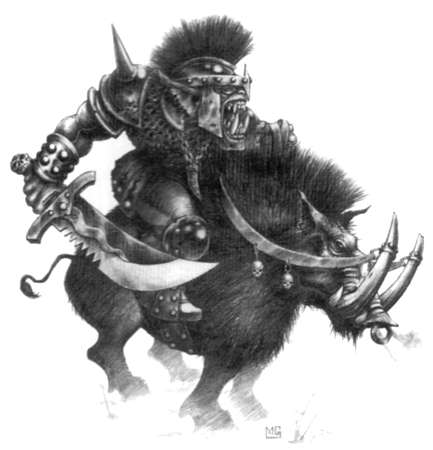
✶ SPEAR CHUKKA 

The Spear Chukka is of Goblin construction. It consists of all manner of pieces of wood and metal crudely thrown together. It shoots large and very heavy spears into the enemy.

 | Spear Chukka
Wounds | 14
Move | -
Weapon Skill | 1
Ballistic Skill | -
Strength | 5
Toughness | 4
Armour | -
Initiative | -
Attacks | 1
Damage | 2D6
Gold | 180

Spear Chukka
Bolt Thrower.

Spear Chukkas can be operated by any Goblins.

✶ BOLT THROWER 

The Bolt Thrower is a huge crudely constructed crossbow on a wooden frame. It shoots incredibly thick bolts with sharp blades on the end into the enemy.

 | Bolt Thrower
Wounds | 20
Move | -
Weapon Skill | 1
Ballistic Skill | -
Strength | 10
Toughness | 5
Armour | -
Initiative | -
Attacks | 1
Damage | 2D6
Gold | 250

Bolt Thrower
Bolt Thrower.

Bolt Throwers can be operated by any Orcs or Hobgoblins.

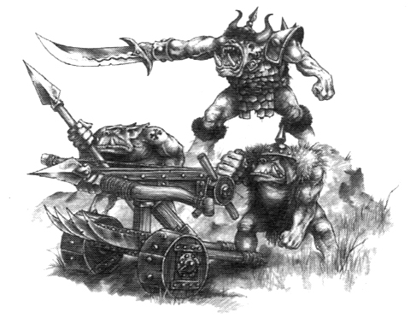
✶ ORC WAR WYVERN 

Wyverns are similar in appearance to dragons, though they are longer and more sinuous and do not have front limbs. Their tails are barbed and have a sharp deadly sting on the end. Orcs have somehow managed to control these beasts and ride them into combat, making them a formidable beast.

 | Wyvern
Wounds | 50
Move | 6
Weapon Skill | 5
Ballistic Skill | -
Strength | 5
Toughness | 6 (9)
Armour | 3
Initiative | 5
Attacks | 3
Damage | 3D6/4D6 (5+)
Gold | 1850

ENEMY’S WS 1 2 3 4 5 6 7 8 9 10
Orc War Wyvern 2 2 3 3 4 4 4 4 4 4

Orc War Wyvern
Drag and Rend; Fly; Ignore Blows 5+; Ignore Pain 6; Large Monster; Never Pinned; Sting (3D6); Terror 10.
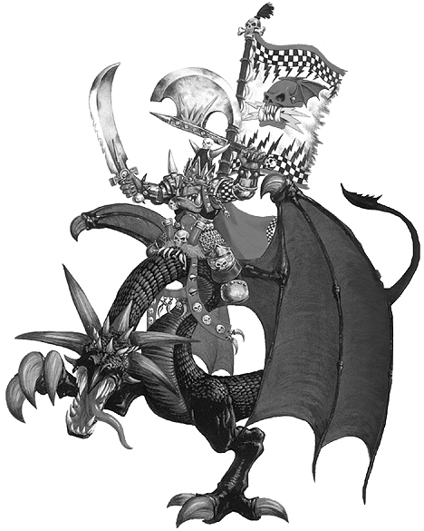

Drag and Rend
At the start of each turn draw a Warrior counter to determine which Warrior the Wyvern attacks. The Wyvern stretches out its long neck and attempts to ensnare and drag him near. The Wyvern makes a normal To Hit roll. If it succeeds it doesn’t cause any damage, but instead has clutched the Warrior and dragged him. That model is immediately moved to the nearest adjacent square to the Wyvern, moving other models out of the way as necessary. All of the Wyvern’s Attacks are then carried out against the captured Warrior as normal. If 2 or more of these remaining Attacks hit home, the Warrior has been stung. Note that the Warrior may only attempt to dodge the initial grab and not any subsequent Attacks.

Orc War Wyverns can be ridden by any Orcs or Orc Shamans.

Orc War Wyverns will always be encountered with a rider.

Orc & Goblin Magic
Orc and Goblin Shamans specialise in casting Orc & Goblin Magic. To see what spell the Orc Shaman or Goblin Shaman casts when given the chance, roll 2D6 on the following table. Goblin Shamans are not as skilled in casting spells so roll 1D6 before casting each one. On a roll of 1 the Goblin Shaman cannot remember the words and fails to cast the spell. If the Shaman is killed while he still has active spells on the board, they will immediately be dispelled.

2 FAILURE
The Shaman fails to cast a spell.

3 ‘ERE WE GO
The Shaman floods his allies with power. All Orcs and Goblins on the board get +1 Attack this turn and +1 Toughness next turn.

4 WAAAGH!
Roll 2D6 for each Warrior spellcaster on the board. If the score is equal to or greater than the Warrior’s Battle Level he is knocked to the ground for 1 turn, during which time he may do nothing and is counted as being Prone. If the Warrior is Prone and is targeted then he remains on the ground for another turn.

5 BRAIN BURSTA
A bolt of power erupts from the Shaman’s head. Draw a Warrior counter to determine which Warrior is targeted. Roll 2D6. If the score is greater than the target’s Battle Level he is hit - roll 1D6:

1 The Warrior’s head explodes, killing him instantly. He may not be resurrected.

2-5 The Warrior suffers (2 x Dungeon Level) Wounds with no modifiers for Toughness or armour.

6 The Warrior suffers 1D6 Wounds with no modifiers for Toughness or armour.

6 HAND OF GORK
This spell moves the Shaman and any allied Monsters using missile weapons out of hand to hand combat with the Warriors. Move the Monsters so that they are no longer adjacent to the Warriors, moving other Monsters out of the way to make room if necessary. If the Shaman is not in hand to hand combat re-roll this result.

7 FIST OF GORK
The Shaman’s arms become enwrapped with glowing bands of power. Draw a Warrior counter to determine which Warrior is targeted. That Warrior suffers 1D6 hits at (Shaman’s Strength +4).

8 DA KRUNCH
One of the Warriors is stamped on by the mighty foot of Gork. Draw a Warrior counter to determine which Warrior is targeted. That Warrior suffers 1D6+10 Wounds.

9 MORK SAVE UZ!
Roll 1D6 for each spellcasting Warrior. On a roll of 4-6 all of that Warriors’ remaining points of Power are lost this turn. This does not affect any innate stored power. If there are no spellcasters in the party then re-roll this spell.

10 ‘EADBUTT
The Shaman magically ‘eadbutts one of the Warrior spellcasters. If there is more than one spellcaster, draw a Warrior counter to determine which Warrior is targeted. Roll (1D6 + Dungeon Level) for the Shaman and (1D6 + Battle Level) for the target. If the Shaman wins or it is a draw add the two dice together. The target takes that many Wounds with no modifiers for Toughness or armour and cannot cast any magic next turn. If the Warrior wins the spell has no effect.

11 MORK WANTS YA!
A giant hand descends through the ceiling and picks up a random Warrior. The captured Warrior cannot do anything while he is held. The Warrior can attempt to escape at the beginning of the Warriors’ Phase by rolling 1D6 + Strength and scoring 8 or over. The Warrior will also be released if the Shaman attempts to cast a spell and fails.

12 GAZE OF MORK
The Shaman stares at a Warrior and a beam of destructive energy streaks from his eyes, striking the Warrior in the chest. Roll 6D6. Subtract the result of all the 1, 2 and 3s from the result of the 4, 5 and 6s. If the result is positive, the Warrior takes that many Wounds with no modifiers for anything. If the result is negative, the beam bounces back at the Shaman, causing that number of Wounds with no modifiers for anything.

