★ PYGMIES 

Pygmies live deep in the jungles of Lustria. They are very primitive and wear nothing more than loincloths and body paint. While Pygmy Shamans have mastered the power of the elements, Pygmy Witchdoctors specialise in the dark magic known as voodoo. It’s strength and power is feared by even the greatest of Warriors.

✶ PYGMIES 

Pygmies are much smaller than a normal sized man and their skin is dark brown in colour. They hunt using blowpipes containing poison darts.

 | Pygmy | Pygmy Champion | Pygmy Hero | Pygmy Chieftain
Wounds | 3 | 6 | 10 | 16
Move | 4 | 4 | 4 | 4
Weapon Skill | 3 | 4 | 4 | 5
Ballistic Skill | 4+ | 3+ | 3+ | 2+
Strength | 2 | 3 | 3 | 4
Toughness | 2 | 3 | 4 | 4
Armour | - | - | - | -
Initiative | 3 | 4 | 4 | 4
Attacks | 1 | 1 | 2 | 2
Damage | 1D6 | 1D6 | 1D6 | 2D6
Gold | 60 | 150 | 330 | 550

ENEMY’S WS 1 2 3 4 5 6 7 8 9 10
Pygmy 2 3 4 4 4 4 5 5 5 6
Pygmy Champion 2 3 3 4 4 4 4 4 5 5
Pygmy Hero 2 3 3 4 4 4 4 4 5 5
Pygmy Chieftain 2 2 3 3 4 4 4 4 4 4

Pygmy
Ambush 4+; Armed with [1-2] Blowpipes (Str 1, Poison), [3-4] Spears (Fight in Ranks) or [5-6] Clubs.

Pygmy Champion
Ambush 4+; Magic Weapon.

Pygmy Hero
Ambush 4+; Magic Item; Magic Weapon.

Pygmy Chieftain
Ambush 4+; Magic Item x 2; Magic Weapon.

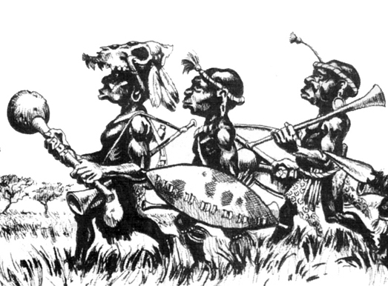

✶ ANCESTOR SPIRIT 

Ancestor Spirits are the ethereal form of dead pygmies who return to visit the living to give assistance. They take the form of shadowy pygmy shapes with grossly distorted features.

 | Ancestor Spirit
Wounds | 8
Move | 4
Weapon Skill | 3
Ballistic Skill | 5+
Strength | 2
Toughness | 3
Armour | -
Initiative | 3
Attacks | 1
Damage | Special
Gold | 250

ENEMY’S WS 1 2 3 4 5 6 7 8 9 10
Ancestor Spirit 2 3 4 4 4 4 5 5 5 6

Ancestor Spirit
Chill 1; Ethereal -1; Fear 3.

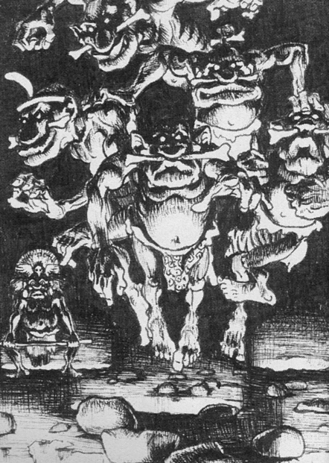

✶ BOAR 

Boars are voracious creatures that are constantly hungry. Their aggressive nature proves them a threat to even well armed Warriors. It is often that a Warrior survives a dungeon adventure only to be savaged to death by a pack of wild boar.

 | Boar
Wounds | 7
Move | 7
Weapon Skill | 3
Ballistic Skill | -
Strength | 3
Toughness | 3
Armour | -
Initiative | 3
Attacks | 1
Damage | 1D6
Gold | 50

ENEMY’S WS 1 2 3 4 5 6 7 8 9 10
Boar 2 3 4 4 4 4 5 5 5 6

Boar
Impale.

Boars can be ridden by any Pygmies, Pygmy Shamans or Pygmy Witchdoctors.

✶ WITCHDOCTOR 

Witchdoctors are special tribal priests found amongst the pygmies. They practise the black art of voodoo and often perform rituals, smearing their bodies with dyed paint and dancing madly around a fire while throwing different ingredients into it to help with their magic.

 | Witchdoctor
Wounds | 8
Move | 4
Weapon Skill | 2
Ballistic Skill | 5+
Strength | 2
Toughness | 2
Armour | -
Initiative | 4
Attacks | 1
Damage | 1D6
Gold | 450

ENEMY’S WS 1 2 3 4 5 6 7 8 9 10
Witchdoctor 3 4 4 4 5 5 6 6 6 6

Witchdoctor
Voodoo 1.

Voodoo
Pygmy Witchdoctors specialise in the black art of Voodoo, the ability to control others bodies from afar - a form of dark magic. The Witchdoctor has a small Voodoo Doll, constructed from straw and cloth and bound by string, of each of the Warriors in the adventuring party. After casting his spell on it, which he does before combat begins, he performs all manner of actions on the Voodoo Doll, resulting in the Warrior experiencing the same action. The Witchdoctor can perform one act of Voodoo per turn. Randomly determine which Warrior the Witchdoctor performs the black magic on at the start of each Monsters’ Phase. Voodoo occurs after all Monster spellcasters have cast spells for this round. Roll 1D6 to determine what the Witchdoctor does:

1 The Witchdoctor seems to have dropped the Voodoo Doll in the heat of battle. The Warrior can have no further voodoo magic cast on him for the remainder of this combat. Unfortunately, the Witch Doctor pulls out a Voodoo Doll of another Warrior.

2 The Witchdoctor throws the Voodoo Doll around the room. Suddenly the Warrior finds himself being flung across the other side of the room. Randomly determine a square on the same board section as the Warrior is currently on. Place the Warrior on this square, moving any other models out of the way if necessary. As well as losing 1D3 unmodified Wounds, if the Warrior lands on a hazard, or falls into a pit, chasm etc, then follow the appropriate rules. Obviously, if he falls down a chasm or something similar he is dead.
3 The Witchdoctor makes the Voodoo Doll dance, moving its arms and legs. The Warrior suddenly dances on the spot, doing a merry jig. For the rest of this turn, all Monsters get +1 To Hit him. In addition, the Warrior is too busy flailing his arms around to Attack or use any objects next turn.

4 The Witchdoctor ties a small black bag around the Voodoo Doll’s head. Suddenly the Warrior cannot see anything! Until the next Monster’s Phase the Warrior is at -2 To Hit and may only move 1 square. All Monsters attacking him in hand to hand combat for the next turn have a +2 bonus To Hit.

5 The Witchdoctor pulls a needle from his clothes and stabs it into the Voodoo Doll’s body. Roll 1D6 to see where he stabs it.

1-2 Body
The needle plunges into the body of the Voodoo Doll and the Warrior grasps his body in pain. He takes 1 unmodified Wound.

3 Legs
The Warrior’s legs suddenly give way and he collapses. He must miss out on his next turn. All Monsters receive +2 To Hit the fallen Warrior.

4 Arms
The Warrior feels a stinging pain in one of his arms. For the next turn he is treated as having a Weapon Skill of 1.

5 Groin
The Warrior doubles over in agony before collapsing. He loses (1D6 + Dungeon Level) Wounds and misses out on his next turn. All Monsters receive +2 To Hit the fallen Warrior.

6 Head
The Warrior feels a searing pain in his head and collapses onto the ground of the dungeon. He loses 1D6 unmodified Wounds and misses out on his next turn. All Monsters receive +2 To Hit the fallen Warrior.

6 The Witchdoctor flexes the leg of the Voodoo Doll, attempting to see if the Warrior’s leg can bend both ways. Roll 1D6. On a roll of 1, the Warrior’s leg snaps in half and he immediately falls to the ground - he loses 1D6 + 2 unmodified Wounds due to the pain. The Warrior must subtract -2 from his Move and Pinning until his leg is healed at a Settlement’s Temple for 1D6 x 50 Gold.

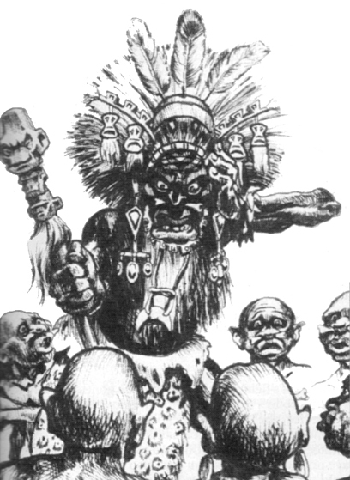
✶ PYGMY SHAMANS 

Pygmy Shamans are well respected in Pygmy society, even feared, for it is quite a powerful Pygmy indeed that is able to draw upon the power of the Gods themselves.

 | Pygmy Shaman | Pygmy Shaman Champion | Master Pygmy  Shaman | Pygmy Shaman Chief
Wounds | 8 | 14 | 20 | 25
Move | 4 | 4 | 4 | 4
Weapon Skill | 2 | 2 | 2 | 2
Ballistic Skill | 5+ | 4+ | 4+ | 4+
Strength | 2 | 3 | 3 | 3
Toughness | 2 | 2 | 2 | 2
Armour | - | - | - | -
Initiative | 4 | 4 | 4 | 5
Attacks | 1 | 1 | 2 | 2
Damage | 1D6 | 1D6 | 1D6 | 2D6
Gold | 300 | 600 | 1000 | 1500

ENEMY’S WS 1 2 3 4 5 6 7 8 9 10
Pygmy Shaman 3 4 4 4 5 5 6 6 6 6
Pygmy Shaman Champion 3 4 4 4 5 5 6 6 6 6
Master Pygmy Shaman 3 4 4 4 5 5 6 6 6 6
Pygmy Shaman Chief 3 4 4 4 5 5 6 6 6 6

Pygmy Shaman
Pygmy Magic 1.

Pygmy Shaman Champion
Magic Weapon; Pygmy Magic 2.

Master Pygmy Shaman
Magic Item; Magic Weapon; Pygmy Magic 3.

Pygmy Shaman Chief
Magic Item x 2; Magic Weapon; Pygmy Magic 4.

Pygmy Magic
Pygmy Shamans specialise in casting Pygmy Magic which deals mainly with nature. To see what spell the Pygmy Shaman casts when given the chance, roll 2D6 on the following table. If the Pygmy Shaman is killed while he still has active spells in play, they will immediately be dispelled.

2-4 Failure
The Pygmy Shaman fails to cast a spell.

5 Poison
The Pygmy Shaman magically coats the weapons of all Pygmies involved in the combat with a rare and deadly poison. Treat all weapons belonging to all Pygmies currently on the board as being Poison.

6 Tough Skin
The Pygmy Shaman casts this spell on himself. His skin hardens and he gains +1 Toughness for the next turn.

7 Cloud of Smoke
A cloud of smoke appears around the Pygmy Shaman. All Warriors are at -1 To Hit the Shaman and any Monsters standing adjacent to him. The effects of this spell last for 1 turn.

8 Rain
Huge storm clouds appear above the Warriors’ heads and it begins to rain heavily. The ground becomes very muddy and slippery and it is difficult to move. At the start of each Warriors movement roll 1D6. On a roll of 1 the Warrior falls over and spends the rest of the turn picking himself up, during which he may perform no other actions. Any Monsters attacking him have +1 added to their To Hit rolls.

9 Blinding Flash
A blinding flash of light causes a random Warrior to lose his sight for an entire turn. While he is blinded he is counted as having a Weapon Skill of 1, and all Monsters have a +2 bonus To Hit him.

10 Cause Fire
The Pygmy Shaman causes the ground to burst into flame. Choose a random square on the same board section as the Shaman. Any model on it takes 1D6 Wounds not modified for Toughness or armour. Any model vulnerable to fire, eg. Treeman, Mummy etc. take a further 2 Wounds before the fire dies out.

11 Create Quicksand
The ground suddenly turns to mush underneath one of the Warriors, and he begins to sink down into it. The Warrior has 1D6 + 1 turns to be rescued otherwise he disappears into the quicksand, never to be seen again. At the start of each turn, he sinks further in unless another Warrior attempts to pull him out. The Warrior must spend a whole turn next to the Warrior in the quicksand and may do nothing else. The square with the quicksand will remain until the Shaman is dead.

12 Summon Spirits
The Pygmy Shaman summons 1D3 Ancestor Spirits. They may be placed on the board immediately and may move and attack this turn.

