★ SKAVEN 

In the distant past, rats infesting a decaying ruin fed upon a mighty source of magic power. This source was a substance called warpstone - solidified fragments of raw sorcery. Under its unwholesome influence the scuttling vermin mutated, growing in size and intelligence into the vile children of Chaos known as the Skaven. The four most powerful Skaven are Clan Moulder, Clan Eshin, Clan Skyre and Clan Pestilens. The Great Clans are the masters of the Skaven and the rulers of their under-empire, and have complete ascendancy over the struggling mass of the ordinary Warlord Clans.

✶ GIANT RATS 

No less dangerous than the more intelligent monsters are the packs of Giant Rats that dwell in the dirtiest corners of the Warhammer World. Bloated by eating indescribable foul things, these rats have grown to immense proportions. When cornered, Giant Rats hurl themselves at their opponent in a maniacal frenzy, lunging for their enemy’s jugular vein with no thought to their own safety. The evil Clan Pestilens use rats as vessels of contagion to spread their lethal diseases. These animals are infected by one of the concoctions created by the Plague Priests and released into a city’s sewers. There, they contaminate the local rat population, which pass the diseases onto the inhabitants. Anyone bitten by one of these creatures will succumb to the virulent fever they carry.

 | Giant Rat | Plague Rat
Wounds | 1 | 1
Move | 6 | 6
Weapon Skill | 2 | 2
Ballistic Skill | - | -
Strength | 2 | 2
Toughness | 3 | 3
Armour | - | -
Initiative | 4 | 4
Attacks | 1 | 1
Damage | Special | Special
Gold | 25 | 40

ENEMY’S WS 1 2 3 4 5 6 7 8 9 10
Giant Rat 3 4 4 4 5 5 6 6 6 6
Plague Rat 3 4 4 4 5 5 6 6 6 6

Giant Rat
Deathleap.

Plague Rat
Deathleap; Plague.

Deathleap
Rats make a special attack, called a Deathleap. Roll the Rat’s attack as normal, but if it hits roll 2D6 + 2 for damage. Once a Rat has attacked the Warrior, roll 1D6. On a result of 3-6 the Rat’s suicidal, frenzied attack has opened it up to the Warrior’s attack and he automatically kills it.

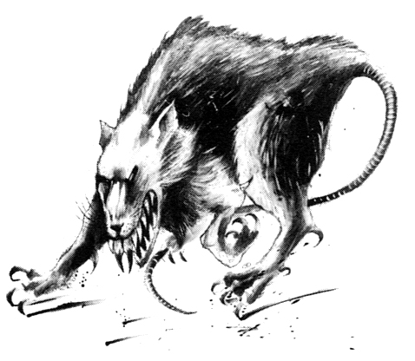

✶ SKAVENSLAVE

Skavenslaves are the dregs of Skaven society, Skaven too unskilled or stupid to be of any use in battle. They have been captured from other Skaven clans in the many battles that are constantly fought between rival Skaven. They aren’t expected to fight well, they are only expected to die. Pawleaders are nothing more than slaves with slightly more intelligence and are often used to lead the Skavenslaves into battle.

 | Skavenslave | Skaven  Pawleader
Wounds | 2 | 5
Move | 5 | 5
Weapon Skill | 2 | 3
Ballistic Skill | 5+ | 5+
Strength | 3 | 4
Toughness | 3 | 3
Armour | - | -
Initiative | 4 | 5
Attacks | 1 | 1
Damage | 1D6 | 1D6
Gold | 20 | 40

ENEMY’S WS 1 2 3 4 5 6 7 8 9 10
Skavenslave 3 4 4 4 5 5 6 6 6 6
Skaven Pawleader 2 3 4 4 4 4 5 5 5 6

Skavenslave
Armed with Sling (Str 2).

Skaven Pawleader
-
✶ SKAVEN CLANRATS 

Individual Skaven Warriors are vicious but cowardly creatures, and they are best deployed in large numbers. The more powerful warriors lead their brethren into combat, and a Clawleader will not think twice about stabbing his leader in the back in his desire to rise to the rank of Warlord.

 | Skaven Clanrat | Skaven  Clawleader | Skaven Chieftain | Skaven Warlord
Wounds | 3 | 11 | 20 | 30
Move | 5 | 5 | 5 | 5
Weapon Skill | 3 | 4 | 5 | 6
Ballistic Skill | 4+ | 3+ | 2+ | 1+
Strength | 3 | 4 | 4 | 4
Toughness | 3 | 3 (5) | 4 (6) | 4 (7)
Armour | - | 2 | 2 | 3
Initiative | 4 | 5 | 6 | 7
Attacks | 1 | 2 | 3 | 4
Damage | 1D6 | 2D6 | 2D6 | 3D6
Gold | 40 | 270 | 590 | 1360

ENEMY’S WS 1 2 3 4 5 6 7 8 9 10
Skaven Clanrat 2 3 4 4 4 4 5 5 5 6
Skaven Clawleader 2 3 3 4 4 4 4 4 5 5
Skaven Chieftain 2 2 3 3 4 4 4 4 4 4
Skaven Warlord 2 2 3 3 3 4 4 4 4 4

Skaven Clanrat
-

Skaven Clawleader
Magic Weapon; Never Pinned.

Skaven Chieftain
Dodge 5+; Never Pinned; Weeping Blade.

Skaven Warlord
Dodge 5+; Magic Armour; Magic Resistance 5+; Magic Weapon.

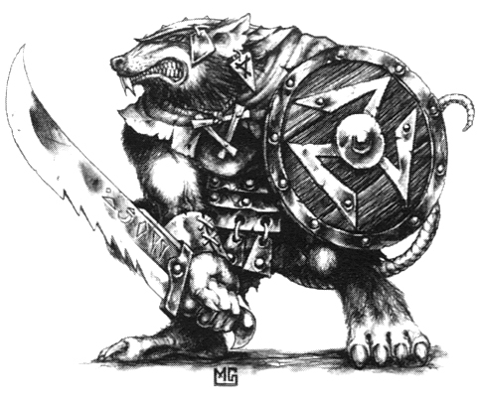

✶ SKAVEN PACKMASTER

Skaven Packmasters are notorious for their use in the whip, a weapon that they learn to use with unparalleled ability. The Packmaster’s intelligence, coupled with the beasts’ ferocity is an extremely dangerous combination.

 | Skaven Pack  master | Giant Rat | Plague Rat | Rat Ogre | Rat Golem
Wounds | 3 | 1 | 1 | 20 | 30
Move | 5 | 6 | 6 | 6 | 6
Weapon Skill | 3 | 2 | 2 | 4 | 2
Ballistic Skill | 4+ | - | - | - | -
Strength | 3 | 2 | 2 | 5 | 6
Toughness | 3 | 3 | 3 | 5 | 6
Armour | - | - | - | - | -
Initiative | 4 | 4 | 4 | 5 | 5
Attacks | 1 | 1 | 1 | 2 | Special
Damage | 1D6 | Special | Special | 2D6 | 2D6
Gold | 60 | 25 | 40 | 500 | 750

ENEMY’S WS 1 2 3 4 5 6 7 8 9 10
Skaven Packmaster 2 3 4 4 4 4 5 5 5 6
Giant Rat 3 4 4 4 5 5 6 6 6 6
Plague Rat 3 4 4 4 5 5 6 6 6 6
Rat Ogre 2 3 3 4 4 4 4 4 5 5
Rat Golem 3 4 4 4 5 5 6 6 6 6

Skaven Packmaster
Beast Handler (Skaven).

Giant Rat
Deathleap.

Plague Rat
Deathleap; Plague.

Rat Ogre
Fear 5.

Rat Golem
Fear 7; Ignore Blows 4+; Magic Resistance 4+; Rat Golem Attack; Regenerate 1D6.

Beast Handler (Skaven)
Skaven Packmasters control a pack of beasts in combat, directing them towards the Warriors using whips. The composition of the Packmaster’s pack will be indicated on the Monster Table. When placing the Packmaster on the board, the beasts are always placed first. While the Packmaster is on the same board section as them, Monsters that he controls can reroll their first Attack that misses each turn, although they must keep the result of the second roll.

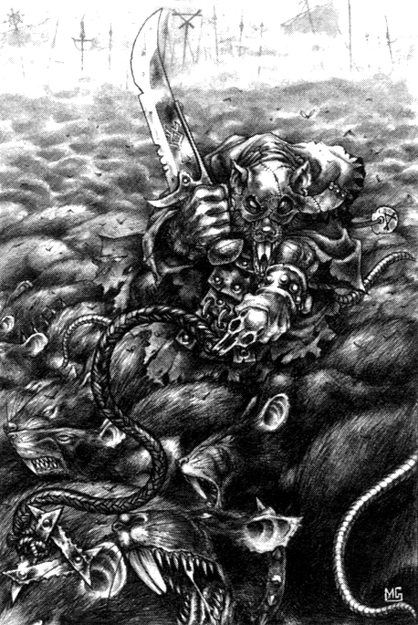
✶ SKAVEN STORMVERMIN 

The biggest, most powerful and vicious Skaven are organised into elite groups known as Stormvermin. Their fur is normally darker than normal and thus they are feared and respected by their brethren. These stronger warriors are picked by the Warlords to be their bodyguards.

 | Skaven Stormvermin | Fangleader
Wounds | 5 | 10
Move | 5 | 5
Weapon Skill | 4 | 4
Ballistic Skill | 4+ | 4+
Strength | 4 | 5
Toughness | 3 (4) | 3 (4)
Armour | 1 | 1
Initiative | 5 | 5
Attacks | 1 | 2
Damage | 1D6 | 1D6
Gold | 95 | 110

ENEMY’S WS 1 2 3 4 5 6 7 8 9 10
Skaven Stormvermin 2 3 3 4 4 4 4 4 5 5
Fangleader 2 3 3 4 4 4 4 4 5 5

Skaven Stormvermin
Armed with Halberds (Fight in Ranks).

Fangleader
Armed with Halberds (Fight in Ranks).

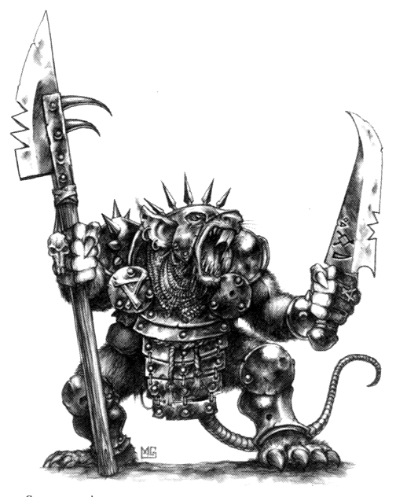

✶ SKAVEN PLAGUE MONKS 

The Plague Monks of Clan Pestilens are dedicated to spreading corruption and decay in the name of the Horned Rat. They are the initiates of infection and disciples of disease with agents scattered across the cities of the Old World. The results of their hideous experiments are listed in the evil tome known as the Book of Woe, which contains details of all known diseases. The Plague Monks are led by Plague Priests or even a mighty Plague Lord, and fight with frenzied devotion.

 | Skaven Plague Monk | Skaven Plague Deacon | Skaven Plague Priest | Skaven Plague Lord
Wounds | 5 | 17 | 23 | 30
Move | 5 | 5 | 5 | 5
Weapon Skill | 3 | 4 | 5 | 6
Ballistic Skill | 4+ | 3+ | 2+ | 2+
Strength | 3 | 4 | 4 | 4
Toughness | 4 | 5 | 5 | 5
Armour | - | - | - | -
Initiative | 4 | 5 | 6 | 7
Attacks | 1 | 2 | 3 | 4
Damage | 1D6 | 1D6 | 1D6 | 3D6
Gold | 60 | 360 | 730 | 2250

ENEMY’S WS 1 2 3 4 5 6 7 8 9 10
Skaven Plague Monk 2 3 4 4 4 4 5 5 5 6
Skaven Plague Deacon 2 3 3 4 4 4 4 4 5 5
Skaven Plague Priest 2 2 3 3 4 4 4 4 4 4
Skaven Plague Lord 2 2 3 3 3 4 4 4 4 4

Skaven Plague Monk
Frenzy 5+; Weeping Blade.

Skaven Plague Deacon
Ambush, Magic 5+; Frenzy 5+; Weeping Blade.

Skaven Plague Priest
Ambush, Magic A; Frenzy 4+; Magic Weapon; Poison Weapon.

Skaven Plague Lord
Ambush, Magic A; Death Fog; Dodge 3+; Frenzy 3+; Magic Resistance 3+; Magic Items x 3; Magic Weapon; Never Pinned; Terror 10; Weeping Blade.

Death Fog
Any Warrior adjacent to a Skaven Plague Lord is overcome by the choking, noxious vapours that surround him. At the end of every turn all adjacent Warriors take 2 Wounds, with no modifiers for Toughness or armour. If a Warrior is reduced to 0 Wounds by a Death Fog and is then healed, his Starting Wounds are reduced by -1D3 permanently.

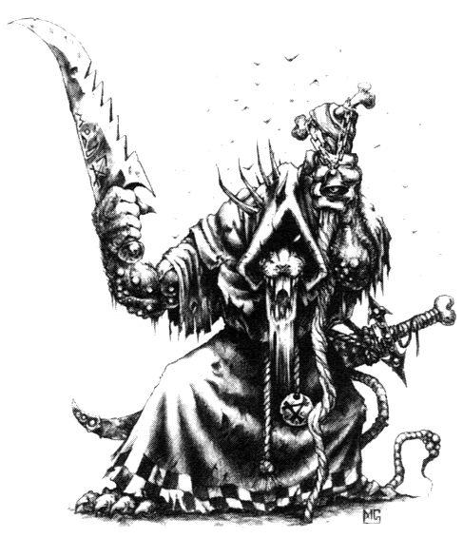
✶ SKAVEN ASSASSINS 

The black-clad assassins of Clan Eshin are rightly feared by those who know of them. They are trained from birth as quick, murderous fighters adept in the use of poisons, garrottes, throwing stars and all manner of exotic weapons. From the lowly Gutter Runners to the deadly Deathmasters, all are feared and respected.

 | Gutter Runner | Black Skaven | Skaven Assassin | Skaven Deathmaster
Wounds | 5 | 7 | 16 | 32
Move | 6 | 6 | 6 | 6
Weapon Skill | 4 | 4 | 5 | 8
Ballistic Skill | 3+ | 3+ | 3+ | 1+
Strength | 3 | 4 | 4 | 4
Toughness | 3 | 3 | 3 | 4
Armour | - | - | - | -
Initiative | 4 | 5 | 8 | 10
Attacks | 1 | 2 | 3 | 5
Damage | 1D6 | 1D6 | 2D6 | 4D6
Gold | 120 | 330 | 700 | 2300

ENEMY’S WS 1 2 3 4 5 6 7 8 9 10
Gutter Runner 2 3 3 4 4 4 4 4 5 5
Black Skaven 2 3 3 4 4 4 4 4 5 5
Skaven Assassin 2 2 3 3 4 4 4 4 4 4
Skaven Deathmaster 2 2 2 3 3 3 3 4 4 4

Gutter Runner
Ambush 4+.

Black Skaven
Ambush 3+; Dodge 6+.

Skaven Assassin
Ambush A; Assassinate 6+; Dodge 5+; Weeping Blade.

Skaven Deathmaster
Ambush A; Assassinate 4+; Dodge 4+; Magic Resistance 5+; Magic Weapon; Weeping Blade.

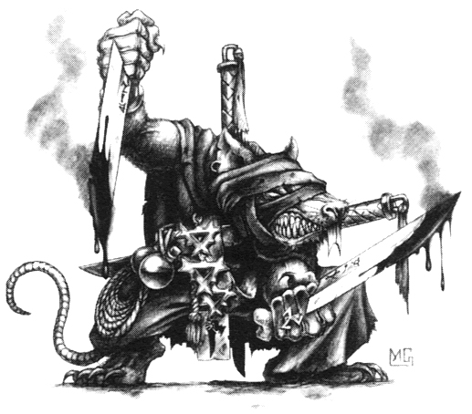

✶ PLAGUE CENSER BEARER 

The most fanatical and deranged members of Clan Pestilens are given the singular honour of wielding a plague censer. Inside this swinging ball burns a plague infested warpstone that emits a foul bubonic vapour as the censer is swung. Flesh exposed to the vapour quickly erupts into sores and fluid filled blisters.

 | Plague Censer Bearer
Wounds | 4
Move | 5
Weapon Skill | 4
Ballistic Skill | -
Strength | 4
Toughness | 4
Armour | -
Initiative | 4
Attacks | 1
Damage | Special
Gold | 150

ENEMY’S WS 1 2 3 4 5 6 7 8 9 10
Plague Censer Bearer 2 3 3 4 4 4 4 4 5 5

Plague Censer Bearer
Armed with Plague Censers.

Plague Censers
A Skaven plague censer is a heavy spiked ball on a length of chain. Make a normal hand to hand To Hit roll against the target to determine if he is struck. If the target is hit, the censer causes 1D6 + Strength damage, plus the victim must make a Toughness check. Roll 1D6 and add the victim’s Toughness. If the score is 7 or more he is unaffected by the fumes that surround the censer. If the score is equal to or less than 7 he takes an additional 1D3 Wounds with no modifiers for Toughness or armour. This additional damage is considered to be Plague damage.

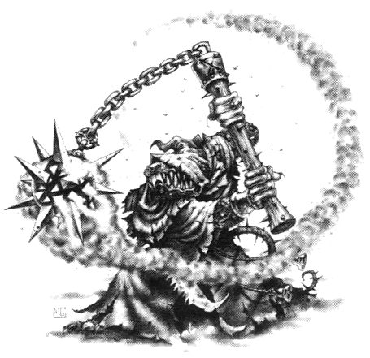

✶ SKAVEN POISON GLOBADIER 

A poisoned wind globe is a fragile crystal sphere filled with a lethal warpstone gas. When the globe is shattered, a yellowish-green vapour billows out to fill the area.

 | Skaven Poison Globadier
Wounds | 4
Move | 5
Weapon Skill | 3
Ballistic Skill | 4+
Strength | 3
Toughness | 3
Armour | -
Initiative | 4
Attacks | 1
Damage | 1D6
Gold | 200

ENEMY’S WS 1 2 3 4 5 6 7 8 9 10
Skaven Poison Globadier 2 3 4 4 4 4 5 5 5 6

Skaven Poison Globadier
Armed with Poison Wind Globes.

Poison Wind Globes
Skaven Poison Globadiers are missile troops and are treated just as if they were using normal missile weapons, applying all the normal missile weapon rules. Work out which Warriors have been hit as normal. The poison globe attack affects those Warriors and all Warriors adjacent to them. Each affected Warrior rolls 1D6 and adds their Toughness to the score. If the total is 6 or less, the Warrior suffers 1D3 Wounds with no modifiers for Toughness or armour. However, as the globes they carry are poisoned, in addition to suffering normal damage. The victim of a globe attack suffers all the effects of the Poison Special Ability.

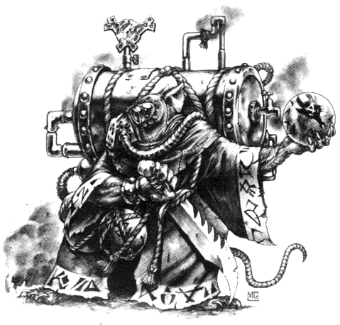

✶ JEZZAIL TEAMS

The Jezzails of Clan Skyre are powerful, long range missile weapons, firing warpstone charges and capable of punching through the toughest armour.

 | Jezzail Team
Wounds | 6
Move | 5
Weapon Skill | 3
Ballistic Skill | 4+
Strength | 3
Toughness | 3 (4)
Armour | 1
Initiative | 4
Attacks | 1
Damage | 1D6
Gold | 300

ENEMY’S WS 1 2 3 4 5 6 7 8 9 10
Jezzail Team 2 3 3 4 4 4 4 4 5 5

Jezzail Team
Armed with Jezzail.

Jezzail
Jezzails are missile weapons that attack with a Strength of 5 and ignore up to 3 points of armour. Each Jezzail Team requires a team of two Skaven to use it. If one of the Skaven is killed the other cannot continue to use the weapon and may only make a normal hand to hand attack from then on. At the start of the Monsters’ Phase draw a Warrior counter to determine which Warrior is targeted by the team. If there is more than one team in combat, distribute their hits according to the normal One on One rule.

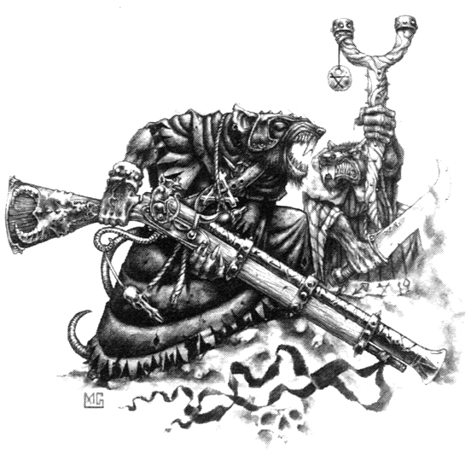

✶ WARPFIRE THROWER TEAM 

The Skaven Warpfire Thrower is an invention of the Warlock Engineers of Clan Skyre. It hurls a blast of a volatile mixture of inflammable chemicals and powdered warpstone combined with magic. A single blast from a Warpfire Thrower can reduce a group of Warriors to charred ash in moments.

 | Warpfire Thrower Team
Wounds | 3
Move | 4
Weapon Skill | 3
Ballistic Skill | 5+
Strength | 3
Toughness | 3 (4)
Armour | 1
Initiative | 4
Attacks | 1
Damage | Special
Gold | 700

ENEMY’S WS 1 2 3 4 5 6 7 8 9 10
Warpfire Thrower Team 2 3 3 4 4 4 4 4 5 5

Warpfire Thrower Team
Armed with Warpfire Thrower.

Warpfire Thrower
Skaven Warpfire Thrower Teams are placed as if they were armed with missile weapons. Each Warpfire Thrower requires a team of two Skaven to use it. If one of the Skaven is killed the other cannot continue to use the weapon and may only make a normal hand to hand attack from then on. At the start of the Monsters’ Phase draw a Warrior counter to determine which Warrior is targeted by the team. If there is more than one team in combat, distribute their hits according to the normal One on One rule. Each time a Warpfire Thrower is fired, the flames form a 1 square wide corridor that travels across the room in a straight line towards the target, hitting everything in its path. If a model is hit by a Warpfire Thrower, it suffers 3D6 Wounds. If the dice come up with two or three natural 1’s the Warpfire Thrower has misfired and you should roll on the following table:

1-2 Kaboom!
The Warpfire Thrower explodes, causing 4D6 Wounds on every model on the board section. Roll 1D6 for each additional Warpfire Thrower on the board section. On a score of 1-3, it too blows up, causing the same damage and requiring another 1D6 roll for each intact Warpfire Thrower and so on.

3-4 Whoosh!
The fuel barrels catch fire. All models within 2 squares of the Warpfire Thrower take 3D6 Wounds damage. The Warpfire Thrower is now rendered useless, but can still explode if result 1-2 is rolled for another Warpfire Thrower.

5-6 Click-Whoosh!
The Warpfire Thrower backfires, causing 3D6 Wounds against its crew.

In addition, roll 1D6 for each item of magical treasure the victim is carrying. On a roll of 1 the item is rendered useless for the rest of the adventure. At the start of the next adventure the item can be used normally again.

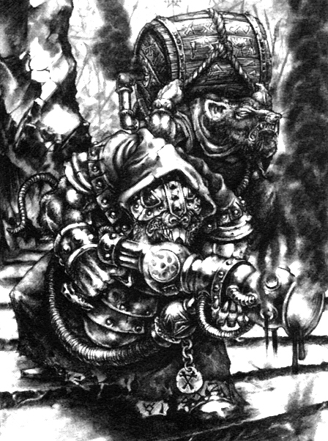

✶ RATLING GUN TEAM 

The Skaven Ratling Gun is an invention of the Warlock Engineers of Clan Skyre. It is powered by steam and repeatedly fires shards of warpstone.

 | Ratling Gun Team
Wounds | 3
Move | 4
Weapon Skill | 3
Ballistic Skill | 5+
Strength | 3
Toughness | 3 (4)
Armour | 1
Initiative | 4
Attacks | Special
Damage | Special
Gold | 900

ENEMY’S WS 1 2 3 4 5 6 7 8 9 10
Ratling Gun Team 2 3 3 4 4 4 4 4 5 5

Ratling Gun Team
Armed with Ratling Gun.

Ratling Gun
Skaven Ratling Gun Teams are placed as if they were armed with missile weapons. Each Ratling Gun requires a team of two Skaven to use it. If one of the Skaven is killed the other cannot continue to use the weapon and may only make a normal hand to hand attack from then on. At the start of the Monsters’ Phase draw a Warrior counter to determine which Warrior is targeted by the team. If there is more than one team in combat, distribute their hits according to the normal One on One rule. Each time a Ratling Gun is fired, roll 1D6 to determine how many shots are fired during the attack. Now roll 1D6 for each shot and add the results together. The total is the amount of damage caused to the Warrior. If any of the damage dice scores a 6 then the Ratling Gun has fired a particularly lethal shard of warpstone and the damage caused by that dice is not modified for Toughness or armour. However, if any of the dice come up with a 1, do not count that dice when determining damage caused. After the damage has been worked out, roll another D6. On a roll of 1, the Ratling Gun has overheated and may not fire next turn while the weapon cools down. On a 5-6 the Ratling Gun continues firing! Draw another Warrior counter to determine who the Ratling Gun targets this time. Note that the same Warrior may be targeted multiple times!

eg. A Skaven Ratling Gun Team fires at the Barbarian. A 5 is rolled, meaning 5D6 dice are rolled for damage. The scores are 4, 3, 6, 2 and 1. The 1 is removed immediately and since the 6 scores unmodified damage, the remaining dice are totalled, scoring 9. The Barbarian has a Toughness of 4, meaning he suffers 5 damage. However, he also takes 6 unmodified Wounds damage from the dice that scored a 6.
✶ WARP LIGHTNING CANNON 

The Warp Lightning Cannon is a huge cannon-like weapon, powered by a huge chunk of raw warpstone. Its magical energy is channelled through a series of lenses that amplify and concentrate it. When fired, a bright green bolt of energy surges from the weapon.

 | Warp Lightning Cannon | Skaven Clanrat
Wounds | 35 | 3
Move | 4 | 5
Weapon Skill | 1 | 3
Ballistic Skill | - | 4+
Strength | 5 | 3
Toughness | 6 | 3
Armour | 1 | -
Initiative | 4 | 4
Attacks | Special | 1
Damage | Special | 1D6
Gold | 1200 | 40

ENEMY’S WS 1 2 3 4 5 6 7 8 9 10
Skaven Clanrat 2 3 3 4 4 4 4 4 5 5

Warp Lightning Cannon
Warp Lightning Cannon.

Skaven Clanrat
-

Warp Lightning Cannon
Warp Lightning Cannons are placed as missile weapons. Each Warp Lightning Cannon is placed with a team of two Skaven to use it. Any Skaven manning the Warp Lightning Cannon do not get to make their normal attacks. If one of the original Skaven manning the Cannon dies, another Skaven that is the closest will move behind the Cannon to help operate it (randomly decide if necessary). That Skaven ignores Pinning for this turn only. Only the lowest rank of Skaven will operate the Warp Lightning Cannon, so Skaven Warlords, etc. will not use it. The Cannon takes its turn using the Initiative value of the Skaven operating it. At the start of the Monsters’ Phase draw a Warrior counter to determine which Warrior is targeted by the team. If there is more than one team in combat, distribute their hits according to the normal One on One rule. Each time a Warp Lightning Cannon is fired, it shoots a bolt of lethal warpstone lightning at a Warrior. Roll 6D6 and total the score to determine the damage caused to the Warrior. Now roll a D6. On a score of 3-6 the warp lightning strikes another random model on the same board section, for 5D6 damage. Keep rolling to see if the warp lightning keeps going or fizzles out. Each subsequent model hit suffers 1 less damage dice than the previous target until the damage reaches zero and the lightning dissipates. Warriors do not receive any Gold for Monsters killed in this way.

eg. A Skaven Warp Lightning Cannon fires at the Barbarian. 6D6 are rolled, totalling 28 damage, modified as normal for Toughness and armour. A further D6 is rolled, scoring a 4. The warp lightning continues, striking a random model which is a Skeleton. The Skeleton suffers 19 damage totalled from 5D6 dice, which kills it. Another D6 is rolled, scoring a 3. The warp lightning hits another Warrior, this time the Dwarf, causing 14 damage. A D6 is rolled, scoring a 2, so the warp lightning dissipates.

✶ SKAVEN SORCERERS 

The mysterious Skaven known as Great Seers are the servants of the Lords of Decay and carry their instructions to the clans. Grey Seers are invariably magicians of great power and may be found leading hordes of Skaven Clans into battle. Other Skaven Sorcerers - from Skaven Warlocks through to the powerful Warlock Chiefs - all recognise the superiority of the Grey Seers, cowering in fear when one approaches.

 | Skaven Warlock | Skaven Warlock Champion | Skaven Master Warlock | Grey Seer
Wounds | 15 | 18 | 30 | 43
Move | 5 | 5 | 5 | 5
Weapon Skill | 3 | 3 | 3 | 6
Ballistic Skill | 4+ | 4+ | 4+ | 1+
Strength | 3 | 4 | 4 | 4
Toughness | 4 | 4 | 4 | 4
Armour | - | - | - | -
Initiative | 5 | 5 | 6 | 7
Attacks | 1 | 1 | 2 | 4
Damage | 2D6 | 2D6 | 2D6 | 2D6
Gold | 560 | 1180 | 1900 | 3400

ENEMY’S WS 1 2 3 4 5 6 7 8 9 10
Skaven Warlock 2 3 4 4 4 4 5 5 5 6
Skaven Warlock Champion 2 3 4 4 4 4 5 5 5 6
Skaven Master Warlock 2 3 4 4 4 4 5 5 5 6
Grey Seer 2 2 3 3 3 4 4 4 4 4

Skaven Warlock
Dodge 5+; Magic Dispel 6+; Skaven Magic 1.

Skaven Warlock Champion
Magic Dispel 5+; Magic Item; Magic Resistance 5+; Skaven Magic 2; Weeping Blade

Skaven Master Warlock
Magic Dispel 4+; Magic Item x 3; Magic Resistance 4+; Magic Weapon; Skaven Magic 3.

Grey Seer
Magic Dispel 4+; Magic Item x 4; Magic Resistance 4+; Magic Weapon; Skaven Magic 4.

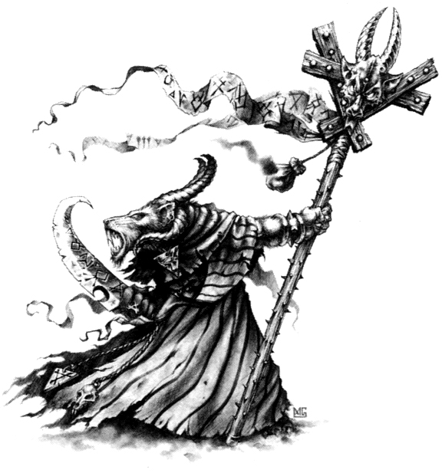
✶ RAT OGRE 

Rat Ogres are the most feared creations of the Skaven Clan Moulder. They are massive bulking monsters, created by a warped mix of different creatures. Devoted entirely to bloodshed, a Rat Ogre is a hugely muscled killing machine with the speed and ferocity of a Skaven.

 | Rat Ogre
Wounds | 20
Move | 6
Weapon Skill | 4
Ballistic Skill | -
Strength | 5
Toughness | 5
Armour | -
Initiative | 5
Attacks | 2
Damage | 2D6
Gold | 500

ENEMY’S WS 1 2 3 4 5 6 7 8 9 10
Rat Ogre 2 3 3 4 4 4 4 4 5 5

Rat Ogre
Fear 5.

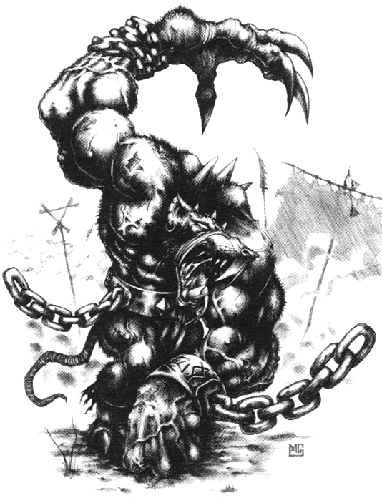

✶ RAT GOLEM 

A Rat Golem is a mechanically modified Rat Ogre, with chunks of warpstone embedded in parts of its body to provide it with a resistance to magic and the ability to heal itself. However, it is even more stupid and frequently needs repairing. It needs no food and draws upon the raw power of the warpstone within it to live. This source of energy is somewhat slow and erratic, and as such, unreliable.

 | Rat Golem
Wounds | 30
Move | 6
Weapon Skill | 2
Ballistic Skill | -
Strength | 6
Toughness | 6
Armour | -
Initiative | 5
Attacks | Special
Damage | 2D6
Gold | 850

ENEMY’S WS 1 2 3 4 5 6 7 8 9 10
Rat Golem 3 4 4 4 5 5 6 6 6 6

Rat Golem
Fear 7; Ignore Blows 4+; Magic Resistance 4+; Rat Golem Attack; Regenerate 1D6.

Rat Golem Attack
Due to the warpstone embedded in it, the Rat Golem is extremely erratic in its movement and fighting style. Roll 2D6 to see how much energy the Rat Golem can draw from the warpstone this turn. Draw a Warrior counter each turn to determine who the Rat Golem will attack. The Rat Golem is never Pinned. Move it towards the Warrior, subtracting one energy point for every square moved. If it cannot reach the Warrior, whether due to lack of energy or obstructing models, the Rat Golem moves as far as possible, then stops and does nothing. If the Rat Golem moves into a square adjacent to its target, roll 1D6 on the Rat Golem Attack Table.

Rat Golem Attack Table
1-2 The Rat Golem makes a number of normal Attacks using its Weapon Skill, Strength etc. It may make one Attack for each remaining point of energy it has when it reaches its target.

3 The Rat Golem picks up the Warrior in a crushing bear hug. The Warrior takes a number of Wounds equal to the remaining number of energy points, with no modifiers.

4 The Rat Golem picks up the Warrior in its massive claws and flings him across the room. Roll 1D6 and refer to the diagram to see which direction the Warrior is thrown.

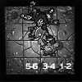

The Warrior travels a number of squares in a straight line equal to the Rat Golem’s remaining energy. If the Warrior hits a wall or another model before moving the full distance, the Warrior (and any model hit) takes a number of Wounds damage equal to the remaining distance. This is not modified for Toughness or armour. For example, if a Warrior is thrown 6 squares and only travels 3 before hitting another model, both models suffer 3 unmodified Wounds each.

5 Roaring in anger, the Rat Golem lunges forward to take a massive bite out of the Warrior. Make a normal To Hit roll for the Rat Golem. If this hits, the Warrior suffers 1D3 Wounds for every remaining point of energy, with normal modifiers for Toughness or armour.

6 The Rat Golem attempts to head butt the Warrior and send him crashing to the ground. Make a normal To Hit roll for the Rat Golem. If successful, the Warrior takes 2D6 + 6 Wounds with normal deductions. In addition, the Warrior may not make any Attacks in the next Warriors’ Phase as he picks himself up from the floor!

✶ VERMIN LORD 

A Vermin Lord is a daemonic form of the Great Horned Rat himself - the Skaven God Incarnate. Wielding a mighty Doom Glaive and capable of great sorcery, the Vermin Lord is a fearsome foe for even the most powerful Warriors to face.

 | Vermin Lord
Wounds | 75
Move | 8
Weapon Skill | 8
Ballistic Skill | A
Strength | 8
Toughness | 7 (13)
Armour | 6
Initiative | 10
Attacks | 8
Damage | 6D6
Gold | 6000

ENEMY’S WS 1 2 3 4 5 6 7 8 9 10
Vermin Lord 2 2 2 3 3 3 3 4 4 4

Vermin Lord
Ambush, Magic A; Armed with Doom Glaive; Dodge 3+; Frenzy 5+; Greater Daemon 14; Ignore Pain 6; Large Monster; Magic Dispel 4+; Magic Resistance 4+; Skaven Magic 4; Skitterleap.

Doom Glaive
A Doom Glaive is heavily woven with dark magic, causing an extra +2 Wounds with no modifiers for Toughness or armour.

Skitterleap
This ability allows the Vermin Lord to disappear, move through the warp and then reappear next to its chosen victim. By moving in this way the Vermin Lord is not subject to pinning and may move through any obstacles as though they were not there. If the Vermin Lord manages to kill a Warrior and still has some Attacks left he may switch to another target to use them.

