★ UNDEAD 

In the Warhammer World, the dead do not rest easy. Necromancers practise their foul arts in distant castles and the deepest caves, and Vampires stalk the darkness. Mummies, Skeletons and the Ghosts of the dead protect their graves, jealously guarding the treasure they coveted whilst their bodies still lived.

✶ VAMPIRE BAT S

Vampire Bats have developed a taste for blood, turning them into frenzied attackers in the midst of battle. The blood drinking bats of Sylvania grow to monstrous proportions. They are nightmarish predators of the dark, silent and deadly. They exist solely on the blood of the living.

 | Vampire Bat | Fell Bat
Wounds | 1 | 20
Move | 8 | 8
Weapon Skill | 2 | 3
Ballistic Skill | - | -
Strength | 2 | 4
Toughness | 2 | 5
Armour | - | -
Initiative | 1 | 3
Attacks | 1 | 3
Damage | 1D6 | 2D6
Gold | 25 | 980

ENEMY’S WS 1 2 3 4 5 6 7 8 9 10
Vampire Bat 3 4 4 4 5 5 6 6 6 6
Fell Bat 2 3 4 4 4 4 5 5 5 6

Vampire Bat
Ambush, Magic A; Fly; Poison Attack.

Fell Bat
Fly; Poison Attack.

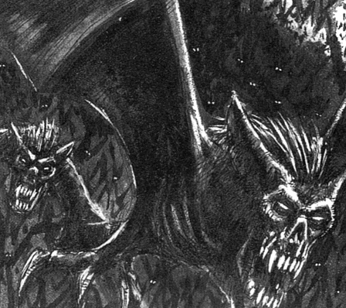

✶ ZOMBIE 

Zombies are fresh corpses brought back to life by foul necromancy. Being more recently dead than Skeletons they retain more of their intellect and are more like living humans, although they are totally under the will of the Necromancer whose conjurations created them. Although rejuvenated by magic they continue to decay. Their flesh is rank and tattered and caked with blood.

 | Zombie
Wounds | 5
Move | 4
Weapon Skill | 2
Ballistic Skill | -
Strength | 3
Toughness | 3
Armour | -
Initiative | 1
Attacks | 1
Damage | 1D6
Gold | 40

ENEMY’S WS 1 2 3 4 5 6 7 8 9 10
Zombie 3 4 4 4 5 5 6 6 6 6

Zombie
Fear 3.

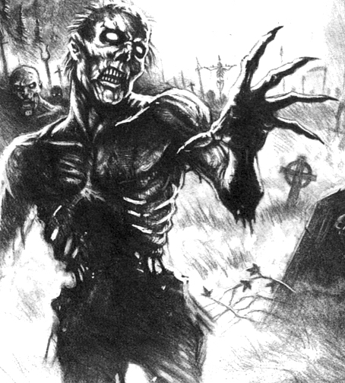

✶ GHOUL 

Ghouls are the descendants of insane and evil hearted cannibals - men who ate the flesh of the dead. Over the years they have degenerated into a race that is no longer human. They live amongst places of the dead, feeding on corpses and sometimes attacking lone travellers or vulnerable groups.

 | Ghoul
Wounds | 4
Move | 4
Weapon Skill | 2
Ballistic Skill | -
Strength | 3
Toughness | 4
Armour | -
Initiative | 3
Attacks | 2
Damage | 1D6
Gold | 80

ENEMY’S WS 1 2 3 4 5 6 7 8 9 10
Ghoul 3 4 4 4 5 5 6 6 6 6

Ghoul
Break; Fear 4.

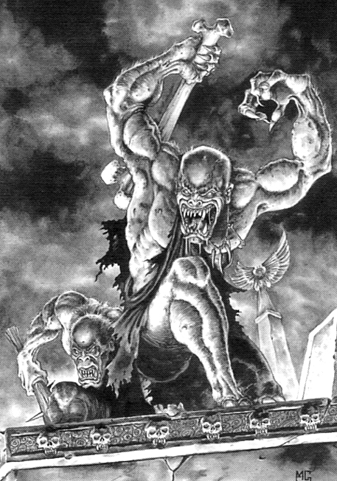

✶ SKELETONS 

Skeleton Warriors claw themselves out of the earth to attack the living. They wield rusty swords and axes, and mouldering remnants of armour still cling to their frame.

 | Skeleton | Skeleton Captain
Wounds | 5 | 13
Move | 4 | 4
Weapon Skill | 2 | 2
Ballistic Skill | 5+ | 5+
Strength | 3 | 3
Toughness | 3 | 3 (4)
Armour | - | 1
Initiative | 2 | 2
Attacks | 1 | 1
Damage | 1D6 | 2D6
Gold | 80 | 200

ENEMY’S WS 1 2 3 4 5 6 7 8 9 10
Skeleton 3 4 4 4 5 5 6 6 6 6
Skeleton Captain 3 4 4 4 5 5 6 6 6 6

Skeleton
Armed with [1-2] Bows (Str 3), [3-4] Spears (Fight in Ranks) or [5-6] Swords; Fear 5; Regenerate 1D6.

Skeleton Captain
Fear 6; Regenerate 1D6.

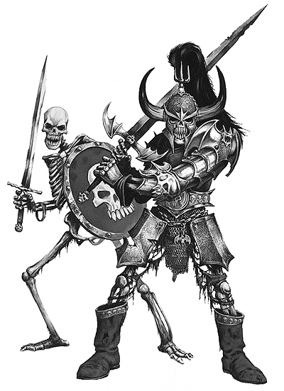

✶ GRAVE GUARD 

Grave Guard are the remains of long dead warriors, summoned from the grave to protect their ancient tombs from the living.

 | Grave Guard | Crypt Keeper
Wounds | 14 | 20
Move | 4 | 4
Weapon Skill | 3 | 3
Ballistic Skill | 5+ | 4+
Strength | 3 | 4
Toughness | 4 (5) | 4 (5)
Armour | 1 | 1
Initiative | 3 | 3
Attacks | 1 | 2
Damage | 2D6 | 2D6
Gold | 280 | 580

ENEMY’S WS 1 2 3 4 5 6 7 8 9 10
Grave Guard 2 3 4 4 4 4 5 5 5 6
Crypt Keeper 2 3 4 4 4 4 5 5 5 6

Grave Guard
Fear 6.

Crypt Keeper
Fear 7; Magic Armour; Magic Weapon.

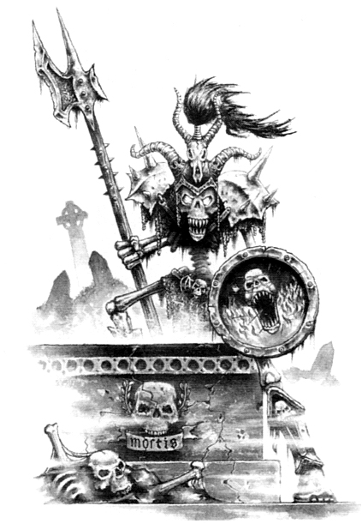

✶ SKELETAL STEED 

Skeletal Steeds are ghastly creatures. They were once normal horses, but when they died their flesh decomposed. When all that was left of them was their bones, evil Necromancers raised them from the dead.

 | Skeletal Steed
Wounds | 6
Move | 8
Weapon Skill | 2
Ballistic Skill | -
Strength | 3
Toughness | 3
Armour | -
Initiative | 2
Attacks | 1
Damage | 1D6
Gold | 70

ENEMY’S WS 1 2 3 4 5 6 7 8 9 10
Skeletal Steed 3 4 4 4 5 5 6 6 6 6

Skeletal Steed
Fear 5; Regenerate 1.

Skeletal Steeds can be ridden by any Skeletons, Wights, Necromancers, Liches or Vampires.

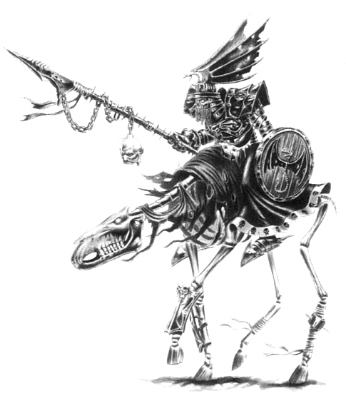

✶ DIRE WOLF 

Dire Wolves have skull-like heads and rotting black fur. Their eyes glow with unnatural light and their bodies dissolve into nothing when they are slain. Doom Wolves, the strongest of the wolves, are specially bred to lead their packs into an unending service of carnage and darkness.

 | Dire Wolf | Doom Wolf
Wounds | 8 | 14
Move | 9 | 9
Weapon Skill | 3 | 3
Ballistic Skill | - | -
Strength | 4 | 5
Toughness | 3 | 4
Armour | - | -
Initiative | 3 | 3
Attacks | 1 | 2
Damage | 2D6 | 2D6
Gold | 250 | 580

ENEMY’S WS 1 2 3 4 5 6 7 8 9 10
Dire Wolf 2 3 4 4 4 4 5 5 5 6
Doom Wolf 2 3 4 4 4 4 5 5 5 6

Dire Wolf
Frenzy 5+; Gang Up.

Doom Wolf
Frenzy 5+; Gang Up.
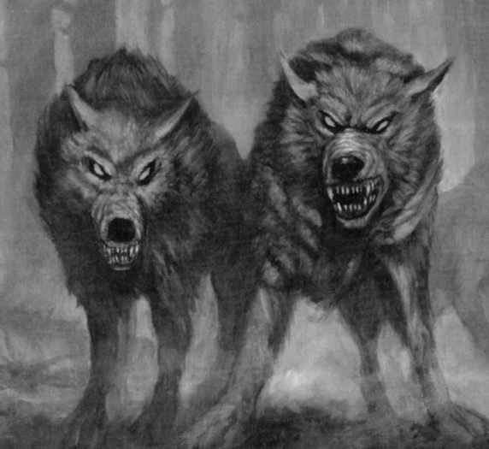

✶ GHOST 

Ghosts are ethereal creatures or spirits, the shades of dead men returned to haunt the land of the living.

 | Ghost
Wounds | 16
Move | 4
Weapon Skill | 2
Ballistic Skill | -
Strength | -
Toughness | 3
Armour | -
Initiative | 3
Attacks | 1
Damage | Special
Gold | -

ENEMY’S WS 1 2 3 4 5 6 7 8 9 10
Ghost 3 4 4 4 5 5 6 6 6 6

Ghost
Chill 1; Ethereal -1; Fear 6.

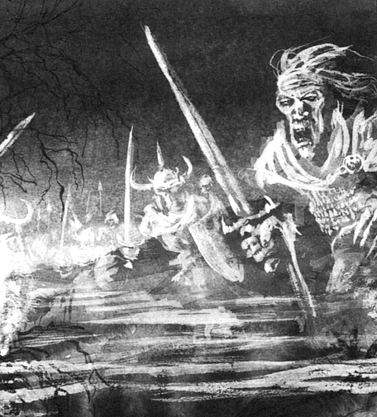

✶ BLACK KNIGHTS 

Black Knights are long-dead warriors who are tied to the land of the living by dark necromantic magic. They ride into battle on undead Nightmares.

 | Black Knight | Hell Knight | Nightmare
Wounds | 14 | 35 | 6
Move | 4 | 4 | 8
Weapon Skill | 3 | 4 | 3
Ballistic Skill | 4+ | 4+ | -
Strength | 3 | 4 | 4
Toughness | 4 (6) | 4 (6) | 3
Armour | 2 | 2 | -
Initiative | 3 | 4 | 8
Attacks | 1 | 2 | 1
Damage | 2D6 | 2D6 | 1D6/2D6 (6+)
Gold | 350 | 650 | 190

ENEMY’S WS 1 2 3 4 5 6 7 8 9 10
Black Knight 2 3 4 4 4 4 5 5 5 6
Hell Knight 2 3 3 4 4 4 4 4 5 5
Nightmare 2 3 4 4 4 4 5 5 5 6

Black Knight
Fear 7.

Hell Knight
Fear 8; Magic Armour; Magic Weapon.

Nightmare
Fear 6.

✶ NIGHTMARE 

Nightmares are carcasses of great warhorses brought back to life by necromantic arts. Balefire glows in their eyes and their decomposed bodies are rotted and foul. The sickening stench of death hangs around them as they gallop into battle, crushing the living beneath their mouldy hooves.

 | Nightmare
Wounds | 6
Move | 8
Weapon Skill | 3
Ballistic Skill | -
Strength | 4
Toughness | 3
Armour | -
Initiative | 8
Attacks | 1
Damage | 1D6/2D6 (6+)
Gold | 190

ENEMY’S WS 1 2 3 4 5 6 7 8 9 10
Nightmare 2 3 4 4 4 4 5 5 5 6

Nightmare
Fear 6.

Nightmares can be ridden by any Necromancers, Black Knights or Vampires.

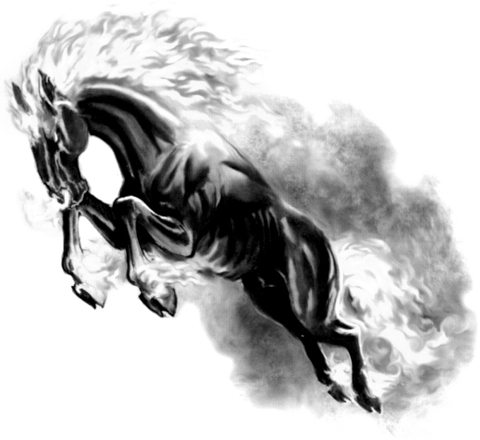
✶ WIGHTS 

Although their bodies are decayed leaving only bones and tattered flesh, Wights are held together by evil magic so strong that it has endured by centuries. They wear ancient battle gear, corroded by time. Their shrivelled and horrific bodies are adorned with golden amulets and rings.

 | Wight | Wight Lord
Wounds | 14 | 35
Move | 4 | 4
Weapon Skill | 3 | 4
Ballistic Skill | 4+ | 4+
Strength | 3 | 4
Toughness | 4 (6) | 4 (6)
Armour | 2 | 2
Initiative | 3 | 4
Attacks | 1 | 2
Damage | 2D6 | 2D6
Gold | 370 | 650

ENEMY’S WS 1 2 3 4 5 6 7 8 9 10
Wight 2 3 4 4 4 4 5 5 5 6
Wight Lord 2 3 3 4 4 4 4 4 5 5

Wight
Fear 7.

Wight Lord
Fear 8; Magic Armour; Magic Weapon.

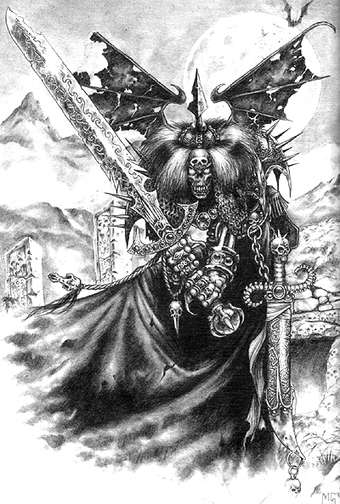

✶ MUMMY 

Mummies are protected by powerful magic to preserve them and cheat death itself. They are deadly opponents, capable of delivering crushing blows upon their enemies.

 | Mummy
Wounds | 40
Move | 3
Weapon Skill | 3
Ballistic Skill | -
Strength | 4
Toughness | 5
Armour | -
Initiative | 3
Attacks | 2
Damage | 2D6
Gold | 450

ENEMY’S WS 1 2 3 4 5 6 7 8 9 10
Mummy 2 3 4 4 4 4 5 5 5 6

Mummy
Fear 7; Tomb Rot (1D3).

Attacking a Mummy with a source of fire causes an extra +1D6 Wounds damage with each hit.

Tomb Rot
Mummies can cause Tomb Rot, their mere presence rotting nearby creature's flesh. Any Warrior who ends the turn adjacent to a Mummy takes an extra 1Dn Wounds (where n is the number in brackets after the Tomb Rot entry), with no modifiers for Toughness or armour. Tomb Rot is Fatal Damage.

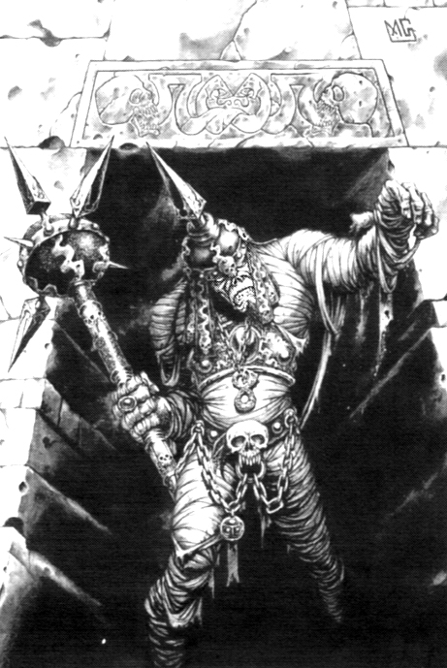

✶ NECROMANCERS 

A Necromancer is an evil wizard with powers over the world of the dead. His magic enables him to extend his own life for centuries and to raise corpses to create Skeletons and Zombies.

 | Necro  mancer | Necro  mancer Champion | Master Necro  mancer | Necro  mancer Lord
Wounds | 25 | 29 | 34 | 39
Move | 4 | 4 | 4 | 4
Weapon Skill | 4 | 5 | 6 | 7
Ballistic Skill | 3+ | 2+ | 1+ | A
Strength | 4 | 4 | 5 | 5
Toughness | 3 | 3 | 4 | 4
Armour | - | - | - | -
Initiative | 3 | 4 | 5 | 6
Attacks | 2 | 3 | 4 | 5
Damage | 2D6 | 2D6 | 3D6 | 4D6
Gold | 680 | 1630 | 2780 | 4100

ENEMY’S WS 1 2 3 4 5 6 7 8 9 10
Necromancer 2 3 3 4 4 4 4 4 5 5
Necromancer Champion 2 2 3 3 4 4 4 4 4 4
Master Necromancer 2 2 3 3 3 4 4 4 4 4
Necromancer Lord 2 2 2 3 3 3 4 4 4 4

Necromancer
Magic Resistance 5+; Magic Weapon; Necromantic Magic 1; Regenerate 2D6.

Necromancer Champion
Magic Resistance 4+; Magic Item x 2; Magic Weapon; Necromantic Magic 2; Regenerate 2D6.

Master Necromancer
Magic Dispel 4+; Magic Resistance 4+; Magic Item x 3; Magic Weapon; Necromantic Magic 3; Regenerate 2D6.

Necromancer Lord
Ambush, Magic A; Magic Dispel 4+; Magic Resistance 4+; Magic Item x 4; Magic Weapon; Necromantic Magic 4; Regenerate 2D6.

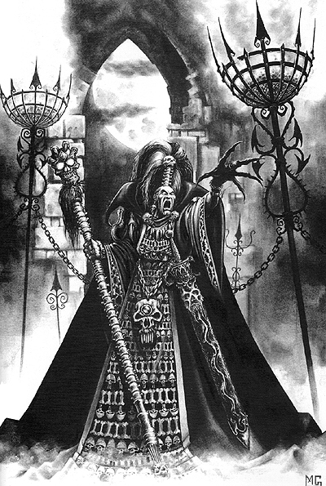
✶ WRAITH 

Continual use of dark magic drains the soul and withers the body, until only an insubstantial husk remains, deprived of its substance and driven by a twisted mind. The victims of such foolishness are called Wraiths. Once they were great men, wizards of considerable power, but now they are just shadows kept between life and death by their own bitterness. Their cloaks give them substance, but nothing remains of their physical bodies. They are dangerous because their chill touch drains life from living creatures.

 | Wraith
Wounds | 30
Move | 4
Weapon Skill | 3
Ballistic Skill | -
Strength | 3
Toughness | 4
Armour | -
Initiative | 3
Attacks | 2
Damage | Special
Gold | 750

ENEMY’S WS 1 2 3 4 5 6 7 8 9 10
Wraith 2 3 4 4 4 4 5 5 5 6

Wraith
Chill 2; Ethereal -1; Terror 8.

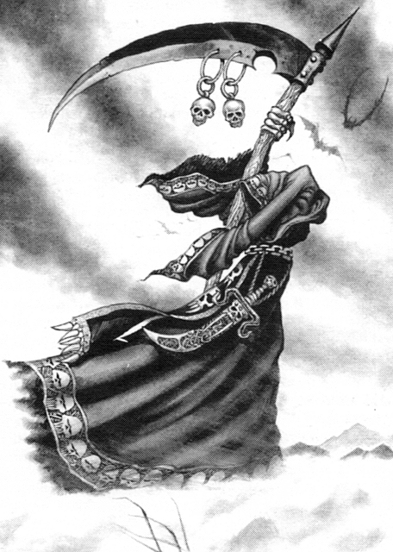
✶ BANSHEE 

A Banshee is a powerful Wraith, who wails constantly in battle. Her wail brings only death and despair to those who hear it.

 | Banshee
Wounds | 38
Move | 6
Weapon Skill | 4
Ballistic Skill | -
Strength | 4
Toughness | 4
Armour | -
Initiative | 4
Attacks | 2
Damage | Special
Gold | 1200

ENEMY’S WS 1 2 3 4 5 6 7 8 9 10
Banshee 2 3 3 4 4 4 4 4 5 5

Banshee
Chill 2; Ethereal -1; Necromantic Magic 1; Terror 8; Wail.

Wail
The Banshee’s wail draws upon the power of the darkest magic and has a deadly effect on those who hear it. At the beginning of each Monsters’ Phase, before anyone casts a spell, the Banshee will begin her wail. Roll 1D6 on the following table.

1 The Banshee’s terrifying wail causes living creatures to age and crumble to dust. Choose a random non-undead model on the board section the Banshee is currently on. The model instantly crumbles to dust and may not be resurrected.

2 The Banshee’s wail invigorates all Undead in the dungeon. For the rest of the turn each Undead model on the board gains an extra Attack. In addition, they shake off any Warrior’s spell effects that they might be affected by.

3 The piercing shriek penetrates the Warriors’ bones. All Warriors on the board suffer a Chill 1 Attack immediately.

4 The wailing strikes fear into all the Warriors. Each Warrior must immediately take a Fear 8 test. If they fail they will be at -1 To Hit as usual. If they are already scared of the Banshee, then they will have a -2 modifier To Hit.

5 The piercing shriek penetrates a random Warrior’s bones. He suffers a Chill 1 Attack immediately.

6 The wailing disrupts the winds of magic. No Warrior may cast a spell for the rest of the turn.

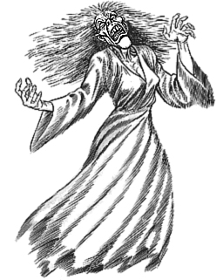

✶ WINGED NIGHTMARE 

A Winged Nightmare is a massive creature assembled from the corpses of powerful monsters such as Manticores, Griffons and Hippogrifs. A Necromancer has to cast many spells to meld and fuse the remains of these monsters into this nightmarish horror.

 | Winged Nightmare
Wounds | 62
Move | 8
Weapon Skill | 4
Ballistic Skill | -
Strength | 5
Toughness | 5 (8)
Armour | 3
Initiative | 2
Attacks | 4
Damage | 4D6
Gold | 2800

ENEMY’S WS 1 2 3 4 5 6 7 8 9 10
Winged Nightmare 2 3 3 4 4 4 4 4 5 5

Winged Nightmare
Fly; Ignore Blows 6+; Ignore Pain 4; Terror 11.

Winged Nightmares can be ridden by any Necromancers or Vampires.

✶ LICHES 

Some Necromancers are powerful enough to defy death and return as evil hearted Liches. Although their flesh is shrivelled and long dead, they are still immensely powerful sorcerers.

 | Liche | Liche King
Wounds | 40 | 63
Move | 4 | 6
Weapon Skill | 7 | 7
Ballistic Skill | A | A
Strength | 5 | 7
Toughness | 4 | 6 (12)
Armour | - | 6
Initiative | 6 | 4
Attacks | 5 | 5
Damage | 4D6 | 6D6
Gold | 3500 | 7500

ENEMY’S WS 1 2 3 4 5 6 7 8 9 10
Liche 2 2 2 3 3 3 4 4 4 4
Liche King 2 2 2 3 3 3 4 4 4 4

Liche
Fear 10; Magic Item x 2; Magic Weapon; Necromantic Magic 3; Regenerate 2.

Liche King
Chaos Magic 2 (choose Chaos God at random); Large Monster; Magic Armour; Magic Dispel 4+; Magic Item x 3; Magic Resistance 4+; Magic Weapon; Necromantic Magic 3; Terror 10.

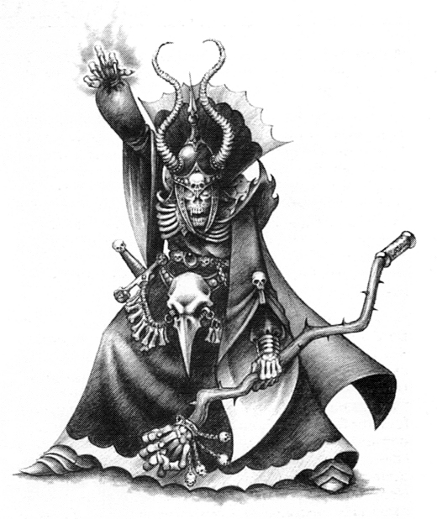
✶ ZOMBIE DRAGON 

Dragons have ruled the skies since time began, and they are fearsome and mighty creatures. When a dragon feels the call of death, it flies wearily off to the Plain of Bones to breathe its last among the bones off its kind. Here the winds of Dark Magic are strong and occasionally a dragon’s massive wings will beat again with unnatural vigour.

 | Zombie Dragon
Wounds | 75
Move | 6
Weapon Skill | 4
Ballistic Skill | -
Strength | 7
Toughness | 6 (14)
Armour | 8
Initiative | 3
Attacks | 6
Damage | 6D6
Gold | 5000

ENEMY’S WS 1 2 3 4 5 6 7 8 9 10
Zombie Dragon 2 3 3 4 4 4 4 4 5 5

Zombie Dragon
Fly; Ignore Blows 4+; Ignore Pain 7; Large Monster; Pestilential Breath; Terror 13.

Pestilential Breath
Zombie Dragons can belch forth a cloud of pestilential corrosive gas that shrivels all it touches. When the dragon attacks roll a 1D6 to see how many Warriors are affected. If the score is greater than the number of Warriors all of them have been affected. Any Warrior affected by the pestilential breath suffers 3D6 Wounds with no deductions for armour. Any Warrior reduced to zero Wounds by this attack suffers from Plague and will therefore lose -1 Toughness when he is healed back to life.

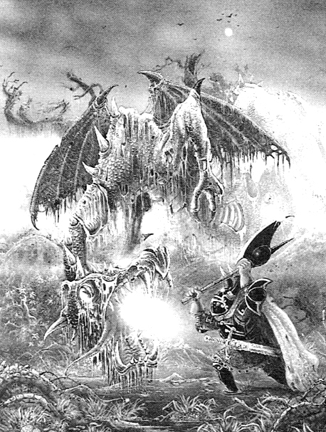

✶ VAMPIRES 

Vampires are human in appearance, but their blood is tainted with supernatural energy. They are undead immortals who must spend the hours of daylight resting in darkness, for strong sunlight burns their flesh and destroys them.

 | Vampire Thrall | Vampire Count | Vampire Lord
Wounds | 26 | 30 | 42
Move | 6 | 6 | 6
Weapon Skill | 6 | 7 | 8
Ballistic Skill | 3+ | 2+ | 1+
Strength | 6 | 7 | 8
Toughness | 5 (8) | 6 (9) | 6 (9)
Armour | 3 | 3 | 3
Initiative | 7 | 8 | 9
Attacks | 3 | 4 | 5
Damage | 2D6/3D6 (5+) | 3D6 | 4D6
Gold | 1850 | 3500 | 4500

ENEMY’S WS 1 2 3 4 5 6 7 8 9 10
Vampire Thrall 2 2 3 3 3 4 4 4 4 4
Vampire Count 2 2 2 3 3 3 4 4 4 4
Vampire Lord 2 2 2 3 3 3 3 4 4 4

Vampire Thrall
Ambush, Magic A, Bloodline Powers; Fly; Magic Resistance 5+; Necromantic Magic 1.

Vampire Count
Ambush, Magic A, Bloodline Powers x 2, Fly; Magic Item; Magic Resistance 5+; Necromantic Magic 2.

Vampire Lord
Ambush, Magic A, Bloodline Powers x 3; Fly; Magic Armour; Magic Dispel 4+; Magic Item x 2; Magic Resistance 4+; Magic Weapon; Necromantic Magic 4.

Bloodline Powers
Vampires originate from the ancient land of Lahmia. When Lahmia was overthrown and destroyed, Vampire nobles fled to different parts of the known world. All the current Vampires are descendants of the original Vampires and have inherited their traits. To determine what family a Vampire belongs to, roll 1D6:

1-2 Von Carstein
3 Necrarch
4 Blood Dragon
5 Strigoi
6 Lahmia

The family a vampire belongs to dictates what Bloodline Powers he has access to and what bonus abilities the Vampire has, if any.

Vampires may make a number of special Attacks each turn depending on the number of Bloodline Powers they have. At the start of the Monsters' Phase roll 1D6 on the appropriate Bloodline table to determine what the Vampire does this turn. Make a roll on this table for each Bloodline Power the Vampire has.

Von Carstein

Of all the Vampire that have ever been known to man, the cursed bloodline of the von Carsteins is the most infamous. Handsome, arrogant, charismatic and proud, the von Carsteins are the true aristocracy of the night.

Von Carstein Vampires have no alterations to their statistics and no additional abilities..

Roll 1D6 to determine what powers the Vampire possesses. If a Vampire has multiple powers and rolls a power he already has, roll again.

1 Summon Bats
The Vampire produces a spine-chilling wail that pierces the darkness and summons the creatures of the night.

The Vampire summons Vampire Bats to his aid. Roll 1D6. On a 1-3 the Vampire summons 2D6 Vampire Bats. On a 4-6 the Vampire summons 1D3 Fell Bats. The summoned Bats are placed immediately and may Move and Attack this turn.

2 Call Winds
The anger of a von Carstein is so powerful that even the weather reflects it; in the form of exceptionally strong winds and storms.

The Vampire summons a wild storm that lasts until the beginning of the next Monsters’ Phase. The storm affects the whole dungeon. The Warriors cannot fire any missile weapons or cast any spells while the wind blows and their hand to hand Attacks are made at -2 To Hit.

3 Walking Death
So powerful is the unholy presence of the Vampire that mere mortals are forced to flee in terror.

All the Warriors must immediately make a Terror test equal to the Dungeon Level the Vampire was encountered on. Any Warriors who fail must immediately roll on the Escaping Table.

4 Summon Wolves
The Vampire produces a bestial howl that awakens the dark creatures of the night and beckons them to his aid.

The Vampire summons Dire Wolves to his aid. Roll 1D6. On a 1-4 the Vampire summons 1D6 Dire Wolves. On a 4-6 the Vampire summons 1D6 Dire Wolves and 1 Doom Wolf. The summoned Dire Wolves are placed immediately and may Move and Attack this turn.

5 Aura of Dark Majesty
The Vampire cloaks himself in a shield of blackness.

All Warriors must subtract -1 To Hit the Vampire. The Aura lasts until the start of the following Monsters’ Phase. The Vampire regains 3D6 Wounds as a result of being enveloped in the Aura.

6 Wolf Form
Seeing his life slipping away, the Vampire change into the form of a massive black wolf and flees into the darkness.

Re-roll this ability if the Vampire has more than 10 Wounds left. If the Vampire has 10 or less Wounds remaining, he will shape shift into a Great Wolf and flee the battle; the Warriors do not receive any Gold or Treasure for him. In the next combat the Warriors are involved in, roll 1D6. On a roll of 5-6 the Vampire will be there, with full Wounds. Keep rolling every combat until the end of the adventure to determine if the Vampire returns to seek vengeance on the Warriors.

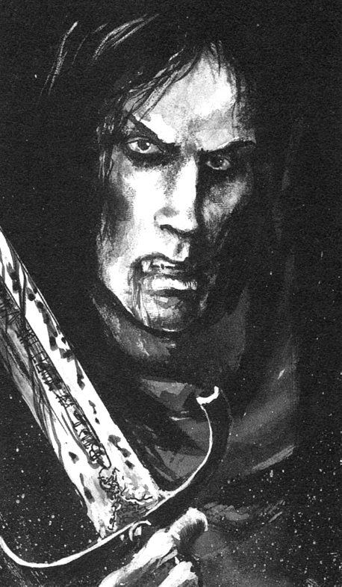

Necrarch
Necrarchs are perhaps the most terrifying of all the lords of the night. Most Vampires retain their human features when they join the ranks of the Undead, but something in the blood of the Necrarchs is tainted and foul. Their physical corruption begins as soon as they become Undead. Skeletal and reeking with a foul stench, the Necrarch Vampires are truly a horrifying sight.

Necrarchs can never fail to cast a spell; reroll any failed spells. They also have -2 Weapon Skill and cannot wear any armour; reduce their stats accordingly.

Roll 1D6 to determine what powers the Vampire possesses. If a Vampire has multiple powers and rolls a power he already has, roll again.

1 Noble Blood
The secrets of Necromantic lore are found in the cursed scrolls hidden in the lairs of the oldest Lords of the Necrarch family.

The Vampire may immediately cast 1D3 random Chaos Magic spells in addition to any other spells he casts this turn.

2 The Awakening
The Vampire senses the remains of long-dead warriors and awakens them to help in the battle.

The Vampire summons Skeletons to his aid. Roll 1D6. On a roll of 1-3, the Vampire summons 2D6 Skeletons. On a roll of 4-6, the Vampire summons 1D6 Grave Guard. The Monsters can Move and Attack this turn.

3 Dark Acolyte
Dark magic flows strongly in the veins of this Vampire of the ancient Necrarch family.

The Necrarch drains power from enemy spellcasters. Warriors may not cast any spells next turn. In addition, any spell casting Warriors must lose 1D6 points of stored Power.
4 Supernatural Horror
So corrupted are Necrarchs’ souls that their bodies reveal on the outside all the evil hidden in their veins.

All the Warriors must immediately make a Terror test equal to the Dungeon Level the Vampire was encountered on. Any Warriors who fail must immediately roll on the Escaping Table.

5 Master of the Black Arts
Who can match the magical ability of a creature so ancient that it’s teacher could have been the Great Necromancer himself?

Any spells that the Necrach Vampire casts this turn have their damage maximized. Any spells that effect the Warrior on a single dice roll have the dice roll required to work doubled. Any spells with a durations or that make the Warriors lose Attacks or statistics have their effects doubled. Any Monsters summoned have an additional 1D3 added to the total Monsters summoned.

6 Forbidden Lore
Long must one study to gain knowledge of the nether world, but time is no worry to an undying scholar.

The Vampire can cast an additional 1D6 Necromantic spells this turn. Any spells the Vampire casts this turn cannot be dispelled, resisted or negated in any way.

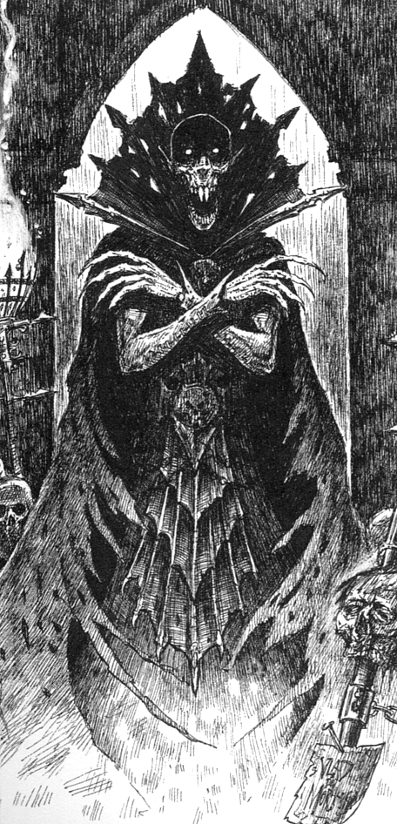
Blood Dragon
Once the knights of the Order of the Blood Dragon were the noblest of the Knightly Orders of the Empire, respected by all it’s defenders. Now Vampires, the Blood Dragons are unequalled swordsmen. Their entire being is devoted to war and death, always striving to become the perfect warrior.

Blood Dragons have an additional +2 Weapon Skill due to their skill in combat, but will fail to cast a spell on a roll of 2-4. All Blood Dragon Vampires will be armed with a Magic Weapon.

Roll 1D6 to determine what powers the Vampire possesses. If a Vampire has multiple powers and rolls a power he already has, roll again.

1 Red Fury
The Vampire enters the combat as he has always done in centuries past with a savage and unstoppable bloodlust.

All Attacks made by the Blood Dragon automatically hit this turn.

2 Blademaster
Trained by the best swordsmen of different periods and cultures, the Blood Dragon easily deflects the blows from his puny enemies.

The Vampire automatically deflects any hand to hand Attacks made against him during the next Warriors' Phase. Spells and ranged attacks are made as usual.

3 Heart Piercing
Using a combination of great strength and amazing speed, it is easy for the Vampire to create a gap in his opponent’s guard.

The Blood Dragon may make a single Attack against every adjacent Warrior. If any of these Attacks hit, do damage as usual, and roll 1D6. If a 6 is rolled, the Blood Dragon has managed to pierce the Warrior's Heart, killing him instantly.

4 Master Strike
So strong is the lord of the night that a well placed blow from his sword can sever a limb or decapitate the toughest opponents.

For each Attack that hits a Warrior, he must pass a Toughness (not Armour) test of 7 or more, or lose 1 Starting Wound, permanently.

5 Strength of Steel
Such is the Vampire’s martial prowess that he is able to strike at the precise moment when it will cause the most carnage.

All of the Vampire's attacks this turn cause double damage.

6 Honour or Death
Many mortal champions quickly change their attitude after the proud challenge they issue is accepted by a dark creature whose eyes are the eyes of death.

The Vampire issues a challenge to a random Warrior on the same board section. The Warrior can either refuse or accept the challenge. If he refuses, he must begin the next adventure with no Luck points. If the Warrior accepts the challenge of the Vampire, place the Vampire model adjacent to the Warrior, moving other models out of the way if neccessary. The Warrior must Attack the Vampire each turn if possible and vice versa, although the Vampire may still use Bloodline Powers to Attack other Warriors if appropriate. If the Warrior moves away from the Vampire, the Vampire will always attempt to move towards the Warrior during the Monsters' Phase if he is not Pinned. If the Warrior kills the Vampire who offered the challenge, he receives double Gold and an extra point of non-permanent Luck. If the Warrior is killed by the Vampire, the challenge is over; the Vampire will attack normally next turn. If the Vampire has already issued a challenge to another Warrior reroll this power.

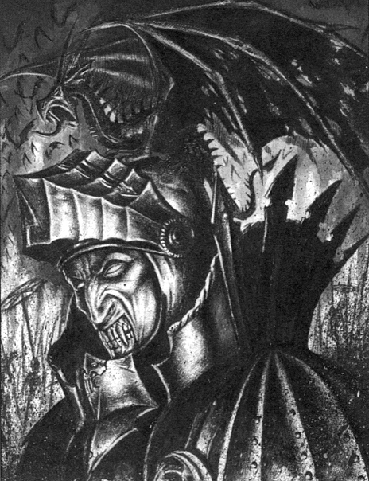

Strigoi
Shunned by their own kind, following the destruction of their homeland by Orcs, they were driven away to the borders of human society. There they were able to scavenge recently buried corpses and feed on the cold blood of the dead. Slowly they transformed into grotesque creatures, more like ghouls than the humans they previously resembled. Strigoi Vampires are often referred to as Ghoul Kings.

Strigoi Vampires Hate All, meaning they get +1 Attack but all their Attacks are at -1 To Hit. Due to their resilience they have Ignore Blows 6+. They cannot be encountered riding a mount of any sort. Reroll this family if the Vampire encountered is riding a mount.

Roll 1D6 to determine what powers the Vampire possesses:

1 Curse of the Revenant
So strong is the desire for some to continue living that they defy death. This has a price though - the eternal thirst for the blood of the living.

The Vampire regenerates 3D6 Wounds, even if the total goes above the Vampire's Starting Wounds.

2 Massive Monstrosity
Such is the size of some of the more ancient Strigoi that a blow which would kill a normal creature is but a mere scratch to these gigantic beasts.

The Strigoi Vampire may immediately make one Attack against every single Warrior on the board section as he uses his massive stature to charge into their ranks, sending them scurrying for a defensive position. Each Attack that hits does 5D6 + Strength damage. In addition, the Vampire gains the Ignore Blows 4+ ability until the next Monsters' Phase.

3 Bat Form
Seeing the tide of battle turning against him, the Strigoi wraps the power of darkness around him and changes into a giant bat. He makes a hasty escape into the shadowy depths of the dungeon.

Re-roll this ability if the Vampire has more than 10 Wounds left. If the Vampire has 10 or less Wounds remaining, he will shape shift into a Vampire Bat and flee the battle; the Warriors do not receive any Gold or Treasure for him. In the next combat the Warriors are involved in, roll 1D6. On a roll of 5-6 the Vampire will be there, with full Wounds. Keep rolling every combat until the end of the adventure to determine if the Vampire returns to seek vengeance on the Warriors.
4 Infinite Hatred
The Strigoi know no love, shunned by all, they brood in their solitude vowing death upon all they meet.

The Vampire targets a random Warrior within Line of Sight, and vents out his hatred upon him by leaping towards his throat. Make 1 To Hit roll against the targetted Warrior, with a -1 penalty. If the Vampire hits, place him in an adjacent square, moving other models out of the way if required. The Attack does 3D6 Wounds, unmodified for anything. The Strigoi adds any Wounds caused to his current Wounds total, even if it takes him higher than his starting Wounds. If the Warrior is reduced to 0 Wounds by this Attack, he immediately wakes up as a Vampire Thrall and may Move and Attack this turn. Any Vampires created in this way will automatically be of the Strigoi Bloodline.

5 Summon Ghouls
The Vampire bellows a guttural cry which can be heard by his flesh eating minions. These creatures are slaves to the authority of the Ghoul Kings.

The Vampire summons 2D6 Ghouls to his aid. They may Move and Attack this turn.

6 Iron Sinews
After death, the Vampire’s muscles grow far greater than they ever could have in mortal life. The Strigoi becomes a beast of pure muscular power.

All Attacks made by the Strigoi this turn are at maximum damage.

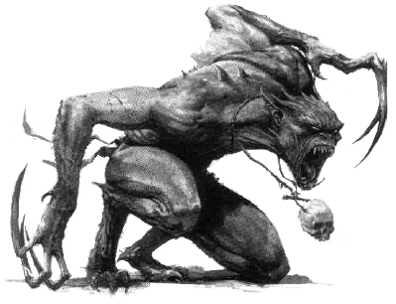

Lahmia
Lahmian Vampires are enchantingly beautiful and despise men. They specialise in cunning and intrigue. No other Vampires excel in infiltrating human society in the same way as the shadowy Vampires of Lahmia.

Lahmia Vampires have -1 Weapon Skill and +2 Initiative.

Roll 1D6 to determine what powers the Vampire possesses. If a Vampire has multiple powers and rolls a power she already has, roll again.

1 Seduction
How can a mortal resist the lure of a creature who has preyed on warm blooded males since the dawn of time?

Randomly choose a Warrior in hand to hand combat with the Vampire. That Warrior must pass a Willpower test of 10 or be seduced by the Vampire. While seduced, the Warrior will attack a random Warrior, believing him to be the enemy. The Warrior will use whatever weapons and armour he was equipped with when he as seduced and may not use any other items of equipment. At the end of each turn the Warrior must make a Willpower test and score 10 or more to break free from the Vampire’s seduction.

2 Charmed Allies
With a serene, almost musical voice, the Lahmian Vampire calls to the shadows, where her Vampire allies have awaited her call.

The Vampire has charmed her way into the hearts of many over her long life, calling upon them to sacrifice their lives in her name when she is in danger. Re-roll this ability if the Vampire has more than 10 Wounds left. If the Vampire has 10 or less Wounds remaining, she will call out to her charmed ones for aid. While the Warriors are distracted by the new enemies, she will turn into mist and make a hasty retreat. Remove her from the board; the Warriors do not receive any Gold or Treasure for her. In the next combat the Warriors are involved in, roll 1D6. On a roll of 5-6 the Vampire will be there, with full Wounds. Keep rolling every combat until the end of the adventure to determine if the Vampire returns to seek vengeance on the Warriors. To see what allies come to her aid, roll once on the Battle Level table one level higher than the Warriors. These Monsters are placed immediately and may Move and Attack this turn.

3 Quickblood
The Vampire moves extremely quickly, her physical image a mere blur to the Warriors as they try in vane to land a blow.

The Vampire may automatically ignore the next 2 ranged or melee attacks that hit it during the next Warrior's Phase. She may make an additional Attack against all adjacent Warriors this turn. This Attack can not be Dodged.

4 Mist Form
The Lahmian Vampire changes her shape into a whirl of mist.

The Vampire changes into mist form. While in mist form, she can not be hit by any weapons other than magical ones, has a Move value of 10 and cannot be pinned. In the Monsters’ Phase she will move out of hand to hand combat with the Warriors and revert to human form.

5 Transfix
The eyes of the Vampire are two deep pits where a mortal can find his doom. The victim can do nothing but stare at the deadly Vampire preparing to strike.

The Vampire transfixes one of the Warriors with his steely glare. Draw a Warrior counter to determine who is affected. Roll 1D6 and add that Warrior's Initiative. If the score is 11 or less he is transfixed for 1 turn. While transfixed the Warrior may do absolutely nothing and any Monster in combat with him automatically hits.

6 Lightning Reflexes
The body of a Vampire looks human, but is capable of reactions so fast that even the quickest swordsman would look clumsy in comparison.

After the Vampire has had her turn, roll 1D6. On a roll of 5-6 she may take another turn immediately. This includes rolling on the Bloodline table, casting a new set of spells, making more Attacks, etc.

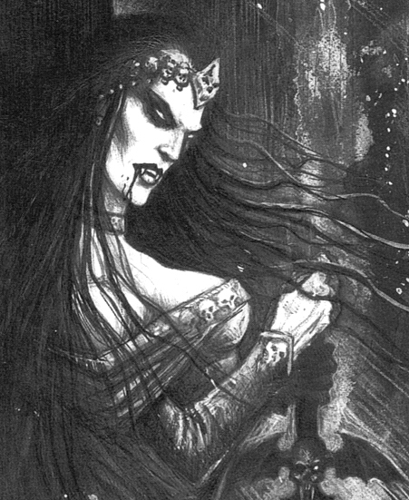
Necromantic Magic
Necromancers specialise in casting magic of Death - Necromantic Magic. To see what spell the Necromancer casts when given the chance, roll 2D6 on the following table. Vampires can also cast Necromantic Magic. When a Vampire casts a spell, replace spells 10, 11 and 12 with the alternative versions indicated. If the Necromancer or Vampire is killed while they still have active spells in play, they will immediately be dispelled.

2 FAILURE
The caster fails to cast a spell.

3 WINDS OF DEATH
This spell creates a cold wind sweeping through the dungeon. Because they are so cold, reduce all of the Warriors’ Attacks by -1 for the next Warriors’ Phase.

4 SOUL DRAIN
The caster attempts to drain the soul from a random Warrior. The affected Warrior takes 2D6 Wounds damage with no modifiers for Toughness or armour.

5 DEATHCHILL
The caster targets a random Warrior with the deathchill, reducing his Toughness by -2. If this reduces his Toughness to zero he is killed and may not be healed by any means except spells and magic items, etc. that can resurrect the dead. If the caster and all of his followers are destroyed, any Warriors whose Toughness has been reduced in this combat and are still alive have the damage to their Toughness restored.

6 GAZE OF NAGASH
A random Warrior is targeted by this spell. Roll 1D6. If he rolls a 1 then the gaze penetrates his soul, destroying it. The Warrior is dead and cannot be healed or resurrected.

7 HAND OF DUST
The caster reaches out and touches a random adjacent Warrior. Roll 1D6 for the Warrior and add his Strength. Then roll 2D6 for the caster and add his Strength. If the caster scores higher, the difference is the amount of Fatal unmodified Wounds the Warrior takes. If the Warrior is killed by this spell he is turned into a Wight. If the Warrior scores higher then he is unaffected by the deadly touch.

8 VANHEL’S DANSE MACABRE
All Undead models on the board except for the caster can have two turns. They take their second turn after each Monster has had their first turn.

9 THE CURSE OF YEARS
Screaming, the caster curses a random Warrior. Roll 1D6 for the Warrior. On a score of 1, the Warrior immediately loses 1 Battle Level. Reduce his skills and statistics accordingly.

NECROMANCER

10 SUMMON SKELETONS
The Necromancer summons 6 Skeletons. They may be placed on the board immediately and may Move and Attack this turn.

11 SUMMON ZOMBIES
The Necromancer summons 6 Zombies. They may be placed on the board immediately and may Move and Attack this turn.

12 SUMMON MUMMIES
The Necromancer summons 1D6 Mummies. They may be placed on the board immediately and may Move and Attack this turn.

VAMPIRE

10 SUMMON GHOSTS
The Vampire summons 1D6 Ghosts. They may be placed on the board immediately and may Move and Attack this turn.

11 SUMMON WIGHTS
The Vampire summons 1D6 Wights. They may be placed on the board immediately and may Move and Attack this turn.

12 SUMMON WRAITHS
The Vampire summons 1D3 Wraiths. They may be placed on the board immediately and may Move and Attack this turn.

