

·A SPIDER’S TOUCH·

by Michael Brockhouse

Location: Lustria Battle-Level: 1-2 Objective Room: Any three

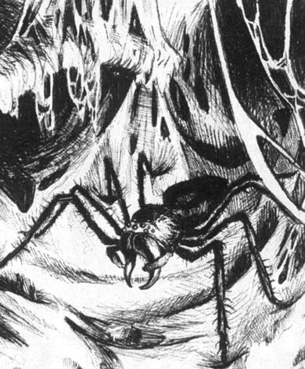

From the look of things around them, the Warriors guess that the tavern is closing for the night as the many patrons gather their belongings, toss coins onto the table for the barkeep and head up stairs to their rooms. Unfortunately for the Warriors, the small, mosquito infested village does not have any rooms left, and the Warriors are forced to head back out onto the road in order to locate a hospitable village for the night.

As they turn to leave, the barkeep steps in front of them and holds his hand out to stop them from going anywhere. “Wait a second, there adventurers, I would ask a boon of you. In exchange for this task, I’ll put in a good word for you at the next settlement, you’ll get good treatment there, on my honour. If you head east, you will reach the logging village of Umbria within a few hours of travel. However, I must warn you, the path is not well travelled anymore, and since the summer storms blew in last month, the area has been infested with dangerous swamp dwelling creatures. Patrols often found human bodies sucked dry of any bodily fluids, and husks hanging limply in the winds from tress covered in think strands of web. The humidity has bought great populations of spiders to the region, and it is not safe to travel any more. Normally the spiders in these parts keep to themselves and feed on culchan and wild boar, but the populations have increased tenfold over the last month and hunger has driven them to attack our village and Umbria. Many mothers have had babies and children stolen away into the night. Scouts have reported three small copses of trees to the east of here, in between our two villages, where the spider concentration seems to the most intense. Please, will you search the jungles for these copses and locate the Queen Spider and burn her from the face of the earth?”

The barkeep informs the Warriors that he has been authorised by the chief of the village to give you supplies for the journey and what you may encounter within the depths of the swampy jungle. He also asks that after they have completed the deed, they take the head of the Queen to the chief of Umbria, where he will reward you for your efforts and you will receive a warm welcome indeed! The Warriors gather their gear and head off into the swampy depths of the jungle…

SPECIAL RULES

The Warriors begin the adventure with 1 Poison Antidote each (see Deathblow number 1) and a small vial of acid, which the barkeep said when broken open onto spider webbing will instantly dissipate the web. When helping a Warrior break free from Webbing, a Warrior may use the vial automatically to break the other Warrior from Webbing. A Warrior can not use the vial when he himself is Webbed.

The scout’s directions are true, and within a few hours (1 roll on the Lustrian Hazards table), the Warriors come to a massive thicket of jungle trees that have been twisted with age and spider silk. Searching more closely, the Warriors discover not one, but three cave entrances leading into the depths of inky blackness, where small beady red eyes gleam out at them with malice. No wonder the spider population is so high, it would appear that as well as the current Queen that lives in the area, the storms have bought two new spider Queens to the region! The Warriors are going to have a hell of a time cleaning this up!

The Warriors can chose to enter whatever cave they wish to first. Each cave consists of 6 board sections. The Objective Room is shuffled randomly into the last 3 cards of each. Each cave system is home to a different Spider Queen.

The Tarantula’s cave

This cavern complex is full of hand sized hairy spiders that keep dropping onto the Warriors from above and crawling underneath their feet. Whenever the Warriors enter a new board section, each Warrior must roll 1D6. On a roll of 1 or 2, they have been bitten by a hairy spider, and must take 1 Unmodified Wound. This damage is considered Poison.

Upon reaching the Objective Room, the Warriors will come face to face with a massive Tarantula that stands as tall as a Minotaur and twice as long as a horse! The room is packed full of bloated cow and horse bodies, riddled with disease ridden puckered holes on their misshapen, shrivelled bodies. The Warriors must fight disease as well as the Giant Tarantula and his 2D6 Giant Spider babies. At the start of each of his turns, the Warrior must roll 1D6. On a roll of 1, he is overcome with the stench of the disease and poisoned ridden bodies and must subtract –1 on all his to hit rolls this turn.

Monstrous Tarantula
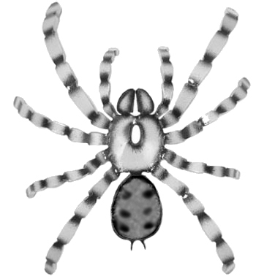
Wounds | 31
Move | 4
Weapon Skill | 5
Ballistic Skill | -
Strength | 4
Toughness | 4 (5)
Armour | 1
Initiative | 1
Attacks | 2
Damage | 2D6
Gold | 550

ENEMY’S WS 1 2 3 4 5 6 7 8 9 10
Monstrous Tarantula 2 2 3 3 4 4 4 4 4 4

Monstrous Tarantula
Fear 5+; Paralysis; Poison.
The Orb Weaver Queen’s cave

Whenever the Warriors encounter Monsters, roll 1D6. On a roll of 1 to 3, there is also 1D6 Giant Orb Weavers in the battle. Once the Warriors reach the Objective Room, they will find the Orb Weaver Queen waiting for them!

The Weaver Queen is a beautiful specimen and would inspire awe if not for the sheer amount of cocooned bodies hanging from the walls and roof of this room. The room is infested with giant spiders! The Warriors must fight 12 Giant Orb Weavers and the Orb Weaver Queen.
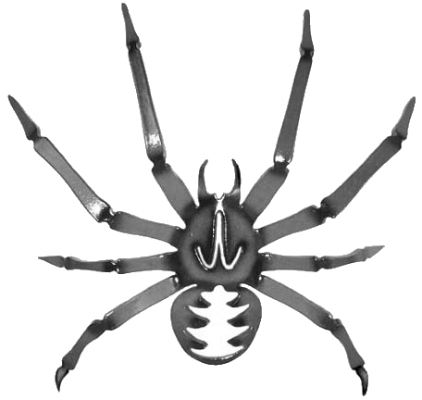
 | Giant  Orb Weaver | Orb Weaver Queen
Wounds | 1 | 16
Move | 6 | 6
Weapon Skill | 2 | 3
Ballistic Skill | 5+ | 3+
Strength | 1 | 3
Toughness | 1 | 3
Armour | - | -
Initiative | 2 | 3
Attacks | 1 | 2
Damage | Special | Special
Gold | 15 | 450

ENEMY’S WS 1 2 3 4 5 6 7 8 9 10
Giant Orb Weaver 3 4 4 4 5 5 6 6 6 6
Orb Weaver Queen 2 3 4 4 4 4 5 5 5 6

Giant Orb Weaver
Poison; Web* (1D3+1).

*The Orb Weaver’s web attack can be used either ranged or in melee. Orb Weavers are placed as if they were missile troops.

Orb Weaver Queen
Cocoon (1D6); Discern Prey; Poison

Cocoon
Cocoon is a more powerful version of Web. When the Orb Weaver Queen successfully Webs a Warrior, she may immediately feed on it for 1D6 Unmodified Poison Damage. This is in addition to any further damage she may cause due to further attacks. In addition, after each web attack after the Warrior has been webbed, roll 1D6. If the result is a 6, the Orb Weaver has successfully cocooned the Warrior completely and sends it up to the ceiling where she can feast on it at her leisure. That Warrior may take no further part in the battle and can only be released after all Monsters in the dungeon are destroyed.

Discern Prey
The Orb Weaver has a talent for choosing the weakest opponent and trying to subdue them before tackling its trickier meals. Every Attack it makes will be at the Warrior with the lowest number of Wounds. If there is a choice, decide randomly.

The Jumping Spider Queen’s cavern

Whenever the Warriors encounter Monsters, roll 1D6. On a roll of 1-3, there is also 1D6 Giant Jumping Spiders in the battle. Once the Warriors reach the Objective Room, they will find the entire royal family of Jumping Spiders ready to feast on their entrails.

There are 3 Great Jumping Spiders in the Objective Room, as well 12 Giant Jumping Spiders!

 | Giant  Jumping Spider | Great Jumping Spider  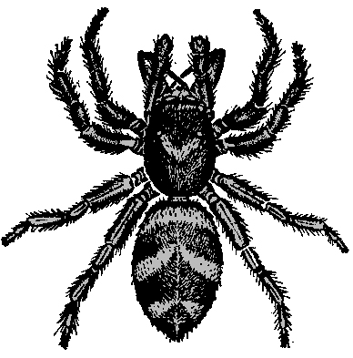
Wounds | 2 | 10
Move | 9 | 8
Weapon Skill | 2 | 4
Ballistic Skill | - | -
Strength | 1 | 3
Toughness | 2 | 4
Armour | - | -
Initiative | 3 | 4
Attacks | 1 | 2
Damage | 1D6 | 1D6
Gold | 15 | 150

ENEMY’S WS 1 2 3 4 5 6 7 8 9 10
Giant Jumping Spider 3 4 4 4 5 5 6 6 6 6
Great Jumping Spider 2 3 3 4 4 4 4 4 5 5

Giant Jumping Spider
Ambush 3+; Bounce, Dodge 6+; Never Pinned.

Great Jumping Spider
Ambush A; Bounce; Dodge 5+; Never Pinned; Poison.

Additional Rules

The Warriors receive Dungeon Room treasure at the end of each Objective Room as for a normal battle. However, if they manage to clear out all three spiders’ lairs, each Warrior may take an Objective Room Treasure Card.

The Warriors can give up and continue their journey to Umbria if they wish at any time. Travel to Umbria takes 1 roll on the Lustrian Hazards table. When they arrive, the chief will give each Warrior 1D3 x 100 Gold for each Spider’s head (or for all three of the Jumping Spider’s heads). From here, the Warriors can chose to journey to another settlement, or they can end their journey here. No matter where they travel, the barkeeper has indeed kept his promise, and word of the Warrior’s spider slaying deeds have reached the population. The Warriors need not pay Living Expenses this stay.

