

·CULCHAN CAPERS·

by Andrew Brockhouse

Location: The Lost Kingdoms Battle-Level: 2-4 Objective Room: Any

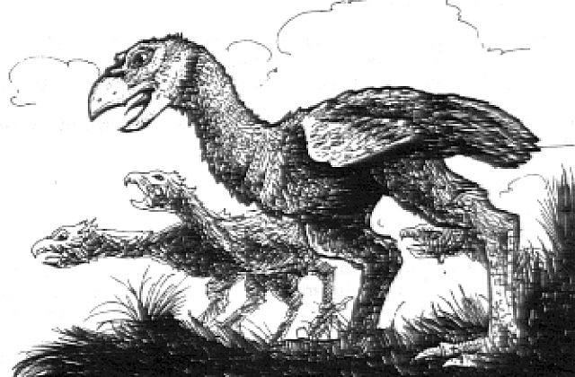

Culchans are flightless birds, prized by Pygmies and Lizardmen for their brightly coloured feathers, used for adorning weapons and helmets. They are extremely fierce and can rip chunks of flesh from the bodies of humans using their sharp beaks. A recent treaty with the Pygmies has resulted in a business deal for a local Merchant, Ali Hal-Ebay. In exchange for vast riches from surrounding temples, Ali has to supply the Pygmies with Culchan. However, even before delivering the first group of Culchan, bad luck has struck Ali - the Culchan have somehow managed to break out of their cages and escape. Ali has hired the Warriors to search for the Culchan and bring them back at all costs, otherwise his business deal will be in jeopardy. A fee of 200 Gold will be paid to the Warriors for each Culchan brought back alive. The Culchan were last spotted heading towards a nearby temple so that is where the Warriors must being their search.

SPECIAL RULES

Before dungeon exploration begins, roll 1D6. This is the amount of Culchan that the Merchant has somehow let escape. In each Dungeon Room the Warriors encounter roll 1D6. on a roll of 4-6 a Culchan lies in the corner in addition to the rooms normal events. To capture a Culchan, fight a battle as usual except that when it is reduced to 0 Wounds, it is knocked unconscious instead of killed (unless of course a spell or magic weapon kills the Culchan outright, eg by decapitation etc). Warriors still receive Gold for a Culchan knocked unconscious, but no Treasure Card. To return the Culchan to the Merchant, the Culchan must be carried or dragged along by the Warrior. A Warrior may only carry a maximum of 2 Culchan at a time, and while doing so his Move is reduced by –1 for each one he is carrying. In addition, he may not use two-handed weapons, shields and anything else that requires the use of 2 hands. Warriors with a Sterength of 2 or less can only carry 1 Culchan at a time. In addition, Wizards may not cast any spells while carrying a Culchan. In combat, a Warrior is assumed to have deposited any Culchan he is carrying in the corner of the room and can pick them up again after the battle has finished.

If at anytime during the adventure the Warriors encounter any Pygmies, they may hand over any captured Culchans directly to them instead of fighting them in a battle, but will not receive any payment for it. The Pygmies will, however convey a message to other Pygmies that the Warriors are undertaking a mission to capture Culchan for them; any other Pygmies encountered during this adventure will not attack the Warriors.

If the Warriors manage to reach the Objective Room without having captured all of the Culchan, then the remainder will be there, along with normal Objective Room Monsters.

Completion

The Warriors must travel back to a City in order to hand the Culchans over to the Merchant. The journey time is increased by 1 week for each captured Culchan there is in the party.

