

·ESCAPE!·

by Andrew Brockhouse

Location: The Old World Battle-Level: 1-2 Objective Room: Special

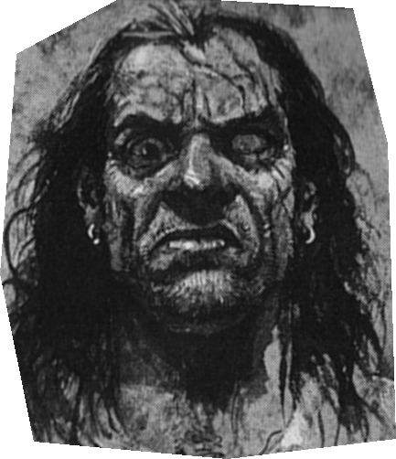
With a groan, the Warriors slowly awake from their deep sleep. Puzzled, they stand and look around. What is this place? How did they get here? Slowly they come to their senses and begin to recall the events of the previous night.

After spending the night drinking and gambling in the local Alehouse, the Warriors can remember being approached by one ‘Mad Dog McGee’, a vicious looking criminal renown for the ‘sculpture’ he can perform on people with an iron bar… He challenged the Warriors to an arm-wrestle contest, with the winner being allowed to keep their life. With no option but to accept, the Warriors begun the contest. Little did they know that Mad Dog McGee had an arm made of solid metal – the contest was won before it had even started. The last thing the Warriors heard before being knocked unconscious was the cruel laughter of Mad Dog McGee.

SPECIAL RULES

This adventure begins differently than normal adventures. When Mad Dog McGee knocked the Warriors unconscious he piled them up on a cart and took them to a nearby dungeon, depositing them in the Objective Room. Draw a random Objective Room card to determine where the Warriors begin the adventure. Construct a dungeon deck consisting of 12 dungeon cards, but since the Warriors begin their adventure in the Objective Room, do not shuffle an Objective Room card in with them.

As the Warriors look around, they see small scurrying shapes in the darkness. Suddenly they are set upon by 1D6 Chaos Rats goaded into combat by 2D6 Skaven Clanrats. Fight a battle as normal, except at the completion of the combat, take Objective Room treasure. Now the Warriors must escape the dungeon!

When the last dungeon card is turned over, Mad Dog McGee will be waiting for them in the entrance of the dungeon. “I told you I would kill you, now I have come to end your miserable lives.” Mad Dog McGee has the statistics below.

 | Mad Dog McGee
Wounds | 30
Move | 4
Weapon Skill | 4
Ballistic Skill | 5+
Strength | 5
Toughness | 4
Armour | -
Initiative | 2
Attacks | 2
Damage | 1D6/2D6 (6+)
Willpower | 2
Gold | 600

ENEMY’S WS 1 2 3 4 5 6 7 8 9 10
Mad Dog McGee 2 3 3 4 4 4 4 4 5 5

Mad Dog McGee
Armed with Warhammer; Ignore Pain 2.

Armed with Warhammer
If Mad Dog McGee rolls a 6 to hit, the Warhammer causes an extra 1D6 damage.

If the Warriors manage to kill Mad Dog McGee, they can leave the dungeon and return to the Settlement. Little did they know, but there was a bounty on Mad Dog’s head for murder! The total bounty is worth 800 Gold.

