

·FOR THE KING!·

by Ben Head

Location: The Old World Battle-Level: 2-10 Objective Room: Any

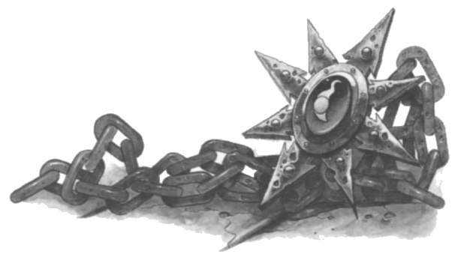

The Warriors have been summoned to the city of Gisoreux. They are quickly ushered inside a great hall by the King’s guards. Before long the King enters, his bloated form telling of a lifetime of luxuries. The King tells the Warriors he has a task for them; they are to venture into the mountains and retrieve an object of great value, a talisman, from within a deep dungeon. It is rumoured that the evil wizard of the dungeon has died and his talisman is there for the taking. He doesn’t really explain the talisman further other than it originated from the temples of Lustria.

As the King continues talking another group of adventurers walks into the hall, four of them in total (dependent on the amount of Warriors). Randomly select four other Warriors equivalent to the Warriors Battle Level.

“Oh yes” the King interrupts himself, “I am sending in two groups of Warriors because of the importance of the talisman, I’m sure you can divide the booty, and my reward money of 1000 gold!” At that both groups look at each other with narrowed eyes.

The King explains the general position in the mountains and says to start immediately!!

As soon as the Warriors reach the foot of the mountains the second group of adventurers runs off into the mountains. Although the Warriors give chase they lose them amongst the rocky boulders and cliffs. Realizing they must get to the dungeon first they head off.

SPECIAL RULES

Roll 1D6 times on the next table.

1 A random Warrior loses his footing climbing a steep cliff. Each Warrior can try and grab his arm with an Initiative test of 7, in which case he is pulled to safety. If his fellow adventurers fail, he tumbles down the cliff banging his head on protruding rocks until he hits the bottom. He takes 3D6 damage.

2 The Warriors are set upon by wandering monsters. Fight a battle.

3 A random Warrior is hit with an arrow fired from the above cliffs if he cannot beat an Initiative test of 8. The arrow inflicts 1D6 + 4 damage. The Warriors are sure they could make out what looks like one of the other Warriors from the opposing group up there.

4-6 The Warriors travel through the rocky cliffs unhindered.

Once the Warriors reach the dungeon they can see footprints around its entrance. Cursing their luck they venture in ready for anything.

Play a normal dungeon with the following changes.

Entering a Dungeon Room
When entering a Dungeon Room, roll 1D6. On a 4-6 treat the room as normal. On a 1-3 the other party of Warriors is there rifling through the rooms booty. They look up as the Warriors approach and give one warning to them to leave the dungeon now or die! If the Warriors remain, fight a battle with them. Before the battle take one Treasure Card for each of the enemy Warriors. They will use their treasures if they can and once slain these treasures can be taken in place of the normal treasure rewarded for a battle. The other Warriors are also worth 200 Gold per Battle Level.

Entering a Corridor
When entering a corridor and the 1-3 result hasn’t been rolled above, roll 1D6. On a 1-2 the other Warriors have set a trap in this room by placing a spring-loaded dagger on the far wall. It fly’s towards a random Warrior hitting if an Initiative roll of 8 isn’t made. It inflicts 1D6+2 damge.

Entering the Objective Room
Upon entering the Objective room, place a Chaos Sorcerer appropriate to the Dungeon Level at the rear of the room.

“The rumours of my death are grossly over rated,” he says with a wry smile, as the Warriors enter.

Place Objective Room Monsters as normal. Roll 1D6 if the other Warriors haven’t been encountered in the dungeon yet. On a 4-6 the Warriors can see them slain at the sorcerers feet.

Once the battle is over, the Warriors snatch the talisman. If the other Warriors still haven’t been encountered in the dungeon yet roll 1D6. On a 1-5 they come bursting into the room, and seeing that the Warrior already have the talisman they demand that they give it to them. If the Warriors refuse, then fight a battle. Before the battle take one Treasure Card for each of the enemy Warriors. They will use their treasures if they can and once slain these treasures can be taken in place of the normal treasure rewarded for a battle. The other Warriors are also worth 200 Gold per Battle Level.

Conclusion
Once the Warriors return to the King they hand over the talisman, the reward being 1000 Gold. If they wish they can try and demand double Gold for the quest seeing as the Sorcerer wasn’t dead. If they try, roll 1D6. On a 4-6 they are rewarded 2000 Gold. On a 1-3 the King is appalled by the Warriors’ greed and his royal guards kick them out of the city, with no reward.

