

·HUNTING SEASON·

by Andrew Brockhouse

Location: Norsca Battle-Level: 3-4 Objective Room: Any

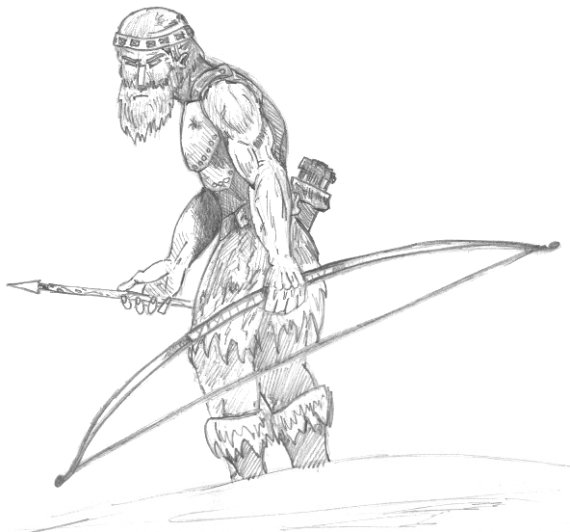
While at the local marketplace, the Warriors are approached by a burly looking Norseman. He inquires a to whether they would like to accompany his hunting party on the annual hunt. Polar Bear pelts bring good money at the market, and if the group is lucky enough to bring back a Yeti pelt then all the better. If the Warriors agree then they leave immediately.

SPECIAL RULES

The Norse hunting party consists of 1D6+1 Norse Hunters – use miniatures to represent them on the board. The Norse Hunters will not take part in combat unless the Warriors are fighting Polar Bears and Yetis, and can not be targeted by spells, although they can be harmed by spells which do area damage. They will however be subjected to events and should be represented by a counter in the Warrior cup. The hunters move after all the Warriors have had their turns, and in combat, where possible, they will stay at the back of the room and fire their bows.

In each board section the Warriors discover roll 1D6. On a score of 5-6 there will be 1D6 Polar Bears in the room as well as the normal rooms events. If the dice rolls a 6 then a Yeti will be present also.

As well as normal Objective Room Monsters in the Objective Room, there will also be 1D6 Polar Bears and 1D3 Yetis.

Completion

After the hunt, the Warriors can sell the pelts of any animal they themselves have killed and receive 100 Gold for each Polar Bear pelt and 250 Gold for each Yeti pelt.

 | Norse Hunter
Wounds | 6
Move | 4
Weapon Skill | 3
Ballistic Skill | 3+
Strength | 3
Toughness | 3
Armour | -
Initiative | 3
Attacks | 1
Damage | 1D6
Gold | 80

ENEMY’S WS 1 2 3 4 5 6 7 8 9 10
Norse Hunter 2 3 4 4 4 4 5 5 5 6

Norse Hunter
Armed with Bow (Str 3).

 | Polar Bear
Wounds | 15
Move | 6
Weapon Skill | 3
Ballistic Skill | -
Strength | 4
Toughness | 4
Armour | -
Initiative | 3
Attacks | 2
Damage | 2D6
Gold | 400

ENEMY’S WS 1 2 3 4 5 6 7 8 9 10
Polar Bear 2 3 4 4 4 4 5 5 5 6

Polar Bear
-

 | Yeti
Wounds | 20
Move | 6
Weapon Skill | 4
Ballistic Skill | 6+
Strength | 4
Toughness | 4
Armour | -
Initiative | 3
Attacks | 2
Damage | 2D6
Gold | 550

ENEMY’S WS 1 2 3 4 5 6 7 8 9 10
Yeti 2 3 3 4 4 4 4 4 5 5

Yeti
Fear 5; Hug 6.

