

INTO THE DAEMON’S LAIR

by Wendy Brown

Location: The Old World Battle-Level: 5-6 Objective Room: The Idol Chamber

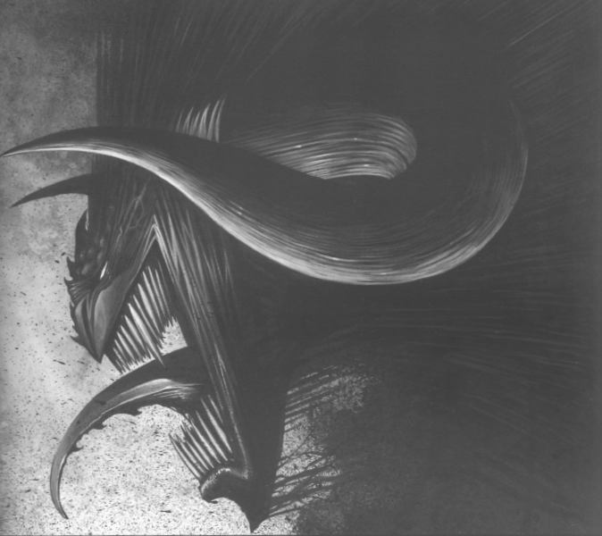

While on a well-deserved holiday in a coastal, tourist-plagued settlement, the Warriors hear news of the devastation of a small town only a few hours walk north. Upon investigation, they learn that a huge, dark red, winged Daemon Prince had decimated the peaceful farming community of Tomatohoe overnight. It was rumoured that a mighty sorcerer had discovered the means to summon and partly control the servants of Khorne, and had ordered the attack on the town as a demonstration of his power. Not only did the Daemon Prince demolish the town and kill many of its inhabitants, he kidnapped a young woman who happened to be the daughter of the King of the realm. Upon hearing the latter news, one of the Warriors feels a sense of righteousness overwhelm him and he convinces the others to rescue the lady from her certain death no matter what the cost.

While getting ready for their adventure, the Warriors receive further news. The kidnapping of the woman was part of an evil plot of the sorcerer to recruit another servant of Khorne into his retinue- a Bloodthirster! The King’s daughter was needed as a special sacrifice to summon this fiend. The Warriors realise the importance of stopping the ritual as fast as possible- if a Daemon Prince can destroy a town in one night, what might a Bloodthirster, the greatest and most deadly of all Khorne’s daemons, accomplish? The Warriors set off at once to search for the evil sorcerer’s lair in the northern wilderness.

SPECIAL RULES

To find the lair, the Warriors must trek through the wilderness, searching. Make one roll on the Hazard Table to see what befalls them on their search, interpreting unusable events as an uneventful search. At the end of their travels they find an entrance to a huge cave, with many large footprints made by someone or something hoofed. Following a hunch, the Warriors decide this must be the place, and enter. Treat the cave as a normal dungeon; 12 Dungeon Cards with the Objective Room randomly placed in the last 6.

When the Objective Room is reached, place the Daemon Prince and the Master Chaos Dwarf Sorcerer, riding a Great Taurus, at the back of the room. The Daemon Prince can replace the Idol at the back of the room if you wish. The King’s daughter should be placed next to the sorcerer. Also, the Warriors find a horde of Bloodletters acting as guards for the sorcerer. Place 2D6 +5 Bloodletter Guards as close as possible to the sorcerer. After the Taurus has flown to attack, the Bloodletters will always try to get as close as possible to the Sorcerer in their turn, before making any attacks. They cannot escape from pinning, however.

When all Monsters are dead, normal Objective Room Treasure and Gold rules apply, in addition to the Treasure Hoard of the Daemon Prince.

 | Daemon Prince of Khorne
Wounds | 65
Move | 6
Weapon Skill | 7
Ballistic Skill | A
Strength | 6
Toughness | 5 (9)
Armour | 4
Initiative | 8
Attacks | 6
Damage | 5D6
Gold | 4000

ENEMY’S WS 1 2 3 4 5 6 7 8 9 10
Daemon Prince of Khorne 2 2 2 3 3 3 4 4 4 4

Daemon Prince of Khorne

Daemonic -2; Daemonic Reward; Fly; Ignore Blows 5+; Ignore Pain 6; Terror 10; Treasure Hoard +1.

Treasure Hoard
This Daemon Prince has hidden a pile of loot away for his own use. Once he is vanquished, make one roll (1D6+1) on the following table to see what the party finds:

2-3 Dungeon Room Treasure
Each Warrior receives one Dungeon Room Treasure Card.

4 Dungeon Room Treasure and Gold
Each Warrior receives one Dungeon Room Treasure Card. Also, each Warrior may roll as many dice as he or she likes, adding up the score and multiplying by 10 to calculate the amount of gold found. However, if any of the dice score a 1 the Warrior finds no gold.

5 Lots of Dungeon Room Treasure
Each Warrior finds 1D3 Dungeon Room Treasure Cards.

6 Objective Room Treasure
Each Warrior finds an Objective Room Treasure Card.

Master
Chaos Dwarf
Sorcerer
Wounds | 26
Move | 3
Weapon Skill | 4
Ballistic Skill | 4+
Strength | 4
Toughness | 5 (8)
Armour | 3
Initiative | 4
Attacks | 2
Damage | 2D6
Gold | 2190

ENEMY’S WS 1 2 3 4 5 6 7 8 9 10
Master Chaos Dwarf Sorcerer 2 3 3 4 4 4 4 4 5 5

Master Chaos Dwarf Sorcerer
Chaos Dwarf Magic 3; Magic Armour; Magic Dispel 4+; Magic Item x 2; Magic Resistance 4+; Magic Weapon; Rides Great Taurus.

 | Great Taurus
Wounds | 50
Move | 6
Weapon Skill | 6
Ballistic Skill | -
Strength | 6
Toughness | 6 (9)
Armour | 3
Initiative | 7
Attacks | 4
Damage | 4D6
Gold | 2250

ENEMY’S WS 1 2 3 4 5 6 7 8 9 10
Great Taurus 2 2 3 3 3 4 4 4 4 4

Great Taurus
Breathe Fire; Fly; Terror 10.

 | Bloodletter Guards
Wounds | 7
Move | 4
Weapon Skill | 5
Ballistic Skill | 2+
Strength | 4
Toughness | 3
Armour | -
Initiative | 6
Attacks | 2
Damage | 2D6
Gold | 350

ENEMY’S WS 1 2 3 4 5 6 7 8 9 10
Bloodletter Guards 2 2 3 3 4 4 4 4 4 4

Bloodletter Guards
Armed with Hellblade; Daemonic -1; Fear 5; Guards Master Chaos Dwarf Sorcerer.

Hellblade
A Hellblade causes an extra 1D3 Wounds on the target, with no modifiers for Toughness or armour.

Aftermath
The Warriors must escort the lady back to a settlement, using the normal wilderness rules. Once there, a courier of the King congratulates them for their brave rescue, and provides them with 500 gold each as a reward.

This adventure is designed for a group of 4 Warriors.

