

KORAG-TOR
“TAKER OF SOULS, CHEATER OF DEATH”

by Ben Head

Location: Any Location Battle-Level: 7-10 Objective Room: Dread King’s Throne Room

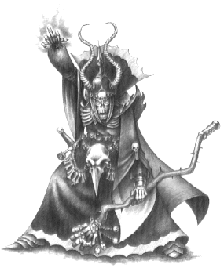

Many seasons past, the Liche Lord Korag-Tor was defeated by a powerful sorcerer. He was finally kept from his ability to regenerate himself. He now roams the dungeon, a lost tortured soul awaiting another way to free himself from his substanceless form. Now sometime later he has found a way, and his loyal minions rush to carry it out. The blood of a magical beast poured on the bones of the Liche Lord will bring him back. His followers have the blood and now travel back to the dungeon.

SPECIAL RULES

The Liche Lord
The Liche Lord has the same characteristics as a Liche from the Warhammer Quest Roleplay Book.

At the start of the adventure, roll 2D6, add the numbers and then double it. The resulting amount is the number of turns the Warriors have to reach the Throne Room before Korag-Tor's minions arrive.

The adventurers must hurry into and through the dungeon to the Liche's bones and destroy them before his minions return with the blood. Whenever a Monster is killed roll 1D6. On a roll of 1 the bodiless soul of Korag-Tor passes through the body and the Monster is resurrected. However, the Warriors still receive the Gold value for killing it. The Monster now has half of its original Wounds. Upon death a second time, the Warriors receive half of the Monsters Gold value.

Not Reaching the Objective Room in Time
If the Warriors do not make it to the Throne Room before their time is up, Korag Tor's minions have arrived before them and have already performed the ritual. A blood curdling cry echoes around the dungeon at the Liche Lord's regeneration. When the Warriors reach the Throne Room he will be waiting for them. Roll once on the Monster Table for the Liche Lord's minions, and once on the Monster Table one level above the current Warriors' Battle Level for the Monsters that the Liche Lord has summoned. The Liche Lord is also there. If the Warriors manage to defeat the Monsters, as well as taking an Objective Room Treasure Card, each Warrior finds 1D6 x 100 Gold.

Reaching the Objective Room in Time
If the Warriors reach the Throne Room before their time is up, they have caught Korag-Tor's minions beginning the ritual. Roll for Objective Room Monsters as normal to represent Korag-Tor's minions. Once all the Monsters are killed, as well as receiving an Objective Room Treasure Card, the Warriors search the Liche Lord's treasure pile and each find two Treasure Cards and 1D6 x 100 Gold.

